1 Introduction

LapLap Game is a music rhythm game developed as a term project of 2110215 Programming Methodology class. It is written entirely with Java language with Javafx library. It uses various crucial aspects of Java language such as Object Oriented Programming (OOP), thread, image and audio integration, and many more. For example, inheritance, polymorphism, access modifier setter/getter are used in this project. This project has begun on 20th November 2017, and with dedication and tremendous endeavour, it was finally completed on 11th December 2017. We hope that it’s fun to play for all adults, children and the instructors as well.

2 User Manual

LapLap Game is a single player game that player select a mode, song, and then play by pressing any of 3 buttons to match the circle that appear on top and slide downward on the screen. This will happen continuously meanwhile music that player chose is still playing. When players type the button correctly, they get a score.

The game has six scenes, a main menu scene, a select mode scene, a select song scene, an in-game scene, a pause scene and a game result scene.

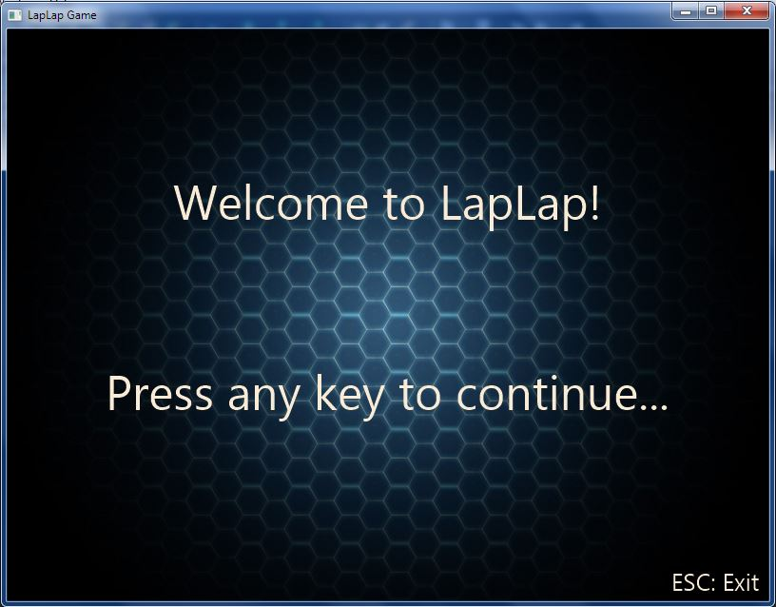

*Figure 1: A main menu scene of the Game*

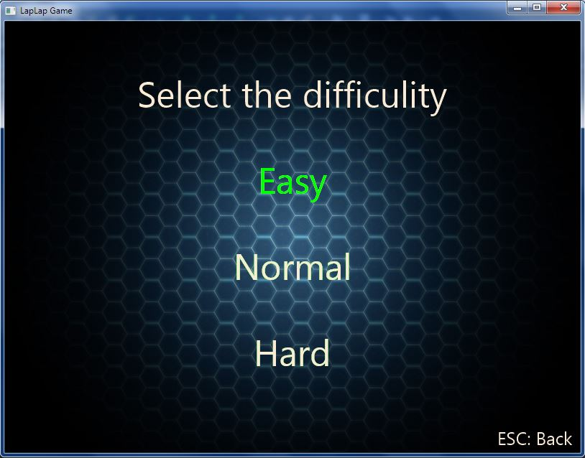

*Figure 2: A Select Mode Scene of the Game*

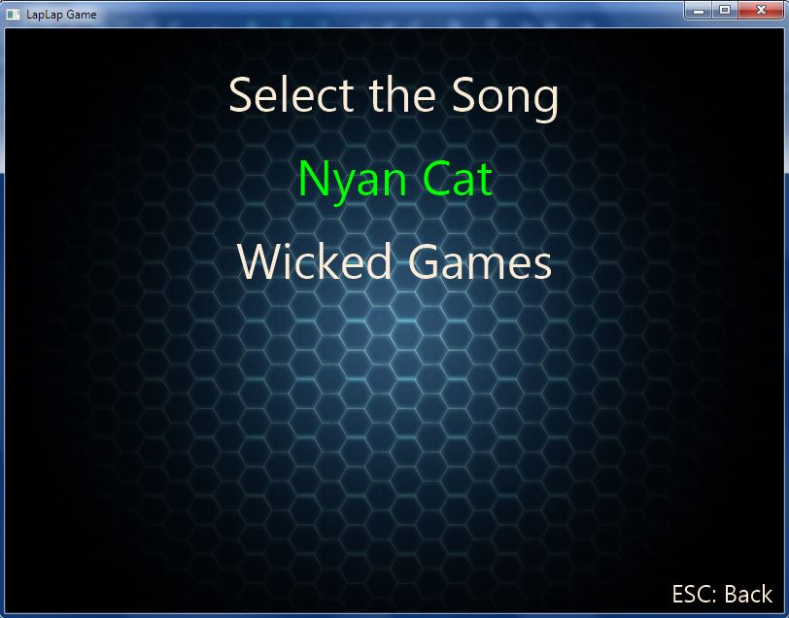

*Figure 3: A Select Song Scene of the Game*

4.

5.

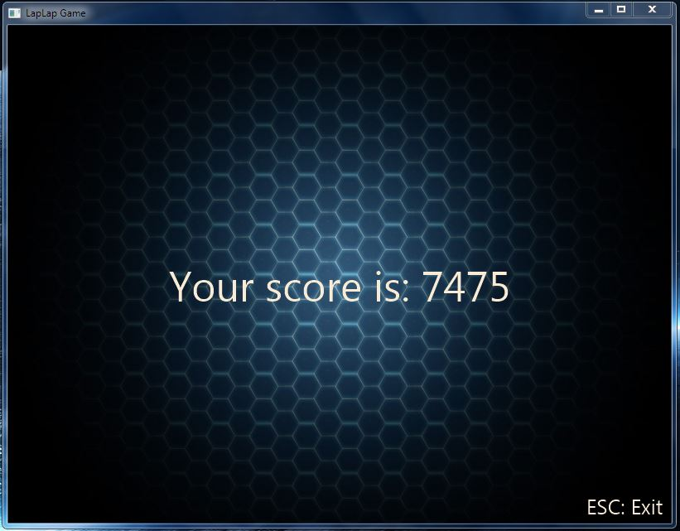

*Figure 6: A Game Result Scene of the Game*