**Report: Dream Car**

<https://github.com/NuraAbdi/Ass2-3-WEB-.git>

<https://nuraabdi.github.io/Ass2-3-WEB-/>

Home page (Nariman)

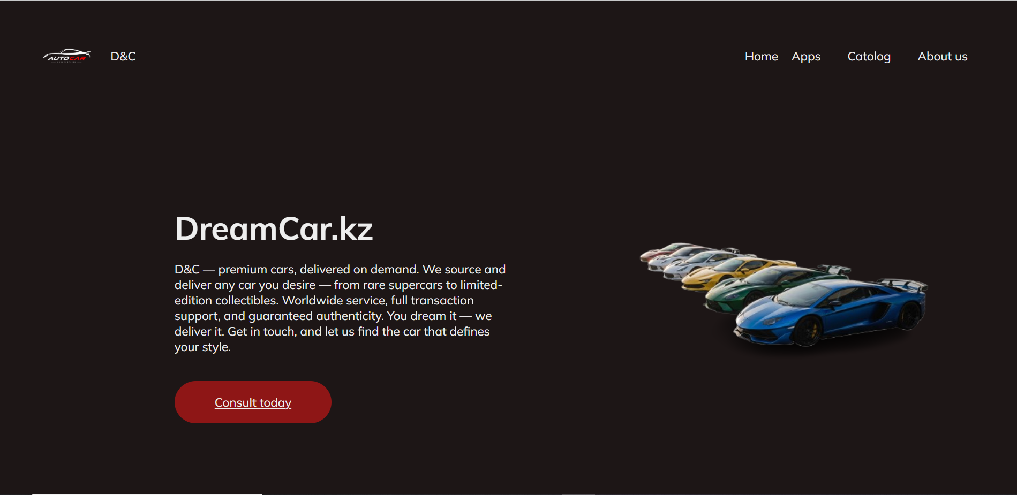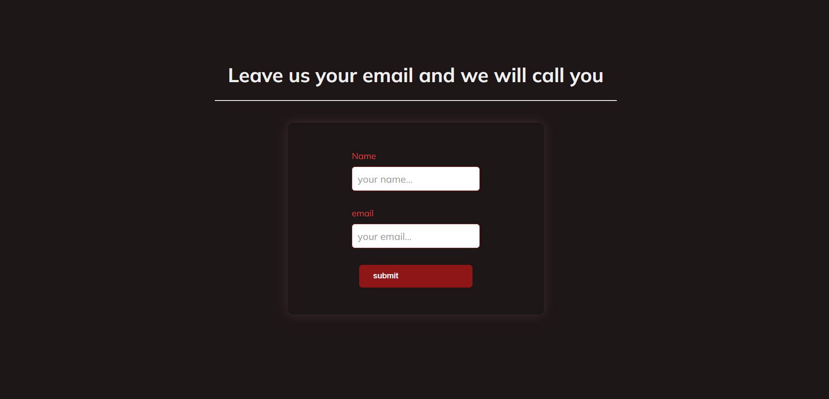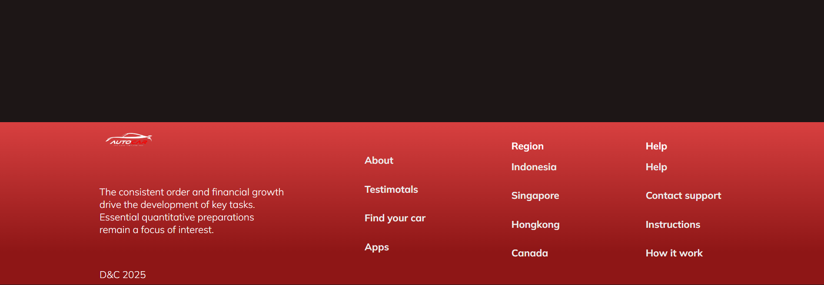

**Overview:**  
The website is designed to promote DreamCar.kz (D&C), a premium car sourcing and delivery service. The platform offers a wide range of luxury cars, from supercars to limited-edition collections. Their target audience likely consists of high-net-worth individuals seeking exclusive and high-end vehicles.

**Page Structure Breakdown:**

1. **Top Section (Hero Banner):**
   * **Visual Elements:**
     + The section features an image of high-end luxury cars, which aligns with the brand's focus on premium cars.
   * **Content:**
     + **Headline:** "DreamCar.kz" prominently placed at the top.
     + **Description:** A brief text explaining the company's services—sourcing and delivering cars on demand, worldwide service, transaction support, and guaranteed authenticity.
   * **Call-to-Action (CTA):**
     + A button labeled "Consult today" encourages users to take action, likely leading to a form or contact page.
2. **Middle Section (Lead Capture Form):**
   * **Visual Elements:**
     + Clean design with dark red and black tones for a sophisticated feel.
   * **Content:**
     + The form asks for the user’s **Name** and **Email** with a CTA button labeled "Submit".
     + **Purpose:** This section is designed for lead generation, with the promise of a follow-up phone call to interested users.
3. **Footer Section:**
   * **Visual Elements:**
     + Red and black color scheme, consistent with the overall theme.
   * **Content:**
     + The footer contains essential links:
       - **About**
       - **Testimonials**
       - **Find your car**
       - **Apps**
       - **Region links:** Various regions (Indonesia, Singapore, Hong Kong, Canada).
       - **Help and Support:** Links to Help, Contact support, Instructions.
   * **Additional Text:** There is also a mention of "The consistent order and financial growth drive the development of key tasks." This suggests an emphasis on financial stability and reliability.

**Design & Aesthetic:**

* **Color Scheme:**
  + The use of dark red and black gives the website an upscale, luxurious feel, which aligns with the premium nature of the cars being offered.
* **Typography:**
  + The font is clean and modern, enhancing readability while maintaining a sophisticated appearance.
* **Imagery:**
  + High-quality images of cars reinforce the premium brand image.

**Functionality:**

* **Lead Generation:**
  + The website effectively captures leads through the form, indicating a focus on converting visitors into potential clients.
* **Navigation:**
  + The header links to "Home", "Apps", "Catalog", and "About us", suggesting a simple and user-friendly navigation structure.
* **Global Reach:**
  + The footer highlights regions like Indonesia, Singapore, Hong Kong, and Canada, signaling that the company operates internationally.

**Potential Improvements:**

* **Clarification of Services:**
  + While the website mentions worldwide services, further details could be provided on how the transaction process works and what sets DreamCar.kz apart from competitors.
* **Testimonials Section:**
  + The footer mentions "Testimonials," but no specific reviews or experiences are highlighted on the page. Adding client testimonials or success stories would boost trust and credibility.
* **More Visual Variety:**
  + Including videos or a gallery of featured cars could make the site more engaging, showcasing the luxury cars in greater detail.

**Conclusion:**

DreamCar.kz's website successfully communicates its premium services and target audience through a clean, visually appealing design. The lead capture form and well-placed CTAs help facilitate potential client engagement. However, adding more details about the services, along with showcasing customer testimonials, could further enhance the site’s effectiveness.

Apps page (Nurbakut)

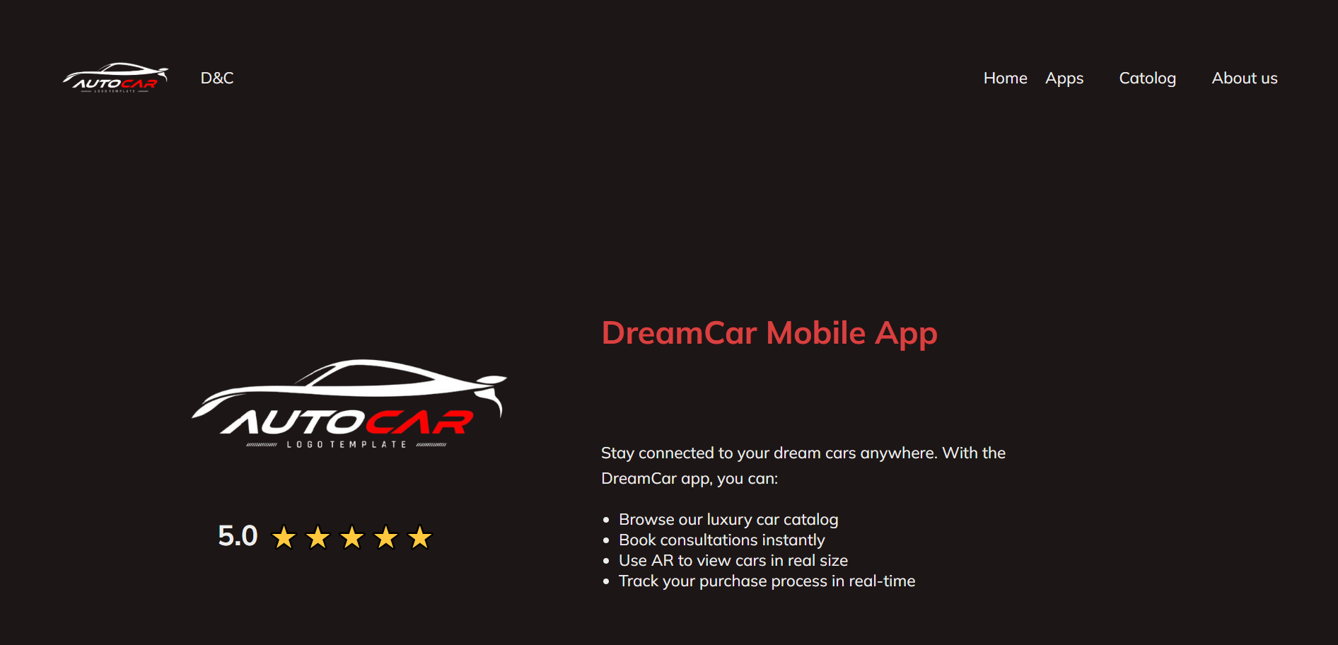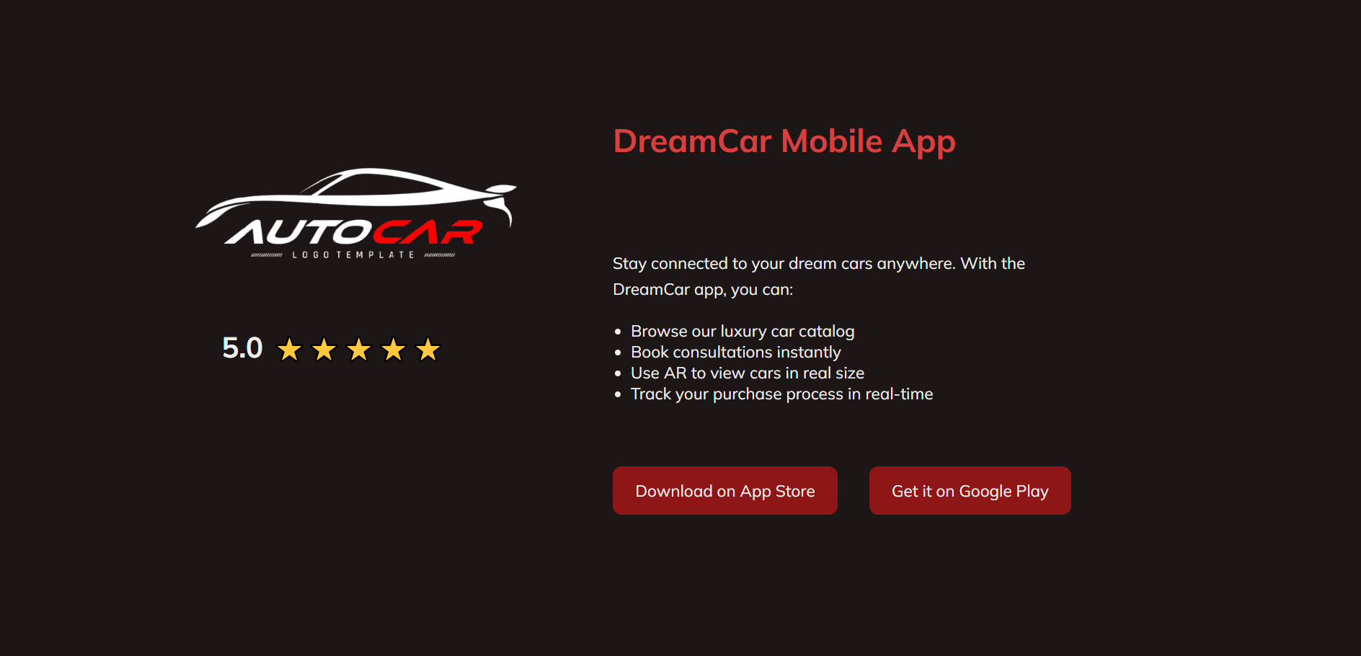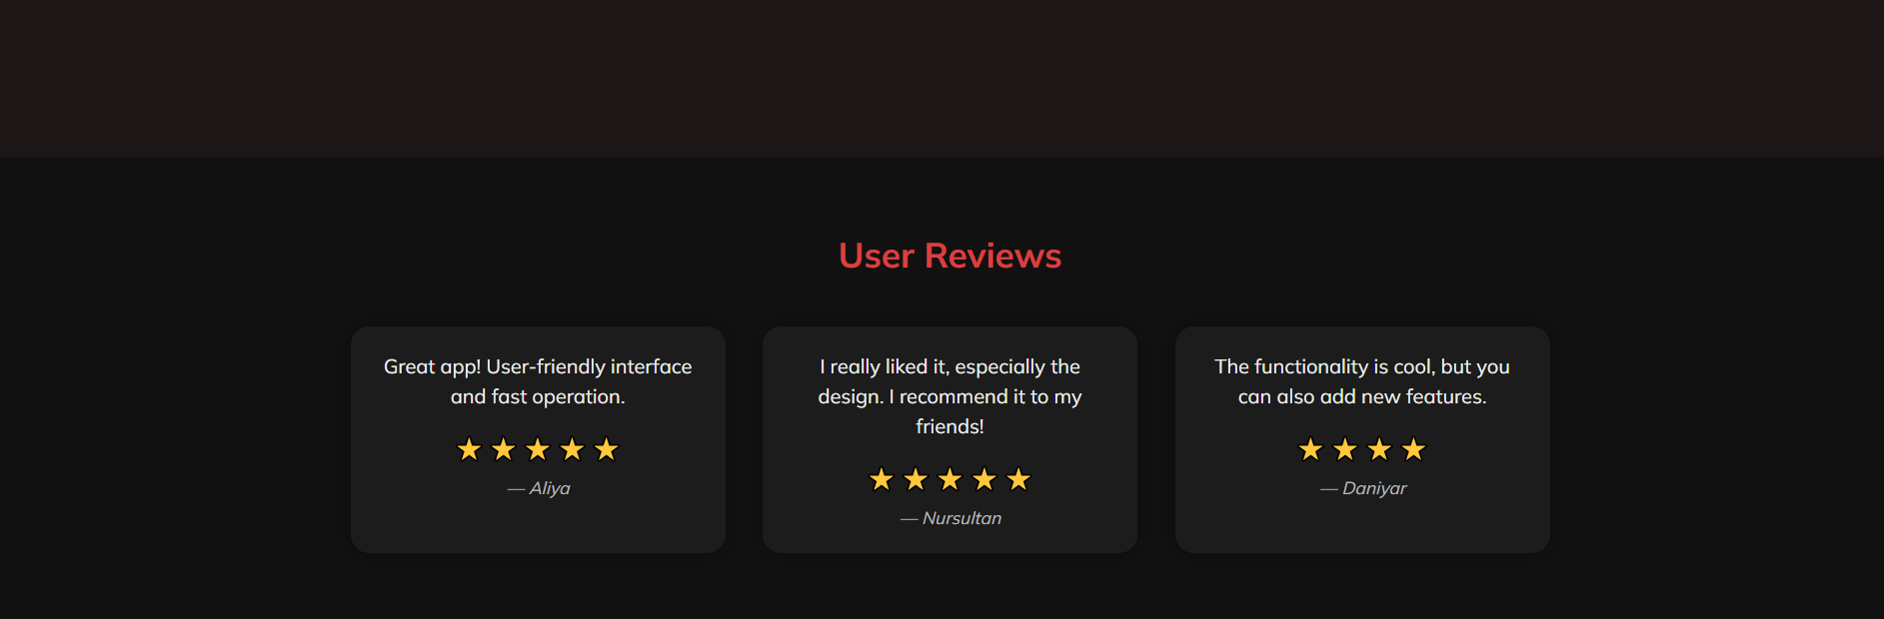

Overview: The DreamCar (AutoCar) mobile application website presents a sleek and modern interface that promotes a mobile app designed for luxury car enthusiasts. The site uses a dark theme with red and white accents, giving it a premium and stylish look. Main Features Highlighted: The app allows users to: Browse a luxury car catalog. Book consultations instantly. Use Augmented Reality (AR) to view cars in real size. Track purchase processes in real-time. User Ratings and Feedback: The app holds an impressive 5.0-star rating. User Reviews: Aliya: Appreciates the user-friendly interface and speed. Nursultan: Praises the design and recommends it to friends. Damiyar: Finds the functionality impressive but suggests adding new features. Call to Action: Two prominent red buttons encourage users to download the app from either the App Store or Google Play. Navigation: Top-right menu includes: Home, Apps, Catalog, About Us. Visual Elements: A logo of a sleek car labeled "AUTO CAR" is placed centrally. The page maintains consistent branding with bold typography and a minimalist layout.

Catolog Page (Nariman)

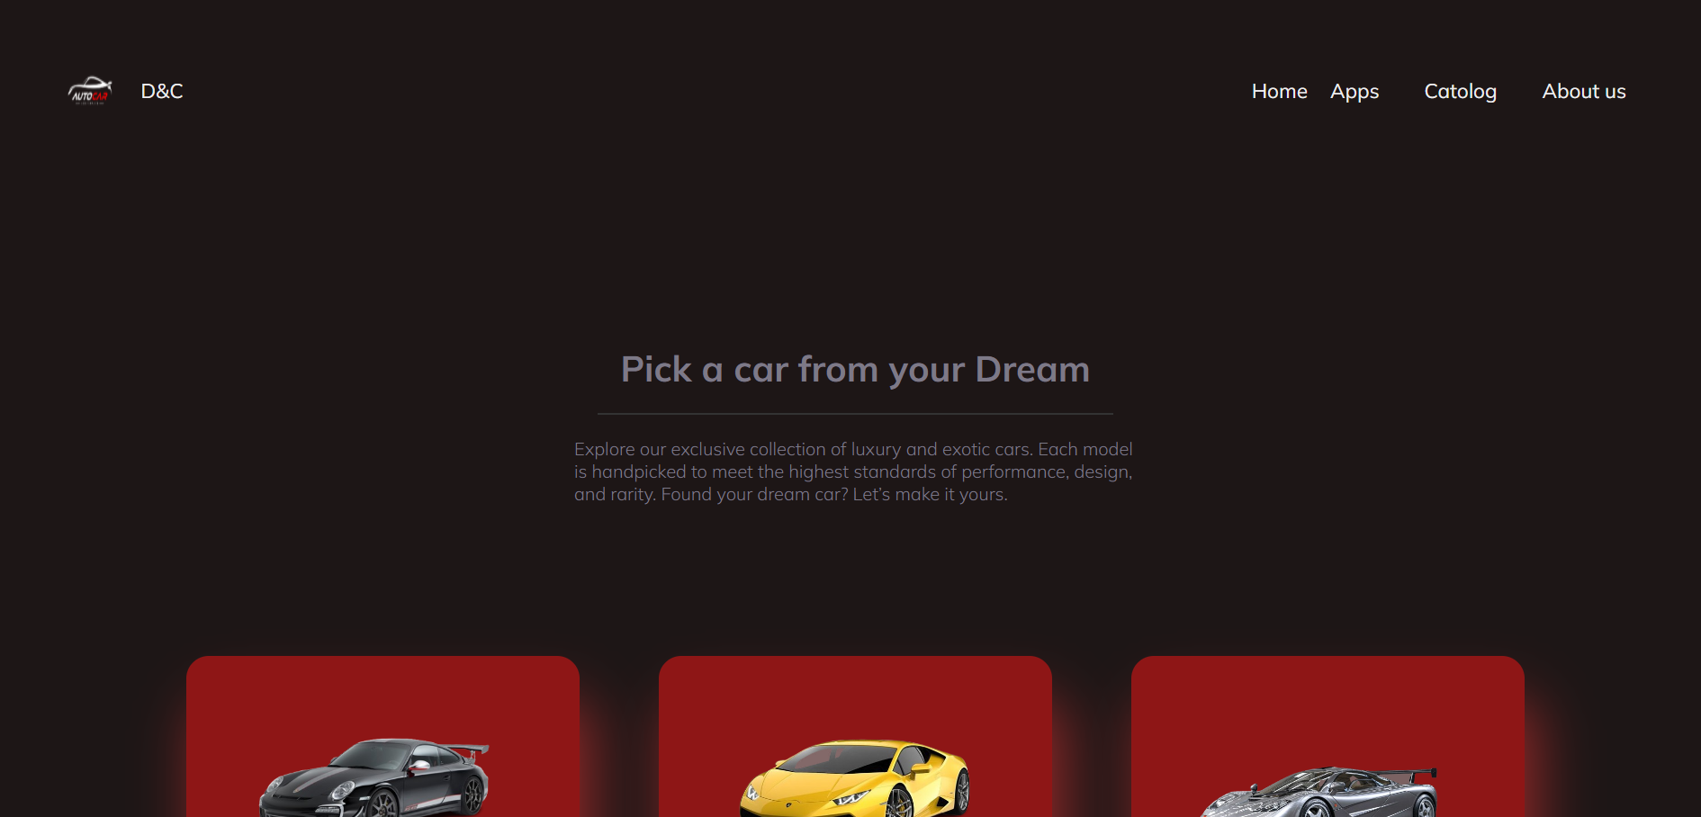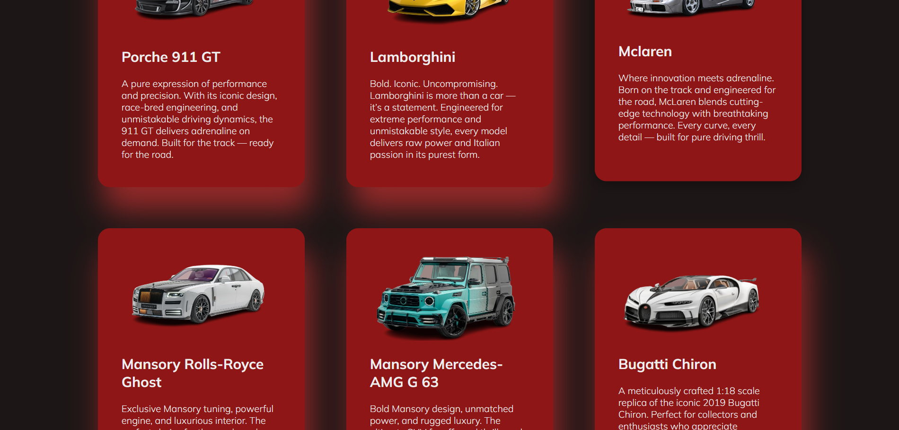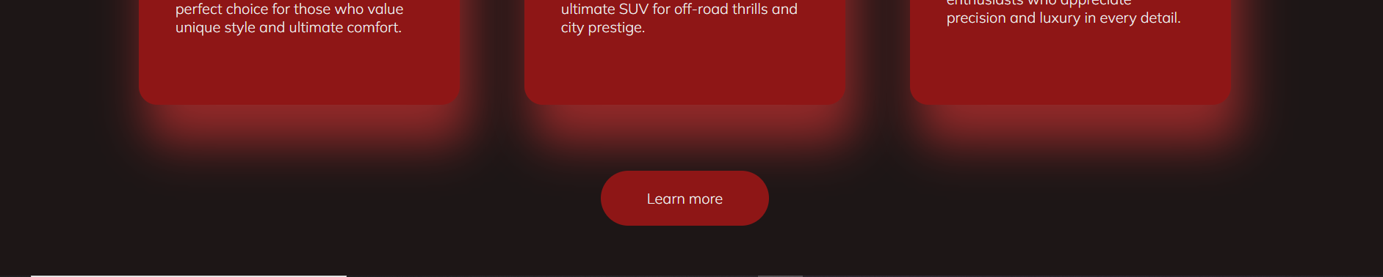

**Overview:**  
This section of the DreamCar.kz website focuses on showcasing a curated selection of luxury and exotic cars available for purchase. The design highlights each car model with a visually appealing layout, encouraging users to explore and select their dream cars.

**Page Structure Breakdown:**

1. **Header Section:**
   * **Headline:** "Pick a car from your Dream"
   * **Subheading:** The subheading emphasizes the luxury aspect, inviting customers to explore exclusive collections of luxury and exotic cars. It mentions the uniqueness of each model, touching on performance, design, and rarity. The tone is aspirational, speaking directly to customers seeking high-end vehicles.
2. **Car Listings:**
   * **Visual Elements:**
     + The car models are presented in neatly arranged rectangular cards with a red background, offering a clean and structured layout. This contrasts well with the dark color scheme of the website and makes the cars stand out.
   * **Content for Each Car:**
     + Each card contains:
       - **Car Image:** High-quality images of the cars.
       - **Car Name:** Clearly labeled with the car's name (e.g., "Porsche 911 GT", "Lamborghini", "Mclaren").
       - **Short Description:** A brief yet captivating description of the car's qualities, such as design, performance, and exclusivity. For instance, "Porsche 911 GT" is highlighted as a "pure expression of performance and precision", and "Bugatti Chiron" is described as a "luxurious 1:18 scale model that defines precision."
     + **Purpose:** These descriptions provide key selling points and enhance the aspirational appeal of each vehicle.
   * **Learn More Button:** Each car listing has a CTA button that says "Learn more," inviting users to explore further details about the car, which likely leads to a more detailed product page or information.

**Design & Aesthetic:**

* **Color Scheme:**
  + The use of red backgrounds in the car cards creates a striking contrast against the dark and luxurious tones of the website. This highlights the cars and draws attention to them, enhancing their exclusivity.
* **Typography:**
  + Clean and bold typography is used for the car names and descriptions, ensuring the text is easily readable and maintaining the sophisticated, high-end theme of the site.
* **Imagery:**
  + Each car is presented with a high-resolution image that showcases the design and features, contributing to the luxury feel of the site.

**Car Selection Overview:**

The displayed cars represent a wide range of prestigious automotive brands, emphasizing the exclusivity and high-performance nature of the vehicles:

* **Porsche 911 GT:** A blend of precision engineering and luxury.
* **Lamborghini:** Known for its bold, uncompromising style and performance.
* **McLaren:** A vehicle that combines extreme performance with cutting-edge technology.
* **Mansory Rolls-Royce Ghost:** Represents luxury with high-performance features and exclusive design.
* **Mansory Mercedes-AMG G63:** A perfect combination of power and off-road capability.
* **Bugatti Chiron:** Represents ultimate luxury and performance with precision engineering.

Each car listing presents its brand identity and the associated lifestyle, appealing to individuals looking for a prestigious and high-performance vehicle.

**Functionality:**

* **Interactive User Experience:**
  + The "Learn more" CTA button under each car listing encourages users to interact with the page, leading them to more detailed information about each vehicle.
* **Engagement:**
  + By highlighting different types of high-performance vehicles, the site is designed to cater to various tastes and preferences, ensuring a personalized browsing experience.

**Potential Improvements:**

* **Filter Options:**
  + Adding filter options to sort the cars based on price, brand, or type would improve the browsing experience, making it easier for potential buyers to find their ideal car.
* **Detailed Car Pages:**
  + Providing more detailed specifications and features directly on the page (e.g., horsepower, price, customization options) could enhance user engagement and decision-making.
* **User Reviews:**
  + Integrating customer reviews or testimonials related to each car model would increase trust and offer social proof for prospective buyers.

**Conclusion:**

The "Pick a car from your Dream" section effectively highlights a curated selection of luxury vehicles, appealing to high-net-worth individuals who seek performance and exclusivity. The visual design, with its clean layout and strong color contrast, draws attention to each car, while the brief descriptions enhance the allure of these high-end vehicles. By offering a smooth and engaging browsing experience, this section effectively showcases the premium services of DreamCar.kz, though additional features like filtering options or customer testimonials could further enhance user experience and decision-making.

About us Page (Nurbakyt)

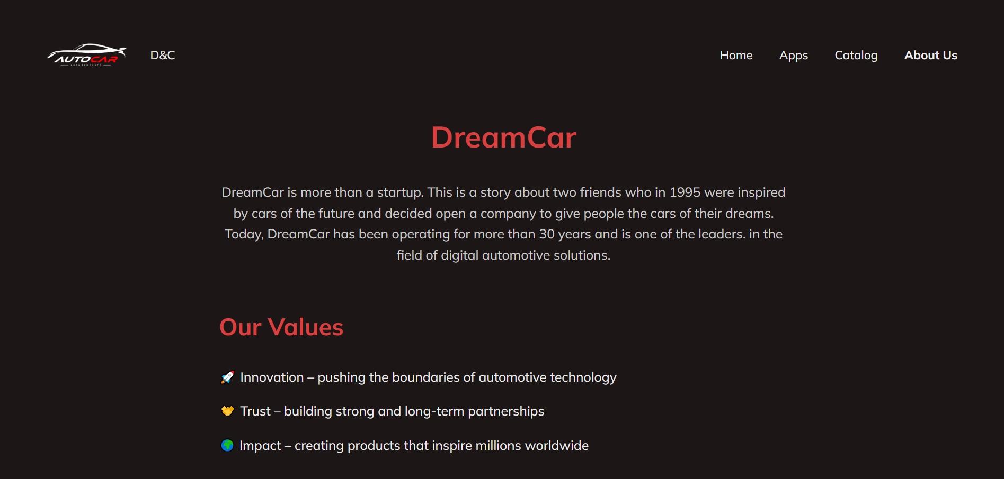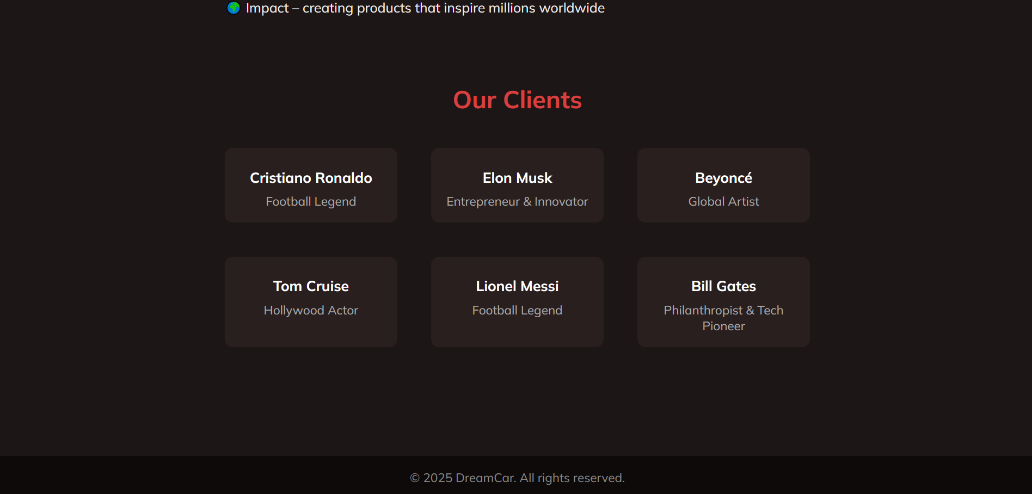

**Overview:**  
The "About Us" section of the DreamCar.kz website introduces the company’s story, its values, and notable clients. It provides insight into the brand's mission and emphasizes its longstanding history and impact on the automotive and digital technology industries.

**Page Structure Breakdown:**

1. **Company Introduction (Top Section):**
   * **Headline:** "DreamCar"
   * **Content:**
     + The paragraph explains the origins of DreamCar, emphasizing that the company was founded in 1995 by two friends who were inspired by futuristic cars. Their goal was to help people acquire the car of their dreams.
     + The text highlights the company’s experience of over 30 years in the industry and positions DreamCar as a leader in digital automotive solutions. This establishes the company’s credibility and expertise.
2. **Our Values Section:**
   * **Headline:** "Our Values"
   * **Content:**
     + **Innovation:** The company pushes the boundaries of automotive technology, focusing on progress and advancement.
     + **Trust:** DreamCar emphasizes building strong and long-term partnerships, reflecting its commitment to reliability and customer relationships.
     + **Impact:** DreamCar highlights its global influence, claiming to create products that inspire millions of people worldwide. This underscores the company’s wide-reaching effect and ambitious goals.
3. **Our Clients Section:**
   * **Headline:** "Our Clients"
   * **Content:**
     + A visual display of notable figures who are clients of DreamCar. The inclusion of high-profile clients enhances the brand’s image of exclusivity and prestige.
     + **Clients Featured:**
       - **Cristiano Ronaldo (Football Legend)**
       - **Elon Musk (Entrepreneur & Innovator)**
       - **Beyoncé (Global Artist)**
       - **Tom Cruise (Hollywood Actor)**
       - **Lionel Messi (Football Legend)**
       - **Bill Gates (Philanthropist & Tech Pioneer)**
     + These names further reinforce DreamCar's status as a brand trusted by influential individuals.

**Design & Aesthetic:**

* **Color Scheme:**
  + The dark background, complemented by red accents, keeps the website’s premium, luxurious feel consistent across all sections.
* **Typography:**
  + The font is clean, modern, and legible, contributing to a professional and sophisticated look.
* **Layout:**
  + The section is organized neatly, with well-defined sections for the company introduction, values, and clients. This makes the content easily digestible and visually appealing.

**Content Focus:**

* **Brand Story:**
  + The company narrative is compelling, focusing on its long history and leadership in the industry. It builds a strong emotional connection by highlighting the founders' initial inspiration and current success.
* **Values:**
  + DreamCar's core values—innovation, trust, and impact—are clearly stated, showcasing the company’s focus on growth, collaboration, and global influence. These values are likely designed to appeal to potential clients who prioritize cutting-edge technology and reliability.
* **Client List:**
  + Featuring prominent clients like Cristiano Ronaldo and Bill Gates provides significant social proof. Associating the brand with such influential figures not only boosts credibility but also positions DreamCar as a luxury, high-end service.

**Functionality:**

* **User Engagement:**
  + The section is informative and designed to engage visitors who want to know more about the company’s background and reputation. The prominent placement of "Our Clients" with recognizable names creates a sense of trust and exclusivity.
* **Navigation:**
  + The page layout is straightforward, with clear navigation links at the top for "Home", "Apps", "Catalog", and "About Us," which enhances the overall user experience.

**Potential Improvements:**

* **More Client Details:**
  + While the section mentions high-profile clients, it could benefit from brief descriptions of how these clients use DreamCar’s services. This could add a personal touch and demonstrate the company’s ability to cater to the needs of ultra-high-net-worth individuals.
* **Visuals of Clients:**
  + Incorporating images or testimonials from these clients could further humanize the brand and showcase authentic success stories.
* **Company Milestones:**
  + Adding more specific milestones or achievements, such as key collaborations, awards, or breakthroughs in automotive technology, would enrich the company’s narrative.

**Assignment 3 – Sidebar Filters**

**In this assignment, we improved our website by adding a sidebar filter panel to all main pages: Home, Catalog, About Us, and Apps.  
The sidebar can be toggled using a button and contains different filters:**

* **Country – USA, Japan, Germany, Russia, Kazakhstan**
* **City – cities related to each selected country (e.g., New York, Tokyo, Berlin, Moscow, Almaty, Astana, Shymkent, etc.)**
* **Car Brand – BMW, Audi, Toyota, Mercedes**
* **Year – from 2015 up to 2025**
* **Price filter – implemented using a range slider with a dynamic value display**

**The sidebar makes it easier for users to filter cars according to their preferences. We integrated it across all website pages to ensure consistency and a better user experience.**

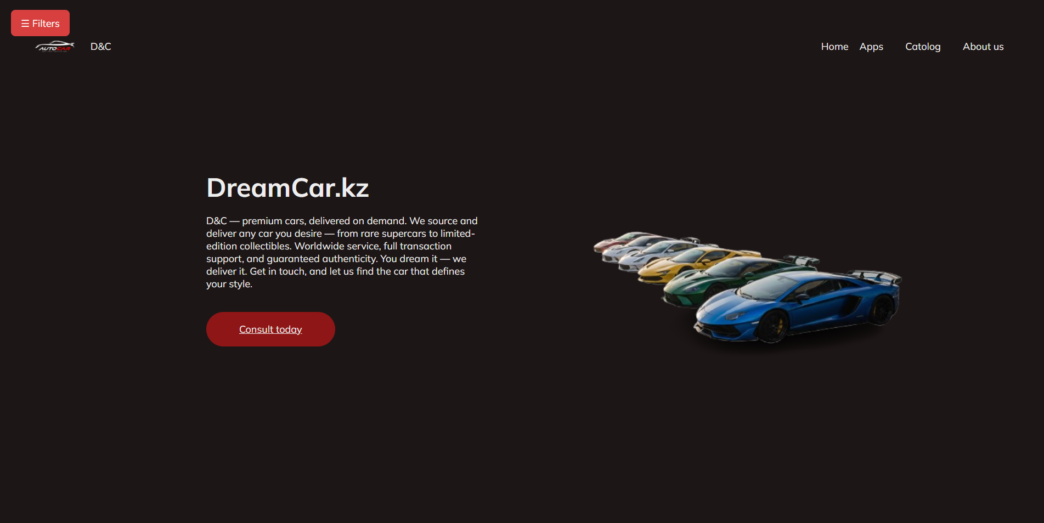

**Изображение выглядит как текст, снимок экрана, дизайн

Содержимое, созданное искусственным интеллектом, может быть неверным.**

**Изображение выглядит как текст, машина, транспортное средство, Наземный транспорт

Содержимое, созданное искусственным интеллектом, может быть неверным.Изображение выглядит как текст, снимок экрана, Шрифт, дизайн

Содержимое, созданное искусственным интеллектом, может быть неверным.**

**Conclusion:**

The "About Us" section of the DreamCar.kz website successfully communicates the company’s rich history, values, and impressive clientele. The storytelling approach, combined with a focus on innovation, trust, and global impact, positions DreamCar as a prestigious brand in the automotive and digital solutions space. The high-profile client list further reinforces the exclusivity and appeal of the brand.  
  
In addition, during Assignment 3, we enhanced the user experience by integrating a sidebar filter panel across all main pages (Home, Apps, Catalog, About Us). This sidebar allows visitors to filter cars by country, city, brand, year, and price range, making navigation easier and more interactive. This improvement ensures that DreamCar.kz is not only visually appealing but also highly functional and user-friendly.