# MBR 1 PERM FLOW

1.0

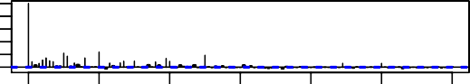

0 20 40 60 80 100 120

0.0

Lag

# MBR 2 PERM FLOW

1.0

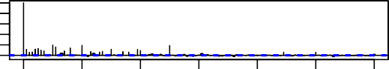

0 20 40 60 80 100 120

0.0

Lag

# MBR AIR SCOUR FLOW

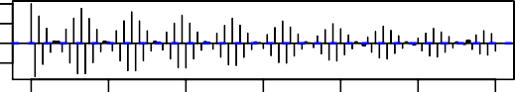

0 20 40 60 80 100 120

Lag

# MBR 1 TRANS PRESS

1.0

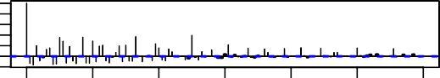

0 20 40 60 80 100 120

−0.2

Lag

# WAS FLOW

1.0

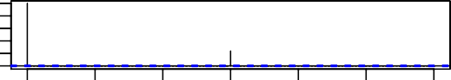

0 20 40 60 80 100 120

0.0

Lag

# SEWAGE FLOW TOTAL BATCH

1.0

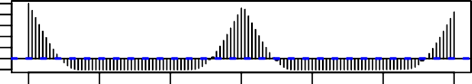

0 20 40 60 80 100 120

−0.2

Lag

# BIO 2 DO

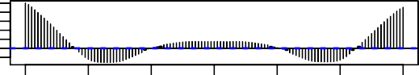

0 20 40 60 80 100 120

Lag

# BIO BLOWER 2 FLOW

ACF

**MBR 1 PERM PRESS**

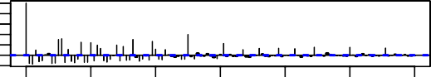

0 20 40 60 80 100 120

ACF

−0.2 1.0

Lag

# MBR 2 PERM PRESS

ACF

−0.2 1.0

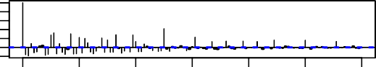

0 20 40 60 80 100 120

Lag

# MBR AIR SCOUR FLOW

ACF

−0.5

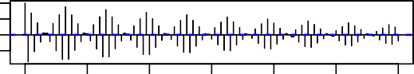

0 20 40 60 80 100 120

Lag

# MBR 2 TRANS PRESS

ACF

−0.2 1.0

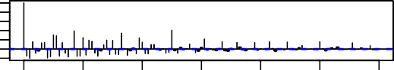

0 20 40 60 80 100 120

Lag

# MBR BATCH VOLUME

ACF

1.0

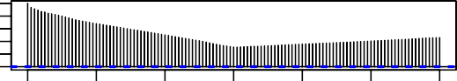

0 20 40 60 80 100 120

0.0

Lag

# BIO 1 DO

ACF

−0.2 1.0

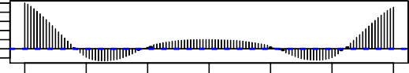

0 20 40 60 80 100 120

Lag

# BIO BLOWER 1 FLOW

ACF

−0.2

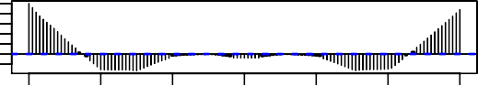

0 20 40 60 80 100 120

Lag

# MBR 1 INF FLOW

0.0

1.0

ACF

−0.2

ACF

−0.2

ACF

ACF

ACF

ACF

−0.5

ACF

ACF

