# MBR 1 LEVEL

1.0

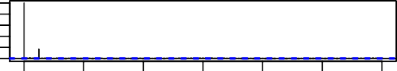

0 20 40 60 80 100 120

0.0

Lag

# MBR 2 LEVEL

1.0

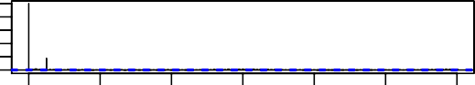

0 20 40 60 80 100 120

0.0

Lag

# SEWAGE FLOW

−0.2

1.0

ACF

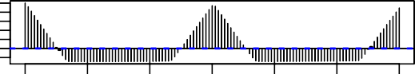

0 20 40 60 80 100 120

Lag

# AMBIENT TEMP

1.0

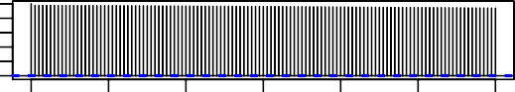

0 20 40 60 80 100 120

0.0

Lag

# BIO 1 TSS

1.0

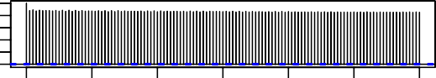

0 20 40 60 80 100 120

0.0

Lag

# BIO 2 TSS

1.0

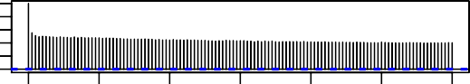

0 20 40 60 80 100 120

0.0

Lag

# PERMEATE TANK LEVEL

0.0

1.0

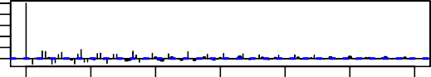

**RAS TROUGH TSS**

0.0

1.0

|  |  |  |  |  |  |  |  |  |  |  |  |
| --- | --- | --- | --- | --- | --- | --- | --- | --- | --- | --- | --- |
| 0 | 20 40 | 60 | 80 100 | 120 | 0 | 20 | 40 | 60 | 80 | 100 | 120 |
|  |  | Lag |  |  |  |  |  | Lag |  |  |  |

**MBR 2 INF FLOW**

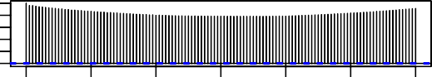

0 20 40 60 80 100 120

ACF

0.0

1.0

Lag

# PERMEATE TANK TURBIDITY

ACF

1.0

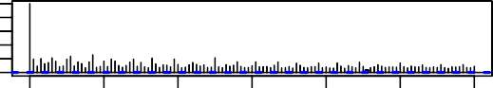

0 20 40 60 80 100 120

0.0

Lag

# SEWAGE LEVEL

1.0

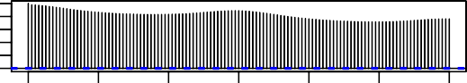

0 20 40 60 80 100 120

0.0

Lag

# BIO 1 LEVEL

ACF

−0.5

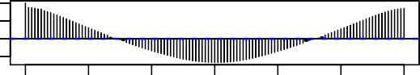

0 20 40 60 80 100 120

Lag

# BIO 2 LEVEL

ACF

−0.5

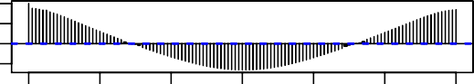

0 20 40 60 80 100 120

Lag

# PERMEATE TANK CONDUCTIVITY

ACF

1.0

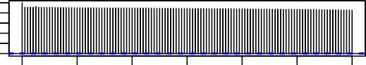

0 20 40 60 80 100 120

0.0

Lag

# RAS TROUGH DO

ACF

0.0

1.0

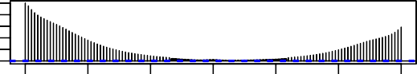

ACF

ACF

ACF

ACF

ACF

ACF

ACF

ACF

