MWRD PAA - Preliminary Data Analysis

Version 3

Kate Newhart

4/16/2019

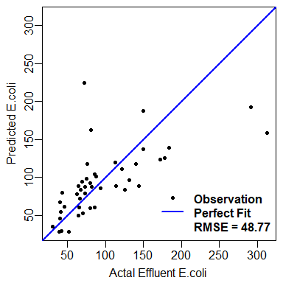

Figure 1 Neural network Effluent E.coli prediction from Oct 2-15, 2018 PAA data

Figure 1 BOO YAH

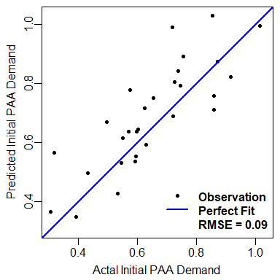

Figure 2 Neural network initial PAA demand/decay prediction from Oct 2-15, 2018 PAA data

Figure 2 BOO YAH