23CSE111 OBJECT ORIENTED PROGRAMMING
S2 B.Tech CSE
Department of Computer Science and Engineering
Amrita School of Computing, Amritapuri Campus
CASE STUDY
PHASE – 2 (Design)
Architectural Modelling (CO2)

Group No :D4
Team Members :
Roll No | Student Name
AM.SC.U4CSE25329 | K NITHIN
AM.SC.U4CSE25328 | K ROHIT
AM.SC.U4CSE25335 | RAM LOKESH
AM.SC.U4CSE25319 | G HARSHA VARDHAN

- Problem Title :HOSPITAL MANAGEMENT SYSTEM(HMS)

STRUCTURAL DESIGN

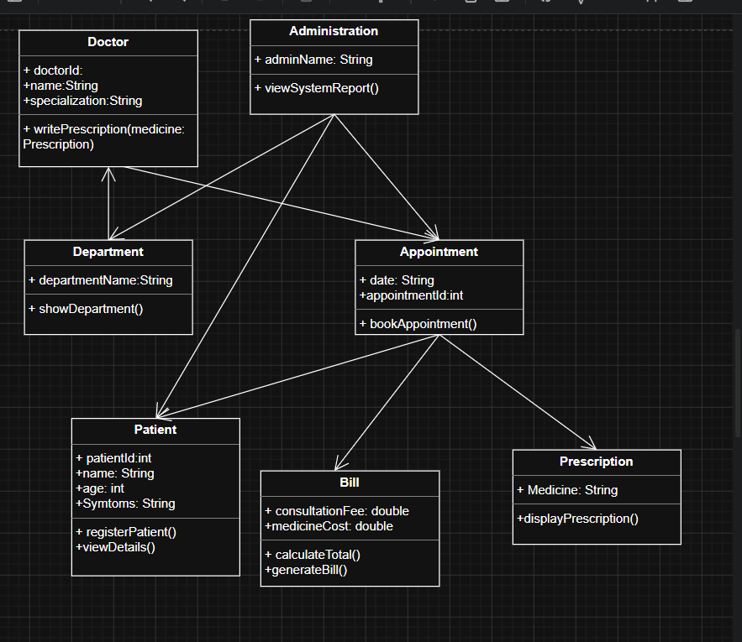

BEHAVIUORAL DESIGN
- Use-case diagram
- List of actors
1.DOCTOR
2.PATIENT
3.ADMINISTRATOR
4.STAFF

- List of use-cases
- Register patient
- Book appointment
- View patient details
- Write prescription
- Display prescription
- Generate bill
- Manage Department
- View report
- Use case diagram (use UML notations)
- 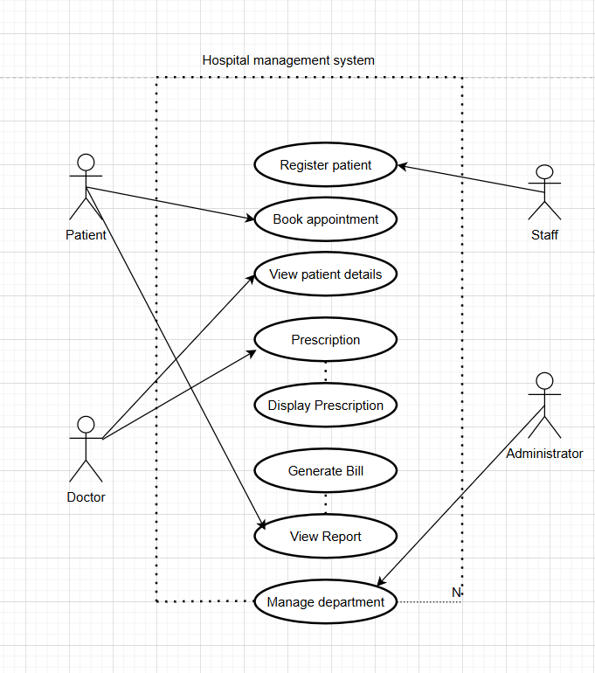

- Sequence diagram (use UML notations)
  - Choose key use cases and draw their sequence diagram. First describe the scenario in few sentences. Then draw the sequence diagram.
