

**Lyceum of the Philippines Cavite**

**College of Engineering, Computer Studies, and Architecture**

**Department of Computer Studies**

|  |
| --- |
| **Laboratory Activity #2 – Math Quiz Game** |

Name: **KOBE JAMES MAWANAY** Date: **FEB 14, 2025**

Section: **IT-102**  Teacher: **Sir. Nava, Prince**

**I. Specific Topic:**

Creating a Math Quiz Game where the player selects the number of questions.

**II. Objectives:**

• Learn how to prompt the player for input and use it to control the flow of the game.

• Practice generating random math questions (addition, subtraction, multiplication, and square roots).

• Use Python’s random, math, and platform modules to make the game interactive and fun.

**III. Definition of a Laboratory Activity:**

This activity involves creating a Math Quiz Game that generates a user-defined number of math questions, including square root problems using Python’s built-in math, random, and platform modules. The player will choose how many questions they want to answer, and the game will ask that number of questions while keeping track of the score.

**IV. Instructions:**

• Take a screenshot of your Python code and its output for several questions with various answers.

• Save your document with the name SURNAME_SECTION_LABACT2_PRELIM.pdf.

• Submit the file to the LMS.

**V. Task**1. Create the Python Game Script:

* Create a Python script (math_quiz_game.py) with the following functionality:
  + Use the random module to generate random math problems (addition, subtraction, multiplication, square root).
  + Allow the player to choose how many questions they want to answer.
  + Track the score and display it at the end.
  + Use math.sqrt() to generate square root questions.
  + Display system information using the platform module.

2. Code Steps:

1. Import Required Modules: Import random, math, and platform.
2. Display System Information: Show OS name and machine architecture using platform.system() and platform.machine().
3. Prompt Player for Number of Questions: Ask the player how many questions they want to answer.
4. Generate Random Math Question: Use random.choice() to randomly select an operation (addition, subtraction, multiplication, or square root).
5. Ask the Question and Get the Answer: Display the question and ask for the player's input.
6. Validate the Answer: Check if the player’s answer is correct and update the score.
7. Repeat for Chosen Number of Questions: Loop through the number of questions the player chose.
8. Display Final Score: Show the final score at the end of the game.

**VI. Screenshots:** (with Comments)

MAIN PROGRAM: CODE

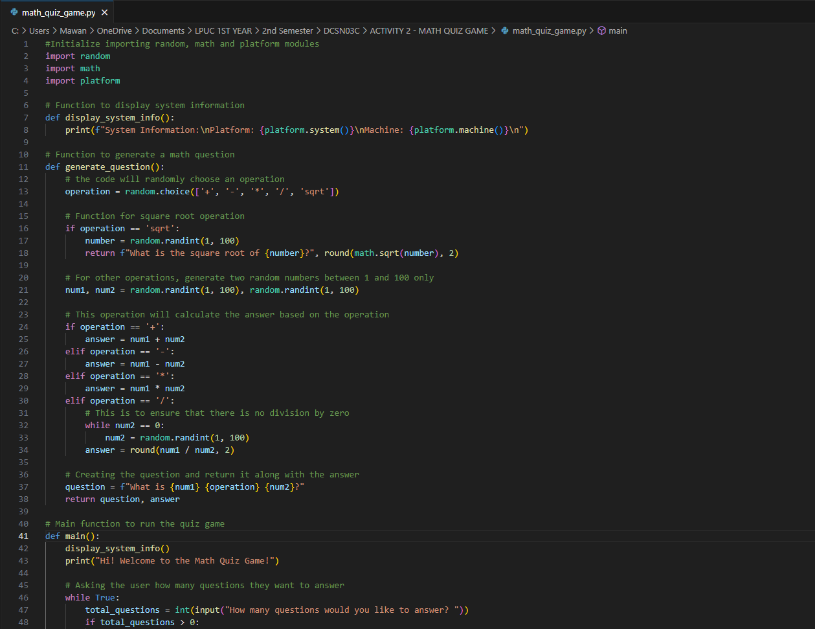

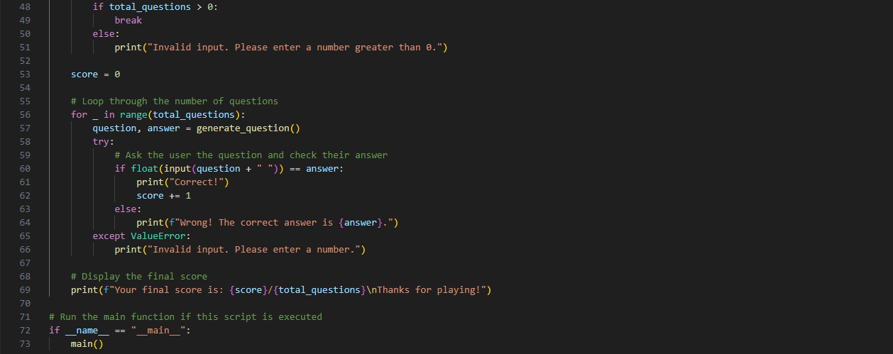

TEST PROGRAM SECTION:

**(Abiding with the code)**

**(Violating the code)**

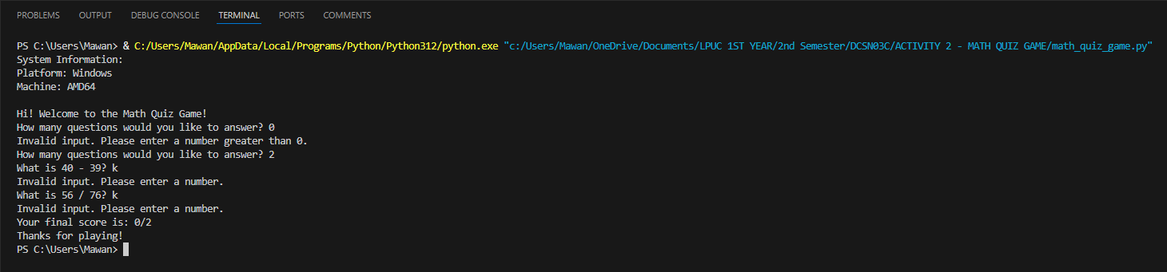

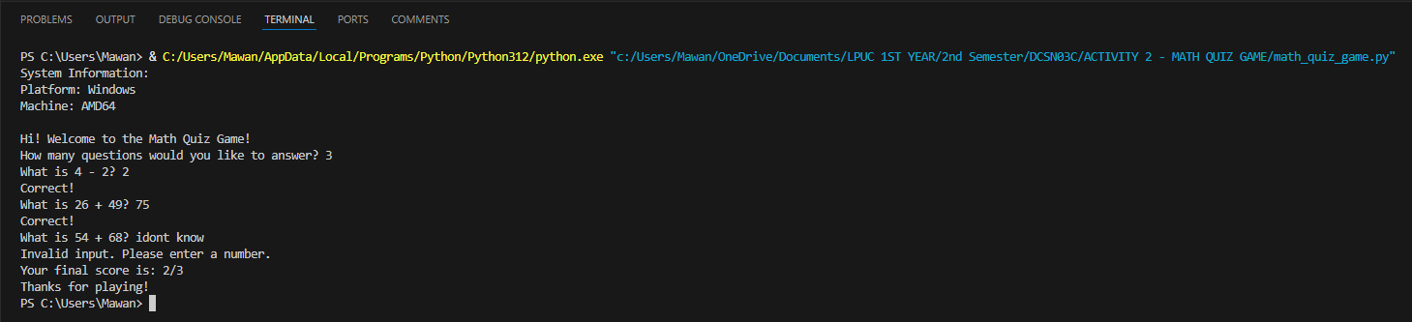

GITHUB LINK: