# EXPERIMENT:2

**AIM:** Implement Half Adder and Full Adder using logic gate ICs.

**Tools:** Logisim 2.7.1 (Open Source)

# Theory:

**Combinational Circuit:** A combinational circuit is a type of electronic circuit where the output depends only on the current inputs, not on past inputs or states.

**Half Adder:** Half-Adder is a combinational logic circuit that is designed by connecting one Ex- OR gate and one AND gate. The half-adder circuit has two inputs: A and B, which add two input digits and generate a carry and a sum.

# Truth Table:

|  |  |  |  |
| --- | --- | --- | --- |
| **Input** | | **Output** | |
| A | B | Sum | Carry |
| 0 | 0 | 0 | 0 |
| 0 | 1 | 1 | 0 |
| 1 | 0 | 1 | 0 |
| 1 | 1 | 0 | 1 |

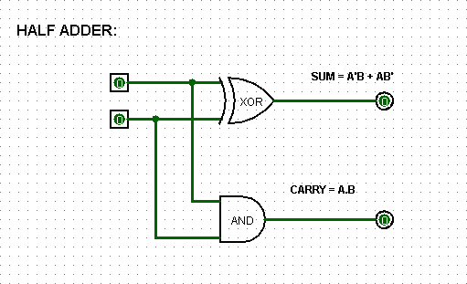

**Full-Adder:** Full Adder is the circuit that consists of two EX-OR gates, two AND gates, and one OR gate. Full Adder is the adder that adds three inputs and produces two outputs which consist of two EX-OR gates, two AND gates, and one OR gate.

**Truth-Table:**

|  |  |  |  |  |
| --- | --- | --- | --- | --- |
| **Input** | | | **Output** | |
| A | B | C | Sum | Carry |
| 0 | 0 | 0 | 0 | 0 |
| 0 | 0 | 1 | 1 | 0 |
| 0 | 1 | 0 | 1 | 0 |
| 0 | 1 | 1 | 0 | 1 |
| 1 | 0 | 0 | 1 | 0 |
| 1 | 0 | 1 | 0 | 1 |
| 1 | 1 | 0 | 0 | 1 |
| 1 | 1 | 1 | 1 | 1 |

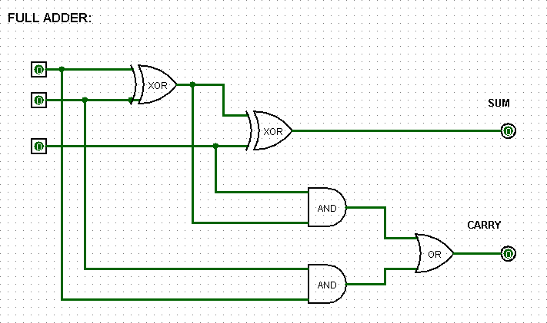

**Observation:**

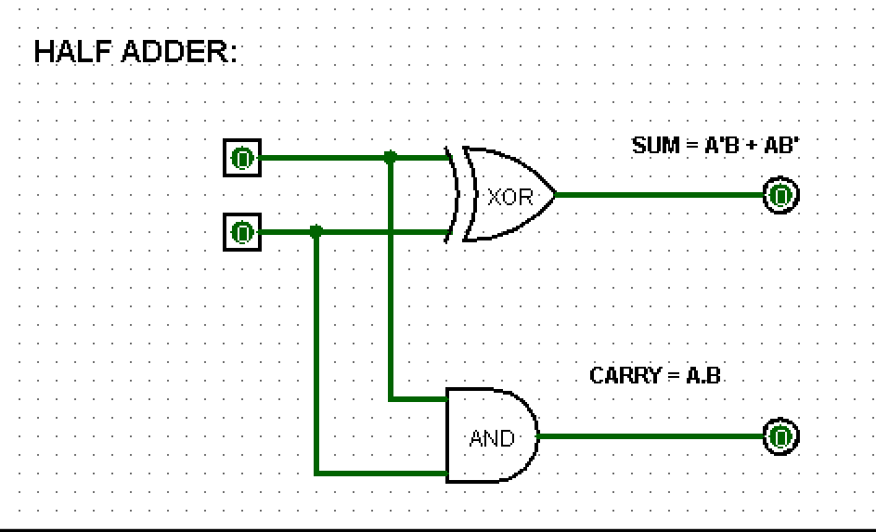

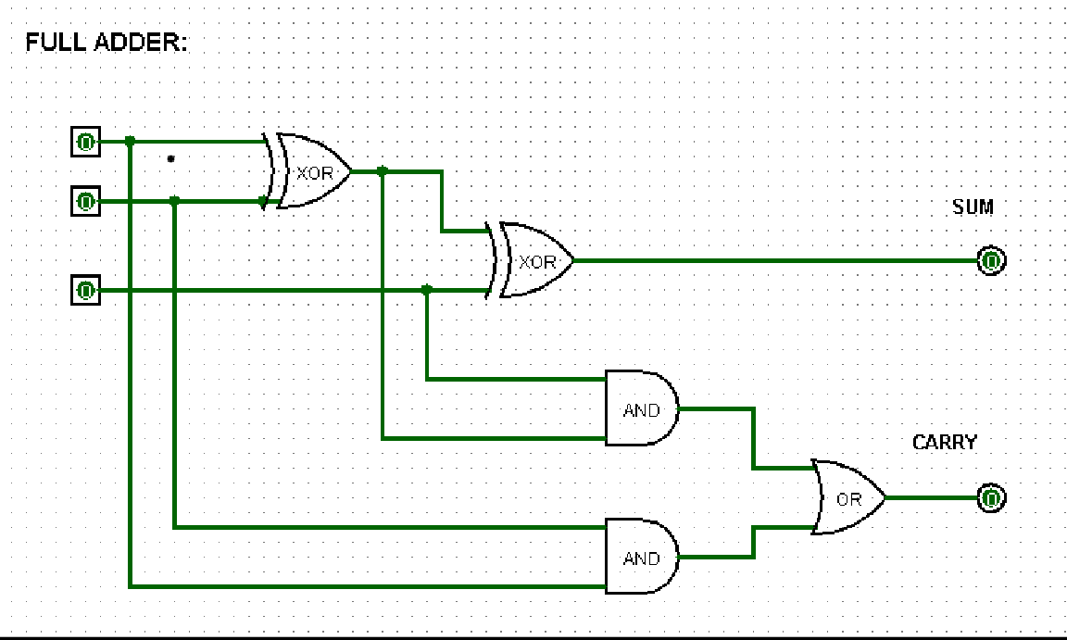

**Result:** Truth Table of logic gates are verified via Logisim

**Half-Adder:**

|  |  |  |  |
| --- | --- | --- | --- |
| **Input** | | **Output** | |
| A | B | Sum | Carry |
| 0 | 0 | 0 | 0 |
| 0 | 1 | 1 | 0 |
| 1 | 0 | 1 | 0 |
| 1 | 1 | 0 | 1 |

**Full-Adder:**

|  |  |  |  |  |
| --- | --- | --- | --- | --- |
| **Input** | | | **Output** | |
| A | B | C | Sum | Carry |
| 0 | 0 | 0 | 0 | 0 |
| 0 | 0 | 1 | 1 | 0 |
| 0 | 1 | 0 | 1 | 0 |
| 0 | 1 | 1 | 0 | 1 |
| 1 | 0 | 0 | 1 | 0 |
| 1 | 0 | 1 | 0 | 1 |
| 1 | 1 | 0 | 0 | 1 |
| 1 | 1 | 1 | 1 | 1 |

**Conclusion:**

Circuit simulation and their Truth Table verification can be achieved using open source **“Logisim”** software.