# EXPERIMENT:3

**AIM:** Implement Half Subtractor and Full Subtractor using logic gate ICs.

**Tools:** Logisim 2.7.1 (Open Source)

# Theory:

**Combinational Circuit:** A combinational circuit is a type of electronic circuit where the output depends only on the current inputs, not on past inputs or states.

**Half Subtractor:** Half subtractor is a combination circuit with two inputs and two outputs that are different and borrow. It produces the difference between the two binary bits at the input and also produces an output.

# Truth Table:

|  |  |  |  |
| --- | --- | --- | --- |
| **Input** | | **Output** | |
| A | B | Diff | Borrow |
| 0 | 0 | 0 | 0 |
| 0 | 1 | 1 | 1 |
| 1 | 0 | 1 | 0 |
| 1 | 1 | 0 | 0 |

**Diff = A ⊕ B Borrow = A’ AND B**

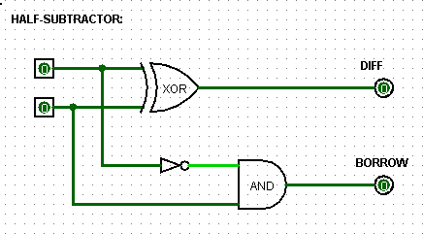

**Full-Subtractor:** A full subtractor is a digital circuit that subtracts three single-digit binary numbers and produces two output bits. It consists of XOR, AND and OR gates.

# Truth-Table:

|  |  |  |  |  |
| --- | --- | --- | --- | --- |
| **Input** | | | **Output** | |
| A | B | C | Diff | Borrow |
| 0 | 0 | 0 | 0 | 0 |
| 0 | 0 | 1 | 1 | 1 |
| 0 | 1 | 0 | 1 | 1 |
| 0 | 1 | 1 | 0 | 1 |
| 1 | 0 | 0 | 1 | 0 |
| 1 | 0 | 1 | 0 | 0 |
| 1 | 1 | 0 | 0 | 0 |
| 1 | 1 | 1 | 1 | 1 |

**Diff = (A XOR B) XOR**

**Bin = (A ⊕ B) ⊕ Bin**

**Borrow = (Bin AND (A XOR B)) OR (A’ AND B) = Bin(A**

**⊕ B) + (¬A ∧ B)**

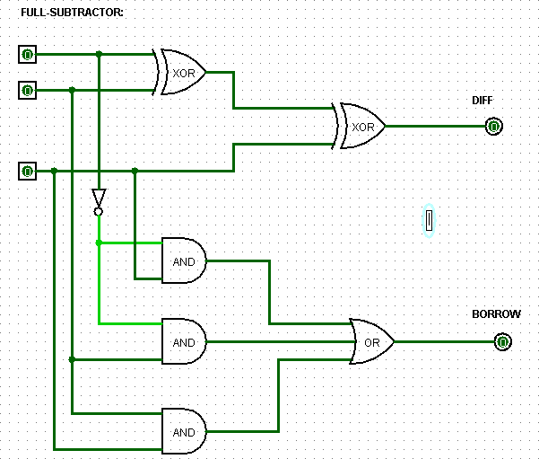

**Observation:**



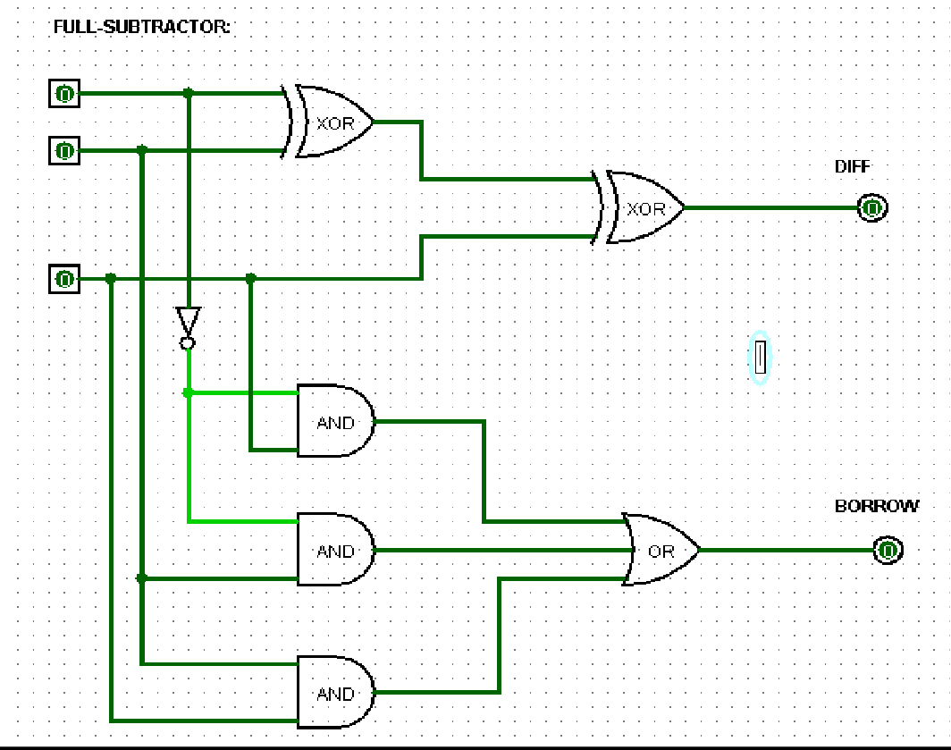

**Result:** Truth Table of logic gates are verified via Logisim

**Half-Adder:**

|  |  |  |  |
| --- | --- | --- | --- |
| **Input** | | **Output** | |
| A | B | Diff | Borrow |
| 0 | 0 | 0 | 0 |
| 0 | 1 | 1 | 1 |
| 1 | 0 | 1 | 0 |
| 1 | 1 | 0 | 0 |

**Full-Adder:**

|  |  |  |  |  |
| --- | --- | --- | --- | --- |
| **Input** | | | **Output** | |
| A | B | C | Diff | Borrow |
| 0 | 0 | 0 | 0 | 0 |
| 0 | 0 | 1 | 1 | 1 |
| 0 | 1 | 0 | 1 | 1 |
| 0 | 1 | 1 | 0 | 1 |
| 1 | 0 | 0 | 1 | 0 |
| 1 | 0 | 1 | 0 | 0 |
| 1 | 1 | 0 | 0 | 0 |
| 1 | 1 | 1 | 1 | 1 |

**Conclusion:**

Circuit simulation and their Truth Table verification can be achieved using open source “**Logisim”** software.