**Experiment-7**

**Aim: To write an assembly language program to multiply two 8-bit numbers**

**Tools Required : DOSBox v0.74-3**

**Code : Write/paste your first code here**

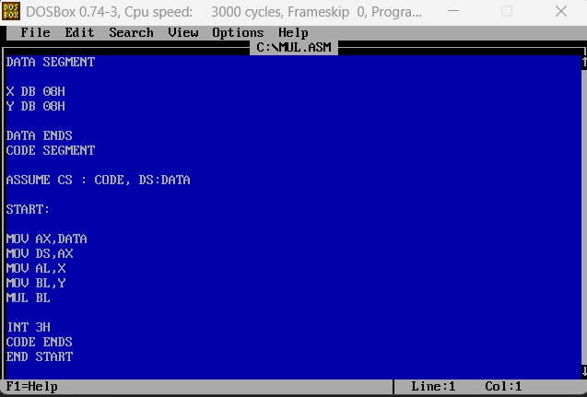

**Output :**

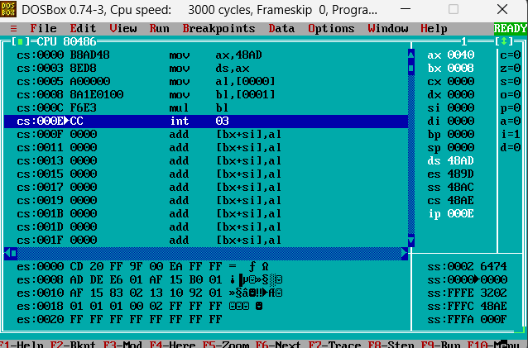

**Code Interpretation: Paste the snapshot of your manual line by line interpretation of the code as discussed in the class.**

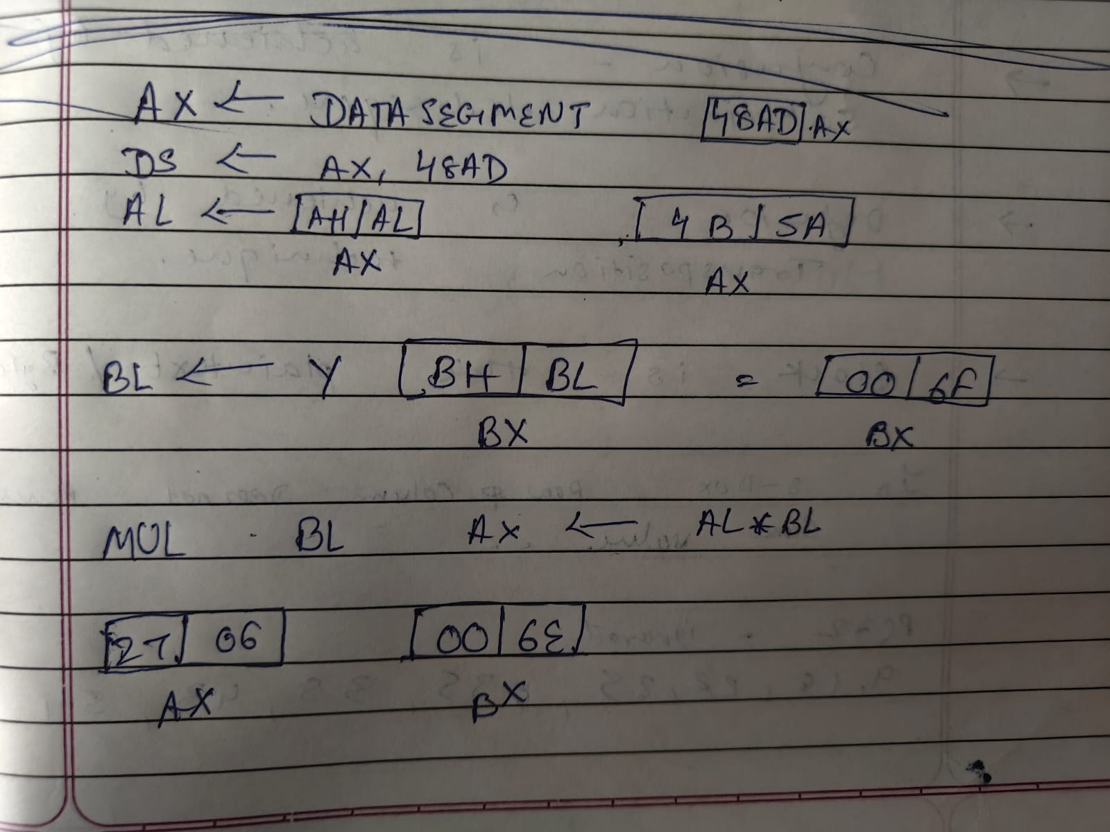

# Results:

# **The Multiplication is stored in BL (or whatever register you use) register.**

**Conclusion:**

**The flags are updated after the program's execution.**

**Lab Quiz:**

Q1. Write an assembly language program to multiply two 16-bit words.

You can refer corresponding instruction in the shared file named “8086 instruction

“set”.

Answer :

DATA SEGMENT

NUM1 DW 1234H ; First 16-bit number

NUM2 DW 0002H ; Second 16-bit number

DATA ENDS

CODE SEGMENT

ASSUME CS:CODE, DS:DATA

START:

MOV AX, DATA ; Load address of DATA segment

MOV DS, AX ; Initialize DS with data segment address

MOV AX, NUM1 ; Load first number into AX

MOV BX, NUM2 ; Load second number into BX

MUL BX ; AX * BX → result in DX:AX

INT 3H ; Halt for debug or view result

CODE ENDS

END START