**Experiment-8**

**Aim: Write a program in assembly language to print input string and print it.**

**Tools Required : DOSBox v0.74-3**

**Code : Write/paste your first code here**

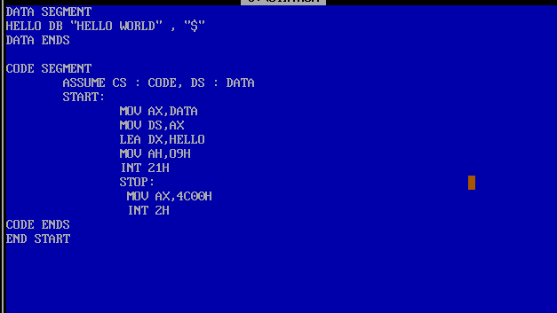

**Output :**

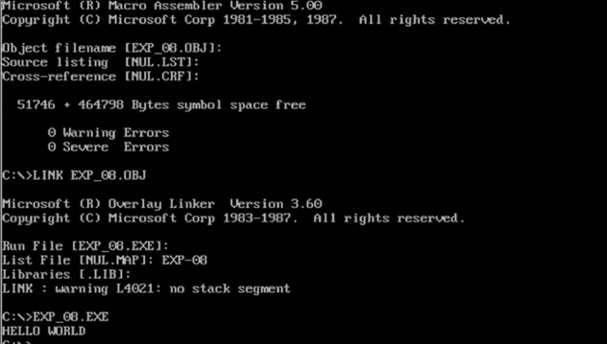

**Code Interpretation: Paste the snapshot of your manual line by line interpretation of the code as discussed in the class.**

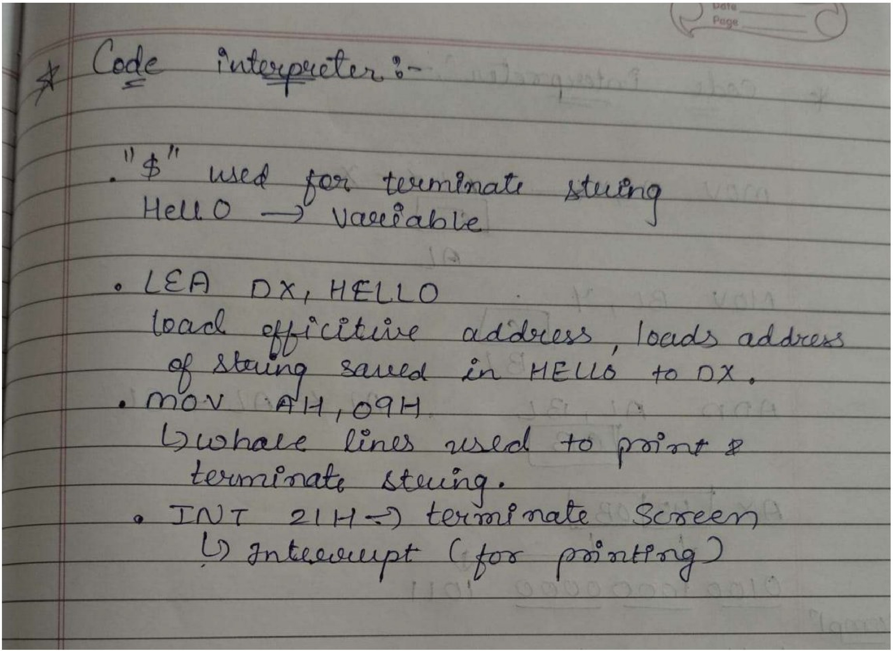

# **Results :**

# **The “HELLO WORLD” Is Displayed When We Run The Exe File Of The Code Given**

**Conclusion:**

**This Assembly Program Is Use To Display An String On The Output Screeen**

**Using Various Interrupts’**