**Experiment-9**

**Aim: Simulate The Machine To Use To Determine the contents of AC,E,PC,AR&IRRegisters in Hex Value After The Execution Of Each Of The Given Refrence Instruction**

**Tools Required : DOSBox v0.74-3**

**Code : Write/paste your first code here**

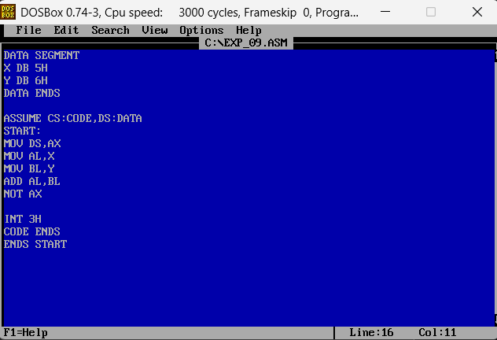

**Output :**

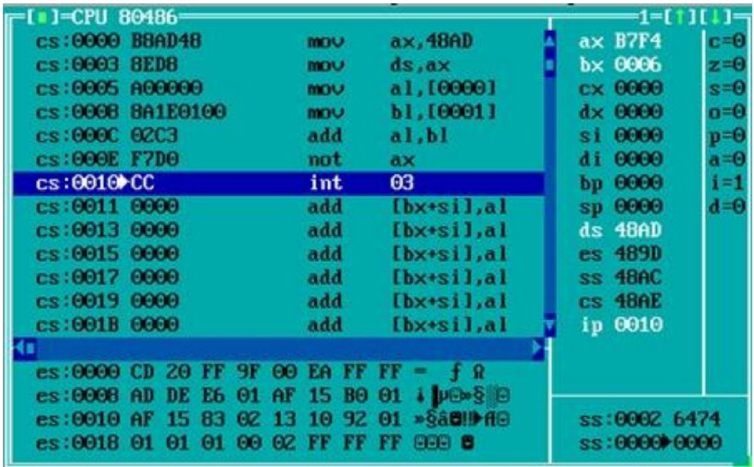

**Code Interpretation: Paste the snapshot of your manual line by line interpretation of the code as discussed in the class.**

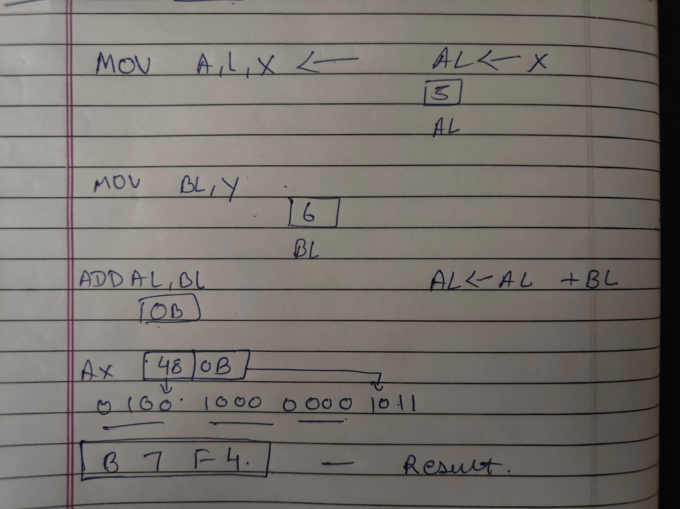

**Results :**

# **The AX Regaiter will strore B7F4 After We Add The Two Numbers**

**Conclusion:**

**This Assembly Program Is** **Use To Determine the contents of AC,E,PC,AR&IR**

**Registers in Hex Value After The Execution Of Each Of The Given Refrence**

**Instruction.**