DESIGN AND ANALYSIS OF ALGORITHMS
COMPREHENSIVE REPORT
Question 39 - Binary Search on Sorted Financial Transaction Data

Abstract
This report presents a comprehensive study of Binary Search in the context of a financial system that stores transaction IDs in sorted order. The report explains the working principle of Binary Search, the need for sorted data, implementation using Python, algorithm design, pseudocode, sample execution, complexity analysis, advantages, limitations, applications and detailed answers to all parts of the given question. This report is prepared according to the Design and Analysis of Algorithms rubric with emphasis on problem understanding, concept application, analysis, justification and solution design.

Introduction
Financial institutions perform millions of searches every day. Customers check transaction status, employees verify records, auditors inspect historical transactions and automated systems validate payments. Searching becomes inefficient if every record is examined one after another. Binary Search solves this problem by reducing the search interval by half after every comparison. This makes it one of the most efficient searching techniques for sorted data. However, its efficiency completely depends on maintaining sorted records.

Problem Statement
A financial system stores transaction IDs in sorted order to perform quick searching using Binary Search. Frequent updates insert new transaction IDs and disturb the sorted order. The objective is to explain Binary Search, analyse its performance when data is sorted and unsorted, discuss the importance of maintaining sorted order and implement the algorithm.

Objectives
The objectives are to understand Binary Search, implement it in Python, study its complexity, analyse sorted versus disturbed data, and justify why maintaining sorted order is necessary in financial databases.

Existing System
In an unsorted financial database, every transaction may need to be checked one by one using Linear Search. This increases response time significantly as the number of transactions grows. Although insertion is easy, searching becomes slow and inefficient.

Proposed System
The proposed system maintains transaction IDs in sorted order and performs searching using Binary Search. After every update, the data should be reordered if necessary so that Binary Search continues to work correctly.

Theory of Binary Search
Explanation 1: Binary Search follows the divide-and-conquer strategy. During every iteration, the algorithm compares the target transaction ID with the middle element of the sorted list. If the target is smaller, the right half is ignored; if greater, the left half is ignored. This repeated elimination of half the search space dramatically reduces the number of comparisons. In financial systems where millions of records are stored, this behaviour improves search efficiency and reduces execution time.
Explanation 2: Binary Search follows the divide-and-conquer strategy. During every iteration, the algorithm compares the target transaction ID with the middle element of the sorted list. If the target is smaller, the right half is ignored; if greater, the left half is ignored. This repeated elimination of half the search space dramatically reduces the number of comparisons. In financial systems where millions of records are stored, this behaviour improves search efficiency and reduces execution time.
Explanation 3: Binary Search follows the divide-and-conquer strategy. During every iteration, the algorithm compares the target transaction ID with the middle element of the sorted list. If the target is smaller, the right half is ignored; if greater, the left half is ignored. This repeated elimination of half the search space dramatically reduces the number of comparisons. In financial systems where millions of records are stored, this behaviour improves search efficiency and reduces execution time.
Explanation 4: Binary Search follows the divide-and-conquer strategy. During every iteration, the algorithm compares the target transaction ID with the middle element of the sorted list. If the target is smaller, the right half is ignored; if greater, the left half is ignored. This repeated elimination of half the search space dramatically reduces the number of comparisons. In financial systems where millions of records are stored, this behaviour improves search efficiency and reduces execution time.
Explanation 5: Binary Search follows the divide-and-conquer strategy. During every iteration, the algorithm compares the target transaction ID with the middle element of the sorted list. If the target is smaller, the right half is ignored; if greater, the left half is ignored. This repeated elimination of half the search space dramatically reduces the number of comparisons. In financial systems where millions of records are stored, this behaviour improves search efficiency and reduces execution time.
Explanation 6: Binary Search follows the divide-and-conquer strategy. During every iteration, the algorithm compares the target transaction ID with the middle element of the sorted list. If the target is smaller, the right half is ignored; if greater, the left half is ignored. This repeated elimination of half the search space dramatically reduces the number of comparisons. In financial systems where millions of records are stored, this behaviour improves search efficiency and reduces execution time.

Algorithm
- Read the number of transaction IDs.
- Store all transaction IDs in sorted order.
- Read the target transaction ID.
- Set low=0 and high=n−1.
- Repeat until low exceeds high.
- Find middle index.
- Compare middle value with target.
- If equal return index.
- If target is greater search right half.
- Else search left half.
- If loop ends return not found.

Pseudocode
BEGIN
Read n
Read sorted transaction IDs
Read target
low ← 0
high ← n−1
WHILE low ≤ high
mid ← (low+high)//2
IF A[mid]=target RETURN mid
ELSE IF A[mid]<target
low ← mid+1
ELSE
high ← mid−1
RETURN -1
END

Flowchart Explanation
Start → Read sorted transaction IDs → Read target → Initialise low and high → Calculate middle element → Compare target with middle → If equal display result → Otherwise move to left half or right half depending on comparison → Repeat until found or search interval becomes empty → Stop.
Start → Read sorted transaction IDs → Read target → Initialise low and high → Calculate middle element → Compare target with middle → If equal display result → Otherwise move to left half or right half depending on comparison → Repeat until found or search interval becomes empty → Stop.
Start → Read sorted transaction IDs → Read target → Initialise low and high → Calculate middle element → Compare target with middle → If equal display result → Otherwise move to left half or right half depending on comparison → Repeat until found or search interval becomes empty → Stop.
Start → Read sorted transaction IDs → Read target → Initialise low and high → Calculate middle element → Compare target with middle → If equal display result → Otherwise move to left half or right half depending on comparison → Repeat until found or search interval becomes empty → Stop.

Python Implementation
The following implementation uses the iterative version of Binary Search because it requires constant extra memory and is easy to understand.
def binary_search(arr,target):
low=0
high=len(arr)-1
while low<=high:
mid=(low+high)//2
if arr[mid]==target:
return mid
elif arr[mid]<target:
low=mid+1
else:
high=mid-1
return -1
CODE
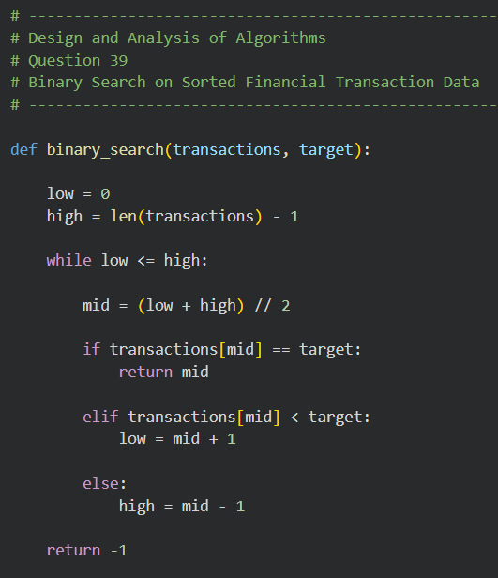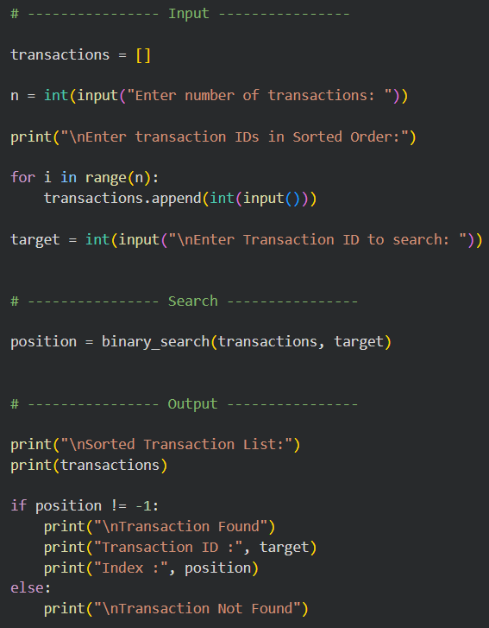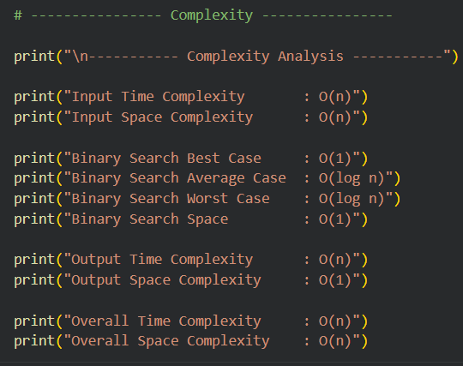

Program Explanation
Step 1: The program first reads the number of transactions and stores them in a sorted list. It then accepts the target transaction ID. The Binary Search function repeatedly calculates the middle index and compares it with the target. Depending on the comparison, half of the remaining search space is discarded. This process continues until the transaction is found or all possibilities are exhausted.
Step 2: The program first reads the number of transactions and stores them in a sorted list. It then accepts the target transaction ID. The Binary Search function repeatedly calculates the middle index and compares it with the target. Depending on the comparison, half of the remaining search space is discarded. This process continues until the transaction is found or all possibilities are exhausted.
Step 3: The program first reads the number of transactions and stores them in a sorted list. It then accepts the target transaction ID. The Binary Search function repeatedly calculates the middle index and compares it with the target. Depending on the comparison, half of the remaining search space is discarded. This process continues until the transaction is found or all possibilities are exhausted.
Step 4: The program first reads the number of transactions and stores them in a sorted list. It then accepts the target transaction ID. The Binary Search function repeatedly calculates the middle index and compares it with the target. Depending on the comparison, half of the remaining search space is discarded. This process continues until the transaction is found or all possibilities are exhausted.
Step 5: The program first reads the number of transactions and stores them in a sorted list. It then accepts the target transaction ID. The Binary Search function repeatedly calculates the middle index and compares it with the target. Depending on the comparison, half of the remaining search space is discarded. This process continues until the transaction is found or all possibilities are exhausted.
Step 6: The program first reads the number of transactions and stores them in a sorted list. It then accepts the target transaction ID. The Binary Search function repeatedly calculates the middle index and compares it with the target. Depending on the comparison, half of the remaining search space is discarded. This process continues until the transaction is found or all possibilities are exhausted.
Step 7: The program first reads the number of transactions and stores them in a sorted list. It then accepts the target transaction ID. The Binary Search function repeatedly calculates the middle index and compares it with the target. Depending on the comparison, half of the remaining search space is discarded. This process continues until the transaction is found or all possibilities are exhausted.
Step 8: The program first reads the number of transactions and stores them in a sorted list. It then accepts the target transaction ID. The Binary Search function repeatedly calculates the middle index and compares it with the target. Depending on the comparison, half of the remaining search space is discarded. This process continues until the transaction is found or all possibilities are exhausted.

Sample Execution
Input:
5
101
203
305
450
560
Target=450
Output:
Transaction Found
Index=3
Execution Trace:
Iteration 1: mid=2 value=305
Iteration 2: mid=3 value=450
Transaction Found.
OUTPUTS
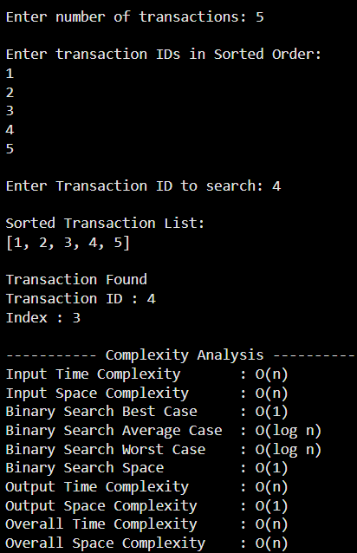

Answer (a): Explain how Binary Search operates on sorted data
Binary Search works only when data is sorted. The algorithm compares the target with the middle element, decides which half cannot contain the target, discards that half and continues searching only in the remaining half. Since the search space is halved after every comparison, the algorithm performs significantly fewer comparisons than Linear Search. This makes Binary Search highly suitable for financial transaction databases where fast retrieval is required.
Binary Search works only when data is sorted. The algorithm compares the target with the middle element, decides which half cannot contain the target, discards that half and continues searching only in the remaining half. Since the search space is halved after every comparison, the algorithm performs significantly fewer comparisons than Linear Search. This makes Binary Search highly suitable for financial transaction databases where fast retrieval is required.
Binary Search works only when data is sorted. The algorithm compares the target with the middle element, decides which half cannot contain the target, discards that half and continues searching only in the remaining half. Since the search space is halved after every comparison, the algorithm performs significantly fewer comparisons than Linear Search. This makes Binary Search highly suitable for financial transaction databases where fast retrieval is required.
Binary Search works only when data is sorted. The algorithm compares the target with the middle element, decides which half cannot contain the target, discards that half and continues searching only in the remaining half. Since the search space is halved after every comparison, the algorithm performs significantly fewer comparisons than Linear Search. This makes Binary Search highly suitable for financial transaction databases where fast retrieval is required.
Binary Search works only when data is sorted. The algorithm compares the target with the middle element, decides which half cannot contain the target, discards that half and continues searching only in the remaining half. Since the search space is halved after every comparison, the algorithm performs significantly fewer comparisons than Linear Search. This makes Binary Search highly suitable for financial transaction databases where fast retrieval is required.
Binary Search works only when data is sorted. The algorithm compares the target with the middle element, decides which half cannot contain the target, discards that half and continues searching only in the remaining half. Since the search space is halved after every comparison, the algorithm performs significantly fewer comparisons than Linear Search. This makes Binary Search highly suitable for financial transaction databases where fast retrieval is required.

Answer (b): Analyse its performance when order is maintained versus disturbed
When transaction records remain sorted, Binary Search achieves excellent performance. Best case occurs when the target is the middle element. Average and worst cases require logarithmic comparisons.
If updates disturb the sorted order, Binary Search cannot determine the correct half to continue searching. Consequently, it may fail even if the transaction exists.
Condition | Correctness | Time | Recommendation
Sorted | Correct | O(log n) | Binary Search
Unsorted | Not Guaranteed | O(n) using Linear Search | Sort then Binary Search
Maintaining sorted order enables Binary Search to eliminate half the search space repeatedly. Disturbing the order destroys this property, forcing the system to use slower methods or to sort the data again before searching.
Maintaining sorted order enables Binary Search to eliminate half the search space repeatedly. Disturbing the order destroys this property, forcing the system to use slower methods or to sort the data again before searching.
Maintaining sorted order enables Binary Search to eliminate half the search space repeatedly. Disturbing the order destroys this property, forcing the system to use slower methods or to sort the data again before searching.
Maintaining sorted order enables Binary Search to eliminate half the search space repeatedly. Disturbing the order destroys this property, forcing the system to use slower methods or to sort the data again before searching.

Answer (c): Importance of Maintaining Sorted Data
Maintaining sorted data is essential because Binary Search depends entirely on ordering. Sorted data guarantees correctness, improves response time, reduces CPU usage during repeated searches, supports efficient financial reporting, enhances customer service and scales effectively as the database grows. Although updates require occasional re-sorting, the benefit gained during thousands of searches outweighs the maintenance cost.
Maintaining sorted data is essential because Binary Search depends entirely on ordering. Sorted data guarantees correctness, improves response time, reduces CPU usage during repeated searches, supports efficient financial reporting, enhances customer service and scales effectively as the database grows. Although updates require occasional re-sorting, the benefit gained during thousands of searches outweighs the maintenance cost.
Maintaining sorted data is essential because Binary Search depends entirely on ordering. Sorted data guarantees correctness, improves response time, reduces CPU usage during repeated searches, supports efficient financial reporting, enhances customer service and scales effectively as the database grows. Although updates require occasional re-sorting, the benefit gained during thousands of searches outweighs the maintenance cost.
Maintaining sorted data is essential because Binary Search depends entirely on ordering. Sorted data guarantees correctness, improves response time, reduces CPU usage during repeated searches, supports efficient financial reporting, enhances customer service and scales effectively as the database grows. Although updates require occasional re-sorting, the benefit gained during thousands of searches outweighs the maintenance cost.
Maintaining sorted data is essential because Binary Search depends entirely on ordering. Sorted data guarantees correctness, improves response time, reduces CPU usage during repeated searches, supports efficient financial reporting, enhances customer service and scales effectively as the database grows. Although updates require occasional re-sorting, the benefit gained during thousands of searches outweighs the maintenance cost.
Maintaining sorted data is essential because Binary Search depends entirely on ordering. Sorted data guarantees correctness, improves response time, reduces CPU usage during repeated searches, supports efficient financial reporting, enhances customer service and scales effectively as the database grows. Although updates require occasional re-sorting, the benefit gained during thousands of searches outweighs the maintenance cost.
Maintaining sorted data is essential because Binary Search depends entirely on ordering. Sorted data guarantees correctness, improves response time, reduces CPU usage during repeated searches, supports efficient financial reporting, enhances customer service and scales effectively as the database grows. Although updates require occasional re-sorting, the benefit gained during thousands of searches outweighs the maintenance cost.
Maintaining sorted data is essential because Binary Search depends entirely on ordering. Sorted data guarantees correctness, improves response time, reduces CPU usage during repeated searches, supports efficient financial reporting, enhances customer service and scales effectively as the database grows. Although updates require occasional re-sorting, the benefit gained during thousands of searches outweighs the maintenance cost.

Complexity Analysis
Operation | Time | Space
Input | O(n) | O(n)
Binary Search Best | O(1) | O(1)
Binary Search Average | O(log n) | O(1)
Binary Search Worst | O(log n) | O(1)
Output | O(n) | O(1)
Overall | O(n) | O(n)

Advantages
- Fast searching
- Fewer comparisons
- Low memory
- Suitable for large databases
- Reliable on sorted data
- Efficient for repeated searches

Limitations
- Requires sorted data
- Re-sorting after updates
- Not ideal for highly dynamic unsorted datasets

Applications
- Banking
- Online payments
- Library systems
- Hospital databases
- Inventory systems
- Student record management
- Payroll systems

Conclusion
Binary Search is one of the most powerful searching algorithms for sorted data. It reduces search time from linear growth to logarithmic growth by eliminating half of the remaining search space during every iteration. Maintaining sorted transaction records is therefore essential in financial systems where fast and accurate searching is required. The Python implementation demonstrates the practical application of Binary Search and the complexity analysis confirms its efficiency.

References
1. Introduction to Algorithms - Cormen et al.
2. Fundamentals of Computer Algorithms - Horowitz & Sahni.
3. Python Documentation.

