****

**NAME : BOOKER OCHIENG OKUMU**

**REG. NO : COM/2525/21**

**TASK : FOURTH YEAR SCHOOL PROJECT**

**COURSE CODE : COM 423**

**TABLE OF CONTENTS**

[Introduction 3](#_Toc1109532088)

[Abstract 4](#_Toc1836152413)

[Existing Work or Implementations (The Idea Source) 5](#_Toc1752740390)

[Deconstructing Pacman: Mechanics and Strategies 5](#_Toc85540354)

[Beyond Pacman: Exploring Maze Chase Game Inspirations 6](#_Toc1202999006)

[My Implementation 7](#_Toc629241946)

[Gameplay screen shots 7](#_Toc1475399126)

[Gameplay Mechanics 9](#_Toc182478629)

[i) Scatter Mode 9](#_Toc2143941131)

[ii) Frightened Mode 10](#_Toc44261719)

[iii) Chase Mode 10](#_Toc1687694613)

[Game Entities 11](#_Toc568837017)

[1. Pac-Man 11](#_Toc740069292)

[2. Ghosts House 12](#_Toc1231141415)

[3. Target Tiles 12](#_Toc2048288309)

[4. Ghosts 12](#_Toc285589276)

[Individual Ghost Personalities 12](#_Toc2110330549)

[Ghost Targeting Strategies 13](#_Toc10562668)

[i) The Red Ghost 13](#_Toc64526103)

[ii) The Pink Ghost 14](#_Toc1416354254)

[iii) The Blue Ghost 14](#_Toc484880396)

[iv) The Orange Ghost 15](#_Toc1211226070)

[Code Implementation for Game Play Mechanics 17](#_Toc864931776)

[i) Pacman and Ghost Collision 17](#_Toc1515301486)

[ii) Setting Optimal Direction before Movement 17](#_Toc173274510)

[iii) Animations 17](#_Toc553600541)

[iv) Chase Mode for the Red Ghost 17](#_Toc1120558229)

[v) Chase Mode for the Pink Ghost 18](#_Toc258814865)

[vi) Chase Mode for the Blue Ghost 18](#_Toc1756599547)

[vii) Chase Mode for the Orange Ghost 18](#_Toc1749800175)

[Technologies Used 18](#_Toc1734213991)

[Recommendations / Conclusion 19](#_Toc798156759)

[Recommendations 19](#_Toc1207432417)

# Introduction

The Pacman game clone project is a comprehensive endeavor undertaken as part of a fourth-year academic course to explore the intricacies of game development and artificial intelligence (AI). Pacman, originally released by Namco in 1980, has been an enduring icon in the gaming world, known for its simple yet addictive gameplay. This project aims to replicate the original game's mechanics while integrating advanced AI algorithms to enhance the ghost entities' behavior, providing a more challenging and dynamic player experience.

The primary objective of this project is to recreate the classic Pacman game using modern programming techniques and tools, specifically leveraging the C++ programming language and the SFML (Simple and Fast Multimedia Library). The project focuses on implementing greedy algorithms for pathfinding, which are utilized by the ghost entities to track and chase the player-controlled Pacman. By doing so, the project aims to delve into the concepts of AI and pathfinding within the context of game development, highlighting their practical applications and impact on gameplay.

The game is designed to retain the core elements that made the original Pacman a beloved classic: a maze filled with pellets, four ghost enemies with distinct behaviors, and the iconic yellow character, Pacman, who must navigate the maze, consume all pellets, and avoid being caught by the ghosts. Each ghost exhibits unique movement patterns based on predefined AI algorithms, which dictate their behavior in different game modes such as Scatter, Chase, and Frightened. These modes ensure varied and unpredictable challenges, enhancing the overall gameplay experience.

The introduction of sophisticated AI into the ghost entities' behavior is a key aspect of this project. By implementing greedy pathfinding algorithms, the ghosts can dynamically adjust their paths to pursue Pacman more effectively. This involves calculating the shortest path to Pacman based on real-time positional data. Additionally, the project explores the different targeting strategies for each ghost, replicating their unique behaviors as observed in the original game.

Overall, this project not only serves as a practical exercise in game development but also as a tribute to one of the most iconic games in history.

# Abstract

This document details a Pacman game clone developed in C++ using the SFML library. The core gameplay replicates classic Pacman mechanics, including pellet consumption, power-ups, and ghost pursuit. The innovation lies in the implementation of dynamic ghost AI utilizing greedy algorithms. Each ghost employs a unique pathfinding strategy that adapts based on Pacman's position and direction, creating a more challenging and engaging experience.

# Existing Work or Implementations (The Idea Source)

The inspiration for this Pacman clone stems from the rich history of maze chase games, particularly the iconic Pacman by Namco (1980). While the core gameplay loop of Pacman is readily apparent – players navigate a maze consuming pellets while avoiding capture by ghosts – the underlying mechanics and character behaviors are surprisingly intricate. Numerous resources delve into these complexities, providing valuable insights that fueled the development of this project.

## Deconstructing Pacman: Mechanics and Strategies

One prominent source, "[Understanding Pac-Man Ghost Behavior](https://gameinternals.com/understanding-pac-man-ghost-behavior" \t "_blank)", offers a detailed breakdown of Pacman's mechanics. It delves into the different ghost modes (Scatter, Chase, Frightened), power-up effects, and scoring systems. More importantly, it sheds light on the unique targeting behaviors exhibited by each ghost character:

* **Clyde (Red Ghost):** The relentless pursuer, Clyde prioritizes the most direct path towards Pacman. This straightforward approach makes him the most predictable ghost, offering players a clear target for strategic pellet collection.
* **Pinky (Pink Ghost):** This ambusher attempts to anticipate Pacman's movements by targeting the tile four spaces ahead in his current direction. This strategy forces players to consider not only their immediate surroundings but also their planned path, adding a layer of tactical thinking.
* **Inky (Blue Ghost):** Inky's behavior is the most complex. He calculates a target point based on the red ghost's position relative to Pacman. This involves doubling the vector distance between the red ghost and a point two tiles ahead of Pacman's direction. This creates a more unpredictable path for Inky, as his movements are not solely dictated by Pacman's location but also influenced by the red ghost's position.
* **Clyde (Orange Ghost):** Clyde exhibits a two-phased approach. When far from Pacman, he behaves similarly to the red ghost, prioritizing direct pursuit. However, upon getting closer (within a set distance), Clyde prioritizes returning to his designated corner in Scatter mode. This "shy" behavior adds another layer of dynamism to the ghost AI, as players can exploit Clyde's indecisiveness to their advantage.

These insights into the original Pacman's ghost behaviors formed the foundation for developing the adaptive ghost AI in this project. By implementing greedy algorithms for pathfinding and incorporating elements of the original ghost strategies, this project creates a more engaging and challenging experience for players.

## Beyond Pacman: Exploring Maze Chase Game Inspirations

The influence of Pacman extends beyond its core mechanics. The concept of navigating a maze while avoiding pursuers has inspired numerous video games across various genres. Here are a few examples that explore this theme in unique ways:

* **Ms. Pac-Man (1982):** This sequel introduced a gender-swapped protagonist with slightly altered maze layouts and faster ghost speeds, offering a fresh take on the classic formula.
* **Super Mario Bros. (1985):** While not strictly a maze chase game, elements of the genre are present. Mario navigates side-scrolling levels, collecting coins and avoiding enemies like Goombas and Koopas. The level design often incorporates maze-like elements, requiring players to strategize their movements.
* **Luigi's Mansion (2001):** This action-adventure game features Luigi exploring haunted mansions filled with ghosts. While not a traditional chase scenario, the core concept of navigating an environment filled with hostile entities with unique behaviors resonates with the maze chase genre.
* **Pac-Man Championship Edition (2007):** This modern take on Pacman emphasizes speed and efficiency. Players collect power-ups that extend the duration of frightened mode, allowing them to chain ghost consumptions for high scores. The game's focus on quick thinking and strategic pellet collection adds a new dimension to the classic gameplay.

# 

# My Implementation

## Gameplay screen shots

1. Main game screen



1. Game won screen

-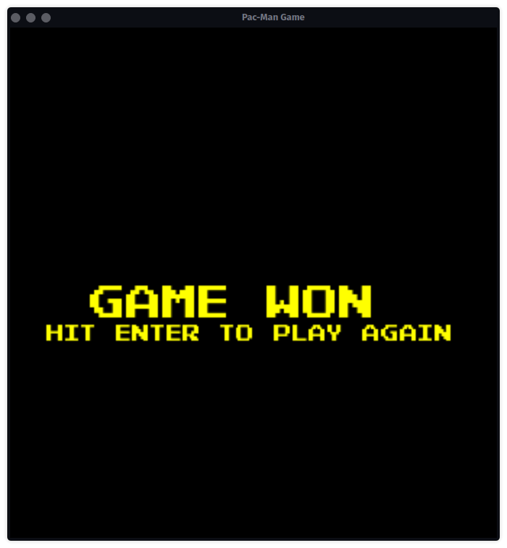

1. Game lost screen

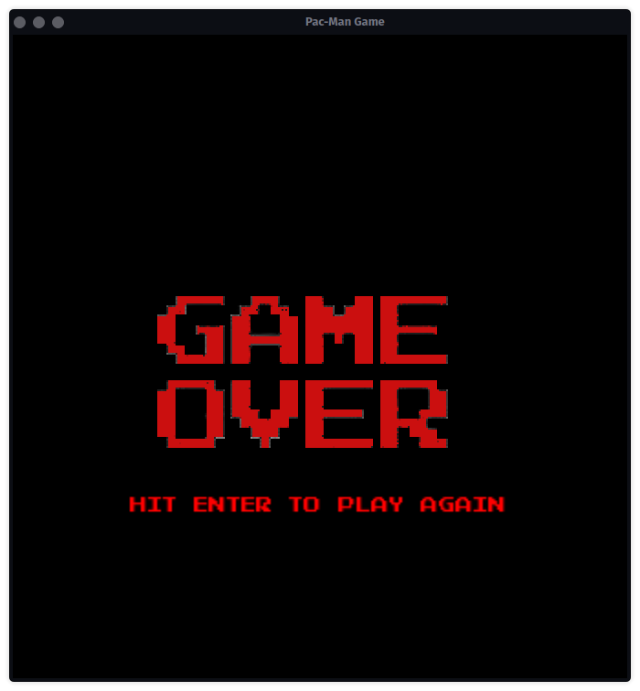

## 

## Gameplay Mechanics

The gameplay is centered around Pac-Man consuming all pellets while avoiding pursuit by the ghosts. Each of the ghosts has 3 modes :

### i) Scatter Mode

• Default starting mode for all ghosts whereby they target their respective corners within the game map.

• The target corners are inaccessible and the ghosts cannot stop moving or reverse direction.

• They are forced to continue past the target but will turn back towards it as soon as possible.

• This results in each ghost's path eventually becoming a fixed loop in their corner.

• If left in Scatter mode, each ghost would remain in its loop indefinitely.

• However, the game's configuration limits the mode to the first 7 seconds of the game which later on switches to chase mode unless interrupted by Pac-Man eating an energizer causing a switch to frightened mode.

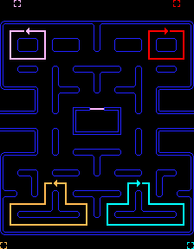

Each ghost's target tile and eventual looping path, color-coded to match their own color.

### ii) Frightened Mode

• Occurs when Pac-Man consumes an energizer resulting in slow movement of the ghosts as well as switching color to dark blue.

• During this mode, Pac-Man can openly attack any of the ghosts without losing a life.

### iii) Chase Mode

• Occurs automatically after the 7 seconds of the scatter mode have elapsed.

• This causes the ghosts to target Pac-Man each in their unique way.

• During this mode, Pac-Man is vulnerable to the ghosts and contact between Pac-Man and any of the ghosts will cost the player a life.

## Game Entities

### 1. Pac-Man

• Is the controllable yellow character that is under the control of the player.

• Control is automatic such that provided there is no wall Pac-Man will progressively move in that current direction until he encounters an obstacle.

• Upon arriving at a junction (map regions with more than 1 pathway), the player can switch Pac-Man's current direction by hitting a different arrow key.

- Pac-Man's control scheme is as follows:

• **Up arrow key** : move up

• **Down arrow key** : move downwards

• **Right arrow key** : move to the right

• **Left arrow key** : move to the left

### 2. Ghosts House

• Only one ghost (the red ghost) begins in the actual maze, while the others are inside a small area in the middle of the maze, often referred to as the "ghost house".

• The pink, blue, and orange ghosts will only return to this area if they are eaten by an energized Pac-Man (when mode = Frightened mode), or as a result of their positions being reset when Pac-Man dies.

• The ghost house is otherwise inaccessible, and is not a valid area for Pac-Man or the ghosts to move into once they get out.

### 3. Target Tiles

• Much of Pac-Man's design and mechanics revolve around the idea of the board being split into tiles.

• As an example of the impact of tiles, a ghost is considered to have caught Pac-Man when it occupies the same tile as him.

• The large majority of the time, each ghost has a specific tile that it is trying to reach, and its behavior revolves around trying to get to that tile from its current one.

### 4. Ghosts

• These are the game enemies: four little ghost-shaped monsters, each of them a different color - blue, yellow, pink, and red.

## Individual Ghost Personalities

• The only differences between the ghosts are their methods of selecting target tiles in Chase and Scatter modes

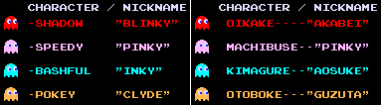

Character and nicknames of the ghosts in English and Japanese.

## Ghost Targeting Strategies

### i) The Red Ghost

- The red ghost starts outside of the ghost house and is usually the first one to be seen as a threat, as he makes a beeline for Pac-Man almost immediately.

- In Chase mode, the red ghost’s target tile is defined as Pac-Man's current tile, ensuring that it follows directly behind Pac-Man.

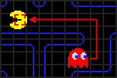

### ii) The Pink Ghost

- The pink ghost starts inside the ghost house but always exits immediately.

- His targeting scheme attempts to move him to the place where Pac-Man is going, instead of where he currently is.

- In Chase mode, the pink ghost’s target tile is determined by looking at Pac-Man's current position and orientation, selecting the location four tiles straight ahead of Pac-Man.

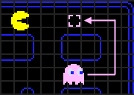

### iii) The Blue Ghost

- The blue ghost is difficult to predict as he uses both Pac-Man's position/facing and the red ghost's position in his calculation.

- To locate the blue ghost’s target, we start by selecting the position two tiles in front of Pac-Man, similar to the pink ghost’s targeting method.

- Then, we imagine drawing a vector from the red ghost’s position to this tile and double the length of the vector.

- The tile that this new, extended vector ends on will be the blue ghost’s actual target.

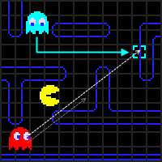

### iv) The Orange Ghost

- The orange ghost’s targeting has two separate modes based on his proximity to Pac-Man.

- If he is farther away, his targeting is identical to the red ghost, using Pac-Man's current tile as his target.

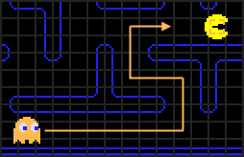

- However, if his distance to Pac-Man becomes less than eight tiles, the orange ghost’s target is set to the same tile as his fixed one in Scatter mode, just outside the bottom-left corner of the maze.

- This method alternates between coming directly towards Pac-Man and heading back to his corner whenever he gets too close.

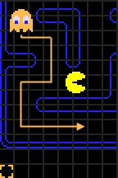

## Code Implementation for Game Play Mechanics

### i) Pacman and Ghost Collision

- Implemented using circle collision detection.

- Involves having a circle surround the sprites (png images of the various characters) of the two entities.

- Calculate the Euclidean distance between the two entities.

- Collision is detected if the distance between the two sprites is less than the sum of the two circle radii.

### ii) Setting Optimal Direction before Movement

- Implemented using a greedy search algorithm:

- Check immediate surroundings for walls in all four directions.

- Keep track of the Euclidean distance from each unblocked cell to the target in a map in key-value pairs.

- If there are multiple accessible paths, select the direction with the lowest Euclidean distance.

- If only one path is accessible, set the direction as the value of the key of the first element in the map.

- Clear elements of the map after setting the optimal direction.

### iii) Animations

- Implemented using sprite sheet PNGs containing multiple images.

- Display specific sections of the PNG image based on time intervals.

- The cycle of image portions starts from a specific point, goes up to a designated end, and then returns to the origin.

### iv) Chase Mode for the Red Ghost

- Set the red ghost's target as Pacman's position.

- Get the optimal direction using Pacman as the target.

- With the optimal direction, increment the ghost's x or y position by some specified value

### v) Chase Mode for the Pink Ghost

- Calculate four tiles in Pacman's direction to get the pink ghost's target.

- Set the optimal direction using this new target and increment the ghost's x or y position.

### vi) Chase Mode for the Blue Ghost

- Get pacman's position and direction and calculate 2 tiles in pacman's direction to get the red ghost's initial target.

- Get the red ghost's position and calculate the euclidean distance between the red ghost and the initial target(2 tiles ahead of pacman).

- Double this distance

- The end point of this vector is the blue ghost's target

- Obtaining blue ghost's target(coordinates at the vector's end) involved :

- Get angle between this vector and the x-axis using the red ghost and the initial target coordinates (Angle is obtained by getting dy and dx then using SOHCAHTOA)

- Now with the angle between x-axis and the vector distance, we can compute dy and dx and with the red ghosts coordinates we can offset it using dy and dx to get the vector's end coordinates.

- Set the optimal direction using this new target and increment the ghost's x or y position by some specified value.

### vii) Chase Mode for the Orange Ghost

- Get the manhattan distance(sum of absolute values of dy and dx for 2 coordinates) from the orange ghost to pacman.

- If the distance is greater than eight cells, use the red ghost's targeting approach; otherwise, target its corner from the scatter mode.

- Set the optimal direction using this new target and increment the ghost's x or y position by some specified value.

### Technologies Used

• C++

• SFML

## Recommendations / Conclusion

### Recommendations

The development of this Pacman game clone has been a valuable learning experience. Based on the insights gained and the challenges encountered during the project, several recommendations can be made for future work and improvements:

###### ****Additional Gameplay Features:****

- Power-Ups and Bonuses: Incorporate new power-ups and bonuses beyond the classic energizers, such as temporary speed boosts, shields, or special abilities that can influence ghost behaviors.

- Multiple Levels and Themes: Expand the game by adding multiple levels with increasing difficulty and varying themes. This would provide a broader and more immersive gameplay experience.

###### ****Visual and Audio Improvements:****

- Background Music and Sound Effects : Introduce background music that dynamically changes based on the game state (e.g., tense music during chase mode, upbeat music during pellet collection). Add sound effects for power-up activations and ghost interactions to create a more immersive soundscape.