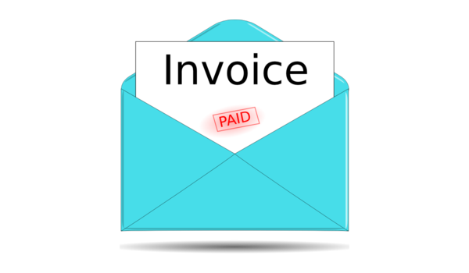Infy Inc

|  |  |  |
| --- | --- | --- |
| INVOICE |  | 123 Main Street |
|  |  | New York, NY, 10025 |
| Invoice |  |  |
| **Invoice Number: 4**  Invoice Date: 2021-12-14  Due Date: 2021-12-24 | **Jack**  pune  pune, mh, india, 411033 |  |
| **Items Quantity** | **Unit Cost Discount** | **Line Total** |
| book 45 | 67 12 | 2653 |
|  | **Sub Total** | **2000** |
|  | **Paid Status** | **UNPAID** |

Payment is due within 15 days. Thank you for your business.