VINAY KUMAR KONDOJU
kondojuvinaykumar2004@gmail.com

UST ASSIGNMENT 1
1. Number Classification (if + function)
Write a shell script that uses a function to check whether a number is positive, negative, or zero using if.
Code:
check_num() {
if [ $1 -gt 0 ]; then
echo "The number is positive"
elif [ $1 -lt 0 ]; then
echo "The number is negative"
else
echo "The number is zero"
fi
}
read -p "Enter a number: " n
check_num $n
Output:
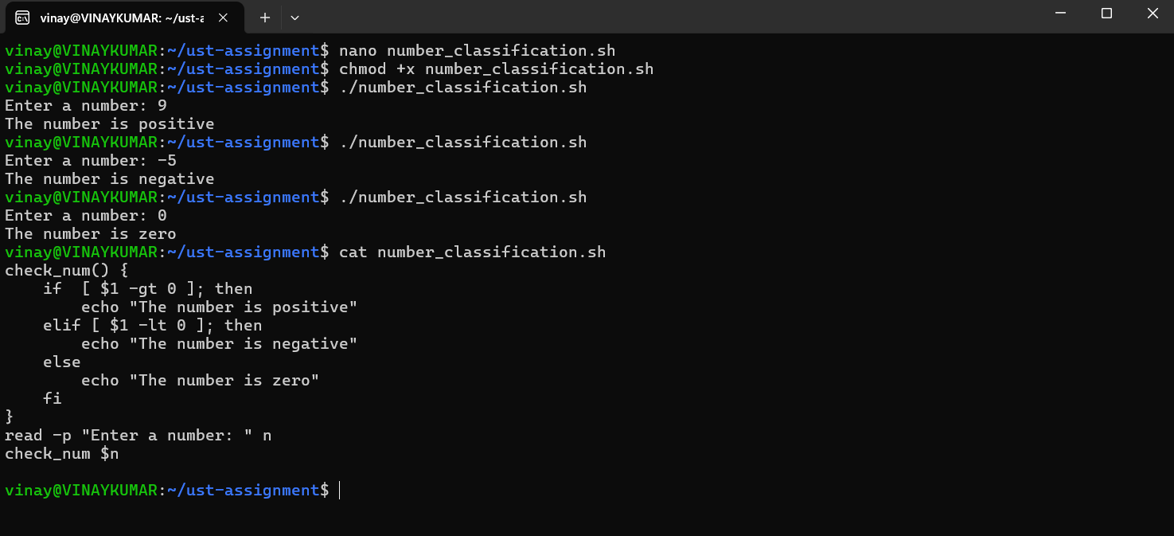
2. Factorial of a Number (while + function)
Write a shell script to calculate the factorial of a number using a while loop inside a function.
Code:
num_factorial() {
n=$1
fact=1
while [ $n -gt 1 ]; do
fact=$((fact * $n))
n=$((n-1))
done
echo "The factorial of $1 is: $fact"
}
read -p "Enter a number: " num
num_factorial $num

Output:
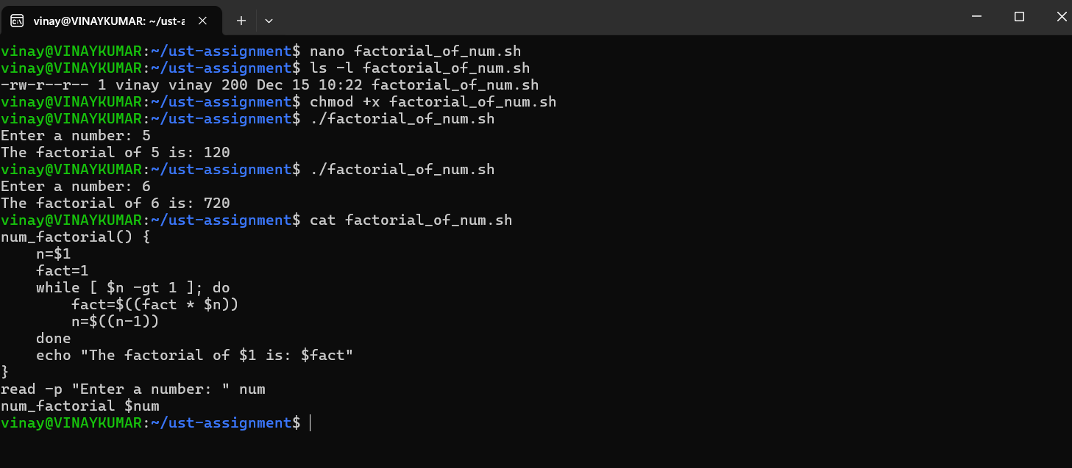

3. Sum of N Numbers (for + function)
Write a shell script to calculate the sum of numbers from 1 to N using a for loop inside a function.
Code:
sum_num() {
n=$1
sum=0
for ((i=1; i<=n; i++))
do
sum=$((sum + i))
done
echo "The sum of numbers from 1 to $1 is: $sum"
}
read -p "Enter a number: " num
sum_num $num

Output:
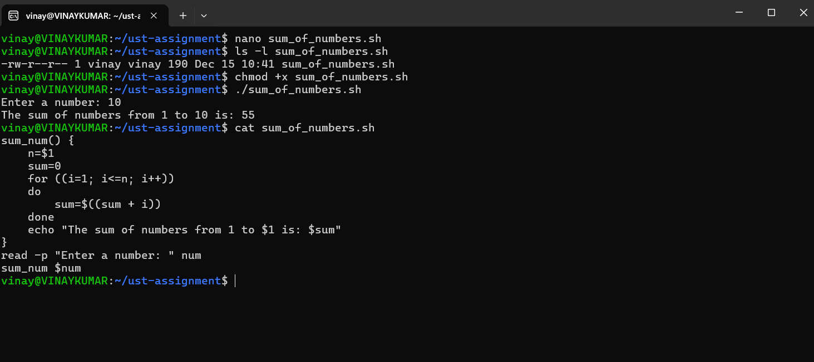

4. Prime Number Check (if + for + function)
Write a shell script that uses a function to check whether a given number is prime using if and for.
Code:
check_prime_number() {
n=$1
if [ $n -lt 2 ]; then
echo "$n is not a Prime Number."
return
fi
for ((i=2; i<=n/2; i++)); do
if [ $((n % i)) -eq 0 ]; then
echo "$n is not a Prime Number."
return
fi
done
echo "$n is a Prime Number."
}
read -p "Enter any number: " num
check_prime_number $num
Output:
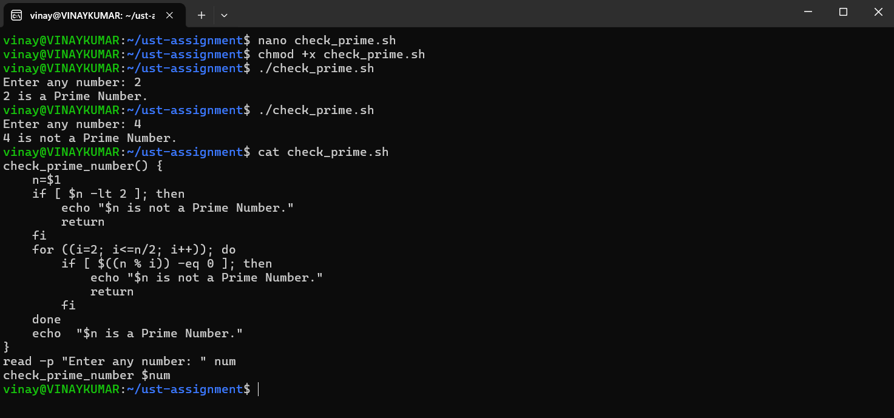
5. Reverse a Number (while + if)
Write a shell script to reverse a number using a while loop and if conditions where required.
Code:
read -p "Enter a number: " num
r=0

while [ $num -gt 0 ]; do
dig=$((num % 10))
r=$((r * 10 + dig))
num=$((num / 10))
done

echo "The reversed number is: $r"

Output:
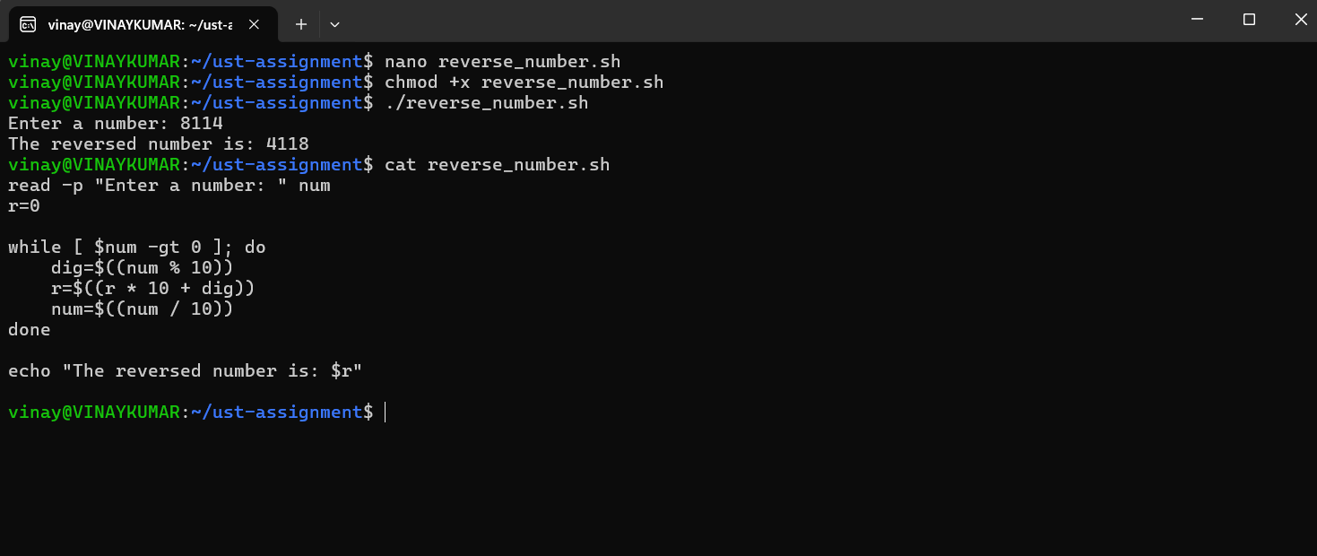

6. File Existence & Permission Check (if + function)
Write a shell script that uses a function to check if a file exists and whether it has read, write, and execute permissions.
Code:
check_f() {
if [ -e $1 ]; then
echo "$1 file exists."
if [ -r $1 ]; then
echo "Read permission exists for $1."
else
echo "Read permission does not exist for $1."
fi
if [ -w $1 ]; then
echo "Write permission exists for $1."
else
echo "Write permission does not exist for $1."
fi
if [ -x $1 ]; then
echo "Execute permission exists for $1."
else
echo "Execute permission does not exist for $1."
fi
else
echo "$1 File does not exist."
fi
}
read -p "Enter a file name: " filename
check_f $filename

Output:
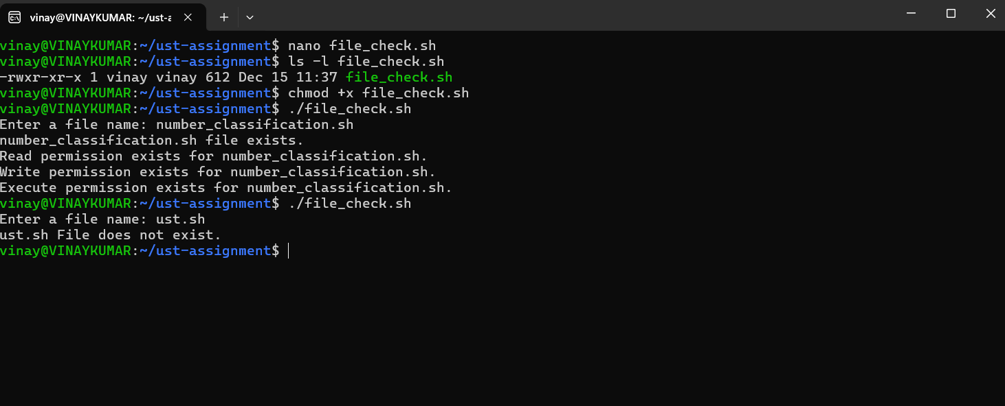

7. Menu-Driven Calculator (while + case + function)
Write a shell script that shows a menu in a while loop and performs add, subtract, multiply, divide using functions.
Code:
add() {
echo "Addition of $1 and $2 is: $(( $1 + $2 ))"
}
subtract() {
echo "Subtraction of $1 and $2 is: $(( $1 - $2 ))"
}
multiply() {
echo "Multiplication of $1 and $2 is: $(( $1 * $2 ))"
}
divide() {
if [ $2 -eq 0 ]; then
echo "Division By Zero is not allowed."
else
echo "Division of $1 and $2 is: $(( $1 / $2 ))"
fi
}
while true; do
echo "***********************"
echo "Menu_Driven_Calculator"
echo "1. Add"
echo "2. Subtract"
echo "3. Multiply"
echo "4. Divide"
echo "5. Exit"
echo "***********************"
read -p "Enter your choice: " ch
case $ch in
1)
read -p "Enter two Numbers: " m n
add $m $n
;;
2)
read -p "Enter two Numbers: " m n
subtract $m $n
;;
3)
read -p "Enter two Numbers: " m n
multiply $m $n
;;
4)
read -p "Enter two Numbers: " m n
divide $m $n
;;
5)
echo "Exiting Calculator!!!"
break
;;
*)
echo "Invalid Choice!!. Please enter right choice."
;;
esac
done
Output:
