uestion code 3-32:
What is the expected output of the following code?
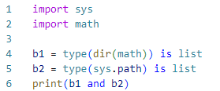
False
Your answer is correct
True
0
None
Overall explanation
dir(math) returns a list of names in the math module.
sys.path is a list of strings that specifies the search path for modules.

Correct:
- True - The expression b1 and b2 evaluates to True because both b1 and b2 are True.

Incorrect:
- 0 - This is incorrect because the expression evaluates to True, not 0.
- False - This is incorrect because both b1 and b2 are True.
- None - This is incorrect because the expression does not evaluate to None.

Code:
- import sys
- import math

- b1 = type(dir(math)) is list
- b2 = type(sys.path) is list
- print(b1 and b2) # True

- print(dir(math))
- print("------")
- print(sys.path)
Resources
Domain
Modules and Packages
Question 2Incorrect
Question code 3-13:
How many lines does the following snippet output?
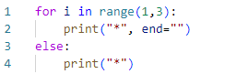
Correct answer
one
four
Your answer is incorrect
three
two
Overall explanation
The range(1, 3) generates the numbers 1 and 2. The for loop iterates over these two numbers and prints 2 **
After the for loop completes, the else block is executed and prints 1 * in the same line.
The entire output will be *** on one line.

Correct:
- one - The output consists of three asterisks *** on a single line.

Incorrect:
- three - This would imply three separate lines of output.
- two - This would imply two separate lines of output.
- four - This would imply four separate lines of output.

Code:
- for i in range(1,3):
- print("*", end="")
- else:
- print("*")
Resources
Domain
Miscellaneous
Question 3Correct
Question code 3-19:
Assuming that the code below has been executed successfully, which of the following expressions will always evaluate to True? (Select two answers)
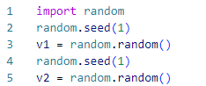
Your selection is correct
random.choice([1,2,3]) >=1
len(random.sample([1,2,3],2)) > 2
v1 >= 1
Your selection is correct
v1 == v2
Overall explanation
random.sample([1, 2, 3], 2) returns a list of 2 unique elements sampled from the list [1, 2, 3]. for example [1, 3]
The random.choice([1, 2, 3]) call will randomly select one of the elements from the list [1, 2, 3]. for example [3]
The random.seed(1) call ensures that random.random() generates the same number each time the seed is set to 1.

Correct:
- v1 == v2 - Ensured by setting the same seed before generating each value.
- random.choice([1,2,3]) >= 1 - Always true as all elements in the list are >= 1.

Incorrect:
- len(random.sample([1,2,3],2)) > 2 - This will always be False because the length will always be 2.
- v1 >= 1 - This will always be False because v1 is in the range [0.0, 1.0).

Code:
- import random
- random.seed(1)
- v1 = random.random()
- random.seed(1)
- v2 = random.random()
- print("v1: ",v1)
- print("v2:",v2)
- print("random.sample([1,2,3],2): ", random.sample([1,2,3],2))
- print("random.choice([1,2,3]): ", random.choice([1,2,3]))

- print("-----------------------")
- print("True or False ?")
- print("-----------------------")
- print("len(random.sample([1,2,3],2)) is ",len(random.sample([1,2,3],2)) > 2) # False
- print("v1==v2 is ",v1==v2) # True
- print("random.choice([1,2,3]) >=1) is ", random.choice([1,2,3]) >=1) # True
- print("v1 >= 1 is ",v1 >= 1) # False
Resources
Domain
Modules and Packages
Question 4Correct
Question code 3-37:
What is true about Object-Oriented Programming in Python? (Select two answers)
if a real-life object can be described with a set of adjectives, they may reflect a Python object method
each object of the same class can have a different set of methods
Your selection is correct
a subclass is usually more specialized than its superclass
Your selection is correct
the same class can be used many times to build a number of objects
Overall explanation
Correct:
- The same class can be used many times to build a number of objects - A class can be instantiated multiple times to create different objects.
- A subclass is usually more specialized than its superclass - A subclass inherits from a superclass and can add more specific behavior.

Incorrect:
- If a real-life object can be described with a set of adjectives, they may reflect a Python object method - Adjectives are more likely to describe attributes, not methods.
- Each object of the same class can have a different set of methods - Objects of the same class share the same methods defined in the class.
Resources
Domain
Object-Oriented Programming
Question 5Correct
Question code 3-30:
A method for passing the arguments used by the following snippet is called:
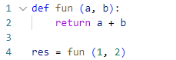
named
sequential
keyword
Your answer is correct
positional
Overall explanation
- Positional Arguments: Arguments are passed to the function in the same order as the parameters are defined. In this case, 1 is passed to a and 2 is passed to b.
- Keyword Arguments: keyword arguments are passed with their parameter names, such as fun(a=1, b=2).

Correct :
- positional

Incorrect:
- sequential: This is not a standard term used to describe how arguments are passed in Python functions.
- named: Named arguments, also known as keyword arguments, are specified by explicitly naming each parameter. For example: fun(a=1, b=2).
- keyword: This is incorrect because keyword arguments are passed with their parameter names, such as fun(a=1, b=2).

Code:
- def fun (a, b):
- return a + b

- res = fun (1, 2)
Resources
Domain
Miscellaneous
Question 6Correct
Question code 3-16:
A variable stored separately in every object is called:
a class variable
There are no such variables, all variables are shared among objects
an object variable
Your answer is correct
an instance variable
Overall explanation
Explanation:
- Instance variable: These are variables that are defined in the __init__ method or any other method using self. Each instance of the class has its own copy of these variables. They are specific to each object (instance) of the class.

Correct:
- an instance variable

Incorrect :
- there are no such variables, all variables are shared among objects: This is incorrect because instance variables are not shared among objects; each object has its own copy.
- a class variable: This is incorrect because class variables are shared among all instances of the class.
- an object variable: This term is not commonly used in Python to refer to instance variables. The correct term is "instance variable".
Resources
Domain
Object-Oriented Programming
Question 7Skipped
Question code 3-06:
Which of the following lines of code will work flawlessly when put independently inside the dup() method in order to make the snippet's output equal to [0, 1, 1]? (Select two answers)
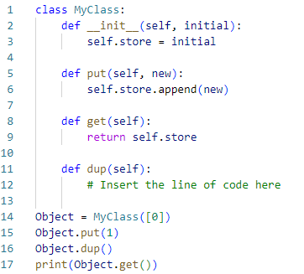
self.put(store[1])
Correct selection
self.put(self.store[1])
Correct selection
self.put(self.get()[-1])
put(self.store[1])
Overall explanation
Correct:
- self.put(self.get()[-1]): is correct. Appends the last element (1) correctly.
- self.put(self.store[1]): is correct. Appends 1 correctly.

Incorrect:
- self.put(store[1]) - Incorrect due to a missing self reference.
- put(self.store[1]) : - Incorrect due to a missing self reference before put. It will raise exception NameError: name 'put' is not defined.

Code:
- class MyClass:
- def __init__(self, initial):
- self.store = initial

- def put(self, new):
- self.store.append(new)

- def get(self):
- return self.store

- def dup(self):
- # Insert the line of code here
- self.put(self.get()[-1])

- Object = MyClass([0])
- Object.put(1)
- Object.dup()
- print(Object.get())
Resources
Domain
Object-Oriented Programming
Question 8Correct
Question code 3-35:
Which of the following statements are true? (Select two answers)
ASCII is synonymous with UTF-8
Your selection is correct
a code point is a number assigned to a given character
\e is an escape sequence used to mark the end of lines
Your selection is correct
II in ASCII stands for Information Interchange
Overall explanation
Correct:
- II in ASCII stands for Information Interchange - This is true because ASCII stands for American Standard Code for Information Interchange.
- A code point is a number assigned to a given character - This is true because a code point is the numerical value assigned to a character in an encoding standard.

Incorrect:
- \e is an escape sequence used to mark the end of lines - This is false because \n is the escape sequence used to mark the end of lines.
- ASCII is synonymous with UTF-8 - This is false because ASCII and UTF-8 are different encoding standards, though UTF-8 includes ASCII as a subset.
Domain
Strings
Question 9Correct
Question code 3-03:
Assuming that the V variable holds an integer value to 2, which of the following operators should be used instead of OPER to make the expression equal to 1?

V OPER 1

Your answer is correct
>>
<<<
<<
>>>
Overall explanation
Correct:
- >> - The right shift operator shifts the bits of 2 right by 1 position, resulting in 1.

Incorrect:
- <<< - This is not a valid operator in Python.
- >>> - This is not a valid operator in Python.
- << - The left shift operator shifts the bits of 2 left by 1 position, resulting in 4, not 1.

Code:
- print(2 >> 1) # output 1
Resources
Domain
Miscellaneous
Question 10Incorrect
Question code 3-39:
Assuming that the following snippet has been successfully executed, which of the equations are True? (Select two answers)
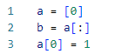
Your selection is correct
len(a) == len(b)
Correct selection
b[0] + 1 == a[0]
Your selection is incorrect
a[0] == b[0]
a[0] + 1 == b[0]
Overall explanation
Correct:
- len(a) == len(b) - Both lists have the same length of 1.
- b[0] + 1 == a[0] - The expression evaluates to 1 == 1, which is true.

Incorrect:
- a[0] == b[0] - a[0] is 1 and b[0] is 0, so this is false.
- a[0] + 1 == b[0] - a[0] + 1 is 2 and b[0] is 0, so this is false.

Code:
- a = [0]
- b = a[:]
- a[0] = 1

- print(len(a) == len (b)) # True
- print(b[0] + 1 == a[0]) # True
- print(a[0] == b [0]) # False
- print(a[0] + 1 == b[0]) # False
Domain
Strings
Question 11Correct
Question code 3-15:
What is the expected output of the following code ? The file named zero_length_existing_file is a zero-length file located inside the working directory.
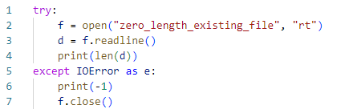
2
-1
Your answer is correct
0
an errno value corresponding to file not found
Overall explanation
Correct:
- 0 - The length of the line read from a zero-length file is 0.

Incorrect:
- -1 - This would be printed if an IOError occurred, which does not happen here.
- an errno value corresponding to file not found - This is not applicable because the file exists.
- 2 - This is incorrect because the length of the line read from a zero-length file is 0.

Code:
- # create the file name zero_length_existing_file, and then test this code.

- try:
- f = open("zero_length_existing_file", "rt")
- d = f.readline()
- print(len(d)) # print 0
- except IOError as e:
- print(-1)
- f.close()
Resources
Domain
Exceptions
Question 12Correct
Question code 3-10:
What is the expected output of the following snippet?
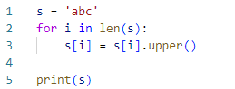
abc
123
ABC
Your answer is correct
The code will cause a runtime exception
Overall explanation
Correct:
- The code will cause a runtime exception - The loop for i in len(s): will raise a TypeError because len(s) is an integer, and integers are not iterable.

Incorrect:
- abc - This is incorrect because the code does not execute correctly due to the TypeError.
- ABC - This is incorrect because the code does not execute correctly due to the TypeError.
- 123 - This is incorrect because the code does not execute correctly due to the TypeError.

Code:
- s = 'abc'
- for i in len(s):
- s[i] = s[i].upper()

- print(s)

- #Error code line 2: TypeError: 'int' object is not iterable
Domain
Strings
Question 13Incorrect
Question code 3-09:
What is the expected behavior of the following snippet?
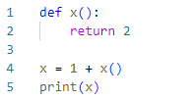
It will:
cause a runtime exception on line 02
Correct answer
print 3
cause a runtime exception on line 01
Your answer is incorrect
cause a runtime exception on line 04
Overall explanation
The function x(), which returns 2.
The expression 1 + x() evaluates to 1 + 2, which is 3.
The variable x is then assigned the value 3.

Correct:
- print 3 - The code correctly evaluates the expression and assigns 3 to x, then prints 3.

Incorrect:
- cause a runtime exception on line 02 - This is incorrect because the function x is defined and can be called without any issues.
- cause a runtime exception on line 01 - This is incorrect because there is no issue with the function definition.
- cause a runtime exception on line 04 - This is incorrect because x is correctly assigned a value and can be printed without any issues.

Code:
- def x():
- return 2

- x = 1 + x()
- print(x) # print 3
Domain
Miscellaneous
Question 14Correct
Question code 3-11:
Which of the following expressions evaluate to True?
Your selection is correct
'True' not in 'False'
Your selection is correct
- str(1-1) in '012345£739'[:2]
'dcb' not in 'abcde'[::-1]
'phd' in 'alpha'
Overall explanation
'012345£739'[:2] gives the substring '01'.
'abcde'[::-1] reverses the string, resulting in 'edcba'.

Correct:
- str(1-1) in '012345£739'[:2] - '0' in '01' evaluates to True.
- 'True' not in 'False' - 'True' not in 'False' evaluates to True.

Incorrect:
- 'phd' in 'alpha' - 'phd' in 'alpha' evaluates to False.
- 'dcb' not in 'abcde'[::-1] - 'dcb' not in 'edcba' evaluates to False.

Code:
- print(str(1-1) in '012345£739'[:2])
- print('phd' in 'alpha')
- print('dcb' not in 'abcde' [::-1])
- print('True' not in 'False')
Resources
Domain
Strings
Question 15Correct
Question code 3-24:
What is the expected behavior of the following code?
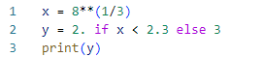
it outputs 3.0
it outputs 2.5
the code is erroneous and it will not execute
Your answer is correct
it outputs 2.0
Overall explanation
Correct:
- it outputs 2.0 - This is true because the cube root of 8 is approximately 2, which is less than 2.3, resulting in y being assigned the value 2.0.

Incorrect:
- it outputs 2.5 - This is incorrect because the conditional expression does not assign 2.5 to y.
- the code is erroneous and it will not execute - This is incorrect because the code is syntactically correct and will execute without errors.
- it outputs 3.0 - This is incorrect because the condition x < 2.3 is true, so y is assigned 2.0, not 3.0.

Code:
- x = 8**(1/3)
- y = 2. if x < 2.3 else 3
- print(y)
Domain
Miscellaneous
Question 16Incorrect
Question code 3-38:
What is the expected behavior of the following code?
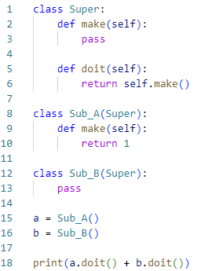
Your answer is incorrect
it outputs 2
Correct answer
it raises an exception
it ouputs 1
it outputs 0
Overall explanation
a.doit():
- Calls doit from Super, which calls self.make().
- self is an instance of Sub_A, so make from Sub_A is called, which returns 1.
- Therefore, a.doit() returns 1.
b.doit():
- Calls doit from Super, which calls self.make().
- self is an instance of Sub_B, so make from Super is called, which does nothing (returns None).
- Therefore, b.doit() returns None.

Correct:
- it raises an exception - The code raises a TypeError when attempting to add 1 and None.

Incorrect:
- it outputs 0 - This is incorrect because the code does not return values that sum to 0.
- it outputs 1 - This is incorrect because the code raises an exception before outputting a result.
- it outputs 2 - This is incorrect because the code raises an exception before outputting a result.

Code:
- class Super:
- def make(self):
- pass

- def doit(self):
- return self.make()

- class Sub_A(Super):
- def make(self):
- return 1

- class Sub_B(Super):
- pass

- a = Sub_A()
- b = Sub_B()

- print(a.doit()) # 1
- print(b.doit()) # None

- print(a.doit() + b.doit()) #TypeError: unsupported operand type(s) for +: 'int' and 'NoneType'
Resources
Domain
Object-Oriented Programming
Question 17Correct
Question code 3-14:
Select the valid fun() invocations (Select two answers)
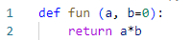
Your selection is correct
fun(1)
Your selection is correct
fun(a=0)
fun(b=1)
fun(b=1, 0)
Overall explanation
Correct:
- fun(a=0) - This is valid because it provides a value for the required parameter a.
- fun(1) - This is valid because it provides a value for the required parameter a using a positional argument.

Incorrect:
- fun(b=1) - This is invalid because it does not provide a value for the required parameter a.
- fun(b=1, 0) - This is invalid because it uses positional arguments after keyword arguments.

Code:
- def fun (a, b=0):
- return a*b

- # fun(b=1) # TypeError: fun() missing 1 required positional argument: 'a'
- fun (a=0) # ok
- # fun(b=1, 0) # SyntaxError: positional argument follows keyword argument
- fun (1) # ok
- fun (b=0, a=3) # ok
Resources
Domain
Miscellaneous
Question 18Correct
Question code 3-26:
The following expression:

1+-2

is:
Your answer is correct
equal to -1
equal to 1
invalid
equal to 2
Overall explanation
Calculation:
- 1 + (−2) = 1 − 2 = −1
Therefore, the expression 1+-2 is equal to -1.

Correct:
- equal to -1

Incorrect:
- equal to 1 - This is incorrect because 1 + -2 equals -1, not 1.
- invalid - This is incorrect because the expression is valid in Python.
- equal to 2 - This is incorrect because 1 + -2 equals -1, not 2.
Domain
Miscellaneous
Question 19Correct
Question code 3-34:
If you want to transform a string into a list of words, what invocation would you use? (Select two answers)

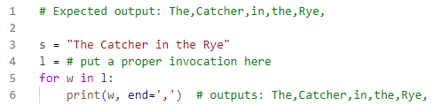
Your selection is correct
s.split(" ")
Your selection is correct
s.split()
split(s)
split(s, " ")
Overall explanation
s.split() splits the string s into a list of words using whitespace as default delimiter.

Correct:
- s.split() - This splits the string into words using any whitespace as the delimiter.
- s.split(" ") - This splits the string into words using a single space as the delimiter.

Incorrect:
- split(s," ") - Incorrect because split is not a standalone function.
- split(s) - Incorrect because split is not a standalone function.

Code:
- # Expected output: The,Catcher,in,the,Rye,

- s = "The Catcher in the Rye"
- l = s.split(" ") # or s.split()
- for w in l:
- print(w, end=',') # outputs: The,Catcher,in,the,Rye,
Resources
Domain
Strings
Question 20Incorrect
Question code 3-17:
Which of the following invocations are valid? (Select two answers)
Your selection is correct
"python".index("th")
Your selection is incorrect
rfind("python","r")
"python".sort()
Correct selection
sorted("python")
Overall explanation
Correct:
- sorted("python") - This returns a sorted list of characters in the string "python".
- "python".index("th") - This returns the starting index of the substring "th" in the string "python".

Incorrect:
- rfind("python","r") - This is incorrect because the rfind method should be called on a string object.
- "python".sort () - This is incorrect because the sort method is not available for strings. It is a list method.

Code:
- # rfind("python","r") # NameError: name 'rfind' is not defined. Did you mean: 'round'?
- sorted("python")
- # "python".sort () # AttributeError: 'str' object has no attribute 'sort'
- "python".index("th")
Resources
Domain
Strings
Question 21Correct
Question code 3-28:
What is the expected output of the following snippet?
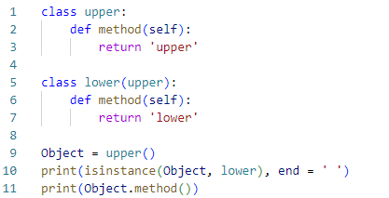
True upper
False lower
True lower
Your answer is correct
False upper
Overall explanation
Object is an instance of upper, not lower.
Object.method() returns 'upper'.

Correct:
- False upper - This is correct because isinstance(Object, lower) is False and Object.method() returns 'upper'.

Incorrect:
- True lower - Incorrect because isinstance(Object, lower) is False and Object.method() returns 'upper'.
- True upper - Incorrect because isinstance(Object, lower) is False.
- False lower - Incorrect because Object.method() returns 'upper', not 'lower'.

Code:
- class upper:
- def method(self):
- return 'upper'

- class lower(upper):
- def method(self):
- return 'lower'

- Object = upper()
- print(isinstance(Object, lower), end = ' ') # False
- print(Object.method()) # upper
Resources
Domain
Object-Oriented Programming
Question 22Incorrect
Question code 3-02:
What is the expected output of the following snippet?
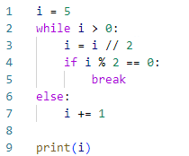
the code is erroneous
7
Correct answer
2
Your answer is incorrect
3
Overall explanation
Iteration of the While Loop:
- Condition i > 0 is true (i is 5).
- i = i // 2 sets i to 2 (integer division of 5 by 2).
- if i % 2 == 0 checks if i is even. Since i is 2, this condition is true.
- The break statement is executed, exiting the while loop.
Else Block:
- The else block after the while loop is only executed if the loop is not exited via break.
- Since the loop was exited via break, the else block is not executed.

Correct:
- 2 - The value of i is 2 after the loop breaks.
Incorrect:
- the code is erroneous - This is incorrect because the code executes without errors.
- 3 - This is incorrect because i is not incremented in the else block.
- 7 - This is incorrect because the initial value of i is 5, and it is changed within the loop.

Code:
- i = 5
- while i > 0:
- i = i // 2
- if i % 2 == 0:
- break
- else:
- i += 1

- print(i)
Resources
Domain
Miscellaneous
Question 23Correct
Question code 3-25:
Which of the following literals reflect the value given as 34.23? (select two answers)
.3423e-2
Your selection is correct
.3423e2
3423e2
Your selection is correct
3423e-2
Overall explanation
Analysis of Each Literal:
.3423e2
- This is scientific notation where .3423 is multiplied by 10^2
- Calculation: 0.3423 × 10^2 = 0.3423 × 100 = 34.23
- This is correct.
3423e-2
- This is scientific notation where 3423 is multiplied by 10^-2.
- Calculation: 3423 × 10^−2 = 3423 × 0.01 = 34.23
- This is correct.
.3423e-2
- This is scientific notation where .3423 is multiplied by 10^-2.
- Calculation: 0.3423 × 10^−2 = 0.3423 × 0.01 = 0.003423
- This is incorrect because it equals 0.003423, not 34.23.
3423e2
- This is scientific notation where 3423 is multiplied by 10^2.
- Calculation: 3423 × 10^2 = 3423 × 100 = 342300
- This is incorrect because it equals 342300, not 34.23.

Correct:
- .3423e2 - This equals 34.23.
- 3423e-2 - This equals 34.23.

Incorrect:
- .3423e-2 - This equals 0.003423, not 34.23.
- 3423e2 - This equals 342300, not 34.23.

Code:
- print(.3423e2) # 34.23
- print(3423e-2) # 34.23
- print(.3423e-2) # 0.003423
- print(3423e2) # 342300.0
Domain
Modules and Packages
Question 24Correct
Question code 3-05:
If you need a function that does nothing, what would you use instead of XXX ? (Select three answers)
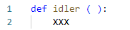
Your selection is correct
return
Null
Your selection is correct
None
exit
Your selection is correct
pass
Overall explanation
Correct:
- pass - This statement does nothing and serves as a placeholder in the function.
- return - This statement without any value causes the function to return None and do nothing.
- None - Interpreted as return None, it explicitly returns None and makes the function do nothing.

Incorrect:
- exit - This exits the program and is not suitable for making a function do nothing within its scope.
- Null - This is not a valid statement in Python; the correct keyword is None.

Code:
- def idler ( ):
- pass
Resources
Domain
Miscellaneous
Question 25Correct
Question code 3-01:
If you want to access an exception object's components and store them in an object called e, you have to use the following form of exception statement
Your answer is correct
except Exception as e:
except e=Exception:
such an action is not possible in Python
except Exception(e):
Overall explanation
Correct:
- except Exception as e: This syntax catches the exception of type Exception and assigns the exception object to the variable e. You can then use e to access the components and details of the exception.

Incorrect:
- except Exception(e): This is incorrect syntax for catching an exception in Python.
- except e=Exception: This is incorrect syntax for catching an exception in Python.
- such an action is not possible in Python: This is incorrect because it is possible to catch an exception and store it in a variable using the as keyword.

Code:
- #Example code:
- try:
- # some code that may raise an exception
- x = 1 / 0

- except Exception as e:
- print("An exception occurred:", e)
Resources
Domain
Exceptions
Question 26Incorrect
Question code 3-27:
Which line can be used instead of the comment to cause the snippet to produce the following expected output? (Select two answers)
- Expected output:
- 1 2 3
Code:
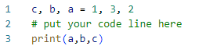
Correct selection
c, b, a = b, a, c
a, b, c = a, b, c
Your selection is correct
a, b, c = c, a, b
c, b, a = a, c, b
Overall explanation
Correct:
- c, b, a = b, a, c - This reassigns the variables correctly to produce the output 1 2 3.
- a, b, c = c, a, b - This reassigns the variables correctly to produce the output 1 2 3.

Incorrect:
- c, b, a = a, c, b - This does not produce the desired output.
- a, b, c = a, b, c - This does not produce the desired output.

Code:
- # Expected output:
- # 1 2 3

- # Code:
- c, b, a = 1, 3, 2
- # put your code line here
- print(a,b,c)
Domain
Miscellaneous
Question 27Incorrect
Question code 3-22:
A Python module named pymod.py contains a function named pyfun(). Which of the following snippets will let you invoke the function? (Select two answers)
Your selection is incorrect
from pymod import
pymod.pyfun()
Correct selection
import pymod
pymod.pyfun()
Your selection is correct
from pymod import pyfun
pyfun()
import pyfun from pymod
pyfun()
Overall explanation
Correct:
- from pymod import pyfun pyfun() - This imports the pymod module and correctly calls the pyfun function using the module name.
- import pymod pymod.pyfun() - This correctly imports the pyfun function and allows direct invocation.

Incorrect:
- from pymod import pymod.pyfun() - Syntax error.
- import pyfun from pymod pyfun() - Incorrect import statement syntax.

Code:
- # create a file pymod.py that contents a function bellow
- def pyfun():
- pass

- # Then test bellow code in another .py file
- # A
- from pymod import
- pymod.pyfun()

- # B
- import pymod
- pymod.pyfun()

- # C
- import pyfun from pymod
- pyfun()

- # D
- from pymod import pyfun
- pyfun()
Resources
Domain
Modules and Packages
Question 28Correct
Question code 3-07:
Assuming that the snippet below has been executed successfully, which of the following expressions will evaluate to True?
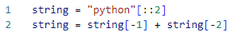
string[0] == string[-1]
Your answer is correct
string[0] == 'o'
string is None
len(string) == 3
Overall explanation
'python'[::2] takes every second character from the string 'python', resulting in 'pto'.
string[-1] is 'o' and string[-2] is 't'.
Therefore, string becomes 'ot'.

Correct:
- string[0] == 'o' - The first character of string is 'o'.

Incorrect:
- string[0] == string[-1] - The first character is 'o' and the last character is 't', so this is false.
- string is None - string is 'ot', not None.
- len(string) == 3 - The length of string is 2, not 3.

Code:
- string = "python"[::2]
- print(string) # output: pto

- string = string[-1] + string[-2]
- print(string) # output: ot

- print(string[0] == string[-1]) # False
- print(string is None) # False
- print(len(string) == 3) # False
- print(string[0] == 'o') # True
Resources
Domain
Strings
Question 29Correct
Question code 3-21:
Which of the following snippets will execute without raising any unhandled exceptions? (Select 2 answers)
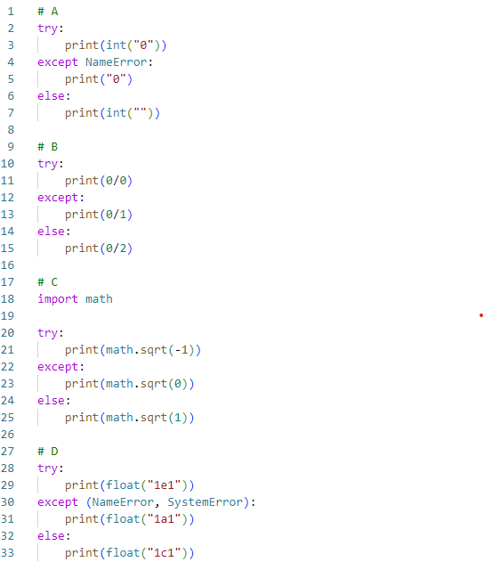
Your selection is correct
Option C
Option A
Your selection is correct
Option B
Option D
Overall explanation
Correct:
- Option B - This snippet catches the ZeroDivisionError and handles it without raising any unhandled exceptions.
- Option C - This snippet catches the ValueError from math.sqrt(-1) and handles it without raising any unhandled exceptions.

Incorrect:
- Option A - This raises an unhandled ValueError in the else block. ValueError: invalid literal for int() with base 10: ''
- Option D - This raises an unhandled ValueError in the else block. ValueError: could not convert string to float: '1c1'

Code:
- # # A
- # try:
- # print(int("0"))
- # except NameError:
- # print("0")
- # else:
- # print(int("")) # ValueError: invalid literal for int() with base 10: ''

- # B
- try:
- print(0/0)
- except:
- print(0/1) # print 0.0
- else:
- print(0/2)

- # C
- import math

- try:
- print(math.sqrt(-1))
- except:
- print(math.sqrt(0)) # print 0.0
- else:
- print(math.sqrt(1))

- # # D
- # try:
- # print(float("1e1")) # print 10.0
- # except (NameError, SystemError):
- # print(float("1a1"))
- # else:
- # print(float("1c1")) # ValueError: could not convert string to float: '1c1'
Domain
Exceptions
Question 30Correct
Question code 3-29:
What is the expected output of the following snippet?
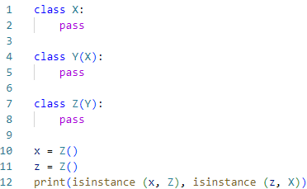
False False
False True
True False
Your answer is correct
True True
Overall explanation
x is an instance of class Z because x is created as an instance of Z. x = Z()
z is an instance of class X. because z is an instance of Z, which inherits from Y, which in turn inherits from X. Therefore, z is also considered an instance of X.

Correct:
- True True

Incorrect:
- True False - This is incorrect because isinstance(z, X) is True.
- False False - This is incorrect because both isinstance(x, Z) and isinstance(z, X) are True.
- False True - This is incorrect because isinstance(x, Z) is True.

Code:
- class X:
- pass

- class Y(X):
- pass

- class Z(Y):
- pass

- x = Z()
- z = Z()
- print(isinstance (x, Z), isinstance (z, X)) # True True
Resources
Domain
Object-Oriented Programming
Question 31Correct
Question code 3-08:
The simplest possible class definition in Python can be expressed as:
class X: {}
class X:
return
class X:
Your answer is correct
class X:
pass
Overall explanation
Correct:
- class X: #- This is the simplest and correct class definition.
pass
Incorrect:
- class X: - This would result in a syntax error because the class body is missing.
- class X: return - This is incorrect because return is not valid in the class body context.
- class X: {} - This is incorrect syntax for a class definition.
Resources
Domain
Object-Oriented Programming
Question 32Correct
Question code 3-18:
What is the expected behavior of the following code?
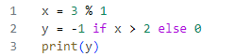
the code is erroneous and it will not execute
Your answer is correct
it outputs 0
it outputs -1
it outputs 1
Overall explanation
X = 3 % 1 calculates the remainder when 3 is divided by 1. So x is assigned the value 0.
As X = 0 the line y = -1 if x > 2 else 0 assigned y to 0

Correct:
- it outputs 0 - The variable y is assigned the value 0 based on the conditional expression.

Incorrect:
- it outputs -1 - This is incorrect because the condition x > 2 is False, so y is not assigned -1.
- the code is erroneous and it will not execute - This is incorrect because the code is syntactically correct and will execute without errors.
- it outputs 1 - This is incorrect because the value assigned to y is 0, not 1.

Code:
- x = 3 % 1
- y = -1 if x > 2 else 0
- print(y) # it prints 0
Domain
Miscellaneous
Question 33Correct
Question code 3-36:
Can a module run like regular code?
yes, but it cannot differentiate its behavior between the regular launch and import
Your answer is correct
yes, and it can differentiate its behavior between the regular launch and import
no. it is not possible; a module can be imported, not run
it depends on the Python version
Overall explanation
Correct:
- yes, and it can differentiate its behavior between the regular launch and import - This is true. A module can run like regular code and can differentiate its behavior using the __name__ variable.

Incorrect:
- it depends on the Python version - This is incorrect. This behavior is consistent across Python versions.
- yes, but it cannot differentiate its behavior between the regular launch and import - This is incorrect. A module can differentiate its behavior using the __name__ variable.
- no. it is not possible; a module can be imported, not run - This is incorrect. A module can be run directly and can also be imported.
Domain
Modules and Packages
Question 34Correct
Question code 3-31:
What is the expected behavior of the following code?
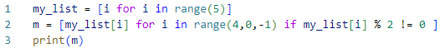
it outputs [1, 3]
the code is erroneous and it will not execute
it outputs [4, 2, 0]
Your answer is correct
it outputs [3, 1]
Overall explanation
range(5) generates a sequence of indices from 0 to 4. Resulting in (0, 1, 2, 3, 4)
The range(4, 0, -1) generates a sequence of indices from 4 to 1 (inclusive), in reverse order.
Indices generated by range(4, 0, -1): [4, 3, 2, 1]
The list comprehension iterates over these indices, selecting elements from my_list if they are odd (i.e., my_list[i] % 2 != 0). Resulting in : [3,1]

Correct:
- C. it outputs [3, 1]

Incorrect:
- A. it outputs [1, 3] - This is incorrect because the elements are selected in reverse order.
- B. the code is erroneous and it will not execute - This is incorrect because the code is syntactically correct and will execute.
- D. it outputs [4, 2, 0] - This is incorrect because these elements are not odd and do not match the filtering condition.

Code:
- my_list = [i for i in range(5)]
- print(my_list) # [0, 1, 2, 3, 4]
- m = [my_list[i] for i in range(4,0,-1) if my_list[i] % 2 != 0 ]
- print(m) # [3, 1]
Resources
Domain
Miscellaneous
Question 35Correct
Question code 3-33:
What is a NOT True about python class constructors? (Select two answers)
The constructor must have at least one parameter
Your selection is correct
The constructor must return a value other than None
the constructor is a method named __init__
Your selection is correct
there can be more than one constructor in a Python class
Overall explanation
Correct (not true):
- the constructor must return a value other than None - This is not true because constructors in Python implicitly return None.
- there can be more than one constructor in a Python class - This is not true because a Python class can have only one __init__ method.

Incorrect (true):
- the constructor must have at least one parameter - This is true because the __init__ method must have the self parameter.
- the constructor is a method named __init__ - This is true because the __init__ method is the constructor in Python.
Resources
Domain
Object-Oriented Programming
Question 36Correct
Question code 3-23:
Assuming that the following piece of code has been executed successfully, which of the expressions evaluate to True? (Select two answers)
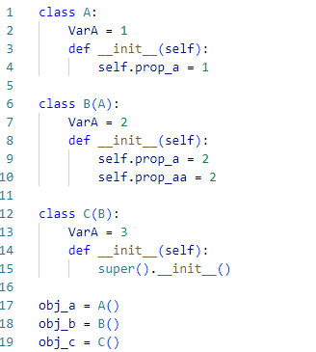
B.VarA == 3
Your selection is correct
hasattr(obj_b, 'prop_aa')
obj_b.prop_a == 3
Your selection is correct
isinstance(obj_c,A)
Overall explanation
Correct:
- hasattr(obj_b, 'prop_aa') - This is true because obj_b has the attribute prop_aa.
- isinstance(obj_c, A) - This is true because obj_c is an instance of C, and C is a subclass of A.

Incorrect:
- obj_b.prop_a == 3 - This is false because obj_b.prop_a is 2.
- B.VarA == 3 - This is false because B.VarA is 2.

Code:
- class A:
- VarA = 1
- def __init__(self):
- self.prop_a = 1

- class B(A):
- VarA = 2
- def __init__(self):
- self.prop_a = 2
- self.prop_aa = 2

- class C(B):
- VarA = 3
- def __init__(self):
- super().__init__()

- obj_a = A()
- obj_b = B()
- obj_c = C()

- print(obj_b.prop_a == 3)
- print(hasattr(obj_b, 'prop_aa')) # True
- print(isinstance(obj_c,A)) # True
- print(B.VarA == 3)
Resources
Domain
Object-Oriented Programming
Question 37Incorrect
Question code 3-20:
Is it possible to safely check if a class/object has a certain attribute?
Your answer is incorrect
yes, by using the hasattr() method
Correct answer
yes, by using the hasattr() function
yes, by using the hasattr attribute
no, it is not possible
Overall explanation
Correct:
- yes, by using the hasattr ( ) function - This is the correct method to check for the presence of an attribute in an object or class.

Incorrect:
- yes, by using the hasattr attribute - hasattr is not an attribute.
- yes, by using the hasattr ( ) method - hasattr is a function, not a method of objects.
- no, it is not possible - This is incorrect because it is possible using the hasattr() function.

Code:
- #Example
- class Person:
- name = "John"
- age = 36
- country = "Norway"

- x = hasattr(Person, 'age')
- print(x) # print True
Resources
Domain
Object-Oriented Programming
Question 38Correct
Question code 3-40:
Assuming that the math module has been successfully imported, which of the following expressions evaluate to True? (Select two answers)
Your selection is correct
math.floor(2.5) == math.trunc(2.5)
Your selection is correct
math.hypot(3,4) == math.sqrt(25)
math.ceil(2.5) == math.floor(2.5)
math.hypot(2,5) == math.trunc(2.5)
Overall explanation
Correct:
- math.hypot(3, 4) == math.sqrt(25) - Both evaluate to 5.
- math.floor(2.5) == math.trunc(2.5) - Both evaluate to 2.

Incorrect:
- math.hypot(2, 5) == math.trunc(2.5) - math.hypot(2, 5) evaluates to approximately 5.385, and math.trunc(2.5) evaluates to 2.
- math.ceil(2.5) == math.floor(2.5) - math.ceil(2.5) evaluates to 3, and math.floor(2.5) evaluates to 2.

Expressions Analysis:
A. math.hypot(3, 4) == math.sqrt(25)
- math.hypot(3, 4) calculates the Euclidean norm, which is the hypotenuse of a right triangle with legs 3 and 4.
  - Calculation: 32+42=9+16=25=5\sqrt{3^2 + 4^2} = \sqrt{9 + 16} = \sqrt{25} = 532+42​=9+16​=25​=5.
- math.sqrt(25) calculates the square root of 25.
  - Calculation: 25=5\sqrt{25} = 525​=5.
- Both expressions evaluate to 5.
- This expression is True.
B. math.floor(2.5) == math.trunc(2.5)
- math.floor(2.5) returns the largest integer less than or equal to 2.5.
  - Result: 2.
- math.trunc(2.5) returns the integer part of 2.5, truncating towards zero.
  - Result: 2.
- Both expressions evaluate to 2.
- This expression is True.
C. math.hypot(2, 5) == math.trunc(2.5)
- math.hypot(2, 5) calculates the Euclidean norm, which is the hypotenuse of a right triangle with legs 2 and 5.
  - Calculation: 22+52=4+25=29\sqrt{2^2 + 5^2} = \sqrt{4 + 25} = \sqrt{29}22+52​=4+25​=29​, which is approximately 5.385.
- math.trunc(2.5) returns the integer part of 2.5, truncating towards zero.
  - Result: 2.
- These values are not equal.
- This expression is False.
D. math.ceil(2.5) == math.floor(2.5)
- math.ceil(2.5) returns the smallest integer greater than or equal to 2.5.
  - Result: 3.
- math.floor(2.5) returns the largest integer less than or equal to 2.5.
  - Result: 2.
- These values are not equal.
- This expression is False.

Code:
- import math
- print(math.hypot(3,4) == math.sqrt(25)) # True
- print(math.floor(2.5) == math.trunc(2.5)) # True
- print(math.hypot(2,5) == math.trunc(2.5)) # False
- print(math.ceil(2.5) == math.floor(2.5)) # False

- math sqrt() function in Python:
- https://www.geeksforgeeks.org/python-math-function-sqrt/
Resources
Domain
Modules and Packages
Question 39Correct
Question code 3-04:
How many elements will the List1 list contain after execution of the following snippet?
zero
Your answer is correct
two
three
one
Overall explanation
Correct:
- two - The list contains two elements: "don't think twice" and " do it!".

Incorrect:
- zero - This is incorrect because the list will have two elements.
- one - This is incorrect because the list will have two elements, not one.
- three - This is incorrect because the list will have two elements, not three.

Code:
- List1 = "don't think twice, do it!".split(',')

- print(List1) # output ["don't think twice", ' do it!']
Resources
Domain
Strings
Question 40Correct
Question code 3-12:
There is a stream named s open for writing. What option will you select to write a line to the stream?
write(s, "Hello")
s.writeline("Hello")
Your answer is correct
s.write("Hello\n")
s.writeln("Hello")
Overall explanation
Correct:
- s.write("Hello\n") - This correctly writes the string "Hello" followed by a newline character to the stream s.

Incorrect:
- write(s, "Hello") - This is incorrect because write should be called on the stream object.
- s.writeln("Hello") - This is incorrect because there is no writeln method in the standard file object interface.
- s.writeline("Hello") - This is incorrect because there is no writeline method in the standard file object interface.

Code:
- # Importing the StringIO module.
- from io import StringIO

- # The arbitrary string.
- string ='This is initial string.'

- # Using the StringIO method to set
- # as file object. Now we have an
- # object file that we will able to
- # treat just like a file.
- file = StringIO(string)

- # this will read the file
- print(file.read())

- # We can also write this file.
- file.write(" Welcome to Easylearning.com")

- # This will make the cursor at
- # index 0.
- file.seek(0)

- # This will print the file after
- # writing in the initial string.
- print('The string after writing is:', file.read())
Resources
Domain
Strings

