Question code :
If you need a function that does nothing, what would you use instead of XXX ? (Select three answers)
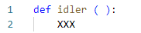

Overall explanation
Correct:
- pass - This statement does nothing and serves as a placeholder in the function.
- return - This statement without any value causes the function to return None and do nothing.
- None - Interpreted as return None, it explicitly returns None and makes the function do nothing.
Incorrect:
- exit - This exits the program and is not suitable for making a function do nothing within its scope.
- Null - This is not a valid statement in Python; the correct keyword is None.

Question 6
A variable stored separately in every object is called:
Overall explanation
Explanation:
- Instance variable: These are variables that are defined in the __init__ method or any other method using self. Each instance of the class has its own copy of these variables. They are specific to each object (instance) of the class.

Correct:
- an instance variable

- a class variable: This is incorrect because class variables are shared among all instances of the class.
- What is the expected output of the following snippet?
- 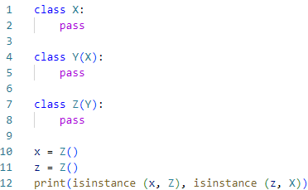

Overall explanation
x is an instance of class Z because x is created as an instance of Z. x = Z()
z is an instance of class X. because z is an instance of Z, which inherits from Y, which in turn inherits from X. Therefore, z is also considered an instance of X.

Correct:
- True True
- =====================

- Question code 3-34:
- If you want to transform a string into a list of words, what invocation would you use? (Select two answers)

- 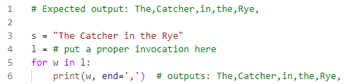

Overall explanation
s.split() splits the string s into a list of words using whitespace as default delimiter.

Correct:
- s.split() - This splits the string into words using any whitespace as the delimiter.
- s.split(" ") - This splits the string into words using a single space as the delimiter.
- s = "The Catcher in the Rye"
- l = s.split(" ") # or s.split()
- for w in l:
- print(w, end=',') # outputs: The,Catcher,in,the,Rye

Question code 3-32:
What is the expected output of the following code?
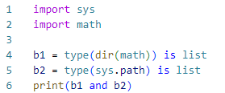

Overall explanation
dir(math) returns a list of names in the math module.
sys.path is a list of strings that specifies the search path for modules.

Correct:
- True - The expression b1 and b2 evaluates to True because both b1 and b2 are True.
- ===================================

- How many elements will the List1 list contain after execution of the following snippet?
Overall explanation
Correct:
- two - The list contains two elements: "don't think twice" and " do it!".

- Question code 3-21:
- Which of the following snippets will execute without raising any unhandled exceptions? (Select 2 answers)
- 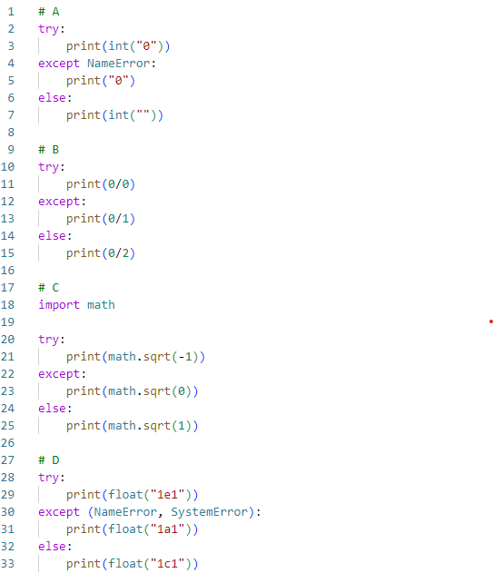

Overall explanation
Correct:
- Option B - This snippet catches the ZeroDivisionError and handles it without raising any unhandled exceptions.
- Option C - This snippet catches the ValueError from math.sqrt(-1) and handles it without raising any unhandled exceptions.

Incorrect:
- Option A - This raises an unhandled ValueError in the else block. ValueError: invalid literal for int() with base 10: ''
- Option D - This raises an unhandled ValueError in the else block. ValueError: could not convert string to float: '1c1'
A Python module named pymod.py contains a function named pyfun(). Which of the following snippets will let you invoke the function? (Select two answers)
Correct:
- from pymod import pyfun . pyfun() - This imports the pymod module and correctly calls the pyfun function using the module name.
- import pymod pymod.pyfun() - This correctly imports the pyfun function and allows direct invocation.
Assuming that the math module has been successfully imported, which of the following expressions evaluate to True? (Select two answers)
Overall explanation
Correct:
- math.hypot(3, 4) == math.sqrt(25) - Both evaluate to 5.
- math.floor(2.5) == math.trunc(2.5) - Both evaluate to 2.

Incorrect:
- math.hypot(2, 5) == math.trunc(2.5) - math.hypot(2, 5) evaluates to approximately 5.385, and math.trunc(2.5) evaluates to 2.
- math.ceil(2.5) == math.floor(2.5) - math.ceil(2.5) evaluates to 3, and math.floor(2.5) evaluates to 2.
What is the expected behavior of the following code?
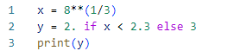
Overall explanation
Correct:
- it outputs 2.0 - This is true because the cube root of 8 is approximately 2, which is less than 2.3, resulting in y being assigned the value 2.0.
- How many lines does the following snippet output?
- 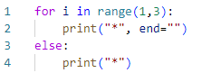
Overall explanation
The range(1, 3) generates the numbers 1 and 2. The for loop iterates over these two numbers and prints 2 **
After the for loop completes, the else block is executed and prints 1 * in the same line.
The entire output will be *** on one line.
Correct:
- one - The output consists of three asterisks *** on a single line.

Question code 3-11:
Which of the following expressions evaluate to True?
Correct selection
- str(1-1) in '012345£739'[:2]
'dcb' not in 'abcde'[::-1]
Correct selection
'True' not in 'False'
'phd' in 'alpha'
Overall explanation
'012345£739'[:2] gives the substring '01'.
'abcde'[::-1] reverses the string, resulting in 'edcba'.

Correct:
- str(1-1) in '012345£739'[:2] - '0' in '01' evaluates to True.
- 'True' not in 'False' - 'True' not in 'False' evaluates to True.

Incorrect:
- 'phd' in 'alpha' - 'phd' in 'alpha' evaluates to False.
- 'dcb' not in 'abcde'[::-1] - 'dcb' not in 'edcba' evaluates to False.

Code:
- print(str(1-1) in '012345£739'[:2])
- print('phd' in 'alpha')
- print('dcb' not in 'abcde' [::-1])
- print('True' not in 'False')
What is true about Object-Oriented Programming in Python? (Select two answers)
Correct selection
a subclass is usually more specialized than its superclass
each object of the same class can have a different set of methods
if a real-life object can be described with a set of adjectives, they may reflect a Python object method
Correct selection
the same class can be used many times to build a number of objects
Overall explanation
Correct:
- The same class can be used many times to build a number of objects - A class can be instantiated multiple times to create different objects.
- A subclass is usually more specialized than its superclass - A subclass inherits from a superclass and can add more specific behavior.

Incorrect:
- If a real-life object can be described with a set of adjectives, they may reflect a Python object method - Adjectives are more likely to describe attributes, not methods.
- Each object of the same class can have a different set of methods - Objects of the same class share the same methods defined in the class.

Question code 3-20:
Is it possible to safely check if a class/object has a certain attribute?
Correct answer
yes, by using the hasattr() function
yes, by using the hasattr attribute
yes, by using the hasattr() method
no, it is not possible
Overall explanation
Correct:
- yes, by using the hasattr ( ) function - This is the correct method to check for the presence of an attribute in an object or class.

Incorrect:
- yes, by using the hasattr attribute - hasattr is not an attribute.
- yes, by using the hasattr ( ) method - hasattr is a function, not a method of objects.
- no, it is not possible - This is incorrect because it is possible using the hasattr() function.

Code:
- #Example
- class Person:
- name = "John"
- age = 36
- country = "Norway"

- x = hasattr(Person, 'age')
- print(x) # print True
- What is the expected output of the following snippet?
- 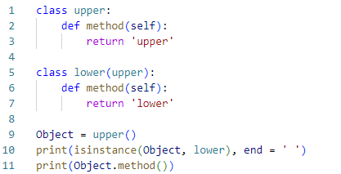

False lower
True upper
Correct answer
False upper
True lower
Overall explanation
Object is an instance of upper, not lower.
Object.method() returns 'upper'.

Correct:
- False upper - This is correct because isinstance(Object, lower) is False and Object.method() returns 'upper'.

Incorrect:
- True lower - Incorrect because isinstance(Object, lower) is False and Object.method() returns 'upper'.
- True upper - Incorrect because isinstance(Object, lower) is False.
- False lower - Incorrect because Object.method() returns 'upper', not 'lower'.

Code:
- class upper:
- def method(self):
- return 'upper'

- class lower(upper):
- def method(self):
- return 'lower'

- Object = upper()
- print(isinstance(Object, lower), end = ' ') # False
- print(Object.method()) # upper

Question code 3-15:
What is the expected output of the following code ? The file named zero_length_existing_file is a zero-length file located inside the working directory.
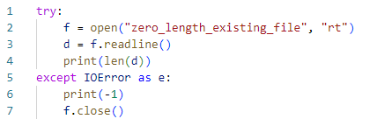

Overall explanation
Correct:
- 0 - The length of the line read from a zero-length file is 0.

If you want to access an exception object's components and store them in an object called e, you have to use the following form of exception statement
such an action is not possible in Python
Correct answer
except Exception as e:
except Exception(e):
except e=Exception:
Overall explanation
Correct:
- except Exception as e: This syntax catches the exception of type Exception and assigns the exception object to the variable e. You can then use e to access the components and details of the exception.

Incorrect:
- except Exception(e): This is incorrect syntax for catching an exception in Python.

- except e=Exception: This is incorrect syntax for catching an exception in Python.
- such an action is not possible in Python: This is incorrect because it is possible to catch an exception and store it in a variable using the as keyword.

- try:
- # some code that may raise an exception
- x = 1 / 0

- except Exception as e:
- print("An exception occurred:", e)

Question code 3-17:
Which of the following invocations are valid? (Select two answers)
rfind("python","r")
Correct selection
"python".index("th")
"python".sort()
Correct selection
sorted("python")
Overall explanation
Correct:
- sorted("python") - This returns a sorted list of characters in the string "python".
- "python".index("th") - This returns the starting index of the substring "th" in the string "python".

Incorrect:
- rfind("python","r") - This is incorrect because the rfind method should be called on a string object.
- "python".sort () - This is incorrect because the sort method is not available for strings. It is a list method.

Code:
- # rfind("python","r") # NameError: name 'rfind' is not defined. Did you mean: 'round'?
- sorted("python")
- # "python".sort () # AttributeError: 'str' object has no attribute 'sort'
- "python".index("th")

Select the valid fun() invocations (Select two answers)
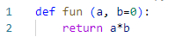
fun(b=1)
Correct selection
fun(1)
Correct selection
fun(a=0)
fun(b=1, 0)
Overall explanation
Correct:
- fun(a=0) - This is valid because it provides a value for the required parameter a.
- fun(1) - This is valid because it provides a value for the required parameter a using a positional argument.

Incorrect:
- fun(b=1) - This is invalid because it does not provide a value for the required parameter a.
- fun(b=1, 0) - This is invalid because it uses positional arguments after keyword arguments.

Code:
- def fun (a, b=0):
- return a*b

- # fun(b=1) # TypeError: fun() missing 1 required positional argument: 'a'
- fun (a=0) # ok
- # fun(b=1, 0) # SyntaxError: positional argument follows keyword argument
- fun (1) # ok
- fun (b=0, a=3) # ok

Question code 3-02:
What is the expected output of the following snippet?
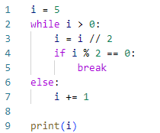

Overall explanation
Iteration of the While Loop:
- Condition i > 0 is true (i is 5).
- i = i // 2 sets i to 2 (integer division of 5 by 2).
- if i % 2 == 0 checks if i is even. Since i is 2, this condition is true.
- The break statement is executed, exiting the while loop.
Else Block:
- The else block after the while loop is only executed if the loop is not exited via break.
- Since the loop was exited via break, the else block is not executed.

Correct:
- 2 - The value of i is 2 after the loop breaks.
Incorrect:
- the code is erroneous - This is incorrect because the code executes without errors.
- 3 - This is incorrect because i is not incremented in the else block.
- 7 - This is incorrect because the initial value of i is 5, and it is changed within the loop.

Code:
- i = 5
- while i > 0:
- i = i // 2
- if i % 2 == 0:
- break
- else:
- i += 1

- print(i)
What is the expected behavior of the following code?
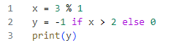
the code is erroneous and it will not execute
it outputs -1
Correct answer
it outputs 0
it outputs 1
Overall explanation
X = 3 % 1 calculates the remainder when 3 is divided by 1. So x is assigned the value 0.
As X = 0 the line y = -1 if x > 2 else 0 assigned y to 0

Correct:
- it outputs 0 - The variable y is assigned the value 0 based on the conditional expression.

Incorrect:
- it outputs -1 - This is incorrect because the condition x > 2 is False, so y is not assigned -1.
- the code is erroneous and it will not execute - This is incorrect because the code is syntactically correct and will execute without errors.
- it outputs 1 - This is incorrect because the value assigned to y is 0, not 1.

Code:
- x = 3 % 1
- y = -1 if x > 2 else 0
- print(y) # it prints 0

Question code 3-03:
Assuming that the V variable holds an integer value to 2, which of the following operators should be used instead of OPER to make the expression equal to 1?

V OPER 1

Correct answer
>>
<<<
<<
>>>
Overall explanation
Correct:
- >> - The right shift operator shifts the bits of 2 right by 1 position, resulting in 1.

Incorrect:
- <<< - This is not a valid operator in Python.
- >>> - This is not a valid operator in Python.
- << - The left shift operator shifts the bits of 2 left by 1 position, resulting in 4, not 1.

Code:
- print(2 >> 1) # output 1

What is the expected behavior of the following snippet?
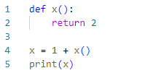
It will:
cause a runtime exception on line 04
Correct answer
print 3
cause a runtime exception on line 01
cause a runtime exception on line 02
Overall explanation
The function x(), which returns 2.
The expression 1 + x() evaluates to 1 + 2, which is 3.
The variable x is then assigned the value 3.

Correct:
- print 3 - The code correctly evaluates the expression and assigns 3 to x, then prints 3.

Incorrect:
- cause a runtime exception on line 02 - This is incorrect because the function x is defined and can be called without any issues.
- cause a runtime exception on line 01 - This is incorrect because there is no issue with the function definition.
- cause a runtime exception on line 04 - This is incorrect because x is correctly assigned a value and can be printed without any issues.

Code:
- def x():
- return 2

- x = 1 + x()
- print(x) # print 3
=================================================

Question 30Skipped
Question code 3-31:
What is the expected behavior of the following code?
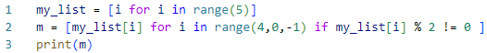
Correct answer
it outputs [3, 1]
the code is erroneous and it will not execute
it outputs [4, 2, 0]
it outputs [1, 3]
Overall explanation
range(5) generates a sequence of indices from 0 to 4. Resulting in (0, 1, 2, 3, 4)
The range(4, 0, -1) generates a sequence of indices from 4 to 1 (inclusive), in reverse order.
Indices generated by range(4, 0, -1): [4, 3, 2, 1]
The list comprehension iterates over these indices, selecting elements from my_list if they are odd (i.e., my_list[i] % 2 != 0). Resulting in : [3,1]

Correct:
- C. it outputs [3, 1]

Incorrect:
- A. it outputs [1, 3] - This is incorrect because the elements are selected in reverse order.
- B. the code is erroneous and it will not execute - This is incorrect because the code is syntactically correct and will execute.
- D. it outputs [4, 2, 0] - This is incorrect because these elements are not odd and do not match the filtering condition.

Code:
- my_list = [i for i in range(5)]
- print(my_list) # [0, 1, 2, 3, 4]
- m = [my_list[i] for i in range(4,0,-1) if my_list[i] % 2 != 0 ]
- print(m) # [3, 1]

Question code 3-07:
Assuming that the snippet below has been executed successfully, which of the following expressions will evaluate to True?
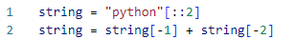
Correct answer
string[0] == 'o'
string is None
len(string) == 3
string[0] == string[-1]
Overall explanation
'python'[::2] takes every second character from the string 'python', resulting in 'pto'.
string[-1] is 'o' and string[-2] is 't'.
Therefore, string becomes 'ot'.

Correct:
- string[0] == 'o' - The first character of string is 'o'.

Incorrect:
- string[0] == string[-1] - The first character is 'o' and the last character is 't', so this is false.
- string is None - string is 'ot', not None.
- len(string) == 3 - The length of string is 2, not 3.

Code:
- string = "python"[::2]
- print(string) # output: pto

- string = string[-1] + string[-2]
- print(string) # output: ot

- print(string[0] == string[-1]) # False
- print(string is None) # False
- print(len(string) == 3) # False
- print(string[0] == 'o') # True

Question code 3-39:
Assuming that the following snippet has been successfully executed, which of the equations are True? (Select two answers)
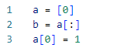
Correct selection
b[0] + 1 == a[0]
a[0] == b[0]
a[0] + 1 == b[0]
Correct selection
len(a) == len(b)
Overall explanation
Correct:
- len(a) == len(b) - Both lists have the same length of 1.
- b[0] + 1 == a[0] - The expression evaluates to 1 == 1, which is true.

Incorrect:
- a[0] == b[0] - a[0] is 1 and b[0] is 0, so this is false.
- a[0] + 1 == b[0] - a[0] + 1 is 2 and b[0] is 0, so this is false.

Code:
- a = [0]
- b = a[:]
- a[0] = 1

- print(len(a) == len (b)) # True
- print(b[0] + 1 == a[0]) # True
- print(a[0] == b [0]) # False
- print(a[0] + 1 == b[0]) # False

===============================================================

Question code 3-35:
Which of the following statements are true? (Select two answers)
Correct selection
a code point is a number assigned to a given character
Correct selection
II in ASCII stands for Information Interchange
ASCII is synonymous with UTF-8
\e is an escape sequence used to mark the end of lines
Overall explanation
Correct:
- II in ASCII stands for Information Interchange - This is true because ASCII stands for American Standard Code for Information Interchange.
- A code point is a number assigned to a given character - This is true because a code point is the numerical value assigned to a character in an encoding standard.

Incorrect:
- \e is an escape sequence used to mark the end of lines - This is false because \n is the escape sequence used to mark the end of lines.
- ASCII is synonymous with UTF-8 - This is false because ASCII and UTF-8 are different encoding standards, though UTF-8 includes ASCII as a subset.
Question code 3-30:
A method for passing the arguments used by the following snippet is called:
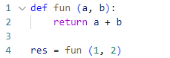
keyword
Correct answer
positional
named
sequential
Overall explanation
- Positional Arguments: Arguments are passed to the function in the same order as the parameters are defined. In this case, 1 is passed to a and 2 is passed to b.
- Keyword Arguments: keyword arguments are passed with their parameter names, such as fun(a=1, b=2).

Correct :
- positional

Incorrect:
- sequential: This is not a standard term used to describe how arguments are passed in Python functions.
- named: Named arguments, also known as keyword arguments, are specified by explicitly naming each parameter. For example: fun(a=1, b=2).
- keyword: This is incorrect because keyword arguments are passed with their parameter names, such as fun(a=1, b=2).

Code:
- def fun (a, b):
- return a + b

- res = fun (1, 2)

Question 35Skipped
Question code 3-08:
The simplest possible class definition in Python can be expressed as:
class X:
return
Correct answer
class X:
pass
class X: {}
class X:
Overall explanation
Correct:
- class X: #- This is the simplest and correct class definition.
pass
Incorrect:
- class X: - This would result in a syntax error because the class body is missing.
- class X: return - This is incorrect because return is not valid in the class body context.
- class X: {} - This is incorrect syntax for a class definition.

What is the expected output of the following snippet?
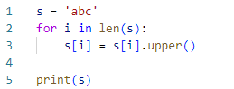
ABC
123
Correct answer
The code will cause a runtime exception
abc
Overall explanation
Correct:
- The code will cause a runtime exception - The loop for i in len(s): will raise a TypeError because len(s) is an integer, and integers are not iterable.

Incorrect:
- abc - This is incorrect because the code does not execute correctly due to the TypeError.
- ABC - This is incorrect because the code does not execute correctly due to the TypeError.
- 123 - This is incorrect because the code does not execute correctly due to the TypeError.

Code:
- s = 'abc'
- for i in len(s):
- s[i] = s[i].upper()

- print(s)

- #Error code line 2: TypeError: 'int' object is not iterable

Question 37Skipped
Question code 3-12:
There is a stream named s open for writing. What option will you select to write a line to the stream?
s.writeln("Hello")
write(s, "Hello")
Correct answer
s.write("Hello\n")
s.writeline("Hello")
Overall explanation
Correct:
- s.write("Hello\n") - This correctly writes the string "Hello" followed by a newline character to the stream s.

Incorrect:
- write(s, "Hello") - This is incorrect because write should be called on the stream object.
- s.writeln("Hello") - This is incorrect because there is no writeln method in the standard file object interface.
- s.writeline("Hello") - This is incorrect because there is no writeline method in the standard file object interface.

Code:
- # Importing the StringIO module.
- from io import StringIO

- # The arbitrary string.
- string ='This is initial string.'

- # Using the StringIO method to set
- # as file object. Now we have an
- # object file that we will able to
- # treat just like a file.
- file = StringIO(string)

- # this will read the file
- print(file.read())

- # We can also write this file.
- file.write(" Welcome to Easylearning.com")

- # This will make the cursor at
- # index 0.
- file.seek(0)

- # This will print the file after
- # writing in the initial string.
- print('The string after writing is:', file.read())

Question code 3-23:
Assuming that the following piece of code has been executed successfully, which of the expressions evaluate to True? (Select two answers)
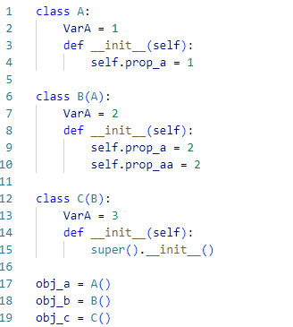
Correct selection
hasattr(obj_b, 'prop_aa')
B.VarA == 3
obj_b.prop_a == 3
Correct selection
isinstance(obj_c,A)
Overall explanation
Correct:
- hasattr(obj_b, 'prop_aa') - This is true because obj_b has the attribute prop_aa.
- isinstance(obj_c, A) - This is true because obj_c is an instance of C, and C is a subclass of A.

Incorrect:
- obj_b.prop_a == 3 - This is false because obj_b.prop_a is 2.
- B.VarA == 3 - This is false because B.VarA is 2.

Code:
- class A:
- VarA = 1
- def __init__(self):
- self.prop_a = 1

- class B(A):
- VarA = 2
- def __init__(self):
- self.prop_a = 2
- self.prop_aa = 2

- class C(B):
- VarA = 3
- def __init__(self):
- super().__init__()

- obj_a = A()
- obj_b = B()
- obj_c = C()

- print(obj_b.prop_a == 3)
- print(hasattr(obj_b, 'prop_aa')) # True
- print(isinstance(obj_c,A)) # True
- print(B.VarA == 3)

Assuming that the code below has been executed successfully, which of the following expressions will always evaluate to True? (Select two answers)
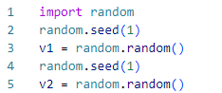
v1 >= 1
Correct selection
random.choice([1,2,3]) >=1
Correct selection
v1 == v2
len(random.sample([1,2,3],2)) > 2
Overall explanation
random.sample([1, 2, 3], 2) returns a list of 2 unique elements sampled from the list [1, 2, 3]. for example [1, 3]
The random.choice([1, 2, 3]) call will randomly select one of the elements from the list [1, 2, 3]. for example [3]
The random.seed(1) call ensures that random.random() generates the same number each time the seed is set to 1.

Correct:
- v1 == v2 - Ensured by setting the same seed before generating each value.
- random.choice([1,2,3]) >= 1 - Always true as all elements in the list are >= 1.

Incorrect:
- len(random.sample([1,2,3],2)) > 2 - This will always be False because the length will always be 2.
- v1 >= 1 - This will always be False because v1 is in the range [0.0, 1.0).

Code:
- import random
- random.seed(1)
- v1 = random.random()
- random.seed(1)
- v2 = random.random()
- print("v1: ",v1)
- print("v2:",v2)
- print("random.sample([1,2,3],2): ", random.sample([1,2,3],2))
- print("random.choice([1,2,3]): ", random.choice([1,2,3]))

- print("-----------------------")
- print("True or False ?")
- print("-----------------------")
- print("len(random.sample([1,2,3],2)) is ",len(random.sample([1,2,3],2)) > 2) # False
- print("v1==v2 is ",v1==v2) # True
- print("random.choice([1,2,3]) >=1) is ", random.choice([1,2,3]) >=1) # True
- print("v1 >= 1 is ",v1 >= 1) # False

