Question 1Incorrect
Question code 1-16:
Assuming that the snippet below has been executed successfully, which of the following expressions will evaluate to True? (Select two answers)

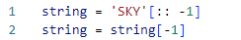
Correct selection
string[0] == string[-1]
Your selection is correct
len(string) == 1
string is None
string[0] == 'Y'
Overall explanation
First line: string = 'SKY'[:: -1]
- The slice [:: -1] reverses the string 'SKY'.
- So, string becomes 'YKS'.

Second line: string = string[-1]
- string[-1] accesses the last character of the string 'YKS'.
- So, string becomes 'S'.

Correct:
- string[0] == string[-1] - Since string is 'S', both string[0] and string[-1] are 'S'.
- len(string) == 1 - The length of string (which is 'S') is 1.

Incorrect:
- string is None - string is 'S', not None.
- string[0] == 'Y' - string[0] is 'S', not 'Y'

Code:
- string = 'SKY'[:: -1]
- print(string) # 'YKS'
- string = string[-1]

- print(string) # s
- print(string[0]) # s
- print(string[-1]) # s
Resources
Domain
Strings
Question 2Correct
Question code 1-22:
With regards to the directory structure below, select the proper forms of the directives in order to import module_a (Select two answers)
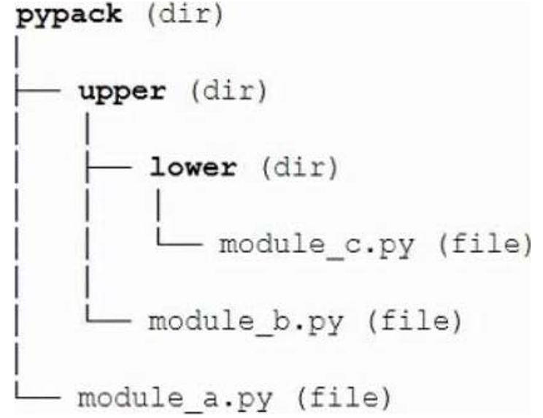
Your selection is correct
import pypack.module_a
import module_a
import module_a from pypack
Your selection is correct
from pypack import module_a
Overall explanation
Correct:
- import pypack.module_a - This imports module_a using the full package path.
- from pypack import module_a - This imports module_a directly from the pypack package.

Incorrect:
- import module_a from pypack - This is incorrect syntax. The correct form would be from pypack import module_a.
- import module_a - This would only work if module_a.py were in the same directory as the importing script and not part of a package.
Domain
Modules and Packages
Question 3Correct
Question code 1-15:
Which of the following statements are true? (Select two answers)
Your selection is correct
Python strings can be concatenated
Python strings are mutable
Python strings are actually lists
Your selection is correct
Python strings can be sliced like lists
Overall explanation
Correct:
- Python strings can be concatenated - Python strings can be combined using the + operator.
- Python strings can be sliced like lists - Python strings support slicing to extract substrings.

Incorrect:
- Python strings are actually lists - Python strings are a distinct data type, not lists.
- Python strings are mutable - Python strings are immutable and cannot be changed after creation.
Resources
Domain
Strings
Question 4Correct
Question code 1-35:
Assuming that the following snippet has been successfully executed, which of the equations are True? (Select two answers)
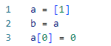
b[0] - 1 == a[0]
a[0] - 1 == b[0]
Your selection is correct
a[0] == b[0]
Your selection is correct
len(a) == len(b)
Overall explanation
Correct:
- len(a) == len(b) - This is true because both a and b reference the same list, which has a length of 1.
- a[0] == b[0] - This is true because both a[0] and b[0] are 0.

Incorrect:
- a[0] - 1 == b[0] - This is false because 0 - 1 is -1, which is not equal to 0.
- b[0] - 1 == a[0] - This is false because 0 - 1 is -1, which is not equal to 0.

Code:
- a = [1]
- b = a
- a[0] = 0

- print(a) # [0]
- print(b) # [0]

- print(len(a) == len(b)) # True
- print(a[0]-1 == b[0]) # False
- print(a[0] == b[0]) # True
- print(b[0]-1 == a[0]) # False
Resources
Domain
Strings
Question 5Correct
Question code 1-04:
Which of the following statements are True? (Select two answers)
Your selection is correct
open() is a function which returns an object that represents a physical file
instd, outstd, errstd are the names of pre-opened streams
open() requires a second argument
Your selection is correct
if invoking open() fails, an exception is raised
Overall explanation
Correct:
- open() is a function which returns an object that represents a physical file - The open() function returns a file object for reading or writing to a file.
- if invoking open() fails, an exception is raised - The open() function raises an exception (e.g., OSError) if it cannot open the file.

Incorrect:
- open() requires a second argument - The open() function does not require a second argument; it defaults to 'r' (read mode) if not provided.
- instd, outstd, errstd are the names of pre-opened streams - The correct names for the pre-opened standard streams are stdin, stdout, and stderr.
Resources
Domain
Miscellaneous
Question 6Correct
Question code 1-30:
What is true about Python class constructors? (Choose two)
Your selection is correct
the constructor is a method named __init__
Your selection is correct
the constructor must have at least one parameter
the constructor must return a value other than None
there can be more than one constructor in a Python class
Overall explanation
Correct:
- the constructor is a method named init - This is true because __init__() is the constructor method in Python.
- the constructor must have at least one parameter - This is true because the self parameter is required to refer to the instance being initialized.

Incorrect:
- there can be more than one constructor in a Python class - This is false because a class can have only one __init__() method.
- the constructor must return a value other than None - This is false because the __init__() method should not return any value. It implicitly returns None.
Resources
Domain
Object-Oriented Programming
Question 7Correct
Question code 1-20:
What is the expected output of the following snippet?
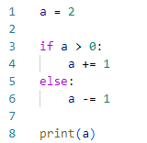
Your answer is correct
3
1
the code is erroneous
2
Overall explanation
Correct:
- 3 - The if condition is true (a is 2), so a is incremented by 1, resulting in 3.

Incorrect:
- 1 - This is incorrect because it would only occur if a was initially less than or equal to 0 and the else block executed.
- 2 - This is incorrect because a is modified by the if block, not remaining 2.
- the code is erroneous - This is incorrect because the code executes without any errors.

Code:
- a = 2

- if a > 0:
- a += 1
- else:
- a -= 1

- print(a)
Resources
Domain
Miscellaneous
Question 8Incorrect
Question code 1-34:
Which of the listed actions can be applied to the following tuple? (Select two answers)

tup = ()
Your selection is incorrect
tup.append(0)
tup[0]
Correct selection
tup[:]
Correct selection
del tup
Overall explanation
Correct:
- tup[:] - This creates a shallow copy of the tuple.
- del tup - While valid in terms of deleting the tuple reference, it's not an action that applies directly to the tuple's content or structure, hence it's typically not considered a tuple operation.

Incorrect:
- tup.append(0) - This is invalid because tuples do not support item assignment or have an append method. It will raise AttributeError: 'tuple' object has no attribute 'append'
- tup[0] - This accesses the first element of the tuple. But in this case, the tuple is empty and this instruction will raise IndexError: tuple index out of range

Code:
- tup = ()

- tup [:]
- #tup.append (0) # AttributeError: 'tuple' object has no attribute 'append'
- #tup [0] # `IndexError: tuple index out of range`
- del tup
Resources
Domain
Miscellaneous
Question 9Correct
Question code 1-17:
What is the expected behavior of the following code?
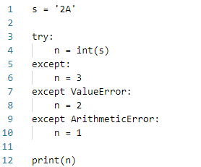
Your answer is correct
the code is erroneous and it will not execute
it outputs 2
it outputs 1
it outputs 3
Overall explanation
Correct:
- the code is erroneous and it will not execute - the code as written would not execute due to a syntax error : default 'except:' must be last.

Incorrect:
- it outputs 1 - This is incorrect because the ArithmeticError block is not reached.
- it outputs 2 - This is incorrect because the ValueError block is not reached. General except: block should have been placed at the end to allow this block to be execute and sets n to 2.
- it outputs 3 - the code causes a syntax error : default 'except:' must be last. So this block did not execute and did not sets n to 3.

Code:
- s = '2A'

- try:
- n = int(s)
- except:
- n = 3
- except ValueError:
- n = 2
- except ArithmeticError:
- n = 1

- print(n)
Resources
Domain
Exceptions
Question 10Correct
Question code 1-03:
What is the expected behavior of the following snippet?
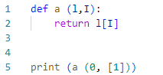
It will:
Your answer is correct
cause a runtime exception
print 1
print 0,[1]
print [1]
Overall explanation
The first element that the function is expected is the list, the the integer.
- Here, l is 0, which is an integer, not a list.
- Attempting to index an integer (0 in this case) with [1] will cause a TypeError because integers are not subscriptable.
Therefore, the expected behavior is that the code will raise a runtime exception.

Correct:
- cause a runtime exception - Attempting to subscript the integer 0 with [1] raises a TypeError.
Incorrect:
- print 1 - This is incorrect because the code does not correctly index a list.
- print 0, [1] - This is incorrect because the function call will not return these values.
- print [1] - This is incorrect because the function call will raise a TypeError.

Code:
- def a (l,I):
- return l[I]

- print (a (0, [1]))
Domain
Miscellaneous
Question 11Correct
Question code 1-19:
Which of the following statements are true? (Select two answers)
an escape sequence can be recognized by the # sign put in front of it
Your selection is correct
ASCII is the name of a character coding standard
a code point is a point inside the code when execution stops immediately
Your selection is correct
UTF-8 is one of the ways of representing UNICODE code points
Overall explanation
Correct:
- UTF-8 is one of the ways of representing UNICODE code points - UTF-8 is a widely used encoding for Unicode.
- ASCII is the name of a character coding standard - ASCII is a character encoding standard used for representing text.

Incorrect:
- a code point is a point inside the code when execution stops immediately - A code point refers to a position in the Unicode character set, not a point where code execution stops.
- an escape sequence can be recognized by the # sign put in front of it - Escape sequences are recognized by a backslash (\), not a # sign.
Resources
Domain
Strings
Question 12Correct
Question code 1-10:
What is the expected output of the following code if there is no file named non_existing_file inside the working directory?
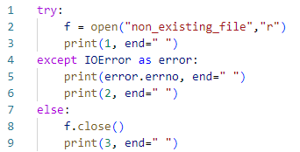

1 3
Your answer is correct
2 2
2 2 3
1 2 3
Overall explanation
Since the file does not exist, an IOError (or more specifically, a FileNotFoundError, which is a subclass of IOError) will be raised.

Correct:
- 2 2 - The except block prints 2 for error.errno and 2 for the second print statement.
Incorrect:
- 1 3 - This is incorrect because the file does not exist, so the else block is not executed.
- 1 2 3 - This is incorrect because the file does not exist, so the else block is not executed and print(1) is not executed.
- 2 2 3 - This is incorrect because the else block is not executed, so print(3) is not executed.

Code:
- try:
- f = open("non_existing_file","r")
- print(1, end=" ")
- except IOError as error:
- print(error.errno, end=" ")
- print(2, end=" ")
- else:
- f.close()
- print(3, end=" ")
Resources
Domain
Exceptions
Question 13Correct
Question code 1-32:
What is the expected output of the following code?
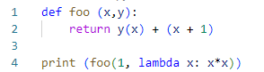
an exception is raised
Your answer is correct
3
5
4
Overall explanation
Function Call:

  - foo(1, lambda x: x*x) is called with x = 1 and y = lambda x: x*x.
  - Inside the function, y(x) is evaluated first:
    - y(1) = 1 * 1 = 1
  - Then, (x + 1) is evaluated:
    - 1 + 1 = 2
  - The function returns the sum of these two values:
    - 1 + 2 = 3
Therefore, the expected output is 3.

Correct:
- 3 - The function call foo(1, lambda x: x*x) returns 3.

Incorrect:
- 5 - This is incorrect because the evaluated sum is 3, not 5.
- 4 - This is incorrect because the evaluated sum is 3, not 4.
- an exception is raised - This is incorrect because the code executes without errors.

Code:
- def foo (x,y):
- return y(x) + (x + 1)

- print (foo(1, lambda x: x*x))
Resources
Domain
Miscellaneous
Question 14Correct
Question code 1-07:
What will the value of the i variable be when the following loop finishes its execution?

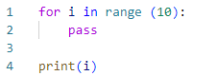
the variable becomes unavailable
11
10
Your answer is correct
9
Overall explanation
The range(10) function generates the sequence: 0, 1, 2, 3, 4, 5, 6, 7, 8, 9.
After the loop finishes, i will have the last value in the sequence, which is 9. Therefore, the print(i) statement will output: 9

Pass only means there are no statements to execute it does not means the variable is unavailable. Try a Print statement Print(i) after the For Loop and there is your result.

Correct:
- 9 - The loop iterates from 0 to 9, so i will be 9 after the loop completes.

Incorrect:
- 10 - This is incorrect because the loop stops before reaching 10.
- the variable becomes unavailable - This is incorrect because i is still available after the loop.
- 11 - This is incorrect because the loop stops before reaching 11.

Code:
- for i in range (10):
- pass

- print(i)
Resources
Domain
Miscellaneous
Question 15Skipped
Question code 1-36:
Assuming that the code below has been executed successfully, which of the following expressions evaluate to True? (Select two answers)
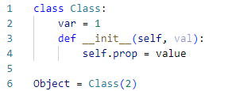
'prop' in Class.__dict__
'var' in Object.__dict __
Correct selection
'var' in Class.__dict__
Correct selection
len(Object.__dict__) == 1
Overall explanation
Correct:
- len(Object.__dict__) == 1 - This expression is true because the instance dictionary of Object contains exactly one entry : prop
- 'var' in Class.__dict__ - This expression is true because var is a class attribute and included in the class dictionary.

Incorrect:
- 'var' in Object.__dict__ - This is false because var is a class attribute, not an instance attribute.
- 'prop' in Class.__dict__ - This is false because prop is an instance attribute, not a class attribute.

Code: Let set value to 5
- class Class:
- # Class attribute
- var = 1
- def __init__(self, val):
- # Instance attributes
- self.prop = 5

- Object = Class(2)

- print('var' in Object.__dict__)
- print('prop' in Class.__dict__)
- print(len(Object.__dict__) == 1)
- print('var' in Class.__dict__)
Resources
Domain
Object-Oriented Programming
Question 16Correct
Question code 1-31:
What is the expected behavior of the following code?
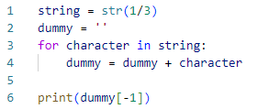
it outputs 0
it outputs 'None'
Your answer is correct
it outputs 3
it raises an exception
Overall explanation
Correct:
- it outputs 3 - The last character of the string representation of 1/3 is '3'.

Incorrect:
- it outputs 'None' - This is incorrect because the last character of the string is '3'.
- it raises an exception - This is incorrect because the code executes without errors.
- it outputs 0 - This is incorrect because the last character of the string is '3'.

Code:
- string = str(1/3)
- dummy = ''
- for character in string:
- dummy = dummy + character

- print(dummy[-1])
Domain
Strings
Question 17Skipped
Question code 1-23:
Which of the following lines of code will work flawlessly when put independently inside the add_new () method in order to make the snippet's output equal to [0, 1, 2]? (Select two answers)
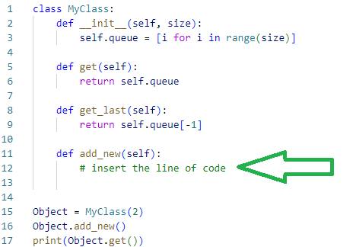
queue.append(self.get_last() + 1)
Correct selection
self.queue.append(self.queue[-1] + 1)
self.queue.append(get_last() + 1)
Correct selection
self.queue.append(self.get_last() + 1)
Overall explanation
Correct:
- self.queue.append(self.get_last()+1) - This correctly calls the get_last method and appends the next integer to queue.
- self.queue.append(self.queue[-1] + 1) - This directly accesses the last element of queue and appends the next integer.

Incorrect:
- self.queue.append(get_last()+1) - This is incorrect because get_last is not called on the self object.
- queue.append(self.get_last() + 1) - This is incorrect because queue is not defined in the current scope; it should be self.queue.

Code:
- class MyClass:
- def __init__(self, size):
- self.queue = [i for i in range(size)]

- def get(self):
- return self.queue

- def get_last(self):
- return self.queue[-1]

- def add_new(self):
- # insert the line of code

- Object = MyClass(2)
- Object.add_new()
- print(Object.get())
Domain
Object-Oriented Programming
Question 18Correct
Question code 1-40:
Which of the following statements are True? (Select two answers)
closing an open file is performed by the closefile() function
the second open() argument describes the open mode and defaults to 'w'
Your selection is correct
if open()'s second argument is 'r' the file must exist or open will fail
Your selection is correct
if open()’s second argument is 'w' and the invocation succeeds, the previous file’s content is lost
Overall explanation
Correct:
- if open( )’s second argument is ‘r’ the file must exist or open will fail - This is true because opening a file in read mode requires the file to exist.
- if open( )’s second argument is ‘w’ and the invocation succeeds, the previous file’s content is lost - This is true because opening a file in write mode truncates the file, losing any existing content.

Incorrect:
- closing an open file is performed by the closefile( ) function - This is false because the correct method is close().
- the second open( ) argument describes the open mode and defaults to ‘w’ - This is false because the default mode is 'r' (read mode).
Resources
Domain
Miscellaneous
Question 19Incorrect
Question code 1-11:
What is the expected output of the following code?
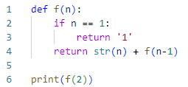
Your answer is incorrect
12
Correct answer
21
3
2
Overall explanation
Correct:
- 21 - The function f(2) evaluates to '2' + '1', resulting in '21'.

Incorrect:
- 2 - This is incorrect because the function concatenates the results recursively.
- 3 - This is incorrect because n does not reach 3 in this call sequence.
- 12 - This is incorrect because the function concatenates n in descending order, not ascending.

Code:
- def f(n):
- if n == 1:
- return '1'
- return str(n) + f(n-1)

- print(f(2))
Resources
Domain
Strings
Question 20Correct
Question code 1-13:
A property that stores information about a given class's super-classes is named:
_ancestors_
_super_
Your answer is correct
__bases__
_upper_
Overall explanation
The __bases__ attribute in Python is used to access a tuple containing the base classes of a class. It provides information about the direct parent classes from which the class inherits.

Correct:
- __bases__ - This attribute stores information about the super-classes of a given class.

Incorrect:
- _upper_ - This is not a valid attribute for storing superclass information.
- _ancestors_ - This is not a valid attribute for storing superclass information.
- _super _- This is not a valid attribute for storing superclass information.

Resources
Domain
Object-Oriented Programming
Question 21Incorrect
Question code 1-14:
Assuming that the following inheritance set is in force, which of the following classes are declared properly? (Select two answers)
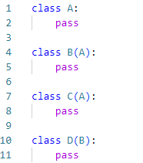
Correct selection
class Class_1(C,D): pass
class Class_3(A,C): pass
class Class_2(B,D): pass
Your selection is correct
class Class_4(D, A): pass
Overall explanation
Correct:
- Class_4(D, A) - This class is declared properly because D is already a subclass of A.
- Class_1(C, D) - This class is improperly declared becase there is no conflict. Please see the link in multiple-inheritance-in-python.

Incorrect:
- Class_3(A, C) - This class is improperly declared because the parent class A appears before its subclass C. Will create a TypeError: Cannot create a consistent method resolution order (MRO) for bases A, C
- Class_2(B, D) - This class is improperly declared because the parent class B appears before its subclass D. Will create a TypeError: Cannot create a consistent method resolution order (MRO) for bases B, D

Code:
- class A:
- pass

- class B(A):
- pass

- class C(A):
- pass

- class D(B):
- pass

- class Class_4(D,A):
- pass

- class Class_1(C,D):
- pass

- # class Class_3(A,C):
- # pass

- # class Class_2(B,D):
- # pass
Resources
Domain
Object-Oriented Programming
Question 22Incorrect
Question code 1-09:
What is the expected output of the following snippet?
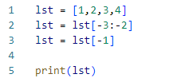
4
1
Your answer is incorrect
3
Correct answer
2
Overall explanation
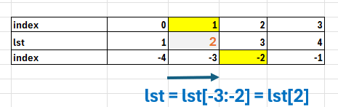

- The list lst is initially [1, 2, 3, 4].
- The slice lst[-3:-2] starts from the third last element (inclusive) and goes up to the second last element (exclusive).
- lst[-3:-2] translates to lst[1:2], which results in [2].
- Therefore, lst is now [2]. lst = [2]
- lst[-1] = 2

Correct:
- 2

Incorrect:
- 1 - This is incorrect because slicing and reassigning lst changes its value.
- 4 - This is incorrect because slicing and reassigning lst changes its value.
- 3 - This is incorrect because slicing and reassigning lst changes its value

Code:
- lst = [1,2,3,4]
- lst = lst[-3:-2]
- lst = lst[-1]

- print(lst)
Resources
Domain
Miscellaneous
Question 23Incorrect
Question code 1-02:
Assuming that the following code has been executed successfully, select the expression which evaluate to True (Select two answers)
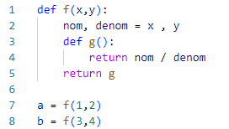
b() == 4
Your selection is correct
a != b
Correct selection
a is not None
a() == 4
Overall explanation
Correct:
- a is not None - a is a function, so it is not None. a is a function that returns 1 / 2, which is 0.5.
- a != b - a and b are different function objects.
Incorrect:
- a() == 4 - a() evaluates to 0.5, not 4.
- b() == 4 - b() evaluates to 0.75, not 4.

Code:
- def f(x,y):
- nom, denom = x , y
- def g():
- return nom / denom
- return g

- a = f(1,2)
- b = f(3,4)

- print(a() == 4) # False
- print(a is not None) # True
- print(b() == 4) # False
- print(a != b) # True
Domain
Miscellaneous
Question 24Correct
Question code 1-18:
A compiler is a program designed to? (select two answers)
rearrange the source code to make it clearer
Your selection is correct
translate the source code into machine code
execute the source code
Your selection is correct
check the source code in order to see if its correct
Overall explanation
Correct:
- check the source code in order to see if it is correct - Compilers check the source code for syntax and semantic correctness.
- translate the source code into machine code - Compilers translate source code into machine code or an intermediate form.

Incorrect:
- rearrange the source code to make it clearer - Compilers do not rearrange or format code for clarity.
- execute the source code - Compilers do not execute the source code; they only translate it. Execution is typically handled by an interpreter or runtime environment.
Resources
Domain
Modules and Packages
Question 25Incorrect
Question code 1-25:
What is the expected output of the following code?
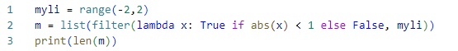
4
16
Correct answer
1
Your answer is incorrect
an exception is raised
Overall explanation
The range object myli generates the sequence of numbers: [-2, -1, 0, 1].
Applying the Filter:
- For x = -2: abs(-2) = 2, which is not less than 1, so False.
- For x = -1: abs(-1) = 1, which is not less than 1, so False.
- For x = 0: abs(0) = 0, which is less than 1, so True.
- For x = 1: abs(1) = 1, which is not less than 1, so False.
- The resulting filtered list m will be [0].

Correct:
- 1 - The filtered list contains only one element (0), so the length is 1.

Incorrect:
- 4 - This is incorrect because only one element satisfies the condition.
- 16 - This is incorrect because the length of the list cannot be 16.
- an exception is raised - This is incorrect because the code does not raise any exceptions and executes correctly.

Code:
- myli = range(-2,2)
- m = list(filter(lambda x: True if abs(x) < 1 else False, myli))
- print(len(m))
Resources
Domain
Miscellaneous
Question 26Incorrect
Question code 1-05:
Which of the equations are True? (Select two answers)
chr(chr(x)) == x
Correct selection
ord(chr(x)) == x
Your selection is correct
chr(ord(x)) == x
ord(ord(x)) == x
Overall explanation
In the provided code snippet:
- The function chr(ord(x)) == x converts a character x to its Unicode code point with ord(), and then chr() converts that code point back to the original character.
- The function ord(chr(x)) == x converts an integer x to a character with chr(), and then ord() converts it back to the integer x.
Correct:
▪ chr(ord(x)) == x — This is correct because:
- The functions ord() and chr() are inverse operations, so this equation will always be true.
▪ ord(chr(x)) == x — This is correct because:
- chr(x) converts the integer x to a character, and ord() converts it back to the integer x.
Incorrect:
▪ ord(ord(x)) == x — This is incorrect because ord() returns an integer, so calling ord() again on the result will raise an error.
▪ chr(chr(x)) == x — This is incorrect because chr() expects an integer, and passing a character will raise an error.

Example Code:
# Correct example of chr(ord(x)) == x
x = 'A'
print(chr(ord(x)) == x) # True, because ord('A') gives 65, and chr(65) gives 'A'

# Correct example of ord(chr(x)) == x
y = 65
print(ord(chr(y)) == y) # True, because chr(65) gives 'A', and ord('A') gives 65

# Incorrect example of ord(ord(x)) == x
try:
print(ord(ord(x)) == x) # This will raise a TypeError because ord() expects a character
except TypeError as e:
print(e) # Output: ord() expected string of length 1, but int found

# Incorrect example of chr(chr(x)) == x
try:
print(chr(chr(y)) == y) # This will raise a TypeError because chr() expects an integer
except TypeError as e:
print(e) # Output: an integer is required (got type str)
Resources
Domain
Strings
Question 27Correct
Question code 1-08:
What is the expected behavior of the following code?
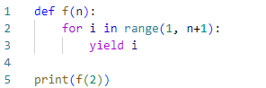

It will:
print 4321
cause a runtime exception
Your answer is correct
print <generator object f at (some hex digits)>
print 1234
Overall explanation
Correct:
- print <generator object f at (some hex digits)> - The call f(2) returns a generator object, and printing it shows the generator object's representation.

Incorrect:
- print 4321 - This is incorrect because the generator yields values one by one, not in a combined form, and the values are not printed directly by calling f(2).
- cause a runtime exception - This is incorrect because calling a generator function and printing the generator object does not cause an exception.
- print 1234 - This is incorrect because the generator yields values from 1 to n (inclusive) one by one, but they are not printed directly by calling f(2).

Code:
- def f(n):
- for i in range(1, n+1):
- yield i

- print(f(2))
Resources
Domain
Miscellaneous
Question 28Correct
Question code 1-27:
Files with the suffix .pyc contain:
Python 4 source code
temporary data
backups
Your answer is correct
semi-compiled Python code
Overall explanation
Correct:
- semi-compiled Python code - .pyc files contain compiled bytecode, which is a form of semi-compiled code that the Python interpreter can execute.

Incorrect:
- Python 4 source code - This is incorrect because .pyc files do not contain source code.
- backups - This is incorrect because .pyc files are not backup files.
- temporary data - This is incorrect because .pyc files contain compiled bytecode, not arbitrary temporary data.
Domain
Modules and Packages
Question 29Skipped
Question code 1-29:
The following class definition is given. We want the show() method to invoke the get() method, and then output the value the get() method returns.
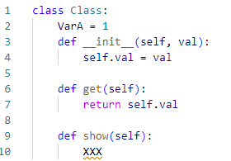
Which of the invocations should be used instead of XXX?
print(get(self))
print(get())
print(self.get(val))
Correct answer
print(self.get())
Overall explanation
Correct:
- print(self.get()) - self.get() calls the get method on the instance (self) and print outputs the value returned by get().

Incorrect:
- print(get(self)) - This is incorrect because it does not properly call the instance method.
- print(get()) - This is incorrect because it does not properly call the instance method.
- print(self.get(val)) - This is incorrect because get() does not accept any parameters.

Code:
- class Class:
- VarA = 1
- def __init__(self, val):
- self.val = val

- def get(self):
- return self.val

- def show(self):
- self.get()

- a = Class(55)
- print(a.val)
Domain
Object-Oriented Programming
Question 30Correct
Question code 1-21:
What is the output of the following piece of code?
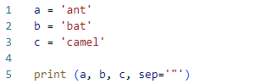
ant bat camel
Your answer is correct
ant"bat"camel
antbatcamel
ant'bat'camel
Overall explanation
The print statement will output the block values of a, b, and c separated by '"'. Therefore, the output will be: ant"bat"camel

Correct:
- ant"bat"camel

Incorrect:
- ant'bat'camel - This is incorrect because the separator is not a single quote.
- antbatcamel - This is incorrect because no separator is specified, but a separator is used in the code.
- ant bat camel - This is incorrect because the default separator (a space) is not used; a double quote is specified as the separator.

Code:
- a = 'ant'
- b = 'bat'
- c = 'camel'

- print (a, b, c, sep='"')
Resources
Domain
Strings
Question 31Skipped
Question code 1-24:
You are going to read 16 bytes from a binary file into a bytearray called data. Which lines would you use? (Select two answers)
data = binfile.read(bytearray(16))
Correct selection
data = bytearray(binfile.read(16))
Correct selection
data = bytearray(16)
bf.readinto(data)
bf.readinto(data = bytearray(16))
Overall explanation
Correct:
- data = bytearray (16); bf.readinto (data) - Initializes data as a bytearray of size 16 and reads bytes directly into it.
- data = bytearray (binfile.read (16)) - Reads 16 bytes from the file and initializes data as a bytearray containing those bytes.

Incorrect:
- data = binfile.read (bytearray (16)) - This is incorrect because bytearray(16) creates a bytearray of size 16, and binfile.read expects an integer argument specifying the number of bytes to read, not a bytearray.
- bf. readinto (data = bytearray (16)) - This is incorrect because the readinto method expects a bytearray object as an argument. The assignment data = bytearray(16) inside the method call is not valid syntax in this context.

Code:
- bf = open("abc.txt", "rb")
- data = bytearray (16)
- bf.readinto (data)

- # data = binfile.read (bytearray (16)) # TypeError: argument should be integer or None, not 'bytearray'
- # bf.readinto (data = bytearray (16)) # TypeError: BufferedReader.readinto() takes no keyword arguments

- binfile = open("abc.txt", "rb")
- data = bytearray (binfile.read (16))
Resources
Domain
Miscellaneous
Question 32Skipped
Question code 1-01:
What is the expected behavior of the following code?
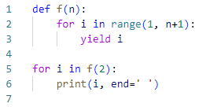
print <generator object f at (some hex digits)>
Correct answer
print 1 2
print 2 1
cause a runtime exception
Overall explanation
Correct:
- print 1 2 - The generator yields 1 and 2, which are printed in sequence.

Incorrect:
- print 2 1 - This is incorrect because the generator yields 1 and 2 in ascending order, not descending.
- cause a runtime exception - This is incorrect because there are no errors in the code.
- print <generator object f at (some hex digits)> - This is incorrect because the generator is being iterated over and its values are being printed, not the generator object itself.
Code:
- def f(n):
- for i in range(1, n+1):
- yield i

- for i in f(2):
- print(i, end=' ')
Resources
Domain
Miscellaneous
Question 33Skipped
Question code 1-28:
Assuming that the following piece of code has been executed successfully, which of the expressions evaluate to True? (Choose two)
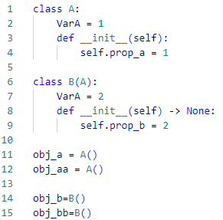
Correct selection
A.VarA == 1
B.VarA == 1
obj_a is obj_aa
Correct selection
isinstance(obj_b, A)
Overall explanation
Correct:
- isinstance(obj_b, A) - This is true because obj_b is an instance of class B, which is a subclass of A.
- A.VarA == 1 - This is true because the class variable VarA in class A is set to 1.

Incorrect:
- obj_a is obj_aa - This is false because obj_a and obj_aa are different instances of class A.
- B.VarA == 1 - This is false because the class variable VarA in class B is set to 2. The attribute VarA was override.

Code:
- class A:
- VarA = 1
- def __init__(self):
- self.prop_a = 1

- class B(A):
- VarA = 2
- def __init__(self) -> None:
- self.prop_b = 2

- obj_a = A()
- obj_aa = A()

- obj_b=B()
- obj_bb=B()

- print(isinstance(obj_b,A)) # True
- print(A.VarA == 1) # True
- print(obj_a is obj_aa) # False
- print(B.VarA == 1) # False
Resources
Domain
Object-Oriented Programming
Question 34Incorrect
Question code 1-06:
What is true about Python packages? (Select two answers)
Your selection is correct
__pycache__ is a folder that stores semi-compiled Python modules
Your selection is incorrect
a code designed to initialize a package's state should be placed inside a file named init.py
Correct selection
the sys.path variable is a list of strings
a package contents can be stored and distributed as an mp3 file
Overall explanation
Correct:
- the sys.path variable is a list of strings - sys.path is a list of strings representing the directories Python searches for modules and packages.
- pycache is a folder that stores semi-compiled Python modules - __pycache__ stores compiled bytecode files to speed up module loading.

Incorrect:
- a package contents can be stored and distributed as an mp3 file - Python packages are not stored or distributed as .mp3 files; they use formats like .py, .pyc, .zip, or .tar.gz.
- a code designed to initialize a package's state should be placed inside a file named init.py - The correct filename is __init__.py (with double underscores).
Domain
Modules and Packages
Question 35Correct
Question code 1-12:
An operator able to perform bitwise shifts is coded as: (select two answers)
Your selection is correct
<<
Your selection is correct
>>
--
++
Overall explanation
Correct:
- << - The left shift operator.
- >> - The right shift operator.

Incorrect:
- - - - This is not a valid operator for bitwise shifts.
- ++ - This is not a valid operator for bitwise shifts and is not used in Python (it is not a valid increment operator in Python either).
Resources
Domain
Miscellaneous
Question 36Correct
Question code 1-39:
What can you do if you don’t like a long package path like this one?
Your answer is correct
you can make an alias for the name using the as keyword
you can make an alias for the name using the alias keyword
you can shorten it to alpha.zeta and Python will find the proper connection
nothing, you need to come to terms with it
Overall explanation
import alpha.beta.gamma.delta.epsilon.zeta as zeta
After this import statement, you can use zeta to refer to alpha.beta.gamma.delta.epsilon.zeta.

Correct:
- you can make an alias for the name using the as keyword - This is the correct method to create a shorter alias for a long package path.

Incorrect:
- you can make an alias for the name using the alias keyword - This is incorrect because there is no alias keyword in Python.
- nothing, you need to come to terms with it - This is incorrect because Python provides a way to create aliases.
- you can shorten it to alpha.zeta and Python will find the proper connection - This is incorrect because the full path is required unless an alias is used.

Resources
Domain
Modules and Packages
Question 37Correct
Question code 1-33:
You are going to read just one character from a stream called s. Which statement would you use?
ch = read(s, 1)
Your answer is correct
ch = s.read(1)
ch = s.input(1)
ch = input(s, 1)
Overall explanation
Explanation:
- The read() method of a file-like object in Python reads the specified number of bytes or characters from the stream. By passing 1 as the argument to s.read(1), it will read one character from the stream s.
Correct:
- ch = s.read(1) - This statement correctly reads one character from the stream s.

Incorrect:
- ch = read(s, 1) - This is incorrect because read() should be called as a method on the stream object s, not as a standalone function.
- ch = s.input(1) - This is incorrect because input() is not a method of file-like objects for reading characters from a stream.
- ch = input(s, 1) - This is incorrect because input() is a built-in function used to get input from the user, not to read from a stream.
Resources
Domain
Miscellaneous
Question 38Correct
Question code 1-38:
What is the expected behavior of the following code?
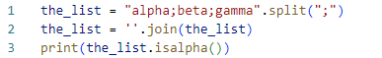
Your answer is correct
it outputs True
it raises an exception
it outputs nothing
it outputs False
Overall explanation
"alpha;beta;gamma".split(";") --> result in the list ['alpha', 'beta', 'gamma'].
''.join(the_list) ---> results in the_list being the string 'alphabetagamma'.

Correct:
- it outputs True - The final string 'alphabetagamma' contains only alphabetic characters, so the_list.isalpha() returns True.

Incorrect:
- it raises an exception - This is incorrect because the code does not raise any exceptions.
- it outputs False - This is incorrect because the final string is composed entirely of alphabetic characters.
- it outputs nothing - This is incorrect because the print statement will output True.

Code:
- the_list = "alpha;beta;gamma".split(";")
- print(the_list) # ['alpha', 'beta', 'gamma']
- the_list = ''.join(the_list)
- print(the_list) # alphabetagamma
- print(the_list.isalpha()) # True
Resources
Domain
Strings
Question 39Incorrect
Question code 1-37:
You need data which can act as a simple telephone directory. You can obtain it with the following clauses (choose two relevant variants; assume that no other items have been created before)
dir={Mom:5551234567, Dad:5557654321}
Your selection is correct
dir={'Mom':5551234567, 'Dad':5557654321}
Correct selection
dir={'Mom':'5551234567', 'Dad':'5557654321'}
dir={Mom:'5551234567', Dad:'5557654321'}
Overall explanation
Correct:
- A. dir={'Mom':5551234567, 'Dad':5557654321} - This is correct as it creates a dictionary with integer
- B. dir={'Mom':'5551234567', 'Dad':'5557654321'} - This is correct as it creates a dictionary with string.

Incorrect:
- C. dir={Mom:5551234567, Dad:5557654321} - This is incorrect because Mom and Dad are not predefined variables.
- D. dir={Mom:'5551234567', Dad:'5557654321'} - This is incorrect because Mom and Dad are not predefined variables.

Code:
- dir={'Mom':5551234567, 'Dad':5557654321}
- dir={'Mom':'5551234567', 'Dad':'5557654321'}
- #dir={Mom:5551234567, Dad:5557654321} # NameError: name 'Mom' is not defined
- #dir={Mom:'5551234567', Dad:'5557654321'} # NameError: name 'Mom' is not defined
Resources
Domain
Miscellaneous
Question 40Skipped
Question code 1-26:
What is the expected behavior of the following code?
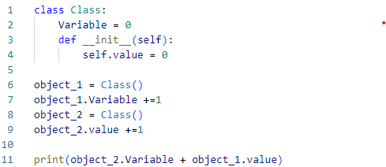
it raises an exception
it outputs 2
it outputs 1
Correct answer
it outputs 0
Overall explanation
In General, Class variables (like Variable in this case ) serve as shared attributes across all instances of a class, providing a centralized means for managing data common to the entire class. On the other hand, instance variables (like value in this case) encapsulate unique characteristics for each object, maintaining individuality.
But Class Variable must be changed by the class itself, not by the instance of the class. For example, object_1 and object_2 can not change the value of the Class variable Variable.

So the line object_1.Variable += 1 in fact, create an instance variable Variable that is unique for object_1. It does not correspond to the Class variable Variable. Therefore object_2.Variable will remain 0.

To better understand, test the code below and check the resource link as well.

Correct:
- it outputs 0 - The class variable object_2.Variableis 0, and the instance variable object_1.value is 0, so their sum is 0.
Incorrect:
- it outputs 1 - This is incorrect because The class variable object_2.Variableis 0, and the instance variable object_1.value is 0, so their sum is 0.
- it raises an exception - This is incorrect because the code does not raise any exceptions and executes correctly.
- it outputs 2 - This is incorrect because the sum of object_2.Variable (0) and object_1.value (0) is 0, not 2.

Code:
- class Class:
- Variable = 0
- def __init__(self):
- self.value = 0

- object_1 = Class()
- object_1.Variable +=1
- object_2 = Class()
- object_2.value +=1

- print(object_2.Variable + object_1.value)

