Experiment: Create a Scrum Project in Jira
AIM
To create a Scrum project in Jira, add and prioritize backlog items, create a one-week sprint, start the sprint, and monitor task progress using the sprint board.
PROCEDURE
- Open Jira in a web browser and log in to your account.
- Navigate to Projects and create a new project named HospitalCare.
- Select the Scrum project template.
- Open the Backlog section.
- Create the following five backlog items:
  - Create user registration page.
  - Develop API for login.
  - Design database for patients.
  - Implement appointment booking.
  - Create dashboard for doctor.
- Set priorities for the backlog items as High, Medium, or Low.
- Create a new sprint named Sprint 1 with a duration of one week.
- Move all five backlog items into the sprint.
- Click Start sprint and set the sprint duration to one week.
- Open the Active Sprints section to view the sprint board.
- Move tasks between the To Do, In Progress, and Done columns according to their actual progress.
- Capture screenshots of the sprint board at the start and at the end of the sprint.
OUTPUT
Screenshot 1: Sprint Board at the Start
The HospitalCare Scrum project displays five prioritized tasks in Sprint 1. The sprint is started, and the tasks are initially in the To Do column.
Screenshot 2: Sprint Board at the End
The sprint board displays the final status of the five tasks. Completed tasks appear in the Done column, while unfinished tasks remain in their respective columns.
RESULT
Thus, a Scrum project named HospitalCare was created in Jira. Five backlog items were added and prioritized, a one-week sprint was created and started, and task progress was tracked using the sprint board.
Output Screenshot 1 – Sprint at the Start: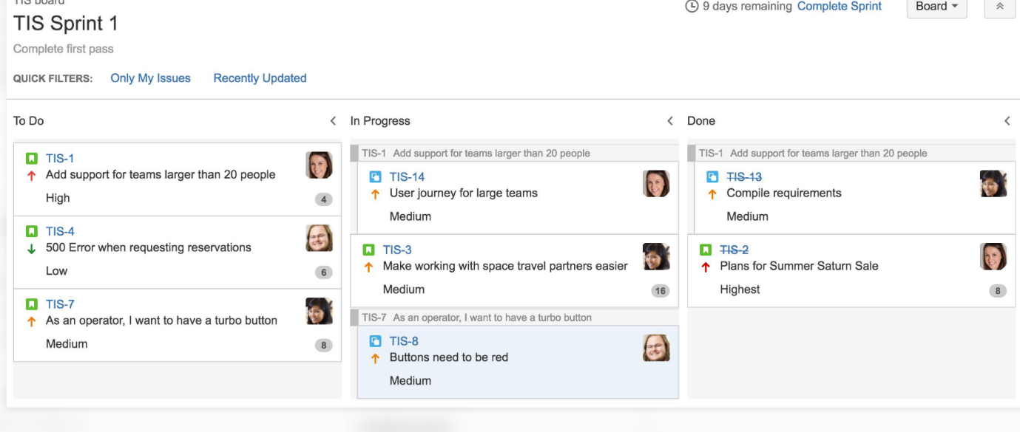
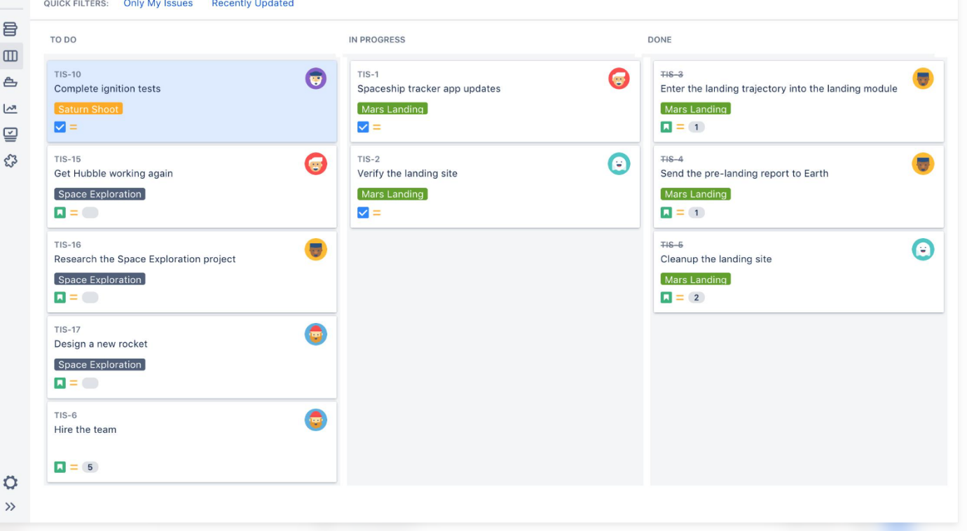
Output Screenshot 2 – Sprint at the End:

