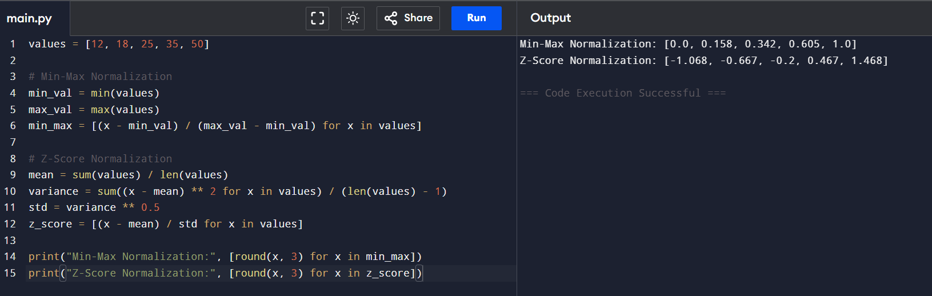
Min-Max Normalization and Z-Score Normalization Using R Programming

