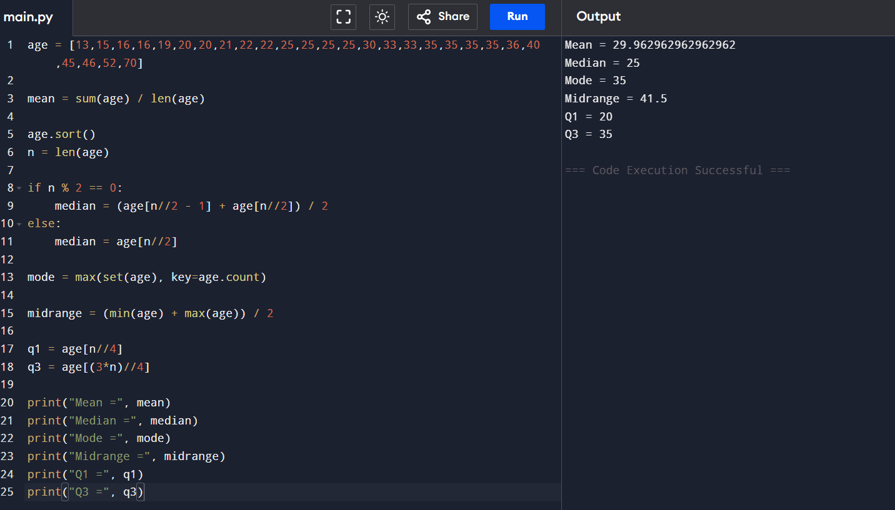
Measures of Central Tendency and Dispersion Using R Programming

