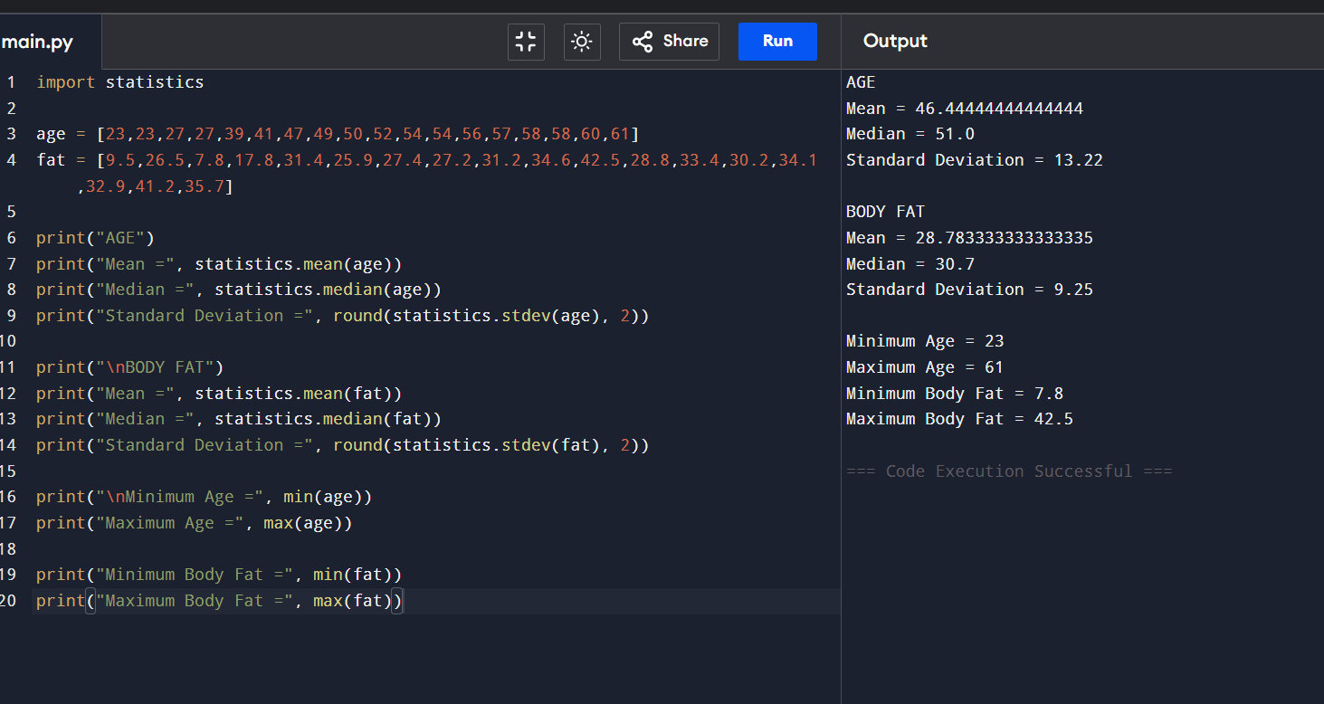
Descriptive Statistics, Box Plot, Scatter Plot, QQ Plot, and Normal Q-Q Plot

