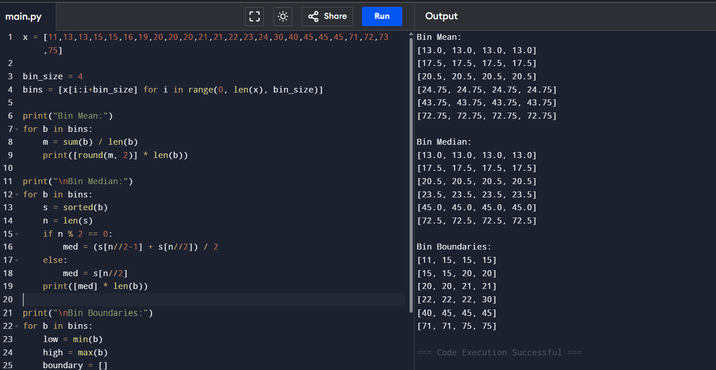
Implementation of Data Binning Using Mean, Median, and Bin Boundaries

