데이터사이언스

**DBSCAN implement assignment**

**2013011800** 구장회

**#** 순서

1. **data structure - DBSCAN,Pair,Point class**
2. **summary of algorithm**
3. **instruction for compiling**

**[**주의**]**

**[**모든스크린샷은첨부되어있음**]**

**[**실제로는 **dbscan package**에넣었지만**,** 제출시에는 **default package**로했음**]**

**[**실행파일은 **jar**파일로첨부했음**]**

**# data structure**

**[DBSCAN class]**

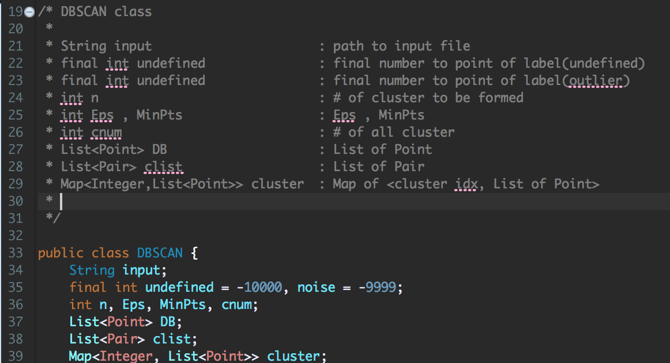

**[Pair class]**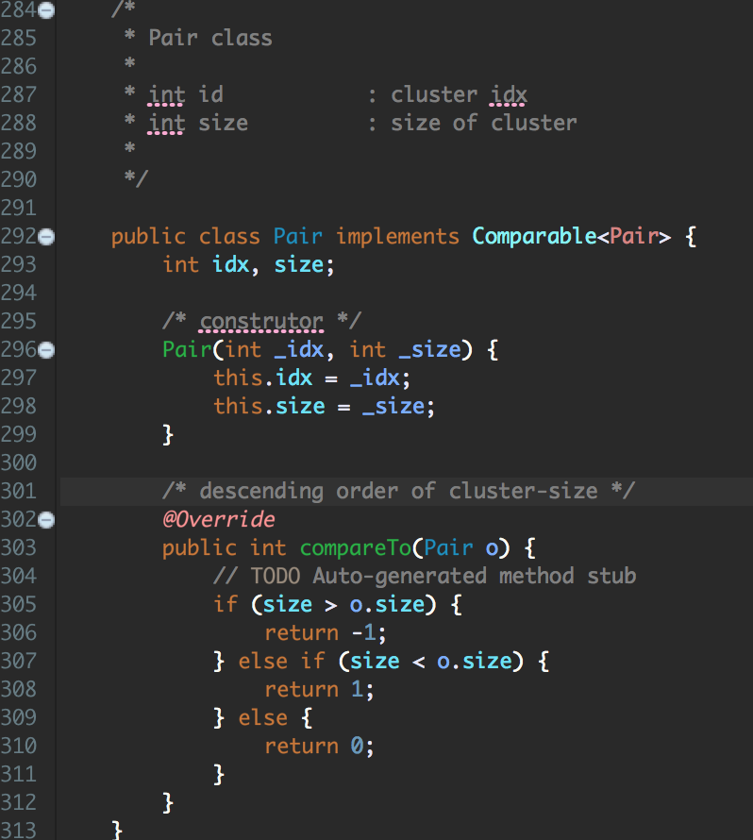

**[Point class]**

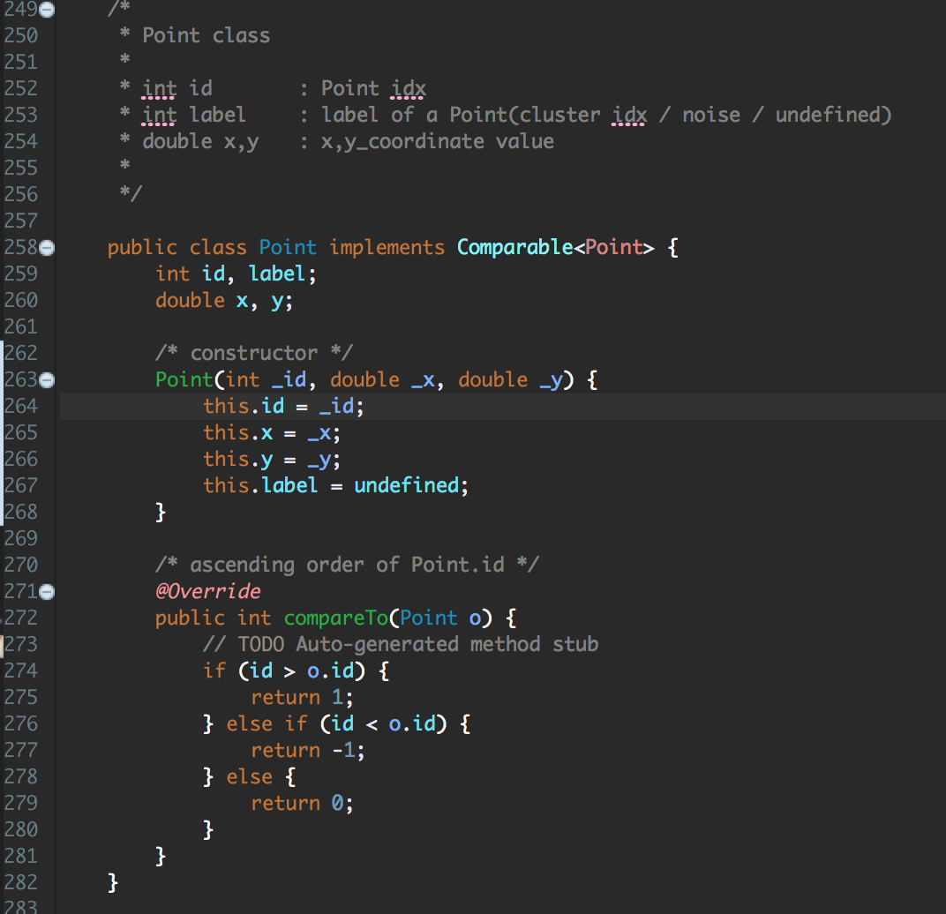

**# summary of algorithms(flow)**

**[main method]**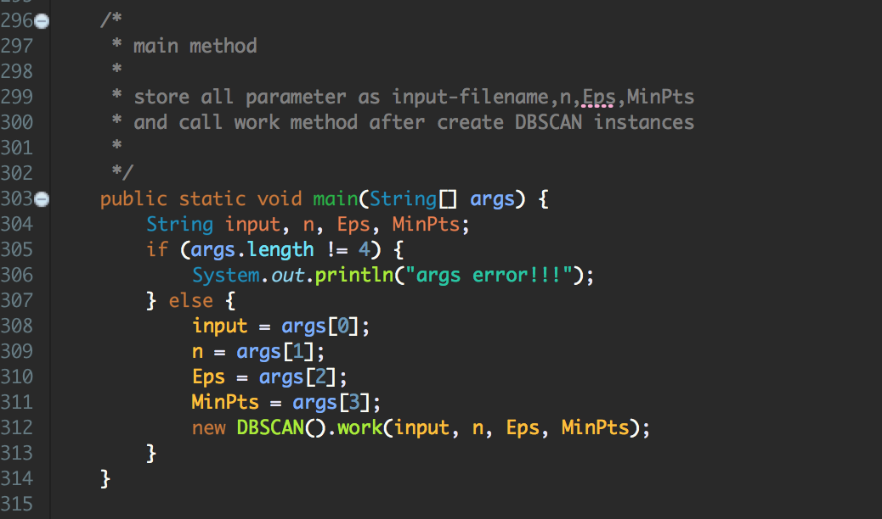

**[main workflow]**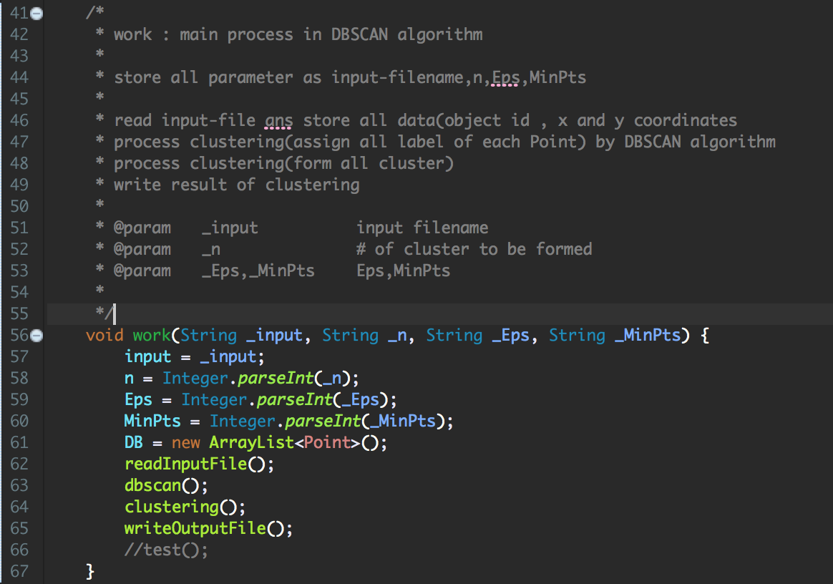

**# summary of algorithms(implemetation details)**

/*

* DBSCAN algorithm : assign all label of each Point

*

* for all Point which has no label,

*

* retrieve neighbor of the Point as set.

* if neighbor's size < MinPts, then assign label as noise.

* if not, the point being core-point.

* so increment cluster idx(cnum).

* and enqueue all neighbor except core-point.

*

* for all Point in queue,

*

* if the Point's label is noise,

* then assign label as same cluster idx before.

* if the Point's label is undefined,

* then continue.

* enqueue all neighbor of the Point which are dense.

*

*/

void dbscan() {}(

/*

* clustering : form all cluster

*

* make clist as list<(cluster-idx,size of cluster)>.

* make cmap as map<cluster-idx,list of Points>.

*

*/

void clustering() {}() {

/*

* write clustering result in output file

*/

void writeOutputFile {}

/*

* RangeQuery : find neighbor

*

* for all Point q,

* if dist(p,q) <= Eps, add to set of Point(neighbor)

*

* return set of neighbors

*

*

* @param p Point as a center.

* @return Set<Point> set of neighbors

*/

Set<Point> RangeQuery(Point p) {}

{ /*

* read inputfile

*/

void readInputFile {}) {

/*

* distance between two Points as Euclidean distance in 2d.

*

*/

double dist(Point p, Point q) {}

**# instruction for compiling**

**[Envoirments]**

**OS : Mac OS**

**Language : java**

**[Screenshot-**실행전**]**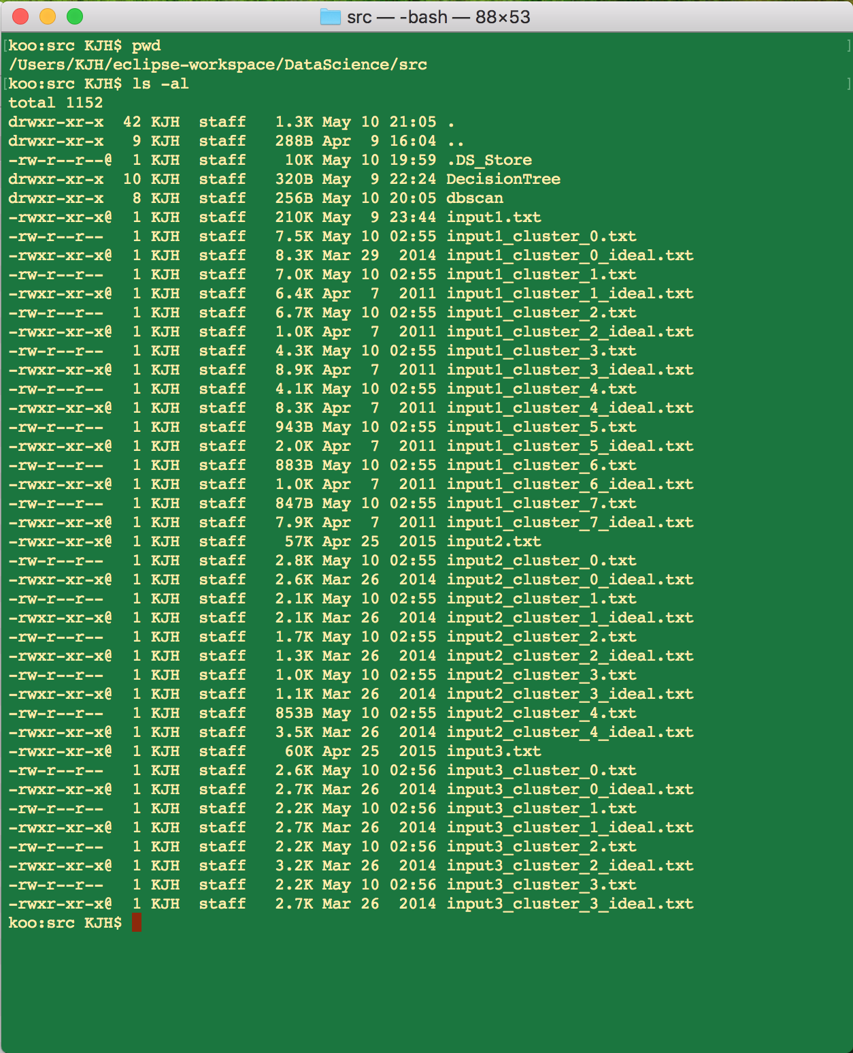

**[screenshot-**컴파일**,**실행**]**

컴파일 **: $ javac dbscan/DBSCAN.java**

실행 **: $ java dbscan/DBSCAN [inputfile] [n] [Eps] [MinPts]**