데이터사이언스

**Recommender**

**2013011800** 구장회

**#** 순서

1. **data structure - recommender,BPRRecommender,SparseMatrix,DenseMatrix,Node**
2. **summary of algorithm(flow)**
3. **summary of algorithm(other crucial method)**
4. **instruction for compiling**
5. **any other specification**

**# data structure**

**[BPRRecommender]**

* 목적
* **BPR-MF**를통해서 **all unrated user-item pair**의 **pre-use preference**를예측한다**.**
* 예측된 **pre-use preference**의상위 **20%**를 **neutral item**으로분류한다**.**
* 이를 **netrainMatrix**로만들어서 **return**한다**.**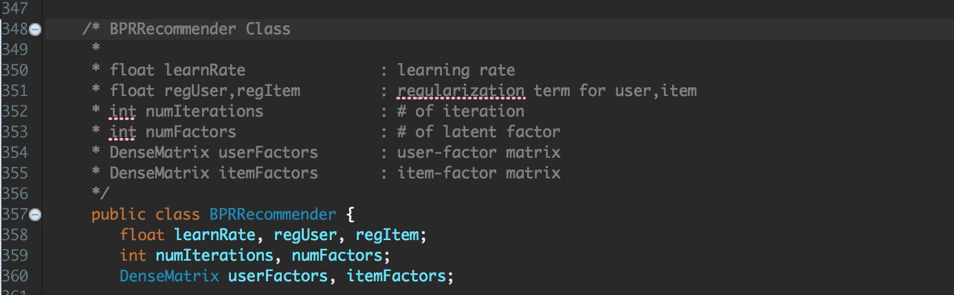

**[Node]**

* 목적

**- user, item ,rating**을묶어서저장하고**, rating**의내림차순으로정렬하기위함

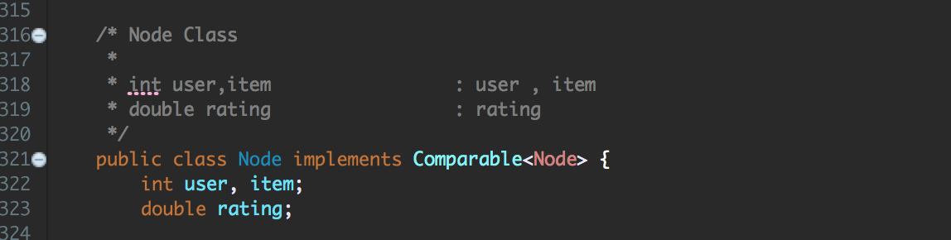

**[recommender]**

* 목적

**- item** 분류

* + **observed rating**으로만들어진 **trainMatrix**를 **interesting item**
  + **BPRRecommender**로부터만들어진 **netrainMatrix**를 **neutral item**
  + 나머지 **item**은 **uninteresting item**

**- BPR concept**에서 **interesting > neutral > uninteresting** 을각각학습하여 **all unrated user-item pair**에대해서 **post-use preference**를예측한다**.**

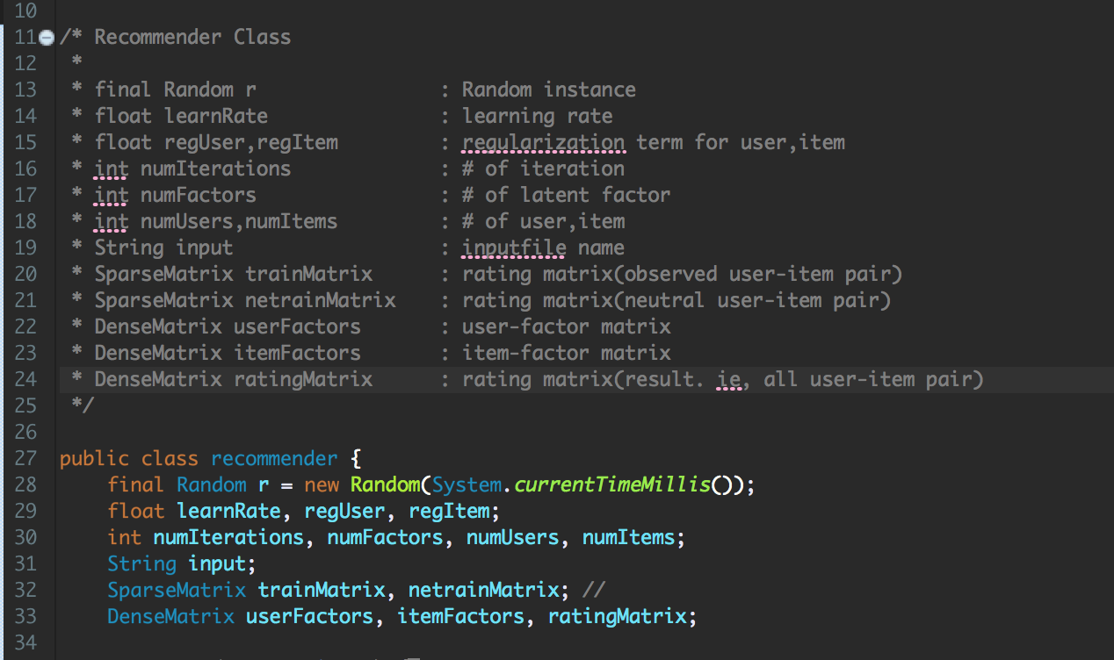

**[SparseMatrix class]**

* 목적

**- user-item pair**의 **rating matrix**를구성하기위함

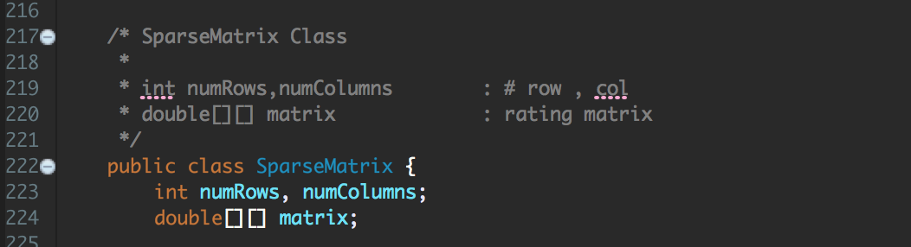

**[DenseMatrix class]**

* 목적

**- user, item factor matrix**를구성하기위함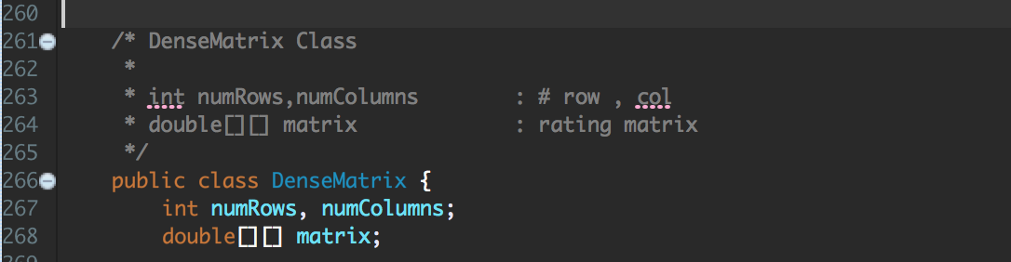

**# summary of algorithms(flow)**

**[main method]**

* 인자로 **training, test filename**을받고**,**
* **recommender class**의 **instance**를만들고**, work() method**에 **training filename**을인자로주면서호출한다**.**

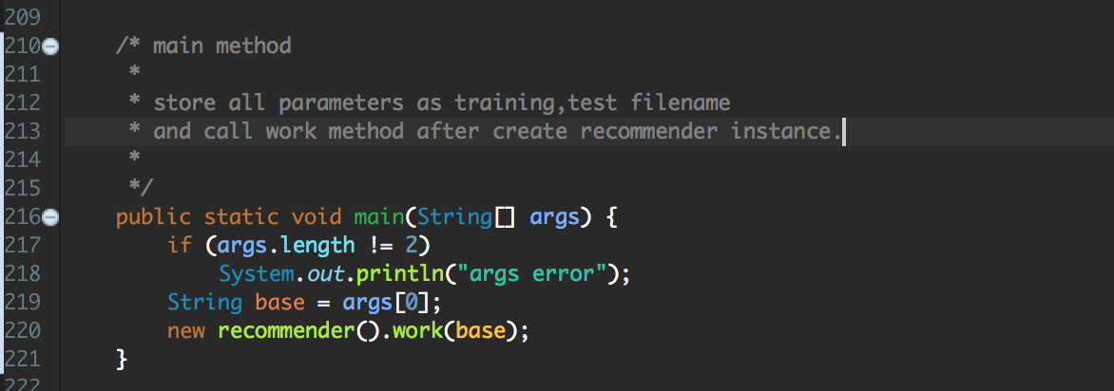

**[main workflow]**

* **BuildTrainMatrix()**
  + **training file**을읽어서 **observed user-item pair**를 **rating matrix**로구성한다**.**
* **BPRRecommender class**의 **instance(bprrecommender)**를생성
* **bprrecommender.recommend()**
  + **BPR-MF**를통해 **all unrated user-item pair**의 **pre-use preference**를예측하고**,** 유사도상위 **20%**의 **pair**로구성된 **netrainMatrix**를 **return**한다**.**
* **setup() :** 변수들의초기화
* **trainModel() :** 모델을 **training**
* **buildRatingMatrix() :** 예측된 **all-user item pair**를 **output file**에쓴다**.**

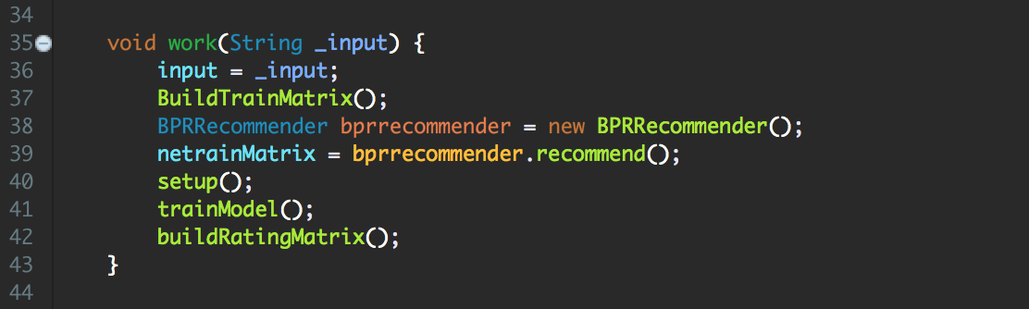

**# summary of algorithms(other crucial method)**

**[BPRRecommender]**

* **recommend()**
  + **setup() method**를호출하고
  + **trainModel() method**를호출한뒤리턴된 **netrainMatrix**를 **return**한다**.**
* **setup()**
  + 변수들의초기화
  + **userFactors,itemFactors matrix**의선언과초기화
* **trainModel() : BPR-MF**를그대로사용**.** 추가적으로 **netrainMatrix** 구성
  + **intuition : observed rating > unrated rating**

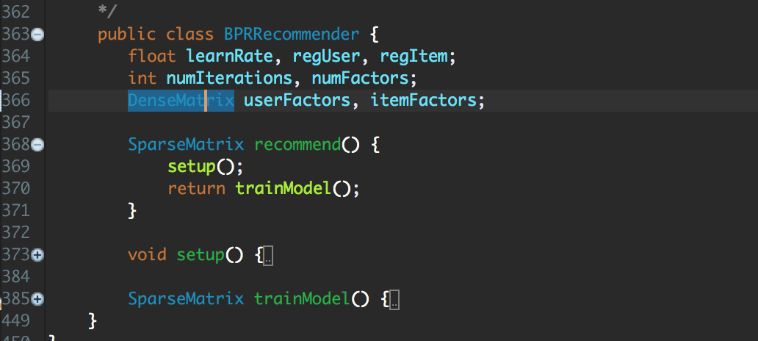

**[recommender]**

* **work() : main flow**
* **BuildTrainMatrix() : input file**을읽어 **observed rating matrix**구성
* **setup() :** 변수들의초기화
* **trainModel() : BPR**컨셉에서변형된 **objective-function**을사용하여학습
  + **intuition : interesting > neutral > uninteresting item**
* **buildRatingMatrix() : user factor** 와 **item factor**를 **mult**한 **matrix**를생성하여 **output file**에씀**.**

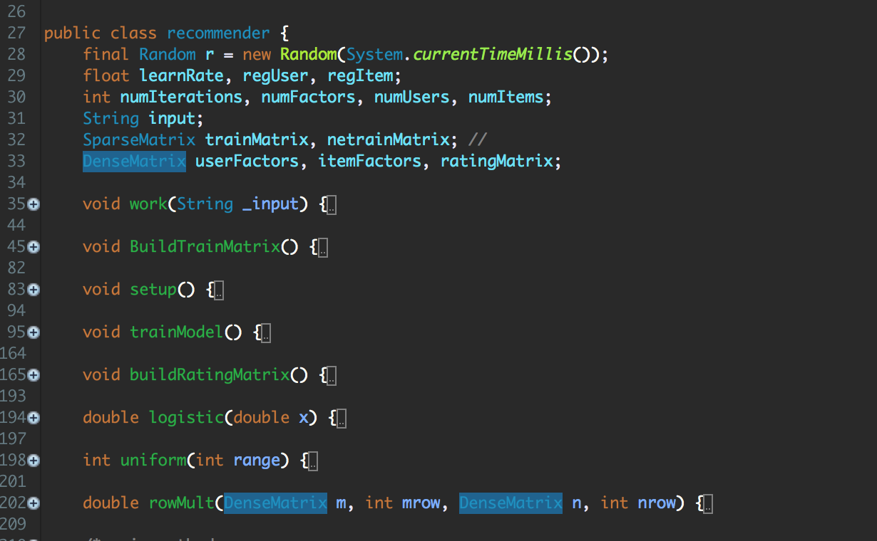

**# instruction for compiling**

**[Envoirments]**

**OS : Mac OS**

**Language : java**

**[Screenshot-**실행전**]**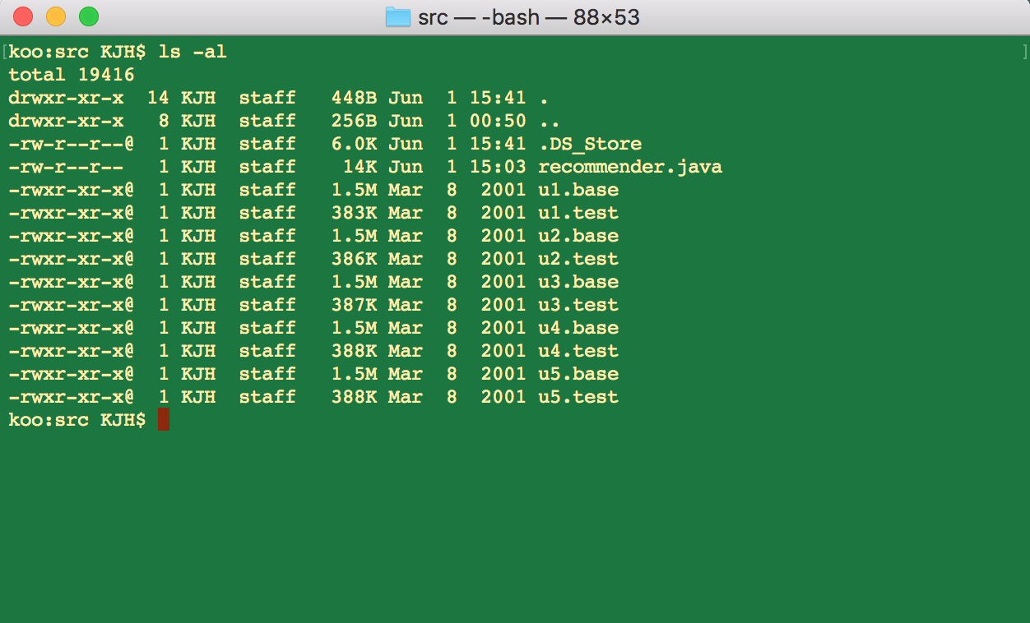

**[screenshot-**컴파일**,**실행**]**

컴파일 **: $ javac recommender.java**

실행 **: $ java recommender [basefile] [testfile]**

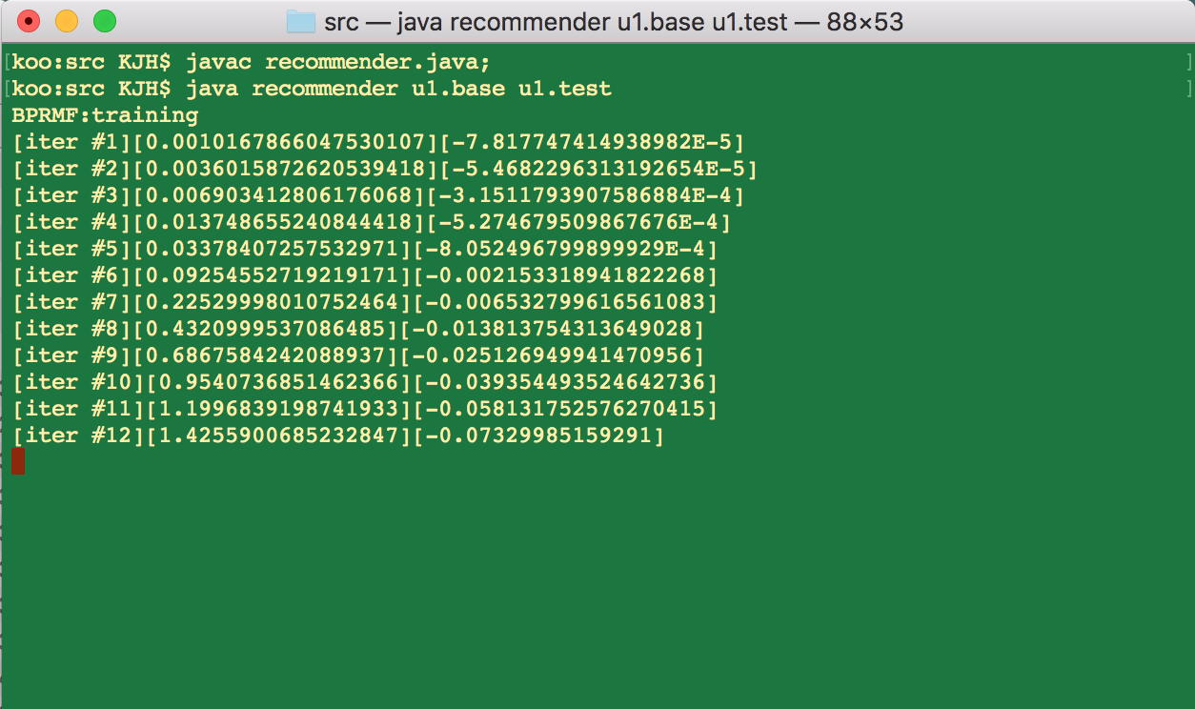

**# any other specification**

**[**참고**]**

* 모든스크린샷은첨부되어있음
* **recommender.java**는 **default package**로되어있음

**[**아이디어**]**

김상욱교수님에게추천시스템관련하여졸업프로젝트를진행하고있습니다**.**

기존추천기술에대한공부를하고있고**,** 새로운추천모델을고안하고구현하는시행착오를통해성능향상이있었던방법을과제에사용하였습니다**.**

**[**구현**]**

기본적인자료구조**(SparseMatrix,DenseMatrix)** 와 **BPR-MF**는추천라이브러리 **Librec**에서참고하였습니다**.**