Ping Utility Analysis

# 1. Ping Basics

The ping utility is used to test the reachability of a host on an IP network. It measures the round-trip time for messages sent from the originating host to a destination computer.

Basic Syntax:

ping [options] destination

Examples:

ping www.google.com

ping 10.15.7.178 (this is local server)

# 2. Ping Output Analysis

Running the Ping Command:  
ping outlook.com

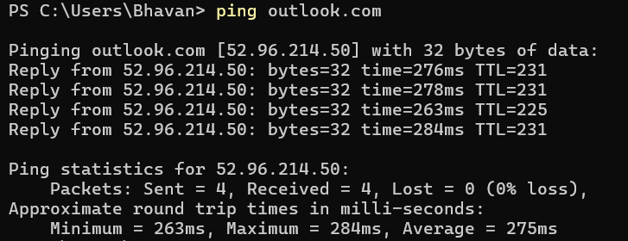

1. **Pinging outlook.com [52.96.214.50] with 32 bytes of data:**: Indicates that 32-byte packets are being sent to the IP address 52.96.214.50 (associated with outlook.com).

2. **Reply from 52.96.214.50: bytes=32 time=276ms TTL=231**: Confirms a successful reply from 52.96.214.50 with a round-trip time of 276 ms and a TTL of 231.

3. **Reply from 52.96.214.50: bytes=32 time=278ms TTL=231**: Indicates another successful reply with a round-trip time of 278 ms and the same TTL of 231.

4. **Reply from 52.96.214.50: bytes=32 time=263ms TTL=225**: Indicates a successful reply with a faster round-trip time of 263 ms and a lower TTL of 225.

5. **Reply from 52.96.214.50: bytes=32 time=284ms TTL=231**: Indicates a successful reply with a round-trip time of 284 ms and a TTL of 231.

6. **Ping statistics for 52.96.214.50:**: Introduces a summary of the ping test results.

7. **Packets: Sent = 4, Received = 4, Lost = 0 (0% loss),**: Confirms that all 4 packets were sent and received with no packet loss.

8. **Approximate round trip times in milli-seconds:**: Prepares to list the minimum, maximum, and average round-trip times.

9. **Minimum = 263ms, Maximum = 284ms, Average = 275ms**: Indicates that the round-trip times varied from 263 ms to 284 ms, with an average of 275 ms.

Local Host Analysis:  
ping 10.15.7.178

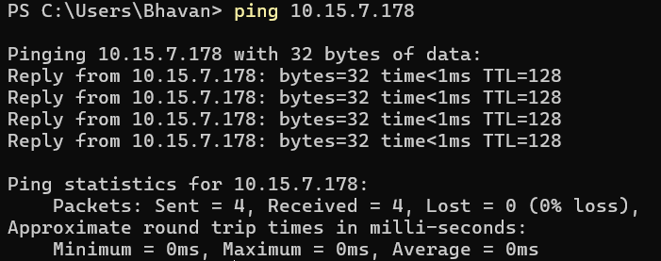

1. **ping 10.15.7.178**: Initiates a ping test to the IP address 10.15.7.178.

2. **Pinging 10.15.7.178 with 32 bytes of data:**: Indicates that 32-byte packets are being sent to 10.15.7.178.

3. **Reply from 10.15.7.178: bytes=32 time<1ms TTL=128**: Confirms a successful reply from 10.15.7.178 with a round-trip time of less than 1 ms and a TTL of 128.

4.**(Repeated 4 times)**: Indicates that all 4 sent packets received replies with the same time and TTL values.

5. **Ping statistics for 10.15.7.178:**: Introduces a summary of the ping test results.

6. **Packets: Sent = 4, Received = 4, Lost = 0 (0% loss),**: Confirms that all 4 packets were sent and received with no packet loss.

7. **Approximate round trip times in milli-seconds:**: Prepares to list the minimum, maximum, and average round-trip times.

8. **Minimum = 0ms, Maximum = 0ms, Average = 0ms**: Indicates that the round-trip times were extremely fast, all measuring 0 milliseconds.

# 3. Ping Options

- -c (count): Specifies the number of packets to send.

In windows we use -n (count) instead of -c   
Example: ping -n 5 [google.com](http://www.google.com)

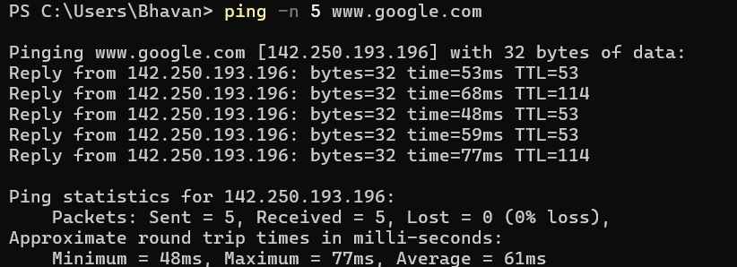

- -s (size): Sets the size of the packet to be sent.

In windows we use -l instead of -s   
Example: ping -l 64 [www.google.com](http://www.google.com)

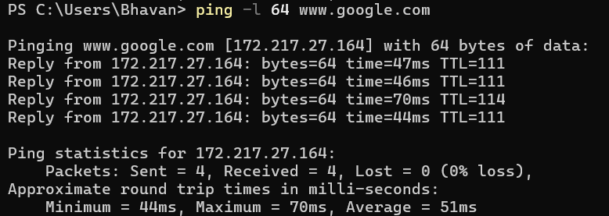

- -t (ttl): Specifies the Time to Live for the packets.

In windows we use -I instead of -t   
Example: ping -i 50 [www.google.com](http://www.google.com)

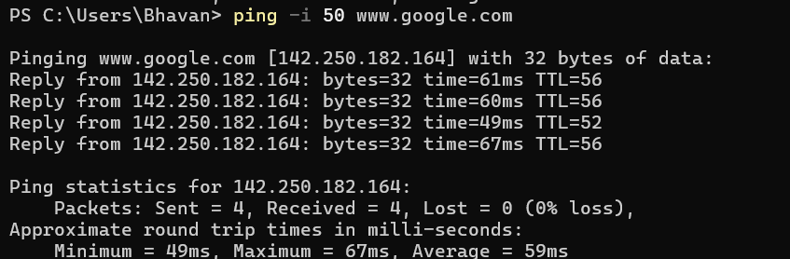

- -w (deadline): Specifies a timeout, in seconds, before ping exits.

This command is same in both linux and windows.  
Example: ping -w 5 [www.google.com](http://www.google.com)

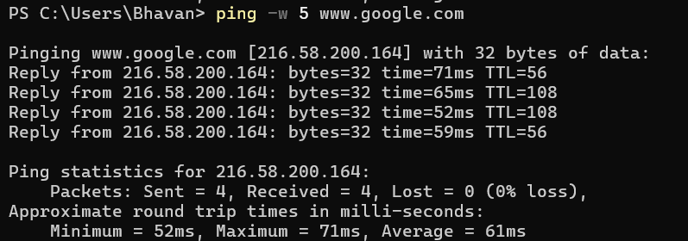

# 4. Troubleshooting with Ping

Example : A user in an office reports that their internet connection is unusually slow, making it difficult to load websites and access online services. Other users on the same network do not seem to experience the same issue.

Using Ping for Diagnosis:

If a user experiences slow network speeds, start by using the ping command to test connectivity to the local router (ping 192.168.1.1) to see if the issue is within the local network. Then, ping an external website (ping www.google.com) to check for high latency or packet loss, which could indicate an issue with the ISP. Finally, compare the ping results on another device in the same network to determine if the problem is isolated to the user’s device or affects the entire network.