**Project Work**

**2. Static Website Hosting with S3**

**Project Title:** Static Website Hosting using AWS S3

**Objective:**  
The objective of this project is to host a basic static website using Amazon Web Services (AWS) Simple Storage Service (S3). The project aims to provide hands-on experience with AWS cloud services by enabling static website hosting, understanding S3 bucket permissions, and configuring public access policies.

**Technologies Used:**

* Amazon Web Services (AWS) – S3
* HTML

**Key Features:**

* Creation of an S3 bucket with unique naming and region configuration
* Uploading and managing static website files (index.html)
* Enabling static website hosting via AWS S3 properties
* Setting up public access through bucket policy to allow global reach
* Hosting and accessing a live static website through a public endpoint

**Outcome:**  
A live, publicly accessible website hosted on AWS S3, demonstrating fundamental cloud deployment concepts such as object storage, permission management, and web hosting without the need for a web server.

**Project URL:** https://github.com/KOTTAPALLISRAVYA2004/AWS_Blackbucks_sravya

**Steps:**

1. **General Configuration and Object Ownership Settings**

This section shows the configuration of a new Amazon S3 bucket including the AWS region, bucket name, bucket type, and object ownership settings. ACLs are disabled and the bucket is set to allow access only through policies.

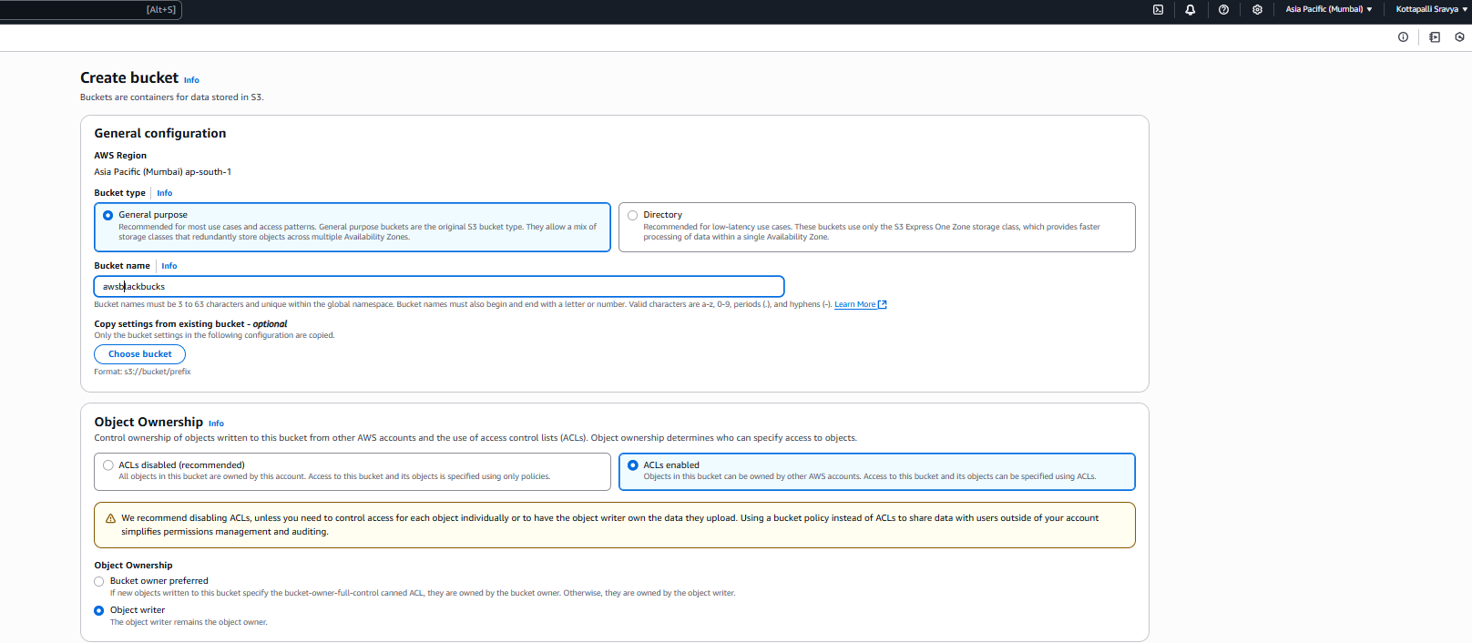

1. **Public Access and Versioning Settings**

This section displays the settings for blocking public access to the bucket and enabling versioning. All public access is blocked to secure the data, and versioning is disabled to maintain a single version of each object. And click on create bucket.

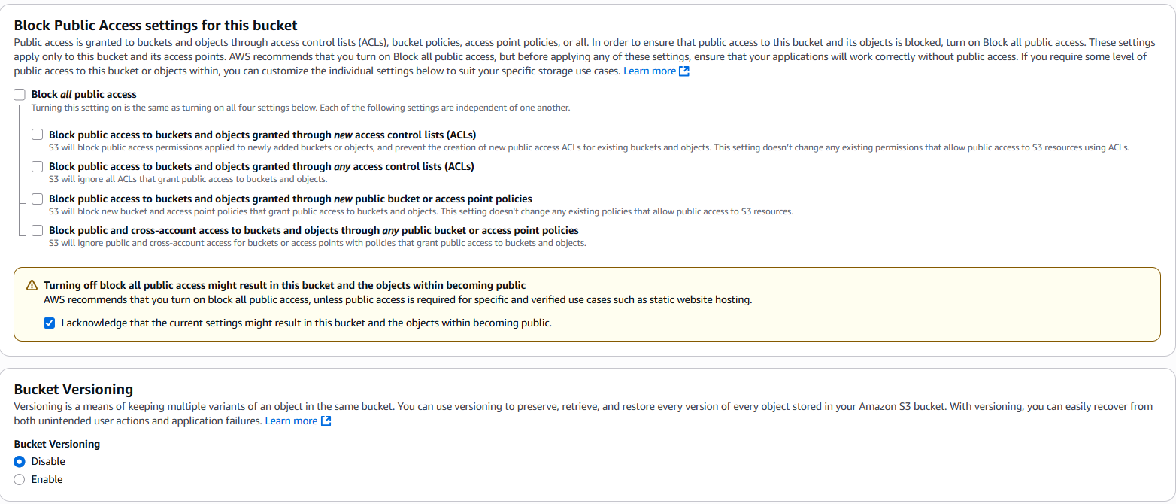

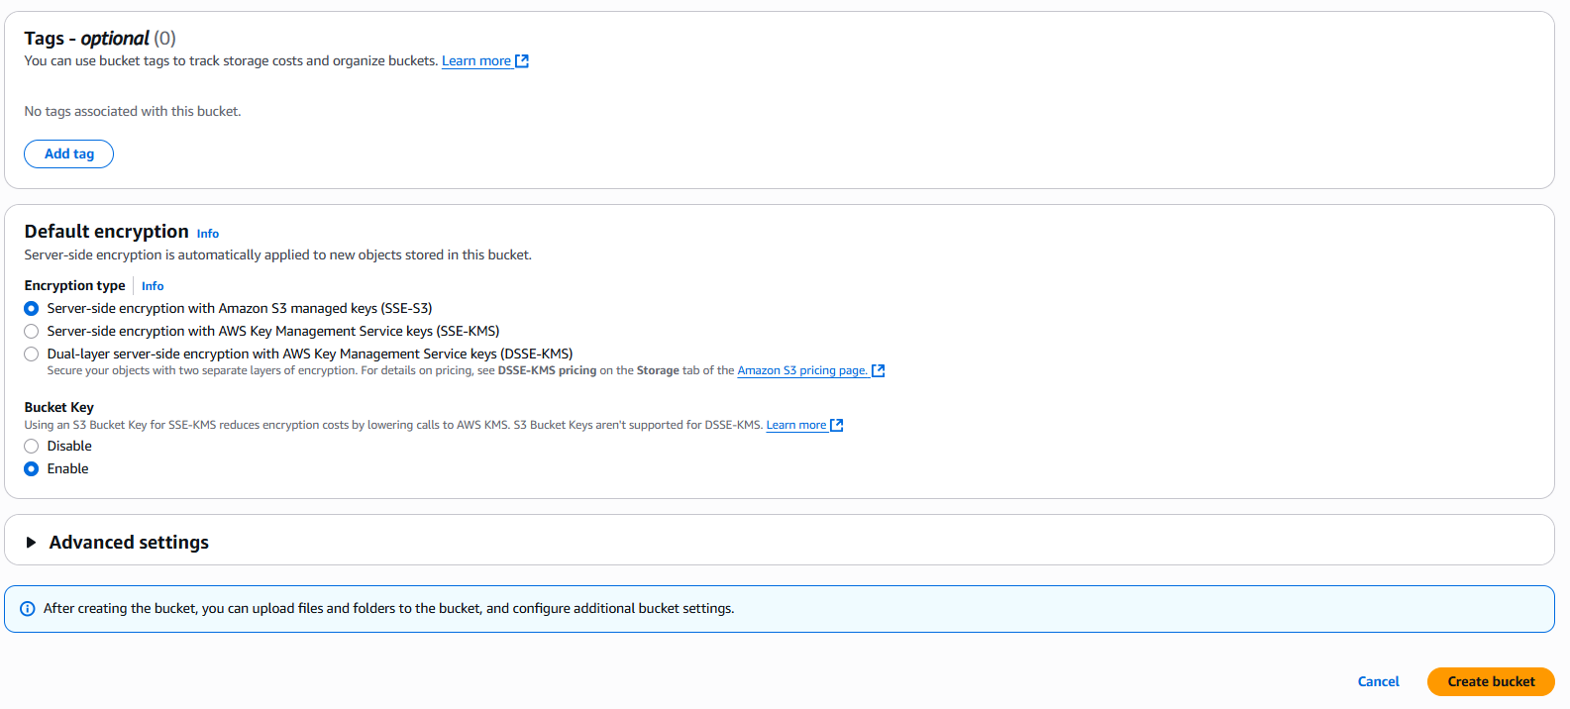

1. To upload the index.html file in Object.

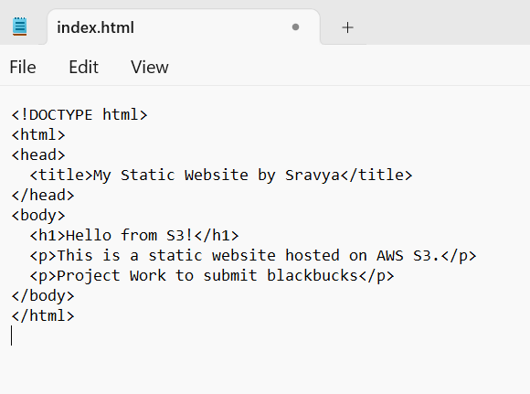

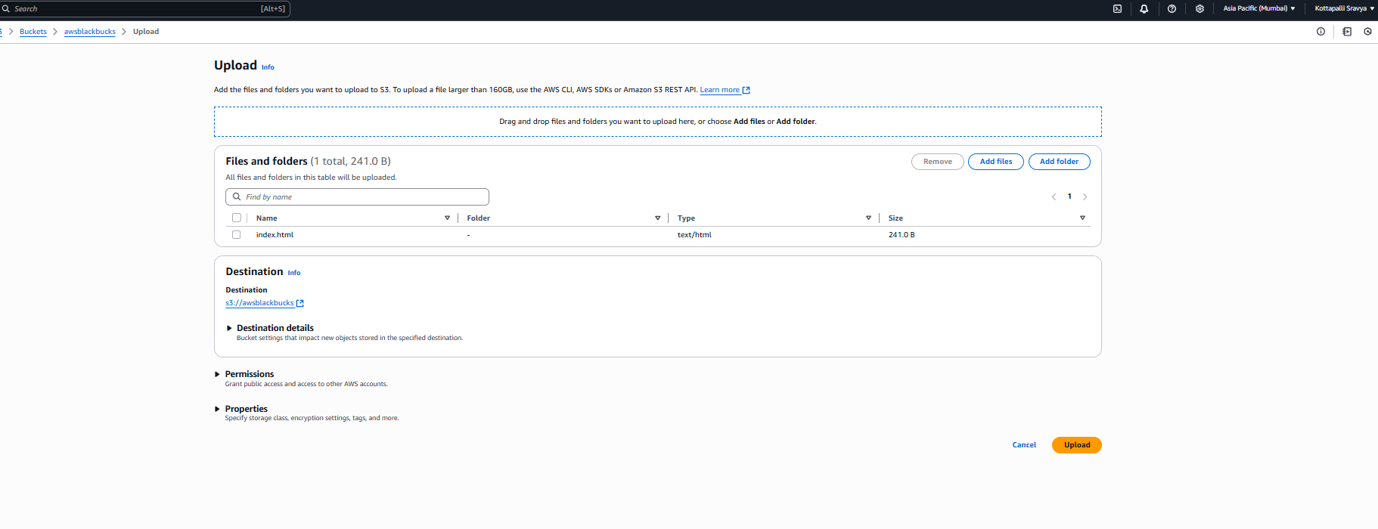

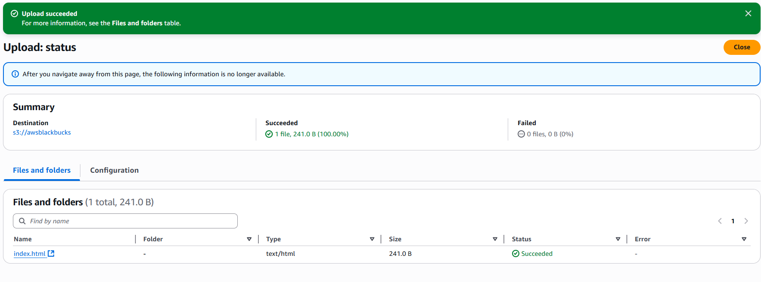

1. Make it as **public** to access the object link or to make a static webpage.

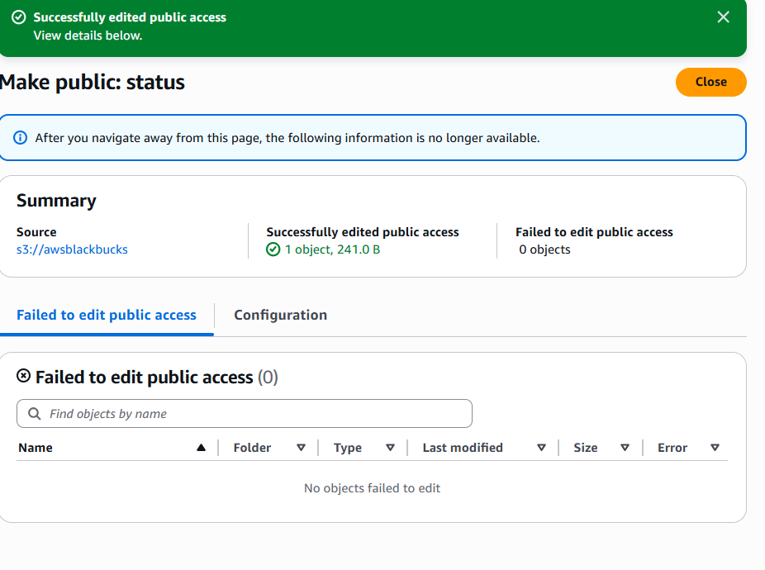

URL: https://awsblackbucks.s3.ap-south-1.amazonaws.com/index.html

1. **Result of webpage:**

