AIM:
To program using class, object, package, overloaded, method, command
line arguments.
PROGRAM:

PACKAGE DIAGRAM:
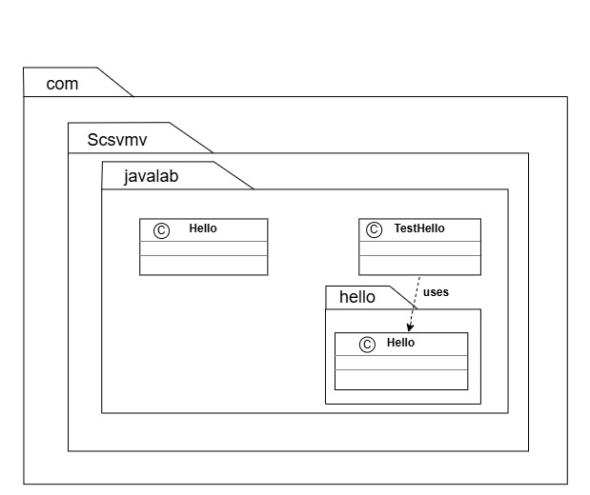
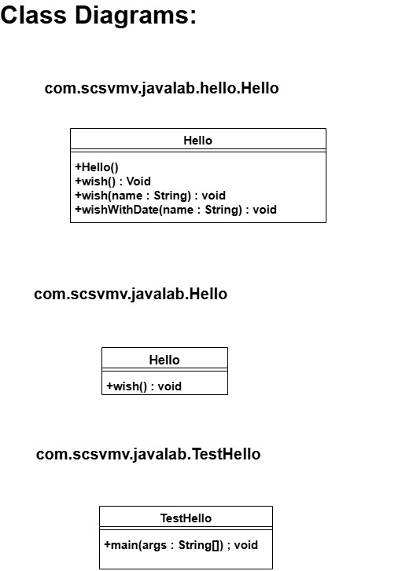

OUTPUT:
