AIM:
To program using class, object, package, overloaded
methods, command line arguments.

PROGRAM:
https://github.com/KOTTEESWARAN2008/JAVALAB/tree/main/program1/src/com/scsvmv/javalabI

PACKAGE DIAGRAM:
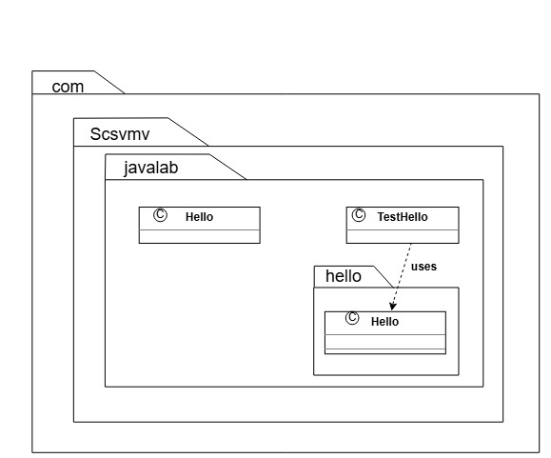

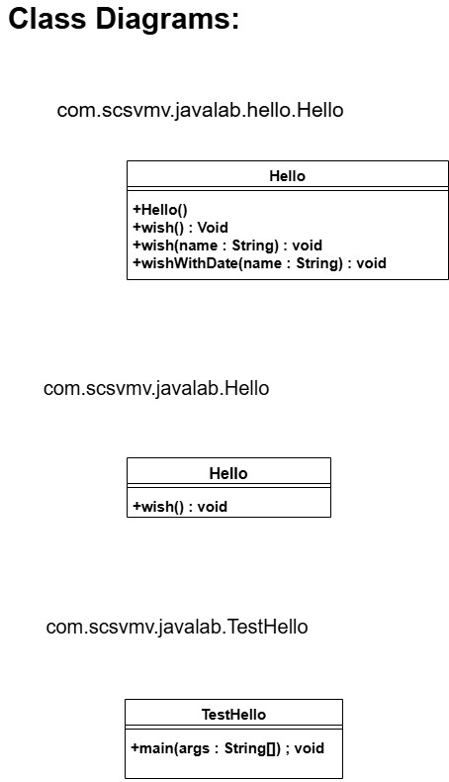

OUTPUT:

