Nkambe Bakery Investment Review

Bakery recipe anthology and production readiness | H3

To | Bakery owner and prospective funders | Date | 8 October 2026
From | Bakery project review | Status | Draft for discussion
Decision Requested | Commissioning and budget review | Current Commitment | Not supplied
Model Version | H2 model with H3 EDC correction | Currency / Scale | FCFA and measured units

1. Executive Summary, Recommendation, and Decision Requested
Recommendation: Advance the evidence-gathering and commissioning plan; defer a capital commitment until a priced budget, measured output and sales evidence exist. EDC is unidentified and must remain separate from margarine. Two affected working recipes are held.
Amount Requested Now | Total Potential Exposure | Entry Valuation / Price | Base Case Return | Primary Operating KPI
Not supplied | Not quantified | Not established | Not calculated | Retained and sold units per campaign

Capital definitions: Existing equipment does not establish its purchase cost or current debt. No funding request, committed capital or total exposure was supplied. Unknown amounts are not zero. This memo does not authorize expenditure.

Decision and exposure
Capital component | Amount | Authorization / timing | Included in returns?
Current commitment | Unknown | Owner records required | No return model
Amount requested now | Not supplied | No funding request assessed | No return model
Conditional future capital | Unknown | After trials and budget review | Not quantified
Total potential exposure | Unknown | Requires complete capital schedule | No return model

Underwriting at a glance
- Why invest? A central production site and retail finishing site may support repeatable quality and replenishment if actual demand covers the full operating cost.
- What supports the case? Owner-supplied equipment details and purchase prices, 138 documented working recipe cards, and a recalculated baguette scheduling model.
- What could break it? Insufficient sales, unqualified equipment or staffing, delayed cooling and delivery, or recipes based on an unidentified ingredient.
- Do terms and returns compensate for risk? This cannot be assessed: investment terms, financial accounts, selling prices and full costs were not provided.
Key highlights: Source-traceable recipes; an editable production model; a documented EDC correction.
Top risks: Unproven throughput and demand; incomplete operating costs; unresolved ingredient identity.

2. Investment Thesis

Consistent daily production
The operating hypothesis is that controlled batch sizes and scheduled dispatch can improve product consistency. The H2 planner provides explicit clocks and resource assumptions, not measured factory output. Three acceptable independent campaigns should establish a repeatable baseline before scaling. [R1, R2]

Shared production with measured retail demand
Facility A prepares breads, fillings and other products; Facility B handles specified retail finishing and assembly. This can simplify standardization, but cooling, transport, retail staging and unsold goods remain costs and capacity constraints. The proposed programme must be matched to recorded orders and sell-through. [R1, R2]

A controlled recipe portfolio
The anthology contains 138 working recipe or component cards, with separate historical and research records. These counts are not unique commercial products or proven successes. H3 corrects two working cards and 92 historical variants affected by EDC being treated as margarine; EDC remains unidentified. [R1, R3]

3. Company and Product

Business overview
The project is a bakery and associated food operation for Nkambe in Cameroon. The documented scope includes breads, pastries, cakes, biscuits, doughnuts, savoury foods, fillings, sauces, drinks and frozen desserts. The sources establish a proposed operating system; they do not establish an audited trading history or verified investment value.

Product and customer value
The intended customer benefit is reliable everyday products and convenient prepared food. Recipe standards, portion control and timely replenishment are proposed means of delivering that benefit. Customer preference, willingness to pay and repeat purchasing still need direct measurement.

Customer and use case
Potential use cases include household bread purchases, individual snacks and preordered food. No segment size, signed supply contract or customer concentration data was supplied. Record purchases and returns by product, outlet and time before allocating higher production volumes.

Differentiation and defensibility
The current evidence supports process documentation and a broad development library. It does not establish a proprietary advantage, superior quality against competitors or protected market share. Blind product comparisons and repeat-purchase data are needed to test differentiation.

Operating model
Reported equipment includes a 16-tray diesel rotary oven with steam, 60 by 40 cm trays, a mixer described as 50 kg flour capacity, two proofers and a moulder. Production starts around 02:00. Mixer load limits, proofing capacity, rack fit, staffing and actual cycle times remain confirmation items. [R1, R2]
Sources: [R1] H3 recipe anthology; [R2] H2 baguette planner, carried unchanged into the H3 package; [R3] H3 EDC correction register; [R4] owner purchase-price inputs. Review date 8 October 2026. Original scheduling evidence is S038 pages 1 and 2, with related S026 and S027.

4. TAM and Market Opportunity

Market definition and size
The relevant market is bakery and related prepared-food purchases reachable from the Nkambe operation. No defensible total market value or annual demand series was supplied. Population, household spending, purchasing frequency and competition would require a separate market study; no market-size number is inferred from oven capacity.
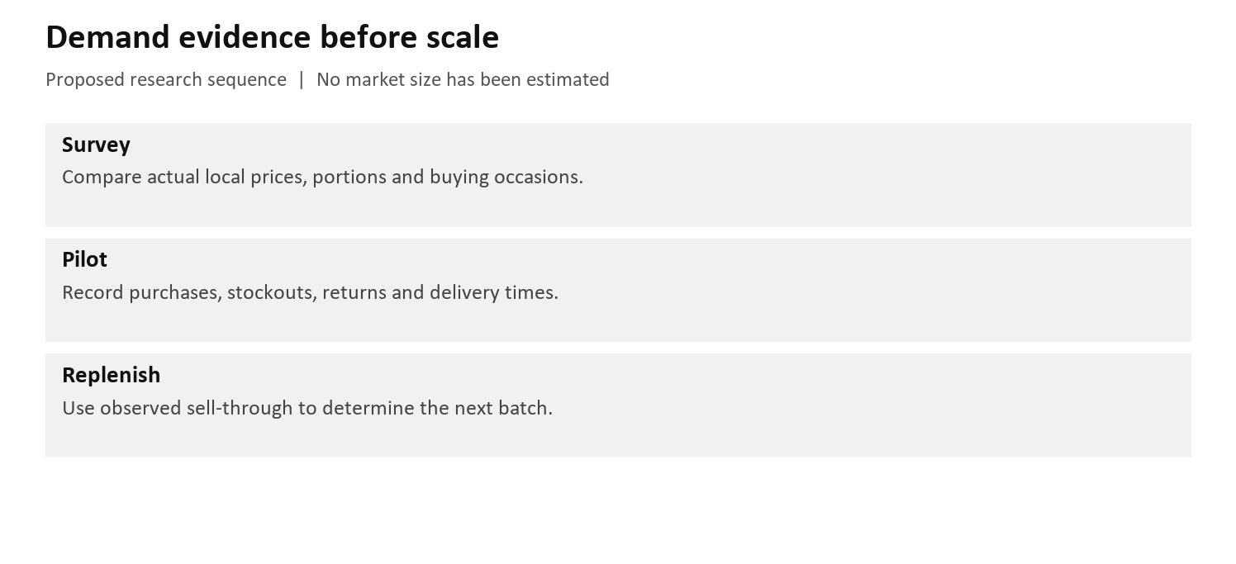
Figure 1. Proposed demand-evidence sequence. No market size or market share is asserted.

Reachable market
The near-term reachable market should be defined by the actual delivery route, retail opening hours, storage capacity and paid orders. First map outlets and travel times, then use a small pilot to observe purchases, stockouts, returns and acceptable prices.

Growth and demand drivers
Convenience, freshness and product consistency are commercial hypotheses to test. No growth rate, seasonality pattern or independent customer research has been established. Owner-supplied plans and repeated source editions are not independent demand evidence.

Underwriting implication
Use measured sell-through to set subsequent batches. The 400-portion and 800-portion programmes are conditional capacity scenarios; neither is a revenue forecast or a daily sales commitment. Reduce production when unsold inventory or dispatch delays erode quality.

5. Capitalization, Market Cap, and Ownership
Applicability: Ownership and capital structure were not supplied. A public market capitalization is not established for this project.

Current capitalization
No current equity register, debt schedule, cash balance or equipment acquisition ledger was provided. Reported installed or planned equipment does not establish its ownership, funding source, remaining obligations or realizable value.

Pro forma capitalization
There is no priced transaction, agreed funding instrument or verified valuation to model. Consequently, a pro forma ownership percentage, debt burden and total exposure cannot be calculated.
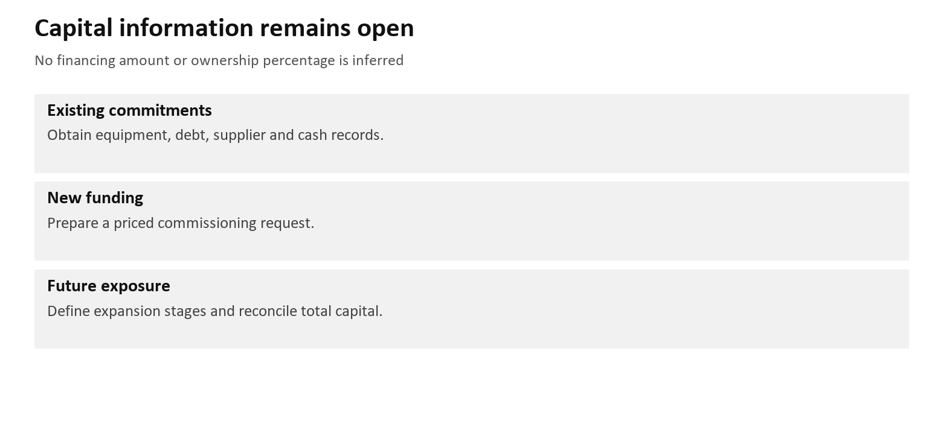
Figure 2. Capital information needed for an investment decision. Amounts remain unquantified.

Ownership and governance
Identify the legal operating entity, beneficial owners, decision rights and financing obligations before seeking external capital. This is a diligence task; the memo does not imply that an investor, committee or governance arrangement already exists.

Underwriting implication
Capital requirements should be tied to specific operational gaps demonstrated during commissioning. Do not purchase additional capacity solely to achieve a theoretical oven-output target.

6. Competitive Landscape and Public or Transaction Comps

Competitive landscape
No verified local competitor price, product-weight, quality or distribution dataset was supplied. Relevant alternatives should be surveyed using comparable portions and purchase times. A comparison based on names alone cannot establish a pricing premium.
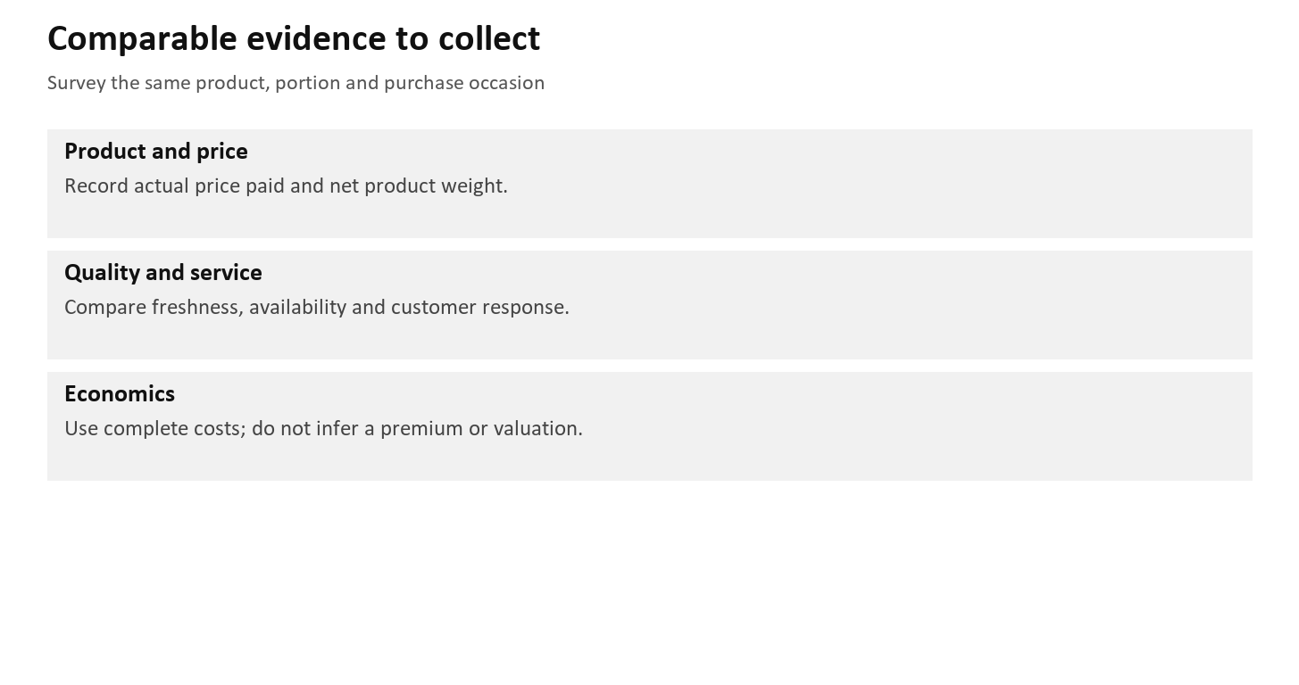
Figure 3. Proposed competitor-survey fields. No competitor ranking or valuation multiple is asserted.

Public and transaction comparables
No suitable public-company or transaction-comparable analysis is available in the project sources. A small local bakery should not inherit an unrelated enterprise valuation multiple without evidence of comparability.

Underwriting takeaway
Set trial prices only after completing product costs and gathering comparable local prices. Record the actual price paid, net product weight and channel. The evidence currently supports a research task, not a premium-pricing conclusion.

7. Team

Leadership and execution fit
No verified staff roster, qualifications or operating track record was supplied. The five production roles and separate driver in the schedule are planning assignments, not confirmed employees.

Ownership, incentives, and governance
Assign a responsible production lead, stock and cash custodian, and reviewer of trial records. Owners should specify who may change formulas, release batches and approve expenditure. These responsibilities remain to be allocated by management.

Capability gaps and key-person risk
Confirm supervision, breaks, relief, cleaning and other-product workload. The extended campaign needs continued production, dispatch and retail coverage. Ingredient identification and perishable-food handling require training.

Underwriting conclusion
Execution capability remains unverified. A machine schedule is not proof of complete staff coverage.

8. Traction and Key Operating Metrics

Operating trajectory
These are conditional planning scenarios. No historical sales or production series was supplied; retained units are not sold units.
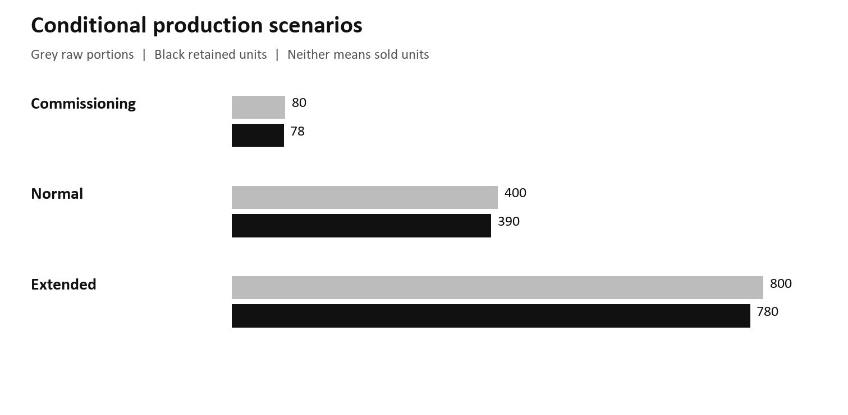
Figure 4. Conditional raw portions and retained units: 80/78, 400/390 and 800/780. Source R2. No sales history is represented.

Quality of traction
Record raw, retained, sold, returned and wasted units by batch and delivery wave.

Benchmarks and targets
Normal-case packing releases span 06:28 to 09:28, conditional on dough, oven and cooling performance. [R2]

Underwriting implication and limitations
Installed capacities, staffing, shelf life and demand remain unverified. Stop additional mixing when downstream operations cannot keep up.

9. Business Model and Unit Economics

Revenue model and pricing
No selling-price schedule or sales volume was confirmed. Base revenue on actual units sold at actual prices; complete costs and measure demand before setting margin targets.

Unit economics
One 80-portion baguette load has a known flour, salt and yeast subtotal of FCFA 6,218.75, or FCFA 79.73 per illustrative retained unit (78 units). Water, dusting, packaging, energy, labour, delivery and other losses are excluded. This is not full cost or profit. [R2, R4]

Retention and durability
Repeat purchasing is unmeasured. Track it separately from promotions. Product keeping quality also needs product-specific evidence.

Scaling and mature-state assumptions
The normal programme depends on verified tray fit, proofing bays, circulating racks, cooling, staffing and dispatch. Longer proof or oven recovery invalidates the default cadence. The 800-portion case extends campaign duration rather than speeding up the process. [R2]

10. Historical Financials and Outlook
Evidence boundary: Financial history and financial forecasts are not available. Operational scenarios are labelled as assumptions and are not substituted for accounts.

Historical performance
No income statement, cash-flow record, balance sheet or reconciled trading ledger was supplied. Revenue, gross margin, operating profit and cash conversion cannot be presented as actual performance.
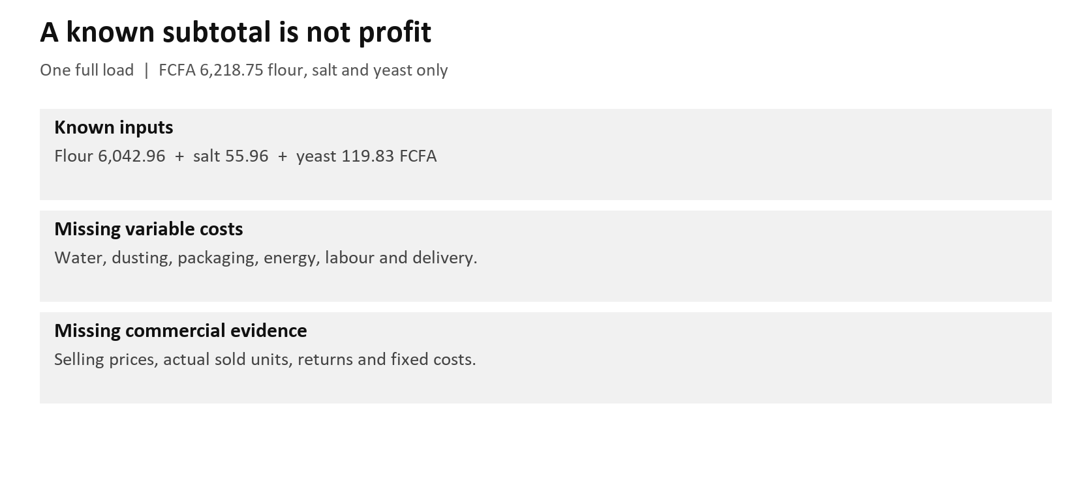
Figure 5. Known and missing cost categories for a full baguette load. Unknown costs are not zero; no profit forecast is shown.

Forecast and key drivers
Build an operating forecast from measured saleable output, sold units, selling prices and complete variable costs. Then add fixed overhead, maintenance, financing, tax and working-capital timing where applicable. No forecast period or growth rate is adopted in this memo.

Liquidity and capital needs
Cash, borrowing, supplier credit, stock requirements and a proposed funding amount remain unspecified. A cash runway or payback period cannot be calculated. Obtain a priced commissioning budget and a separate expansion budget with payment dates.

Model tie-out
R2 is Nkambe_Baguette_Production_Planner_H3.xlsx, retaining the checked H2 numerical model. R3 is Nkambe_EDC_Correction_Register_H3.csv. The recipe register is Nkambe_Editable_Recipe_and_Costing_Registers_H3.xlsx. Owner supplied R4 prices: flour 420/kg, yeast 1,666.67/kg, Roma 1,333.33/kg, Millac 3,200/kg, sugar 640/kg, salt 194.44/kg and oil 1,300/litre, all FCFA.

11. Valuation and Return Scenarios
Decision role: The available calculations support production planning and identification of missing costs. They do not establish a business valuation or investor return.

Model reference and return definition
No investment amount, financing terms, distributions, exit value or holding period is available. IRR, investment multiple and net investor return are therefore not calculated. The H2 production scenarios remain operational cases only.

Key valuation and return assumptions
Any valuation would need verified earnings or cash-flow assumptions, capital requirements and an explicit method. No proxy valuation is derived from the recipe count, equipment rating or theoretical bread output.

Downside case
Operational downside: longer proofing, slower oven recovery, delivery queues or low sell-through reduce useful output and increase cost per sold unit. For example, 90-minute proofing cannot sustain 45-minute starts with only two full-rack bays under the model. Financial proceeds and returns remain unquantified. [R2]

Base case
Operational reference case: five full loads produce 400 raw portions and an illustrative 390 retained units. The first mix starts at 02:20 and final packing release is 09:28 under default assumptions. No sale-through percentage, revenue or investment return is inferred. [R2]

Upside case
Operational extended case: ten full loads produce 800 raw portions and an illustrative 780 retained units, with final packing release at 13:13. This requires staffing relief and continued transport and retail capacity. It is not an upside valuation or guaranteed sales outcome. [R2]
Required reconciliation: Before financial assessment, reconcile existing commitments, new funding, conditional future capital and total exposure to the same cash-flow model. None is currently quantified.

3 x 3 sensitivity
Return metric: Not calculated. Operating and valuation ranges are unavailable; the matrix records the evidence gap rather than fabricated sensitivity values.
 | Low valuation | Reference valuation | High valuation
Low operating case | Not calculated | Not calculated | Not calculated
Reference operating case | Not calculated | Not calculated | Not calculated
High operating case | Not calculated | Not calculated | Not calculated

A return sensitivity cannot be interpreted until the underlying funding and cash-flow inputs are established.

12. Deal Terms

Transaction structure and economics
No security, loan structure, funding amount, ownership percentage, valuation or use-of-proceeds agreement was supplied. This document is a readiness review and does not constitute a transaction proposal.

Governance and investor protections
If financing is later proposed, document reporting duties, approval rights, repayment or distribution terms and any security with the relevant advisers. No legal rights or protections are assumed to exist in the current project.

Closing conditions and key dates
Suggested sequence: identify EDC; complete the affected formulations and costs; verify equipment and staffing; record independent commissioning trials; measure sales and returns; assemble a priced funding proposal. Owners, dates and expenditure authority require management confirmation.

Term assessment
Terms cannot be assessed without an actual proposal. Compare funding alternatives only after capital need and cash-generation assumptions are supported.

Staged capital
Capital stage | Amount | Authorization status | Timing / trigger | Conditions
Existing commitments | Unknown | Records not supplied | Owner confirmation | Reconcile obligations
Commissioning request | Not supplied | No approval recorded | Priced budget | Identify staff and costs
Conditional expansion | Unknown | Not authorized | Successful trials | Demand and cash model
Further capacity | Unknown | Not authorized | Proven bottleneck | Compare alternatives
Total potential exposure | Unknown | Not a funding authorization | Before commitment | Reconcile every stage

13. Key Risks, Diligence Items, and What Needs to Be True

Ingredient identity and recipe release
The owner states that EDC does not mean butter. H3 separates it from margarine in 92 historical variants and the T01 and H05 working cards. Its composition, function, dose, method and price are unknown. Those cards remain held; historical amounts are evidence only. Proposed owner: production lead, to be assigned. Required before either affected formula is manufactured. [R3]

Capacity and product handling
Reported equipment ratings do not prove complete-line throughput. Verify tray clearance, mixer load range, proofing bays, rack inventory, cooling readiness and the delivery route. Existing perishable-food controls in the anthology remain applicable. Proposed owner: operations lead, to be assigned. Required before the relevant campaign is released. [R1, R2]

Demand and complete economics
Missing sale prices, sell-through, overhead and operating costs prevent a profitability conclusion. Obtain observed demand and a complete cash-cost model before selecting an expansion budget. Proposed owner: business owner or finance lead, to be assigned. No funding decision date is assumed. [R2, R4]

Decision blockers and conditions to approval
Decision status: retain the recipe-development and commissioning programme, with the EDC holds in force. A capital approval requires a priced request, clear existing obligations, measured production performance and sales evidence. No money, transaction or production release is authorized by this memo. The H3 correction supersedes the EDC interpretation in H1 and H2.

