Baguette Production Planning and Daily Capacity

H3 ingredient correction
EDC is not butter and must not be treated or priced as margarine. Its identity, specification, permitted application, dose and purchase price remain unresolved. Keep EDC as a separate historical ingredient and hold affected formulas until it is identified. The earlier owner-workbook butter-to-margarine instruction remains separate; true dairy butter in independent recipes retains its specification. Milk tantalizer and improver remain omitted from revised recipes.
T01 cake doughnuts and H05 Danisa biscuits are held. Ninety-two historical formula variants retain EDC separately and unpriced. The lean baguette programme BAG-H2-01 contains no EDC and its formula and timing assumptions are unchanged. H3 supersedes the EDC interpretation in H1 and H2; original editions are retained only as historical records.
H2 planning module • 8 October 2026 • Nkambe, Cameroon • All clock times are local bakery planning times.
Decision and source identification
The requested document was located: Staggered_Baguette_Production_Schedule.pdf, source S038, in the owner's Downloads folder. It has two pages and was modified on 11 September 2026. Its filename describes scheduling; its internal heading is “Commercial Baguette Production Guide”. This is the closest direct match, supported by the five-batch programmes in S026 and S027. Current file hashes match the H1 source inventory.
S038 describes two 80-piece batches. S026/S027 extend related reasoning to five batches of allegedly 101 pieces each, implying 505 pieces in a production campaign. That is a source claim, not a verified daily output. No sales orders, successful timed campaign, installed rack count or signed production record were supplied.
H2 retains the useful idea of staggered mixing and converts it into whole-load programmes. It does not adopt the source's contradictory clocks, unverified equipment claims or immediate closed-box packing. The new recipe BAG-H2-01 is a separate direct-dough commercial trial; existing M1-B12, M1-B13 and S-B01 remain separate formulas.
Source | Relevant evidence | Decision
S038 | PDF p1 formulation/cadence; p2 two-rack timeline and controls | Primary requested scheduling document; correct arithmetic and sequencing
S030 | PDF pp1–2; 80-piece formula and industrial workflow | Formula/process companion; contains the same yield discrepancy
S027 | PDF pp1–2; five-batch checklist, 18 kg flour and 101 pieces/batch | Retain implied 505-piece target as historical; rack and timing claims rejected
S026 | Lines 9–29 schedule; 33–70 staff/logistics; subsequent water/ice discussion | Useful duty and distribution concepts; reject hot airtight packing and unqualified par-bake route
S001 | PDF p1 audit and section 4 baguette system | Earlier corrections are supporting analysis, not a production test
S131 / S137 | Equipment sections and two-site business plans | Broad operating context; not the requested baguette-specific programme

ID | Document | Full path
S038 | Staggered_Baguette_Production_Schedule.pdf | C:\Users\J COMPUTER\Downloads\Staggered_Baguette_Production_Schedule.pdf
S030 | Commercial_Baguette_Production_Guide.pdf | C:\Users\J COMPUTER\Downloads\Commercial_Baguette_Production_Guide.pdf
S027 | Bakery_Empire_Master_Operations_Manual.pdf | C:\Users\J COMPUTER\Downloads\Bakery_Empire_Master_Operations_Manual.pdf
S026 | Bakery_Empire_Master_Operations_Manual.md | C:\Users\J COMPUTER\Downloads\Bakery_Empire_Master_Operations_Manual.md
S001 | bakery_strategy_and_recipe_manual_updated.pdf | C:\Users\J COMPUTER\Documents\Codex\2026-09-12\x20-go\docs\bakery\bakery_strategy_and_recipe_manual_updated.pdf
S131 | Nkambe_Bakery_Business_and_Production_Plan.pdf | C:\Users\J COMPUTER\WPS Cloud Files\.3728209773449\cachedata\2B0BE17ABD444588A82615757DB640F5\Nkambe_Bakery_Business_and_Production_Plan.pdf
S137 | Nkambe_Bakery_Business_and_Production_Plan.pdf | C:\Users\J COMPUTER\WPS Cloud Files\.3728209773449\cachedata\D084D8E5B0104800B3A610A601B8DF7B\Nkambe_Bakery_Business_and_Production_Plan.pdf

Source audit and corrected calculations
Topic | Original claim / input | H2 correction
Ingredient total | S038 lists flour 14.20 kg, water 9.37 kg, salt 284 g, yeast 71 g. | Sum = 23.925 kg. At exactly 66% water, water would be 9.372 kg and total 23.927 kg. Neither is 24 kg.
Whole pieces | S038 says the batch yields exactly 80 × 300 g. | 23,925 / 300 = 79 pieces and 225 g left before handling loss. With 1% handling loss: 23,685.75 g → 78 pieces and 285.75 g left.
Cooled weight | 300 g raw is described as 250 g at 15% bake loss. | 300 × 0.85 = 255 g. A mathematical 250 g target at 15% loss requires 294.118 g raw, before portion and process variation.
18 kg flour variant | S027 uses 18 kg flour, 8.28 kg water, 3.6 kg ice, 360 g salt, 90 g yeast. | Total 30.330 kg, hydration 66% including ice. Before handling loss: 101 pieces + 30 g. At 1% loss: 100 pieces + 26.7 g.
Five-batch output | Five batches are claimed to yield 505 baguettes. | With 1% handling loss and 300 g portions, five 18 kg-flour batches give 500 pieces before rejects. At 80/load, 7 pooled loads are needed; if every batch is kept separate, 10 loads (80+20 per batch). Proofing must be redesigned for either route.
Rack geometry | 101 pieces are treated like one 16-tray load. | 16 × 5 = 80. 101 requires at least 21 trays at 5/tray. It cannot fit the assumed one-load geometry.
Proof window | S038 p2 starts batch 1 proof at elapsed 01:30, promises 60 min, but loads at 02:15. | That window is 45 min. Batch 2 proof 02:15–03:15 is 60 min. H2 uses a common explicit 60-minute planning slot, subject to dough endpoint.
Remaining times | At 00:45, S038 says batch 1 has 27 min left in bulk; its bulk actually ends 01:03. | 18 min remain. Several remaining-time and overlap annotations disagree with their own start/end times.
Cadence | S038 calls the oven cycle 25 min, prescribes 45-minute mixing starts, then shows first/second oven starts 60 min apart. | These are three different intervals. H2 reserves 40 minutes for scoring/loading, baking, unloading and recovery; 45-minute starts leave 5 minutes of nominal slack.
Recovery | S038 alternates 3-minute recovery and a mandatory 23-minute thermal recovery statement. | Neither is a measured requirement. Time actual recovery; H2 provisionally reserves 5 min after unloading. If 23 min is actually required, the H2 45-min cadence fails.
Mix rest | A 10-minute rest with yeast already included is labelled autolyse. | H2 calls it a hydrated-dough rest. A flour/water-only autolyse is a different method and must not be inserted as extra time without revising the schedule.
Dispatch | Some related manuals seal hot bread immediately and assume a 23-minute delivery. | Cool in a protected ventilated area; validate packing readiness. H2 uses explicit cooling, packing, vehicle loading, travel, handover and return assumptions.
Retail bake | S026 offers a 15-minute par-bake option. | This edition schedules full baking at A. A qualified second bake, cooling/storage process and suitable B oven have not been established.

BAG-H2-01 Direct-dough commercial baguette
Status: harmonized source adaptation, version H2, production trials required. Sources: S038 pp1–2, S030 pp1–2 and S027 pp1–2. Intended result: a lean, crisp-crusted, roughly 48–50 cm commercial baguette, with an evenly expanded crumb and consistent raw portion. It is not a claim to a protected French designation or to a guaranteed finished retail weight.
Retain the source's nominal flour 100%, water 66%, salt 2% and instant yeast 0.5%. Scale to the required portions and allow 1% handling loss. Round flour upward to a whole gram, water to a gram, and salt/yeast to 0.1 g; recheck the resulting total. This avoids promising an additional whole piece from a rounded-down batch. The 40-piece pilot needs a suitably sized mixer; it is not automatically a permissible minimum load for the large spiral.
Ingredient / specification | Baker % | Pilot 40 pieces, g | One load 80 pieces, g
Le Choix du Boulanger flour; absorption/protein to verify | 100 | 7,194 | 14,388
Potable chilled water; ice included within this total | 66 | 4,748 | 9,496
Fine food-grade salt | 2 | 143.9 | 287.8
Nevada instant dry yeast | 0.5 | 36.0 | 71.9
Total weighed input | 168.5 nominal | 12,121.9 | 24,243.7

Mass/yield measure | 40-piece pilot | 80-piece load
Input g | 12,121.90 | 24,243.70
After 1% handling loss, g | 12,000.68 | 24,001.26
Raw pieces × 300 g | 40 × 300 = 12,000 | 80 × 300 = 24,000
Unallocated dough after handling, g | 0.68 | 1.26
Bake loss illustration | 15%; 255 g cooled per piece | 15%; 255 g cooled per piece
Before-reject cooled mass, kg | 10.200 | 20.400
Reject allowance: ceil(pieces × 2%) | 1 piece; 39 retained | 2 pieces; 78 retained
Retained saleable mass illustration, kg | 9.945 | 19.890

“Retained saleable” is a planning allowance, not a measured result or an order forecast. Rounding rejects upward makes the effective allowance 2.5% in these examples. Unsold stock is a separate commercial loss and is not silently included in this allowance. Record leftovers and their disposition; no extra loaf or unpriced rework is assumed.
At 13–17% bake loss a 300 g portion finishes around 261–249 g. Therefore this plan does not establish a guaranteed 250 g net weight. Measure cooled weights and their variation before choosing a declared weight. If a particular minimum is required, design the portion allowance from actual worst-case process data and applicable requirements.
Numbered process and observable endpoints
1. Before mixing, verify ingredient lots, clean scales, water supply, tray/rack fit, guards and steam controls. Record room, flour and water temperatures. Do not taste raw flour or dough. Prepare batch labels and weigh all ingredients separately; no improver, Milk tantalizer, milk, margarine or sugar belongs in BAG-H2-01.
2. Start with most of the listed water, flour and yeast, mix gently for about 3 minutes, rest the hydrated dough for 10 minutes, then add salt and the balance of the listed water and mix about 5 minutes to moderate development. The 18-minute slot is a trial. Target source-derived final dough temperature 23–24°C; adjust water temperature from measured friction and ambient conditions. Do not automatically use 4°C water or a fixed ice percentage in every season. All ice must be food-grade, melt by the end of mixing and replace an equal mass of listed water.
3. Transfer into a covered food-grade bulk bin. Allow a provisional 45-minute bulk fermentation. Require visible fermentation and extensibility, not a timer alone. At 0.5% instant yeast and this dough temperature, actual required time may be longer. Record the result; if the baseline under-ferments, extend bulk/proof and rerun the resource model rather than increasing yeast ad hoc.
4. Divide and preshape in a 15-minute planning slot, checking pieces against 300 g. Keep pieces in numbered first-in/first-out order. The next 15-minute slot moulds those same pieces in the same order: at an even rate each piece has approximately 15 minutes between preshape and moulding. That rest overlaps division of later pieces; do not insert another full-batch 15 minutes unless the schedule is revised. Irregular work rates require timed subgroups and a new slot allowance.
5. Mould gently, using verified roller settings and minimal measured dusting flour. Trial 48–50 cm lengths. Place seam-down, five per 60 × 40 cm tray only if the finished width and airflow test pass. Dusting flour is an additional process quantity to weigh and cost; the dough formula does not include an unlimited dusting allowance.
6. Load a verified proofer bay. Plan 60 minutes from the last tray loaded, near 26°C and 75–80% relative humidity if the installed controls can maintain it. The first formed pieces begin expanding earlier. Check tray-to-tray consistency; a slowly recovering light indentation and expanded, aerated dough are guides. Bake at the appropriate endpoint. The schedule includes a further 10-minute scoring/loading slot; dough must tolerate that actual elapsed time. Record proof exit and oven entry separately.
7. Preheat using the oven manual and a measured lead time. A trial starting point inherited from the source is 240°C preheat, about 220°C baking and 22 minutes for this size. Commission a steam programme through the working injection system; the source's 15–20-second pulse is not a universal setting. Score before loading, following the shaping style and a blade-handling procedure. Never throw water into the diesel oven or improvise the steam plumbing. Use the manufacturer's damper procedure to finish the crust.
8. Check even colour, expansion and fully set crumb using cooled cut samples as well as the established bake controls. Unload with appropriate heat protection. Log recovery to the next qualified loading condition, rather than assuming the thermostat display proves recovery. Reserve 3 minutes to unload and 5 minutes to recover in the model; replace these with measurements.
9. Cool protected on racks. The 45-minute allowance is a trial, not automatic packing release. Check that packaging causes no condensation and the crust specification is acceptable. Pack in clean food-grade paper or the qualified pack; use protected ventilated transport crates. Do not tightly seal steaming bread, reuse raw-food containers or place bread directly against vehicle surfaces.
10. Release by lot and measured count, then dispatch to B. Check transport hygiene, quantities, time and condition at handover. Plan same-production-day quality review under C05; no multi-day shelf life is established. Retail replenishment follows actual sales and available display space. Segregate underbaked, damaged or otherwise rejected pieces; record any food-safe alternative use as a separate authorised product, not hidden yield.
Allergens: wheat/gluten; review flour processing aids, yeast and shared-equipment labels for additional allergens or cross-contact. No allergen-free claim is made. C01 and C05 remain applicable; filled baguettes additionally require the relevant meat, egg, dairy and sauce controls.
Cost audit and labour distinction
Input | One-load amount | Confirmed rate | Known FCFA
Flour | 14.388 kg | 420/kg | 6,042.96
Salt | 0.2878 kg | 194.44/kg | 55.96
Nevada yeast | 0.0719 kg | 1,666.67/kg | 119.83
Water | 9.496 kg | UNPRICED | UNPRICED
Known ingredient subtotal | 80 raw / 78 retained units | Incomplete | 6,218.75

The known subtotal is 79.73 FCFA per planned retained unit. It excludes water, dusting flour, consumables, packaging, energy, paid labour, transport and unsold stock. No complete margin or selling-price recommendation follows from it. A 10% increase in currently priced inputs adds 7.97 FCFA per retained unit; 10% fewer sold units increases the same batch-cost allocation by 11.11% before whole-unit rounding.
Reserve 35 staff-minutes per batch for M1 preweighing, mixer supervision, transfer and cleaning; 20 for D2 division/bench cleaning; 20 for F3 moulding/loading/bench cleaning; 13 active minutes for O4 score/load and unload; and 25 for P5 packing and tray-set cleanup. This gives about 113 allocated staff-minutes per batch before opening/closing, quality monitoring, relief, walking, transport or paid waiting. It includes the supervised dough-rest interval and is not a measured stopwatch labour standard. Record hands-on labour separately. Cost actual paid staffed hours, including coverage and waiting; do not multiply 113 minutes by a wage and call it full campaign labour cost.
The model's first-batch elapsed time from mixing start to packing release is 248 minutes, plus opening checks before mixing. Active labour and elapsed process time are different quantities. The staffing allocation is intentionally generous for a commissioning bakery and can be redesigned only after timed trials.
Tray layout, rack count and capacity gates
Trial layout: orient baguette length along the 60 cm tray edge. Five pieces at up to 6 cm finished width occupy five parallel lanes across the 40 cm edge: centres at about 5, 12.5, 20, 27.5 and 35 cm. A 50 cm finished length leaves 5 cm at each end; 6 cm width leaves 2 cm outer margins and 1.5 cm inter-piece gaps. These are geometric trial allowances, not proof of adequate airflow, pan-channel fit or final expansion. Check the actual usable surface inside rims. If loaves spread wider, use four per tray and replan quantities.
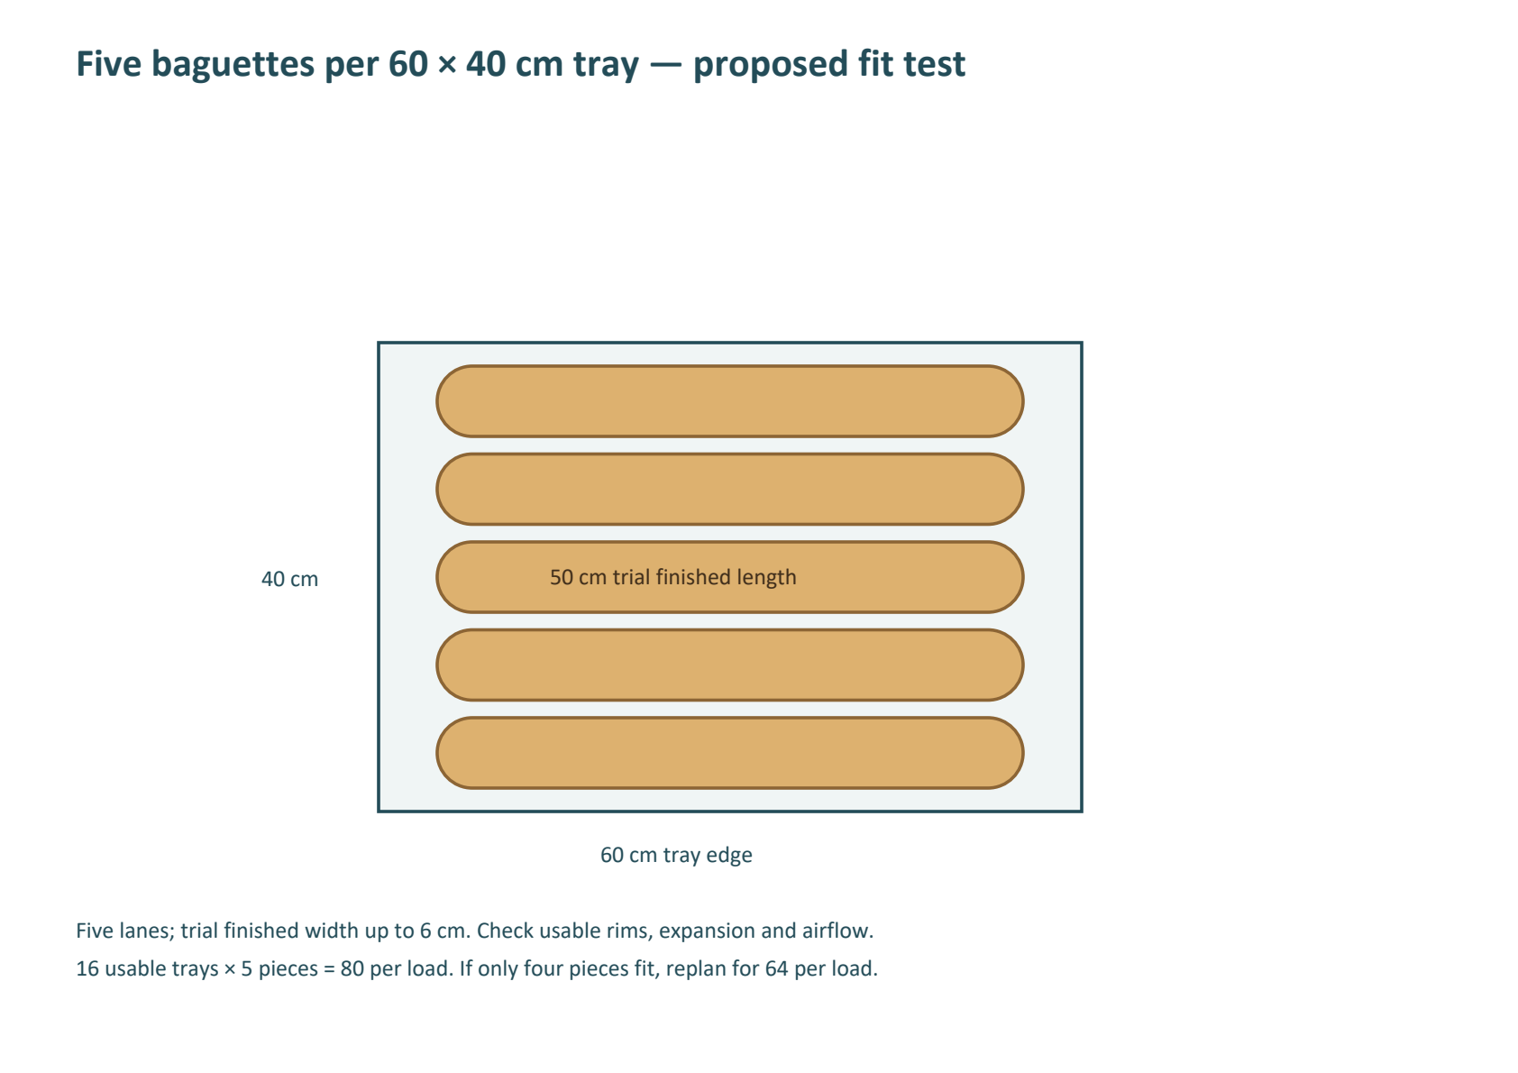
The accompanying tray-layout diagram is schematic. The full 16-tray test must check all levels, colour, clearance, steam distribution and rack weight. The partial commissioning load uses 8 trays × 5 pieces, spread according to the oven manual; do not claim half the baking time because the load is halved.
Constraint | H2 baseline requirement | What changes the plan
Mixer | 80-piece batch 24.244 kg dough, 14.388 kg flour | Verify minimum/maximum dough mass and duty cycle; the reported 50 kg flour description is not a confirmed bowl or dough rating
Moulding / division | Two separate work surfaces/operators; 80 pieces in each 15-minute stage | Slower actual throughput increases stage slots; revise rest and proof age
Proofers | Two independently usable bays, each holding one full 16-tray rack | 60 min proof + 5 min bay turnover at 45 min starts needs two bays. At 90 min proof, two bays require cadence at least 47.5 min: trial 50 min, then recheck all stages
Oven | 10 min score/load + 22 bake + 3 unload + 5 recovery = 40 min reservation | 45 min starts leave 5 min nominal slack. A measured 23 min recovery makes reservation 58 min and requires a slower programme
Rack/tray sets | Four active sets in steady operation; a fifth full set provides contingency | A set is occupied from mould/loading through proof, bake, cool, pack and 10-min cleanup: 180 min. At 45-min starts, four sets are the calculated minimum; five sets = 80 trays, ownership unconfirmed
Cooling/packing space | Two full-load equivalent positions for cooling/packing overlap | Keep a separate dispatch staging area sized to the delivery waves; do not borrow proofer space
Vehicle | One vehicle, assumed 85-minute loaded-to-ready round trip | 5 load + 30 outward + 15 handover + 30 return + 5 clean/check. Driver and vehicle cannot be sent on two overlapping trips
Power and fuel | Measured connected electrical loads, priority cold stores and oven diesel consumption | 20 kW inverter, 30 kWh nominal storage and 25 kW generator are reported; usable energy, electrical phase, surges and diesel litres/hour remain open

Rack sets are not the same as the oven's one-rack capacity. A rack occupied by cooling bread cannot simultaneously carry the next proofed load. The fifth contingency set is a planning provision, not a finding that the bakery owns five racks. No purchase has been made or assumed.
At five pieces/tray the nominal oven-only rate is 80 × 60 / 40 = 120 pieces/hour. The planned 45-minute production cadence is 106.67 pieces/hour once the pipeline is filled. Neither rate applies from 02:00: the first-batch lead time, opening work, cooling, dispatch and end-of-shift cleaning remain. With only four pieces/tray, each load becomes 64; five/ten loads become 320/640 raw pieces before rejects if all other stage times still pass.
If 505 is an actual sales requirement rather than the historical raw-output claim, distinguish the two. Seven full 80-piece loads give 560 raw and 546 retained pieces under the stated reject model. A calculated alternative is six full loads plus a separately scaled 38-piece last load: 6 × 78 + (38 − 1 reject) = 505 retained pieces from 518 raw. That mixed-load option needs its own last-batch weighing and partial-rack test; it is not a fourth released programme or a recommendation to manufacture unsold surplus.
Chronological production scenarios
All scenarios begin opening checks at 02:00 and first mixing at 02:20. Times are planning outputs; they are not proof that dough will be ready on those clocks. The 800-piece case extends the campaign at the same cadence; it does not claim faster fermentation or an unproven faster oven.
Programme | Loads and cadence | Raw / retained pieces | Final pack release
PLAN-BAG-P | 2 × 40; 90 min | 80 / 78 | 07:58
PLAN-BAG-N | 5 × 80; 45 min | 400 / 390 | 09:28
PLAN-BAG-H | 10 × 80; 45 min | 800 / 780 | 13:13

PLAN-BAG-P Commissioning programme
Batch | Mix | Bulk | Divide → mould | Proof bay / proof | Score/load → bake out
1 | 02:20–02:38 | 02:38–03:23 | 03:23–03:38 → 03:38–03:53 | 1: 03:53–04:53 | 04:53 → 05:25
2 | 03:50–04:08 | 04:08–04:53 | 04:53–05:08 → 05:08–05:23 | 2: 05:23–06:23 | 06:23 → 06:55

Batch | Unload / recover done | Cooling | Packing / lot release | Rack free after clean
1 | 05:28 / 05:33 | 05:28–06:13 | 06:13–06:28 | 06:38
2 | 06:58 / 07:03 | 06:58–07:43 | 07:43–07:58 | 08:08

Delivery wave | Batches / retained units | Load → depart | Arrival at B | Vehicle ready back at A
1 | 1 / 39 | 06:28 → 06:33 | 07:03 | 07:53
2 | 2 / 39 | 07:58 → 08:03 | 08:33 | 09:23

Calculated simultaneous requirements for this finite campaign: 1 proofer bays; 2 active rack/tray sets; 1 full-load equivalent cooling/packing positions. Maximum packed staging wait before vehicle loading is 0 minutes. These waits affect crust quality and sales freshness and must be tested.
Commissioning is a learning run. Use a verified small mixer or an approved large-mixer load. Check the partial rack, portion consistency and process endpoints before increasing to 80 pieces per load. Retained-unit figures do not authorize sale of an unsuccessful trial.
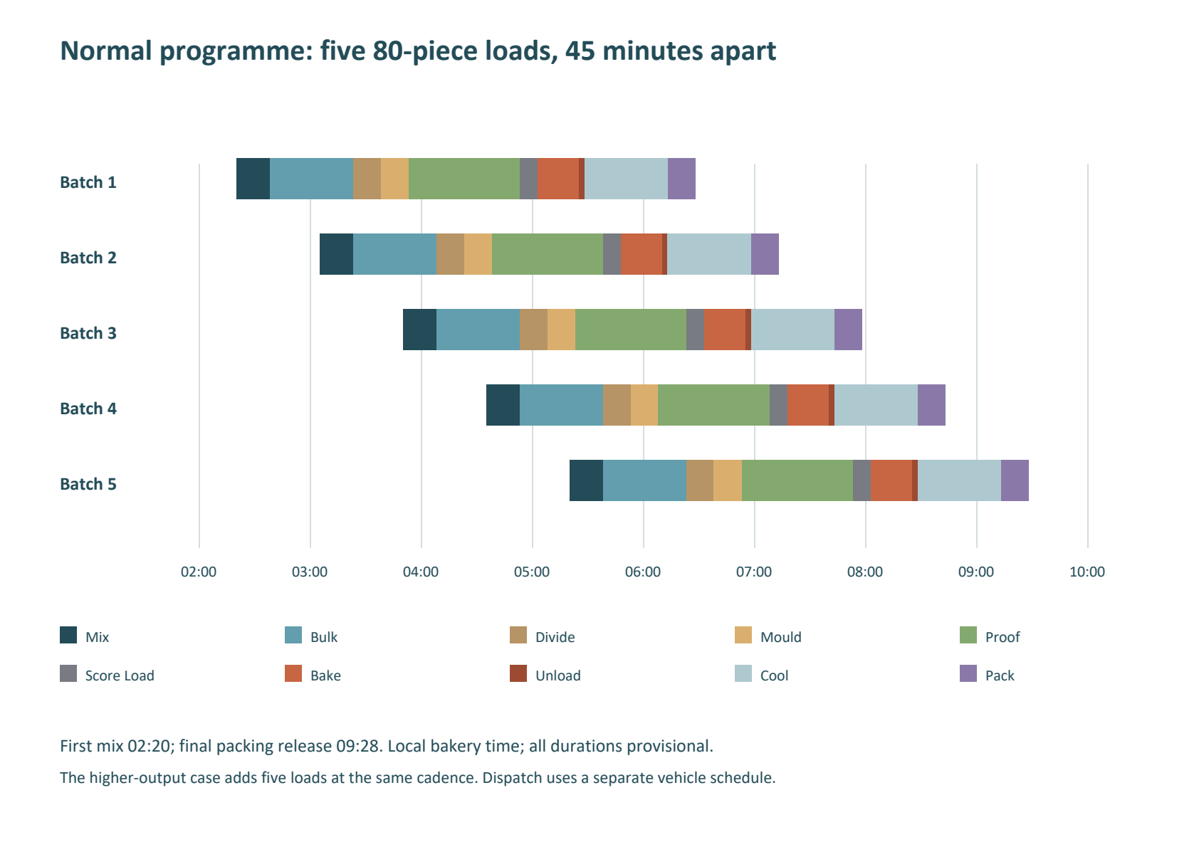
PLAN-BAG-N Proposed normal programme
Batch | Mix | Bulk | Divide → mould | Proof bay / proof | Score/load → bake out
1 | 02:20–02:38 | 02:38–03:23 | 03:23–03:38 → 03:38–03:53 | 1: 03:53–04:53 | 04:53 → 05:25
2 | 03:05–03:23 | 03:23–04:08 | 04:08–04:23 → 04:23–04:38 | 2: 04:38–05:38 | 05:38 → 06:10
3 | 03:50–04:08 | 04:08–04:53 | 04:53–05:08 → 05:08–05:23 | 1: 05:23–06:23 | 06:23 → 06:55
4 | 04:35–04:53 | 04:53–05:38 | 05:38–05:53 → 05:53–06:08 | 2: 06:08–07:08 | 07:08 → 07:40
5 | 05:20–05:38 | 05:38–06:23 | 06:23–06:38 → 06:38–06:53 | 1: 06:53–07:53 | 07:53 → 08:25

Batch | Unload / recover done | Cooling | Packing / lot release | Rack free after clean
1 | 05:28 / 05:33 | 05:28–06:13 | 06:13–06:28 | 06:38
2 | 06:13 / 06:18 | 06:13–06:58 | 06:58–07:13 | 07:23
3 | 06:58 / 07:03 | 06:58–07:43 | 07:43–07:58 | 08:08
4 | 07:43 / 07:48 | 07:43–08:28 | 08:28–08:43 | 08:53
5 | 08:28 / 08:33 | 08:28–09:13 | 09:13–09:28 | 09:38

Delivery wave | Batches / retained units | Load → depart | Arrival at B | Vehicle ready back at A
1 | 1 / 78 | 06:28 → 06:33 | 07:03 | 07:53
2 | 2,3 / 156 | 07:58 → 08:03 | 08:33 | 09:23
3 | 4,5 / 156 | 09:28 → 09:33 | 10:03 | 10:53

Calculated simultaneous requirements for this finite campaign: 2 proofer bays; 4 active rack/tray sets; 2 full-load equivalent cooling/packing positions. Maximum packed staging wait before vehicle loading is 45 minutes. These waits affect crust quality and sales freshness and must be tested.
This replaces the historical five-mix/505-piece claim with five deliberately matched 80-piece loads. It requires confirmed rack sets, two proof bays, five production roles and an independent delivery driver. Do not combine the old 18 kg flour charge with this one-load schedule.
PLAN-BAG-H Higher-output extended programme
Batch | Mix | Bulk | Divide → mould | Proof bay / proof | Score/load → bake out
1 | 02:20–02:38 | 02:38–03:23 | 03:23–03:38 → 03:38–03:53 | 1: 03:53–04:53 | 04:53 → 05:25
2 | 03:05–03:23 | 03:23–04:08 | 04:08–04:23 → 04:23–04:38 | 2: 04:38–05:38 | 05:38 → 06:10
3 | 03:50–04:08 | 04:08–04:53 | 04:53–05:08 → 05:08–05:23 | 1: 05:23–06:23 | 06:23 → 06:55
4 | 04:35–04:53 | 04:53–05:38 | 05:38–05:53 → 05:53–06:08 | 2: 06:08–07:08 | 07:08 → 07:40
5 | 05:20–05:38 | 05:38–06:23 | 06:23–06:38 → 06:38–06:53 | 1: 06:53–07:53 | 07:53 → 08:25
6 | 06:05–06:23 | 06:23–07:08 | 07:08–07:23 → 07:23–07:38 | 2: 07:38–08:38 | 08:38 → 09:10
7 | 06:50–07:08 | 07:08–07:53 | 07:53–08:08 → 08:08–08:23 | 1: 08:23–09:23 | 09:23 → 09:55
8 | 07:35–07:53 | 07:53–08:38 | 08:38–08:53 → 08:53–09:08 | 2: 09:08–10:08 | 10:08 → 10:40
9 | 08:20–08:38 | 08:38–09:23 | 09:23–09:38 → 09:38–09:53 | 1: 09:53–10:53 | 10:53 → 11:25
10 | 09:05–09:23 | 09:23–10:08 | 10:08–10:23 → 10:23–10:38 | 2: 10:38–11:38 | 11:38 → 12:10

Batch | Unload / recover done | Cooling | Packing / lot release | Rack free after clean
1 | 05:28 / 05:33 | 05:28–06:13 | 06:13–06:28 | 06:38
2 | 06:13 / 06:18 | 06:13–06:58 | 06:58–07:13 | 07:23
3 | 06:58 / 07:03 | 06:58–07:43 | 07:43–07:58 | 08:08
4 | 07:43 / 07:48 | 07:43–08:28 | 08:28–08:43 | 08:53
5 | 08:28 / 08:33 | 08:28–09:13 | 09:13–09:28 | 09:38
6 | 09:13 / 09:18 | 09:13–09:58 | 09:58–10:13 | 10:23
7 | 09:58 / 10:03 | 09:58–10:43 | 10:43–10:58 | 11:08
8 | 10:43 / 10:48 | 10:43–11:28 | 11:28–11:43 | 11:53
9 | 11:28 / 11:33 | 11:28–12:13 | 12:13–12:28 | 12:38
10 | 12:13 / 12:18 | 12:13–12:58 | 12:58–13:13 | 13:23

Delivery wave | Batches / retained units | Load → depart | Arrival at B | Vehicle ready back at A
1 | 1 / 78 | 06:28 → 06:33 | 07:03 | 07:53
2 | 2,3 / 156 | 07:58 → 08:03 | 08:33 | 09:23
3 | 4,5 / 156 | 09:28 → 09:33 | 10:03 | 10:53
4 | 6,7 / 156 | 10:58 → 11:03 | 11:33 | 12:23
5 | 8,9 / 156 | 12:28 → 12:33 | 13:03 | 13:53
6 | 10 / 78 | 13:53 → 13:58 | 14:28 | 15:18

Calculated simultaneous requirements for this finite campaign: 2 proofer bays; 4 active rack/tray sets; 2 full-load equivalent cooling/packing positions. Maximum packed staging wait before vehicle loading is 45 minutes. These waits affect crust quality and sales freshness and must be tested.
The final delivery is later than the final bake because one vehicle must finish its earlier trip before collecting the last load. The workbook exposes that queue. Use preorders and measured afternoon demand; a larger campaign is not automatically a better commercial choice. If the market needs all 800 pieces early in the morning, this programme does not meet that requirement. A separately validated earlier start, fermentation-retardation process, capacity expansion or revised product mix would be needed. Provide shift relief and handovers; do not assign a single person to an unbroken extended shift.
Day-before preparation and staffing
Opening allocation: M1 checks scales, ingredient labels and the mixer from 02:00–02:10, then preweighs batch 1 from 02:10–02:20. D2/F3 prepare clean work surfaces, bins and trays. O4 checks the oven and steam system before starting an approved preheat programme. A provisional 45-minute preheat lead would mean 04:08 for the default first scoring/loading slot at 04:53; actual required lead time and readiness override this illustration. Count preheat and standby fuel/electricity in campaign costs. Complete opening sanitation before exposed-food handling.
BAG-H2-01 is direct dough and does not require a poolish. Before the night shift, arrange water-temperature control, ingredients, clean racks/trays, labelled bulk bins, dispatch crates, fuel and customer orders. Do not leave mixed dough overnight under this recipe.
M1-B12 is a different poolish baguette. Its 300 g flour, 300 g water and 0.3 g yeast preferment per 1 kg total flour are part of the total formula. Its 12–16-hour maturation must be started the previous day and assessed for readiness. Do not use BAG-H2-01's clock or add a second full flour/water charge. M1-B13 is a softer baguette; S-B01 is another daily baguette formula. Each requires its own dough, proof, bake and dispatch validation before being assigned a production programme.
Role | Reserved work | Coverage / staffing condition
M1 mixer lead | 10 min preweigh before mix; 18-min mix/rest supervision; 7-min transfer and clean | 35 minutes reserved per batch. On the extended plan relief R6 covers all of batch 4 weighing/mixing/cleanup so M1 can take an uninterrupted break; further breaks require recorded coverage.
D2 divider/preshaper | 15-min division plus 5-min bench clean | Separate from F3. Keep FIFO labels and weight checks; batch count assumes this rate can be maintained.
F3 moulder/rack loader | 15-min mould/load plus 5-min work-area clean | Track first/last tray formation age; use a separate surface so cleaning does not obstruct D2.
O4 oven/proof lead | Proof endpoint checks, 10-min score/load, supervised bake, 3-min unload and recovery monitoring | Dedicated to hot operations; do not use this person as the delivery driver. Arrange qualified relief during the extended campaign.
P5 cooling/packing | Cooling checks, 15-min pack, 10-min rack/tray cleanup; opening/closing support | Packing and dispatch staging must remain separate from raw-food handling.
R6 relief | Named trained relief for break coverage and handovers | Extended campaign needs planned staffing beyond uninterrupted single-worker shifts. Never double-book the relief person across simultaneous roles.
Driver / B receiver | Vehicle waves as listed; independent receiving person at B | Load handover is not full receiving-staff capacity planning. Confirm vehicle/crate capacity for the largest wave and retailer storage.

Treat the roles as the resource model, not proof of the exact payroll required. Named people, opening/closing periods, lawful shift arrangements, breaks and paid hours must be assigned before release. Short gaps between tasks are not automatically sufficient rest breaks. The workbook schedules production stages and vehicle use; the supervisor must also schedule quality checks, breaks and other products. The extended programme remains on hold if that staffing plan is not supplied.
Purchasing, complete costing and sensitivity
Programme | Flour kg | Water kg | Salt kg | Yeast kg | Known subtotal FCFA
PLAN-BAG-P | 14.388 | 9.496 | 0.2878 | 0.0720 | 6,218.92
PLAN-BAG-N | 71.940 | 47.480 | 1.4390 | 0.3595 | 31,093.77
PLAN-BAG-H | 143.880 | 94.960 | 2.8780 | 0.7190 | 62,187.54

These are campaign consumption quantities, not instructions to buy a full bag/carton for every batch. Flour bags are 50 kg; yeast packs are 450 g. Deduct usable opening stock, choose a documented stock buffer, then round purchasing to supplier packs. Record chilled-water/ice energy, dusting flour and leftovers separately. Never add ice on top of the recipe water allowance.
The editable workbook leaves water, packaging, dusting/consumables, electrical energy, diesel, variable staffing and transport blank until supplied. A genuinely zero cost must be explicitly entered as zero. Full variable campaign cost and contribution stay unavailable while required fields are blank. All paid staffing relevant to the campaign must be included once; do not add both a full shift and the same batch labour again.
No selling price is imposed. Enter a candidate price and expected sold units only after a customer and outlet check. Contribution is revenue less complete variable cost; fixed rent, depreciation, financing and other fixed expenses still separate it from net profit. Cold storage and other products may share power and labour; document an allocation instead of assuming baguettes use the entire generator or that all energy is free solar power at 02:00.
Sensitivity checks to run before release: 10% flour-price increase; lower actual sold units; 4 instead of 5 pieces/tray; proof 90 instead of 60 minutes; slower moulding; recovery 23 instead of 5 minutes; longer cooling; and delayed vehicle return. A resource conflict means the schedule is invalid until recalculated, not permission to hold proofed dough indefinitely.
Contingencies, quality and release records
Trigger | Action
Proof not ready | Bake by dough endpoint; record the extension, hold the next mix if needed and recalculate bay/cadence requirements. Do not compress bulk or proof to catch up.
Dough ready before oven | Stop further starts; assess the batch with the lead baker. No unverified fridge/retarder shortcut or repeated arbitrary knock-back is prescribed.
Power or diesel interruption | Stop machinery safely, protect cold stores and record dough stage/time/temperature. Follow equipment restart procedures. Decide batch disposition from condition; recalculate the queue before restarting.
Slow recovery / pale or uneven bake | Measure loaded oven recovery and map tray levels. Reduce load or revise oven cycle. Do not direct combustion exhaust toward food, staff or the street.
Moulding tears / sticking | Check relaxation, flour absorption, dough temperature, roller gaps and measured dusting. Do not add flour or oil without logging the formula change.
Weight / reject variance | Check scales and cooled samples across trays. Recalculate portions, handling loss, bake loss and rejects from measurements; do not sell an assumed net weight.
Cooling or packaging condensation | Delay packing until release criteria pass; expand protected cooling space or slow starts. Record the delay and its rack impact.
Delivery delay / low sell-through | Keep protected staging, notify the receiving team through normal business procedures, reduce subsequent production and update sold-unit costing. Do not make additional batches solely to keep the oven busy.

For each trial record: recipe/version; date; batch; operator/relief; ingredient lots and weighed masses; room/flour/water/dough temperatures; actual mix end; bulk start/end; first/last divide and mould; proof start/end and actual temperature/humidity; score/load and bake times; steam programme; unloaded weight/count; recovery time; cooled sample weights; rejects/leftovers; packing release; tray/rack available time; staff hours; water/dusting/oil-free process consumables; electricity and diesel; dispatch/arrival/return; B receipt; sold/returned units; full cost; corrective action; reviewer.
Run at least three independently acceptable trials of the selected load and cadence before treating the programme as an operating standard. The programme is conditional on demonstrated product quality, safe handling and resource availability. Reissue the schedule when recipe, portion, oven load, proof duration, staff or route changes.
Technical reference and evidence limit
King Arthur's professional baguette material reinforces that fermentation, shaping and steam are process-specific. Its professional sourdough formula uses a different fermentation system and is not the recipe adopted here. The H2 numerical timings come from the audited local sources and explicit planning assumptions, not from a manufacturer validation of this oven. King Arthur professional baguette reference (https://www.kingarthurbaking.com/pro/formulas/sourdough-baguettes)
The source register distinguishes the local documents from this external technical reference. C01–C05 and their authoritative references remain in the anthology. This new section establishes no new Cameroon legal limit, food shelf life or guaranteed output.
H2 integration and verification record
H2 adds one traceable recipe, BAG-H2-01, and three planning scenarios to the 137 working cards and 792 H1 coverage records. It preserves all earlier formulas, variants, prices and unresolved source records. H1 remains unchanged. The corrected baguette section supersedes conflicting scheduling statements for BAG-H2-01 only; it does not rewrite another recipe's fermentation method.
The programme has been checked for batch mass, integer portions, loss arithmetic, source discrepancies, nonoverlapping equipment bookings, two-bay proof allocation, rack/cooling peaks and serialized delivery trips. Passing those arithmetic checks does not validate the assumed cycle times, named staffing, product quality or customer demand. Open gates remain visible in the workbook and issue register.

