WEEK-2 **JUnit_Basic_Testing**

Exercise 1: Setting Up Junit:

pom.xml:

<?xml version="1.0" encoding="UTF-8"?>  
<project xmlns="http://maven.apache.org/POM/4.0.0"  
 xmlns:xsi="http://www.w3.org/2001/XMLSchema-instance"  
 xsi:schemaLocation="http://maven.apache.org/POM/4.0.0 http://maven.apache.org/xsd/maven-4.0.0.xsd">  
 <modelVersion>4.0.0</modelVersion>  
  
 <groupId>org.example</groupId>  
 <artifactId>Junit_DN</artifactId>  
 <version>1.0-SNAPSHOT</version>  
  
 <dependencies>  
 <!-- JUnit Dependency -->  
 <dependency>  
 <groupId>junit</groupId>  
 <artifactId>junit</artifactId>  
 <version>4.13.2</version>  
 <scope>test</scope>  
 </dependency>  
 <dependency>  
 <groupId>junit</groupId>  
 <artifactId>junit</artifactId>  
 <version>4.13.1</version>  
 <scope>compile</scope>  
 </dependency>  
 </dependencies>  
 <properties>  
 <maven.compiler.source>21</maven.compiler.source>  
 <maven.compiler.target>21</maven.compiler.target>  
 <project.build.sourceEncoding>UTF-8</project.build.sourceEncoding>  
 </properties>  
  
</project>

Output:

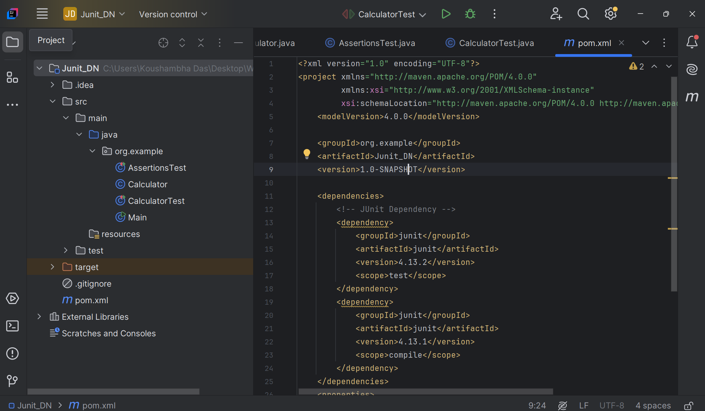

Exercise 3: Assertions in Junit:

CODE:

package org.example;  
  
import org.junit.Test;  
import static org.junit.Assert.*;  
public class AssertionsTest {  
 @Test  
 public void testAssertions() {  
 *assertEquals*(5, 2 + 3);  
 *assertTrue*(5 > 3);  
 *assertFalse*(5 < 3);  
 String str = null;  
 *assertNull*(str);  
 *assertNotNull*("JUnit", "JUnit");  
 }  
}

OUTPUT:

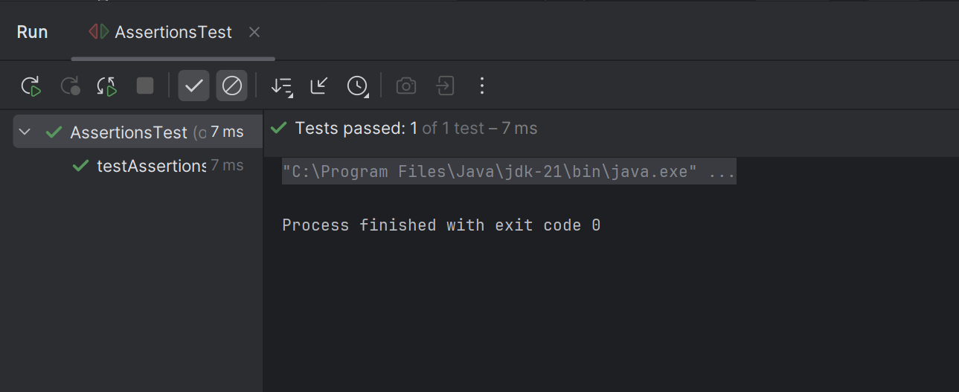

Exercise 4: Arrange-Act-Assert (AAA) Pattern, Test Fixtures, Setup and Teardown Methods in Junit:

CODE:

package org.example;  
  
public class Calculator {  
 public int add(int a, int b) {  
 return a + b;  
 }  
 public int subtract(int a, int b) {  
 return a - b;  
 }  
}

package org.example;  
  
import org.junit.After;  
import org.junit.Before;  
import org.junit.Test;  
import static org.junit.Assert.*;  
  
public class CalculatorTest {  
  
 private Calculator calculator;  
  
 @Before  
 public void setUp() {  
 calculator = new Calculator();  
 System.*out*.println("Setup complete");  
 }  
  
 @After  
 public void tearDown() {  
 calculator = null;  
 System.*out*.println("Teardown complete");  
 }  
  
 @Test  
 public void testAddition() {  
 int a = 10;  
 int b = 5;  
 int result = calculator.add(a, b);  
 *assertEquals*(15, result);  
 }  
  
 @Test  
 public void testSubtraction() {  
 int a = 10;  
 int b = 3;  
 int result = calculator.subtract(a, b);  
 *assertEquals*(7, result);  
 }  
}

**OUTPUT**:

