**Exercise 1: Control Structures**

**Scenario 1:**

**CODE**:

DECLARE

CURSOR cur_customers IS

SELECT c.CustomerID, l.LoanID, l.InterestRate

FROM Customers c

JOIN Loans l ON c.CustomerID = l.CustomerID

WHERE MONTHS_BETWEEN(SYSDATE, c.DOB) / 12 > 60;

BEGIN

FOR rec IN cur_customers LOOP

UPDATE Loans

SET InterestRate = InterestRate - 1

WHERE LoanID = rec.LoanID;

END LOOP;

COMMIT;

END;

/

**OUTPUT**:

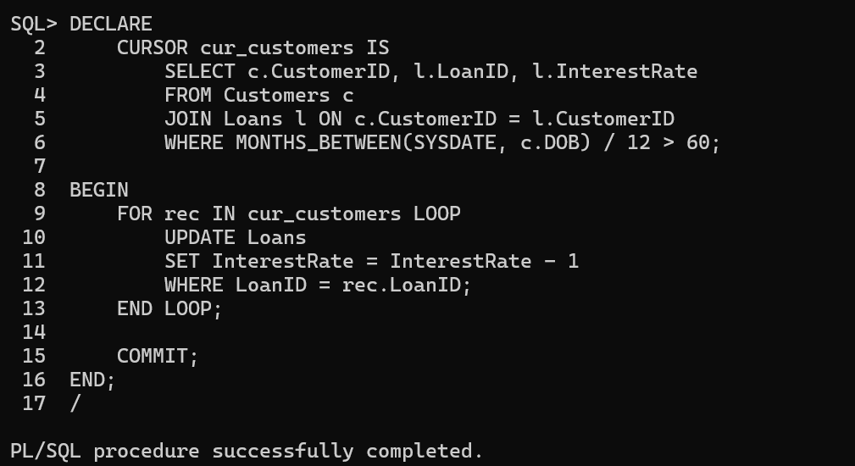

**Scenario 2:**

**CODE**:

ALTER TABLE Customers ADD IsVIP VARCHAR2(5);

DECLARE

CURSOR cur_customers IS

SELECT CustomerID FROM Customers WHERE Balance > 10000;

BEGIN

FOR rec IN cur_customers LOOP

UPDATE Customers

SET IsVIP = 'TRUE'

WHERE CustomerID = rec.CustomerID;

END LOOP;

COMMIT;

END;

/

**OUTPUT**:

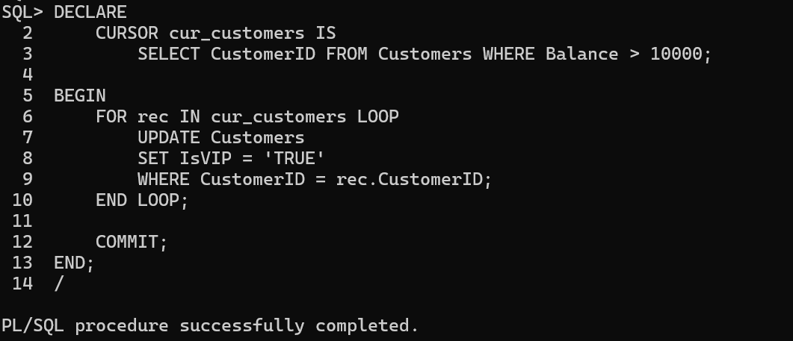

**Scenario 3:**

**CODE**:

DECLARE

CURSOR cur_loans IS

SELECT l.LoanID, c.Name, l.EndDate

FROM Loans l

JOIN Customers c ON l.CustomerID = c.CustomerID

WHERE l.EndDate BETWEEN SYSDATE AND SYSDATE + 30;

BEGIN

FOR rec IN cur_loans LOOP

DBMS_OUTPUT.PUT_LINE('Reminder: Loan ID ' || rec.LoanID ||

' for ' || rec.Name ||

' is due on ' || TO_CHAR(rec.EndDate, 'DD-MON-YYYY'));

END LOOP;

END;

/

**OUTPUT**:

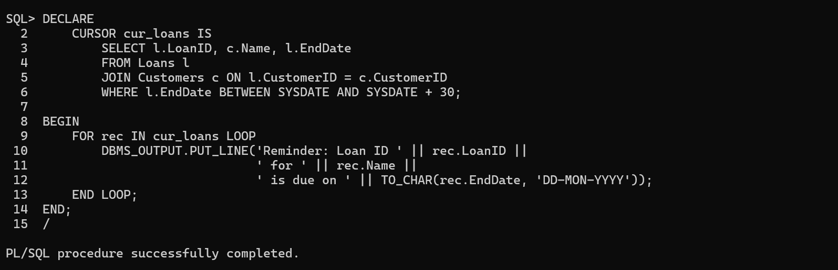

**Exercise 3: Stored Procedures**

**Scenario 1:**

**CODE:**

CREATE OR REPLACE PROCEDURE ProcessMonthlyInterest IS

BEGIN

UPDATE Accounts

SET Balance = Balance + (Balance * 0.01),

LastModified = SYSDATE

WHERE LOWER(AccountType) = 'savings';

COMMIT;

END;

/

**OUTPUT:**

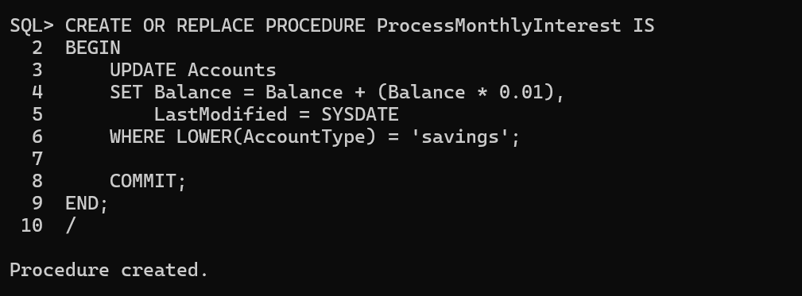

**Scenario 2:**

**CODE:**

CREATE OR REPLACE PROCEDURE UpdateEmployeeBonus (

p_department IN VARCHAR2,

p_bonus_percent IN NUMBER

) IS

BEGIN

UPDATE Employees

SET Salary = Salary + (Salary * p_bonus_percent / 100)

WHERE Department = p_department;

COMMIT;

END;

/

**OUTPUT:**

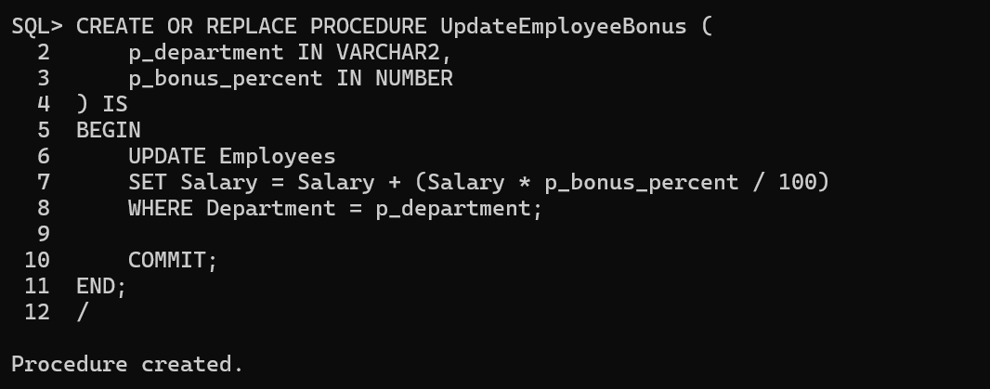

**Scenario 3:**

**CODE:**

CREATE SEQUENCE Transactions_seq START WITH 3 INCREMENT BY 1;

CREATE OR REPLACE PROCEDURE TransferFunds (

p_from_account IN NUMBER,

p_to_account IN NUMBER,

p_amount IN NUMBER

) IS

v_balance NUMBER;

BEGIN

-- Lock the source row and check balance

SELECT Balance INTO v_balance

FROM Accounts

WHERE AccountID = p_from_account

FOR UPDATE;

IF v_balance < p_amount THEN

RAISE_APPLICATION_ERROR(-20001, 'Insufficient balance in source account.');

END IF;

-- Debit source account

UPDATE Accounts

SET Balance = Balance - p_amount,

LastModified = SYSDATE

WHERE AccountID = p_from_account;

-- Credit destination account

UPDATE Accounts

SET Balance = Balance + p_amount,

LastModified = SYSDATE

WHERE AccountID = p_to_account;

-- Insert transaction records

INSERT INTO Transactions (TransactionID, AccountID, TransactionDate, Amount, TransactionType)

VALUES (Transactions_seq.NEXTVAL, p_from_account, SYSDATE, p_amount, 'Debit');

INSERT INTO Transactions (TransactionID, AccountID, TransactionDate, Amount, TransactionType)

VALUES (Transactions_seq.NEXTVAL, p_to_account, SYSDATE, p_amount, 'Credit');

COMMIT;

END;

/

**OUTPUT:**

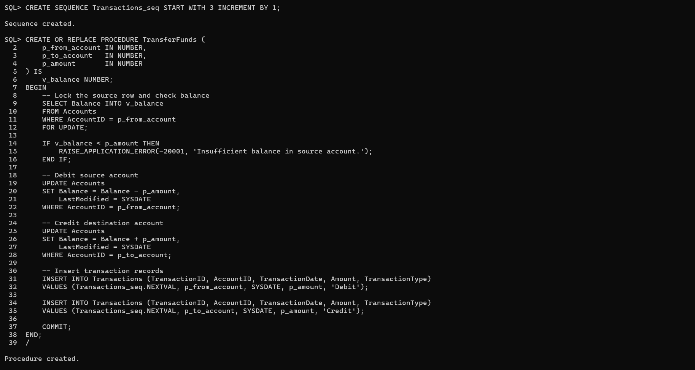

**Schema to be Created**

*CREATE TABLE Customers (*

*CustomerID NUMBER PRIMARY KEY,*

*Name VARCHAR2(100),*

*DOB DATE,*

*Balance NUMBER,*

*LastModified DATE*

*);*

*CREATE TABLE Accounts (*

*AccountID NUMBER PRIMARY KEY,*

*CustomerID NUMBER,*

*AccountType VARCHAR2(20),*

*Balance NUMBER,*

*LastModified DATE,*

*FOREIGN KEY (CustomerID) REFERENCES Customers(CustomerID)*

*);*

*CREATE TABLE Transactions (*

*TransactionID NUMBER PRIMARY KEY,*

*AccountID NUMBER,*

*TransactionDate DATE,*

*Amount NUMBER,*

*TransactionType VARCHAR2(10),*

*FOREIGN KEY (AccountID) REFERENCES Accounts(AccountID)*

*);*

*CREATE TABLE Loans (*

*LoanID NUMBER PRIMARY KEY,*

*CustomerID NUMBER,*

*LoanAmount NUMBER,*

*InterestRate NUMBER,*

*StartDate DATE,*

*EndDate DATE,*

*FOREIGN KEY (CustomerID) REFERENCES Customers(CustomerID)*

*);*

*CREATE TABLE Employees (*

*EmployeeID NUMBER PRIMARY KEY,*

*Name VARCHAR2(100),*

*Position VARCHAR2(50),*

*Salary NUMBER,*

*Department VARCHAR2(50),*

*HireDate DATE*

*);*

**Example Scripts for Sample Data Insertion**

*INSERT INTO Customers (CustomerID, Name, DOB, Balance, LastModified)*

*VALUES (1, 'John Doe', TO_DATE('1985-05-15', 'YYYY-MM-DD'), 1000, SYSDATE);*

*INSERT INTO Customers (CustomerID, Name, DOB, Balance, LastModified)*

*VALUES (2, 'Jane Smith', TO_DATE('1990-07-20', 'YYYY-MM-DD'), 1500, SYSDATE);*

*INSERT INTO Accounts (AccountID, CustomerID, AccountType, Balance, LastModified)*

*VALUES (1, 1, 'Savings', 1000, SYSDATE);*

*INSERT INTO Accounts (AccountID, CustomerID, AccountType, Balance, LastModified)*

*VALUES (2, 2, 'Checking', 1500, SYSDATE);*

*INSERT INTO Transactions (TransactionID, AccountID, TransactionDate, Amount, TransactionType)*

*VALUES (1, 1, SYSDATE, 200, 'Deposit');*

*INSERT INTO Transactions (TransactionID, AccountID, TransactionDate, Amount, TransactionType)*

*VALUES (2, 2, SYSDATE, 300, 'Withdrawal');*

*INSERT INTO Loans (LoanID, CustomerID, LoanAmount, InterestRate, StartDate, EndDate)*

*VALUES (1, 1, 5000, 5, SYSDATE, ADD_MONTHS(SYSDATE, 60));*

*INSERT INTO Employees (EmployeeID, Name, Position, Salary, Department, HireDate)*

*VALUES (1, 'Alice Johnson', 'Manager', 70000, 'HR', TO_DATE('2015-06-15', 'YYYY-MM-DD'));*

*INSERT INTO Employees (EmployeeID, Name, Position, Salary, Department, HireDate)*

*VALUES (2, 'Bob Brown', 'Developer', 60000, 'IT', TO_DATE('2017-03-20', 'YYYY-MM-DD'));*