**Exercise 1: Configuring a Basic Spring Application**

**Code:**

package com.library;  
  
import com.library.service.BookService;  
import org.springframework.context.ApplicationContext;  
import org.springframework.context.support.ClassPathXmlApplicationContext;  
  
public class LibraryManagementApplication {  
 public static void main(String[] args) {  
 ApplicationContext context = new ClassPathXmlApplicationContext("applicationContext.xml");  
 BookService bookService = context.getBean("bookService", BookService.class);  
 bookService.addBook("Spring Starter");  
 }  
}

package com.library.repository;  
  
public class BookRepository {  
 public void saveBook(String bookName) {  
 System.*out*.println("Book saved:" + bookName);  
 }  
}

package com.library.service;  
  
import com.library.repository.BookRepository;  
  
public class BookService {  
 private BookRepository bookRepository;  
 public void setBookRepository(BookRepository bookRepository) {  
 this.bookRepository = bookRepository;  
 }  
 public void addBook(String bookName) {  
 bookRepository.saveBook(bookName);  
 }  
}

<?xml version="1.0" encoding="UTF-8"?>  
<beans xmlns="http://www.springframework.org/schema/beans"  
 xmlns:xsi="http://www.w3.org/2001/XMLSchema-instance"  
 xsi:schemaLocation="  
 http://www.springframework.org/schema/beans  
 http://www.springframework.org/schema/beans/spring-beans.xsd">  
  
 <bean id="bookRepository" class="com.library.repository.BookRepository"/>  
 <bean id="bookService" class="com.library.service.BookService">  
 <property name="bookRepository" ref="bookRepository"/>  
 </bean>  
  
</beans>

<?xml version="1.0" encoding="UTF-8"?>  
<project xmlns="http://maven.apache.org/POM/4.0.0"  
 xmlns:xsi="http://www.w3.org/2001/XMLSchema-instance"  
 xsi:schemaLocation="http://maven.apache.org/POM/4.0.0 http://maven.apache.org/xsd/maven-4.0.0.xsd">  
 <modelVersion>4.0.0</modelVersion>  
  
 <groupId>com.library</groupId>  
 <artifactId>LibraryManagement</artifactId>  
 <version>1.0-SNAPSHOT</version>  
  
 <dependencies>  
 <!-- Spring Core -->  
 <dependency>  
 <groupId>org.springframework</groupId>  
 <artifactId>spring-context</artifactId>  
 <version>6.2.7</version>  
 </dependency>  
 </dependencies>  
  
 <properties>  
 <maven.compiler.source>21</maven.compiler.source>  
 <maven.compiler.target>21</maven.compiler.target>  
 <project.build.sourceEncoding>UTF-8</project.build.sourceEncoding>  
 </properties>  
  
</project>

**Output**:

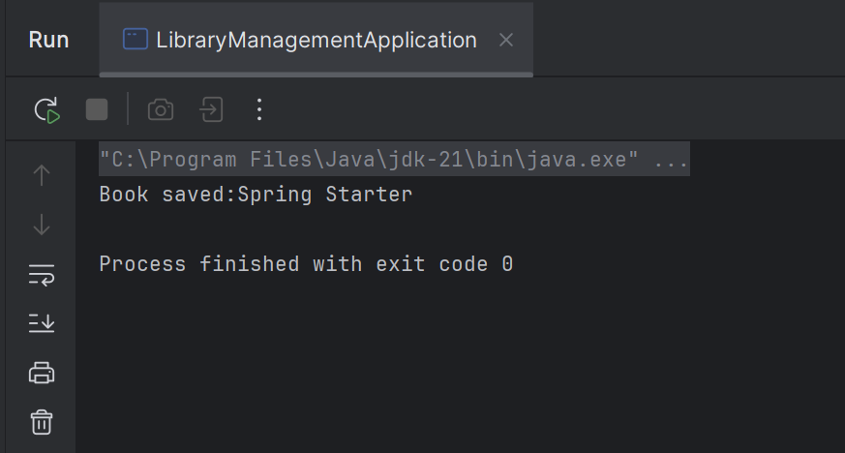

**Exercise 2: Implementing Dependency Injection**

**Code:**

<?xml version="1.0" encoding="UTF-8"?>  
<beans xmlns="http://www.springframework.org/schema/beans"  
 xmlns:xsi="http://www.w3.org/2001/XMLSchema-instance"  
 xsi:schemaLocation="  
 http://www.springframework.org/schema/beans  
 http://www.springframework.org/schema/beans/spring-beans.xsd">  
  
 <bean id="bookRepository" class="com.library.repository.BookRepository"/>  
 <bean id="bookService" class="com.library.service.BookService">  
 <property name="bookRepository" ref="bookRepository"/>  
 </bean>  
  
</beans>

**Exercise 4: Creating and Configuring a Maven Project**

**Code**:

<?xml version="1.0" encoding="UTF-8"?>  
<project xmlns="http://maven.apache.org/POM/4.0.0"  
 xmlns:xsi="http://www.w3.org/2001/XMLSchema-instance"  
 xsi:schemaLocation="http://maven.apache.org/POM/4.0.0 http://maven.apache.org/xsd/maven-4.0.0.xsd">  
 <modelVersion>4.0.0</modelVersion>  
  
 <groupId>com.library</groupId>  
 <artifactId>LibraryManagement</artifactId>  
 <version>1.0-SNAPSHOT</version>  
  
 <dependencies>  
 <!-- Spring Core -->  
 <dependency>  
 <groupId>org.springframework</groupId>  
 <artifactId>spring-context</artifactId>  
 <version>6.2.7</version>  
 </dependency>  
  
 <!-- Spring AOP -->  
 <dependency>  
 <groupId>org.springframework</groupId>  
 <artifactId>spring-aop</artifactId>  
 <version>5.3.33</version>  
 </dependency>  
  
 <!-- Spring WebMVC (optional, for future exercises) -->  
 <dependency>  
 <groupId>org.springframework</groupId>  
 <artifactId>spring-webmvc</artifactId>  
 <version>6.1.14</version>  
 </dependency>  
 </dependencies>  
  
 <properties>  
 <maven.compiler.source>21</maven.compiler.source>  
 <maven.compiler.target>21</maven.compiler.target>  
 <project.build.sourceEncoding>UTF-8</project.build.sourceEncoding>  
 </properties>  
  
</project>