Week1_Design Principles and Patterns

Exercise 1: Implementing the Singleton Pattern
Program:
Logger class:
package singleton;
public class Logger {
private static Logger instance;
private Logger() {
System.out.println("Logger instance created.");
}
public static Logger getInstance() {
if (instance == null) {
synchronized (Logger.class) {
if (instance == null) {
instance = new Logger();
}
}
}
return instance;
}

public void log(String message) {
System.out.println("LOG: " + message);
}
}
Class SingletonTest :
package singleton;

public class SingletonTest {

public static void main(String[] args) {
System.out.println("--- Testing Logger Singleton ---");

System.out.println("Attempting to get first logger instance...");
Logger logger1 = Logger.getInstance();
logger1.log("This is the first log message.");

System.out.println("\nAttempting to get second logger instance...");
Logger logger2 = Logger.getInstance();
logger2.log("This is the second log message.");

System.out.println("\nAttempting to get third logger instance...");
Logger logger3 = Logger.getInstance();
logger3.log("This is the third log message.");

System.out.println("\n--- Verifying Instances ---");
boolean areSameInstance1And2 = (logger1 == logger2);
boolean areSameInstance2And3 = (logger2 == logger3);

System.out.println("Are logger1 and logger2 the same instance? " + areSameInstance1And2);
System.out.println("Are logger2 and logger3 the same instance? " + areSameInstance2And3);

if (areSameInstance1And2 && areSameInstance2And3) {
System.out.println("\nSuccess: All logger instances are indeed the same.");
System.out.println("The Singleton pattern is correctly implemented.");
} else {
System.out.println("\nFailure: Different logger instances were created.");
System.out.println("The Singleton pattern might not be correctly implemented.");
}

System.out.println("\n--- End of Test ---");
}
}
OUTPUT :
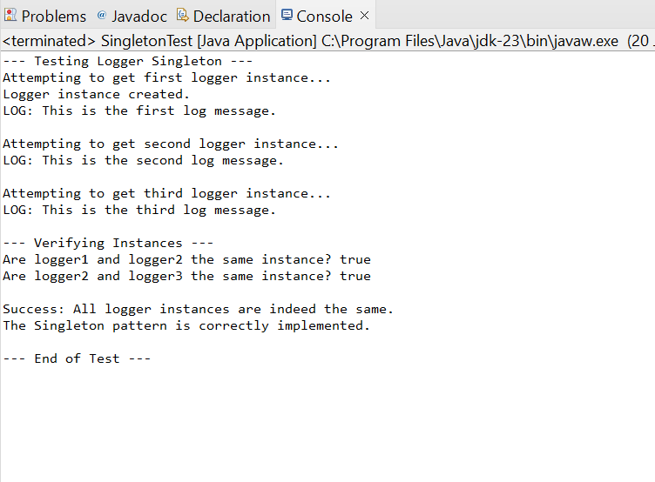
Exercise 2: Implementing the Factory Method Pattern
Program:
package factory;

/**
* Product Interface: Defines the common interface for all document types.
* Concrete products will implement this interface.
*/
interface Document {
void open();
void save();
void close();
}

/**
* Concrete Product: Implements the Document interface for a Word document.
*/
class WordDocument implements Document {
@Override
public void open() {
System.out.println("Opening Word Document...");
}

@Override
public void save() {
System.out.println("Saving Word Document...");
}

@Override
public void close() {
System.out.println("Closing Word Document.");
}
}

/**
* Concrete Product: Implements the Document interface for a PDF document.
*/
class PdfDocument implements Document {
@Override
public void open() {
System.out.println("Opening PDF Document...");
}

@Override
public void save() {
System.out.println("Saving PDF Document...");
}

@Override
public void close() {
System.out.println("Closing PDF Document.");
}
}

/**
* Concrete Product: Implements the Document interface for an Excel document.
*/
class ExcelDocument implements Document {
@Override
public void open() {
System.out.println("Opening Excel Document...");
}

@Override
public void save() {
System.out.println("Saving Excel Document...");
}

@Override
public void close() {
System.out.println("Closing Excel Document.");
}
}

/**
* Creator Interface/Abstract Class: Declares the factory method,
* which returns an object of the Product type.
*/
abstract class DocumentCreator {
// The factory method
public abstract Document createDocument();

// Other operations that might use the factory method
public void printDocumentDetails() {
Document doc = createDocument(); // Call the factory method
doc.open();
System.out.println("Document created by " + this.getClass().getSimpleName());
doc.save();
doc.close();
}
}

/**
* Concrete Creator: Overrides the factory method to return a specific
* concrete product (WordDocument).
*/
class WordDocumentCreator extends DocumentCreator {
@Override
public Document createDocument() {
return new WordDocument();
}
}

/**
* Concrete Creator: Overrides the factory method to return a specific
* concrete product (PdfDocument).
*/
class PdfDocumentCreator extends DocumentCreator {
@Override
public Document createDocument() {
return new PdfDocument();
}
}

/**
* Concrete Creator: Overrides the factory method to return a specific
* concrete product (ExcelDocument).
*/
class ExcelDocumentCreator extends DocumentCreator {
@Override
public Document createDocument() {
return new ExcelDocument();
}
}

/**
* Client Code: Demonstrates the usage of the Factory Method Pattern.
* The client code works with the creator interface rather than concrete creators,
* making it flexible and easy to introduce new document types.
* This class now contains the main method and encapsulates all other classes.
*/
public class FactoryMethodProgram {
public static void main(String[] args) {
System.out.println("--- Demonstrating Factory Method Pattern (Single File) ---");

// Create a Word Document using its creator
System.out.println("\nCreating Word Document:");
DocumentCreator wordCreator = new WordDocumentCreator();
Document wordDoc = wordCreator.createDocument();
wordDoc.open();
wordDoc.save();
wordDoc.close();

// Demonstrate the utility method in DocumentCreator
System.out.println("\nUsing creator utility for PDF Document:");
DocumentCreator pdfCreator = new PdfDocumentCreator();
pdfCreator.printDocumentDetails(); // This calls createDocument internally

// Create an Excel Document using its creator
System.out.println("\nCreating Excel Document:");
DocumentCreator excelCreator = new ExcelDocumentCreator();
Document excelDoc = excelCreator.createDocument();
excelDoc.open();
excelDoc.save();
excelDoc.close();

System.out.println("\n--- Factory Method Test Complete ---");
}
}

OUTPUT:

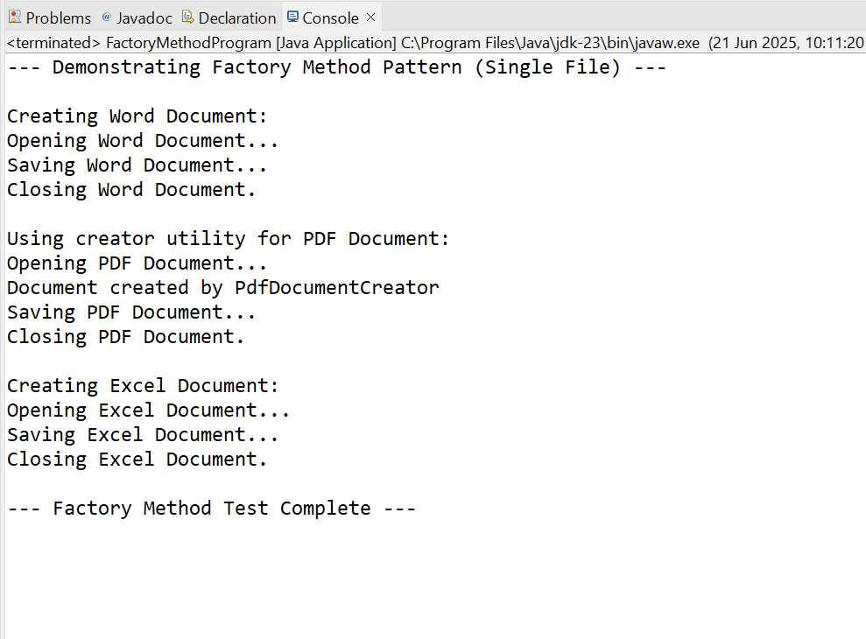
Exercise 3: Implementing the Builder Pattern:
Program:
package builderpattern;

/**
* Product Class: Computer
* Represents the complex object to be built.
* It has various attributes, some of which may be optional.
*/
class Computer {
// Required attributes
private String cpu;
private int ramGB;
private int storageGB;

// Optional attributes
private boolean hasGraphicsCard;
private String operatingSystem;
private String keyboardType;
private String mouseType;

// Private constructor to enforce creation through the Builder.
// It takes the Builder instance as a parameter to get all attribute values.
private Computer(ComputerBuilder builder) {
this.cpu = builder.cpu;
this.ramGB = builder.ramGB;
this.storageGB = builder.storageGB;
this.hasGraphicsCard = builder.hasGraphicsCard;
this.operatingSystem = builder.operatingSystem;
this.keyboardType = builder.keyboardType;
this.mouseType = builder.mouseType;
}

// Getters for all attributes
public String getCpu() {
return cpu;
}

public int getRamGB() {
return ramGB;
}

public int getStorageGB() {
return storageGB;
}

public boolean hasGraphicsCard() {
return hasGraphicsCard;
}

public String getOperatingSystem() {
return operatingSystem;
}

public String getKeyboardType() {
return keyboardType;
}

public String getMouseType() {
return mouseType;
}

@Override
public String toString() {
return "Computer Configuration:\n" +
" CPU: " + cpu + "\n" +
" RAM: " + ramGB + "GB\n" +
" Storage: " + storageGB + "GB\n" +
" Graphics Card: " + (hasGraphicsCard ? "Included" : "Not Included") + "\n" +
" OS: " + (operatingSystem != null ? operatingSystem : "N/A") + "\n" +
" Keyboard: " + (keyboardType != null ? keyboardType : "N/A") + "\n" +
" Mouse: " + (mouseType != null ? mouseType : "N/A");
}

/**
* Builder Class: ComputerBuilder
* A static nested class that provides a fluent API for building Computer objects.
*/
public static class ComputerBuilder {
// Same attributes as Computer, initially set to default/null
private String cpu;
private int ramGB;
private int storageGB;
private boolean hasGraphicsCard = false; // Default to false
private String operatingSystem = null;
private String keyboardType = null;
private String mouseType = null;

// Constructor for required attributes
public ComputerBuilder(String cpu, int ramGB, int storageGB) {
this.cpu = cpu;
this.ramGB = ramGB;
this.storageGB = storageGB;
}

// Methods to set optional attributes, returning the builder itself for chaining
public ComputerBuilder withGraphicsCard(boolean hasGraphicsCard) {
this.hasGraphicsCard = hasGraphicsCard;
return this;
}

public ComputerBuilder withOperatingSystem(String operatingSystem) {
this.operatingSystem = operatingSystem;
return this;
}

public ComputerBuilder withKeyboardType(String keyboardType) {
this.keyboardType = keyboardType;
return this;
}

public ComputerBuilder withMouseType(String mouseType) {
this.mouseType = mouseType;
return this;
}

/**
* build() method: Creates and returns a Computer instance.
*/
public Computer build() {
return new Computer(this);
}
}
}

/**
* Test Class: BuilderPatternProgram
* Demonstrates the creation of different configurations of Computer
* using the Builder pattern.
*/
public class BuilderPatternProgram {
public static void main(String[] args) {
System.out.println("--- Demonstrating Builder Pattern ---");

// 1. Build a basic gaming PC
System.out.println("\nBuilding a Basic Gaming PC:");
Computer gamingPC = new Computer.ComputerBuilder("Intel i7", 16, 512)
.withGraphicsCard(true)
.withOperatingSystem("Windows 11")
.withMouseType("Gaming Mouse")
.build();
System.out.println(gamingPC);

// 2. Build a high-end workstation
System.out.println("\nBuilding a High-End Workstation:");
Computer workstation = new Computer.ComputerBuilder("AMD Ryzen 9", 64, 2048)
.withGraphicsCard(true)
.withOperatingSystem("Linux")
.withKeyboardType("Mechanical Keyboard")
.withMouseType("Ergonomic Mouse")
.build();
System.out.println(workstation);

// 3. Build a simple office PC (without graphics card or specific peripherals)
System.out.println("\nBuilding a Simple Office PC:");
Computer officePC = new Computer.ComputerBuilder("Intel i3", 8, 256)
.withOperatingSystem("Windows 10")
.build();
System.out.println(officePC);

System.out.println("\n--- Builder Pattern Test Complete ---");
}
}

OUTPUT:

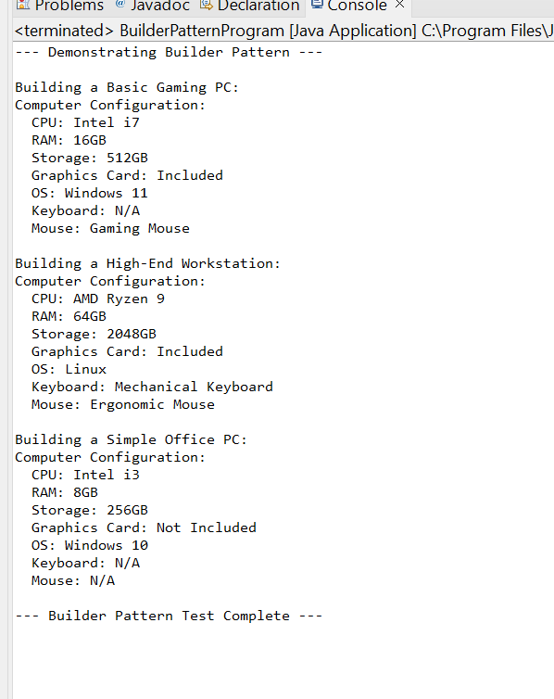

Exercise 4: Implementing the Adapter Pattern
Program:
package adapterpattern;

/**
* Target Interface: PaymentProcessor
* This is the interface that our client code expects to work with.
*/
interface PaymentProcessor {
void processPayment(double amount);
}

/**
* Adaptee Class 1: OldPaymentGatewayA
* An existing third-party payment gateway with a specific interface.
* It has its own methods that are not compatible with PaymentProcessor directly.
*/
class OldPaymentGatewayA {
public void makePaymentA(double amount) {
System.out.println("Processing payment of $" + amount + " through OldPaymentGatewayA.");
// Simulate complex logic specific to Gateway A
}
}

/**
* Adaptee Class 2: LegacyPaymentGatewayB
* Another existing third-party payment gateway with a different interface.
*/
class LegacyPaymentGatewayB {
public void executePaymentB(double value) {
System.out.println("Initiating payment for amount " + value + " via LegacyPaymentGatewayB.");
// Simulate complex logic specific to Gateway B
}

public void completeTransaction() {
System.out.println("LegacyPaymentGatewayB: Transaction completed.");
}
}

/**
* Adapter Class 1: PaymentGatewayAAdapter
* Adapts OldPaymentGatewayA to the PaymentProcessor interface.
* It implements the Target interface and wraps an instance of the Adaptee.
*/
class PaymentGatewayAAdapter implements PaymentProcessor {
private OldPaymentGatewayA gatewayA; // Reference to the adaptee

public PaymentGatewayAAdapter(OldPaymentGatewayA gatewayA) {
this.gatewayA = gatewayA;
}

@Override
public void processPayment(double amount) {
System.out.println("Adapter: Converting processPayment call to makePaymentA for Gateway A.");
gatewayA.makePaymentA(amount); // Delegates the call to the adaptee's specific method
}
}

/**
* Adapter Class 2: PaymentGatewayBAdapter
* Adapts LegacyPaymentGatewayB to the PaymentProcessor interface.
*/
class PaymentGatewayBAdapter implements PaymentProcessor {
private LegacyPaymentGatewayB gatewayB; // Reference to the adaptee

public PaymentGatewayBAdapter(LegacyPaymentGatewayB gatewayB) {
this.gatewayB = gatewayB;
}

@Override
public void processPayment(double amount) {
System.out.println("Adapter: Converting processPayment call to executePaymentB for Gateway B.");
gatewayB.executePaymentB(amount); // Delegates the call to the adaptee's specific method
gatewayB.completeTransaction(); // Can also handle additional, related calls if needed
}
}

/**
* Test Class: AdapterPatternProgram
* Demonstrates the use of different payment gateways through their respective adapters.
* The client code (main method) interacts solely with the common PaymentProcessor interface,
* making it independent of the specific gateway implementations.
*/
public class AdapterPatternProgram {
public static void main(String[] args) {
System.out.println("--- Demonstrating Adapter Pattern ---");

// Client code expects a PaymentProcessor interface
PaymentProcessor processor1;
PaymentProcessor processor2;

// Scenario 1: Integrate with OldPaymentGatewayA using its adapter
System.out.println("\nIntegrating with OldPaymentGatewayA:");
OldPaymentGatewayA oldGateway = new OldPaymentGatewayA();
processor1 = new PaymentGatewayAAdapter(oldGateway);
processor1.processPayment(100.50);

// Scenario 2: Integrate with LegacyPaymentGatewayB using its adapter
System.out.println("\nIntegrating with LegacyPaymentGatewayB:");
LegacyPaymentGatewayB legacyGateway = new LegacyPaymentGatewayB();
processor2 = new PaymentGatewayBAdapter(legacyGateway);
processor2.processPayment(250.75);

// You can easily add more payment gateways and their adapters
// without modifying the client code (this main method).

System.out.println("\n--- Adapter Pattern Test Complete ---");
}
}
OUTPUT:
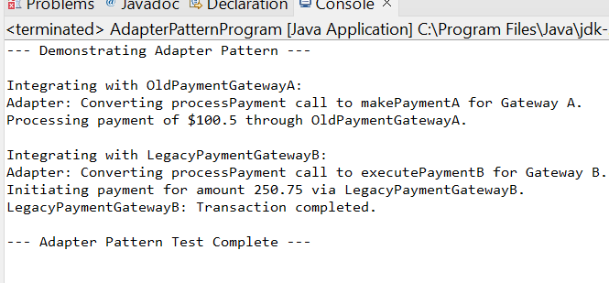
Exercise 5: Implementing the Decorator Pattern
Program:
package decoratorpattern;

/**
* Component Interface: Notifier
* Defines the common operation that both concrete components and decorators will implement.
*/
interface Notifier {
void send(String message);
}

/**
* Concrete Component: EmailNotifier
* The base concrete implementation of the Notifier.
*/
class EmailNotifier implements Notifier {
@Override
public void send(String message) {
System.out.println("Sending Email: " + message);
}
}

/**
* Abstract Decorator: NotifierDecorator
* Implements the Component interface and holds a reference to a Component object.
* It also implements the send method by delegating to the wrapped component.
*/
abstract class NotifierDecorator implements Notifier {
protected Notifier wrappedNotifier; // The notifier being decorated

public NotifierDecorator(Notifier notifier) {
this.wrappedNotifier = notifier;
}

@Override
public void send(String message) {
wrappedNotifier.send(message); // Delegates to the wrapped notifier
}
}

/**
* Concrete Decorator 1: SMSNotifierDecorator
* Adds SMS sending functionality to the wrapped Notifier.
*/
class SMSNotifierDecorator extends NotifierDecorator {
public SMSNotifierDecorator(Notifier notifier) {
super(notifier);
}

@Override
public void send(String message) {
super.send(message); // Call the wrapped notifier's send method
sendSMS(message); // Add SMS specific functionality
}

private void sendSMS(String message) {
System.out.println("Sending SMS: " + message);
}
}

/**
* Concrete Decorator 2: SlackNotifierDecorator
* Adds Slack notification functionality to the wrapped Notifier.
*/
class SlackNotifierDecorator extends NotifierDecorator {
public SlackNotifierDecorator(Notifier notifier) {
super(notifier);
}

@Override
public void send(String message) {
super.send(message); // Call the wrapped notifier's send method
sendSlackMessage(message); // Add Slack specific functionality
}

private void sendSlackMessage(String message) {
System.out.println("Sending Slack Message: " + message);
}
}

/**
* Test Class: DecoratorPatternProgram
* Demonstrates sending notifications via multiple channels using decorators.
*/
public class DecoratorPatternProgram {
public static void main(String[] args) {
System.out.println("--- Demonstrating Decorator Pattern ---");

// 1. Send a basic email notification
System.out.println("\nSending only Email Notification:");
Notifier emailOnlyNotifier = new EmailNotifier();
emailOnlyNotifier.send("Hello World!");

// 2. Send notification via Email and SMS
System.out.println("\nSending Email and SMS Notification:");
Notifier emailAndSMSNotifier = new SMSNotifierDecorator(new EmailNotifier());
emailAndSMSNotifier.send("Your order has shipped!");

// 3. Send notification via Email, SMS, and Slack
System.out.println("\nSending Email, SMS, and Slack Notification:");
Notifier fullNotifier = new SlackNotifierDecorator(new SMSNotifierDecorator(new EmailNotifier()));
fullNotifier.send("System update completed successfully.");

System.out.println("\n--- Decorator Pattern Test Complete ---");
}
}

OUTPUT:
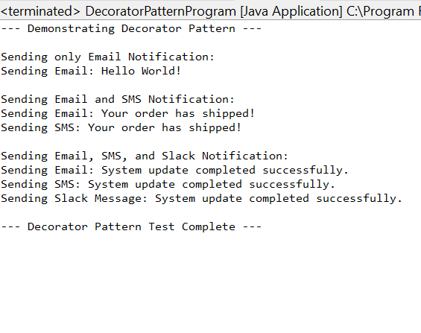
Exercise 6: Implementing the Proxy Pattern
Program:
package proxypattern;

/**
* Subject Interface: Image
* Defines the common interface for RealImage and ProxyImage.
*/
interface Image {
void display();
}

/**
* Real Subject Class: RealImage
* Represents the actual image that needs to be loaded (potentially an expensive operation).
*/
class RealImage implements Image {
private String filename;

public RealImage(String filename) {
this.filename = filename;
loadFromRemoteServer(filename); // Simulates expensive loading
}

private void loadFromRemoteServer(String filename) {
System.out.println("Loading image: " + filename + " from remote server...");
try {
Thread.sleep(2000); // Simulate network delay
} catch (InterruptedException e) {
Thread.currentThread().interrupt();
}
System.out.println("Image " + filename + " loaded.");
}

@Override
public void display() {
System.out.println("Displaying image: " + filename);
}
}

/**
* Proxy Class: ProxyImage
* Controls access to RealImage, providing lazy initialization and caching.
*/
class ProxyImage implements Image {
private String filename;
private RealImage realImage; // Reference to the real subject
private boolean isCached = false; // Simple caching mechanism

public ProxyImage(String filename) {
this.filename = filename;
}

@Override
public void display() {
if (!isCached) {
System.out.println("Proxy: Image not cached. Initializing RealImage for " + filename + ".");
if (realImage == null) {
realImage = new RealImage(filename); // Lazy initialization
}
isCached = true; // Mark as cached after first load
} else {
System.out.println("Proxy: Image " + filename + " is already cached. Displaying directly.");
}
realImage.display(); // Delegate the display call to the real image
}
}

/**
* Test Class: ProxyPatternProgram
* Demonstrates the use of ProxyImage to load and display images.
*/
public class ProxyPatternProgram {
public static void main(String[] args) {
System.out.println("--- Demonstrating Proxy Pattern ---");

// Image will not be loaded immediately, only when display() is called
System.out.println("\nFirst image creation (lazy load):");
Image image1 = new ProxyImage("photo1.jpg");
// No "Loading image..." message yet

System.out.println("\nFirst call to display() for photo1.jpg:");
image1.display(); // This will trigger the actual loading

System.out.println("\nSecond call to display() for photo1.jpg:");
image1.display(); // This should use the cached image

System.out.println("\nCreating and displaying a second image:");
Image image2 = new ProxyImage("document_scan.png");
image2.display(); // This will trigger loading for the new image

System.out.println("\n--- Proxy Pattern Test Complete ---");
}
}
OUTPUT:
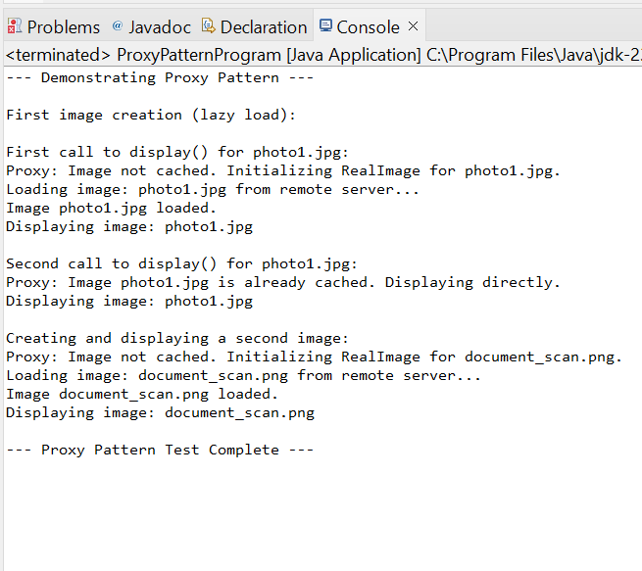
Exercise 7: Implementing the Observer Pattern
Program:
package observerpattern;
import java.util.ArrayList;
import java.util.List;

/**
* Observer Interface: StockObserver
* Defines the update method that concrete observers will implement
* to receive notifications from the subject.
*/
interface StockObserver {
void update(String stockSymbol, double price);
}

/**
* Subject Interface: StockSubject
* Defines methods for attaching, detaching, and notifying observers.
*/
interface StockSubject {
void registerObserver(StockObserver observer);
void deregisterObserver(StockObserver observer);
void notifyObservers();
}

/**
* Concrete Subject: StockMarket
* Maintains a list of observers and notifies them when its state (stock prices) changes.
*/
class StockMarket implements StockSubject {
private List<StockObserver> observers = new ArrayList<>();
private String stockSymbol;
private double price;

public StockMarket(String stockSymbol, double initialPrice) {
this.stockSymbol = stockSymbol;
this.price = initialPrice;
System.out.println("StockMarket created for " + stockSymbol + " with initial price $" + initialPrice);
}

@Override
public void registerObserver(StockObserver observer) {
observers.add(observer);
System.out.println("Observer registered: " + observer.getClass().getSimpleName());
}

@Override
public void deregisterObserver(StockObserver observer) {
observers.remove(observer);
System.out.println("Observer deregistered: " + observer.getClass().getSimpleName());
}

/**
* Notifies all registered observers about the change in stock price.
*/
@Override
public void notifyObservers() {
System.out.println("\nNotifying observers for " + stockSymbol + " price change to $" + price);
for (StockObserver observer : observers) {
observer.update(stockSymbol, price);
}
}

/**
* Method to change the stock price and trigger notification.
*/
public void setPrice(double newPrice) {
if (this.price != newPrice) {
System.out.println("\nStock " + stockSymbol + " price changed from $" + this.price + " to $" + newPrice);
this.price = newPrice;
notifyObservers(); // Notify observers when price changes
} else {
System.out.println("Stock " + stockSymbol + " price remains $" + newPrice + ". No notification needed.");
}
}

public String getStockSymbol() {
return stockSymbol;
}

public double getPrice() {
return price;
}
}

/**
* Concrete Observer 1: MobileAppDisplay
* Updates its display when notified of a stock price change.
*/
class MobileAppDisplay implements StockObserver {
private String name;

public MobileAppDisplay(String name) {
this.name = name;
}

@Override
public void update(String stockSymbol, double price) {
System.out.println(name + " (Mobile App): " + stockSymbol + " is now $" + price);
}
}

/**
* Concrete Observer 2: WebAppDisplay
* Updates its display when notified of a stock price change.
*/
class WebAppDisplay implements StockObserver {
private String name;

public WebAppDisplay(String name) {
this.name = name;
}

@Override
public void update(String stockSymbol, double price) {
System.out.println(name + " (Web App): " + stockSymbol + " price updated to $" + price);
}
}

/**
* Test Class: ObserverPatternProgram
* Demonstrates the registration and notification of observers.
*/
public class ObserverPatternProgram {
public static void main(String[] args) {
System.out.println("--- Demonstrating Observer Pattern ---");

// Create a StockMarket subject
StockMarket appleStock = new StockMarket("AAPL", 170.00);

// Create observers
StockObserver mobileApp1 = new MobileAppDisplay("User A's Phone");
StockObserver webApp1 = new WebAppDisplay("User B's Dashboard");
StockObserver mobileApp2 = new MobileAppDisplay("User C's Tablet");

// Register observers to the subject
appleStock.registerObserver(mobileApp1);
appleStock.registerObserver(webApp1);
appleStock.registerObserver(mobileApp2);

// Simulate stock price changes
System.out.println("\n--- Simulating Price Changes ---");

appleStock.setPrice(172.50); // Price changes, observers are notified

appleStock.setPrice(172.50); // No change, no notification

// Deregister one observer
System.out.println("\n--- Deregistering User A's Phone ---");
appleStock.deregisterObserver(mobileApp1);

appleStock.setPrice(175.00); // Price changes again, only remaining observers are notified

System.out.println("\n--- Observer Pattern Test Complete ---");
}
}

OUTPUT:
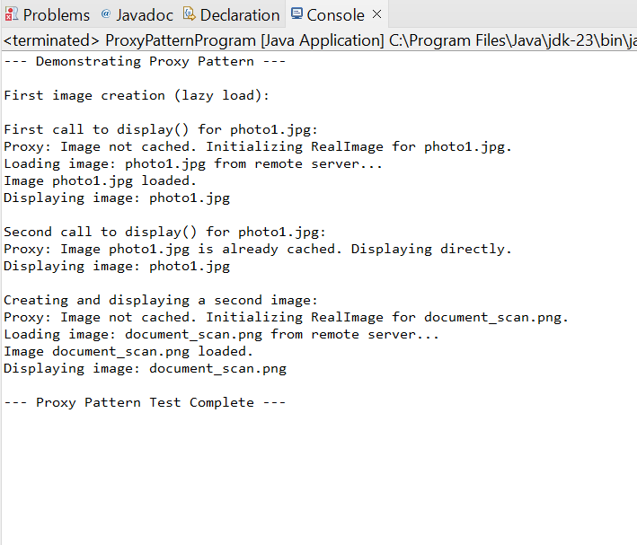

Exercise 8: Implementing the Strategy Pattern
Program:
package strategypattern;

/**
* Strategy Interface: PaymentStrategy
* Declares the common interface for all supported payment algorithms.
*/
interface PaymentStrategy {
void pay(double amount);
}

/**
* Concrete Strategy 1: CreditCardPayment
* Implements the payment logic for credit card.
*/
class CreditCardPayment implements PaymentStrategy {
private String cardNumber;
private String cardHolderName;

public CreditCardPayment(String cardNumber, String cardHolderName) {
this.cardNumber = cardNumber;
this.cardHolderName = cardHolderName;
}

@Override
public void pay(double amount) {
System.out.println("Paying $" + amount + " using Credit Card (Card No: " + cardNumber.substring(0, 4) + "XXXX XXXX " + cardNumber.substring(12) + ")");
// Simulate actual credit card processing logic
}
}

/**
* Concrete Strategy 2: PayPalPayment
* Implements the payment logic for PayPal.
*/
class PayPalPayment implements PaymentStrategy {
private String email;

public PayPalPayment(String email) {
this.email = email;
}

@Override
public void pay(double amount) {
System.out.println("Paying $" + amount + " using PayPal (Email: " + email + ")");
// Simulate actual PayPal processing logic
}
}

/**
* Concrete Strategy 3: BitcoinPayment (Example of adding a new strategy)
* Implements the payment logic for Bitcoin.
*/
class BitcoinPayment implements PaymentStrategy {
private String walletAddress;

public BitcoinPayment(String walletAddress) {
this.walletAddress = walletAddress;
}

@Override
public void pay(double amount) {
System.out.println("Paying $" + amount + " using Bitcoin (Wallet: " + walletAddress + ")");
System.out.println(" -- Please confirm transaction on your Bitcoin wallet.");
}
}

/**
* Context Class: PaymentContext
* Holds a reference to a Strategy object and delegates the payment execution to it.
* The client interacts with the context.
*/
class PaymentContext {
private PaymentStrategy paymentStrategy;

public void setPaymentStrategy(PaymentStrategy paymentStrategy) {
this.paymentStrategy = paymentStrategy;
System.out.println("Payment strategy set to: " + paymentStrategy.getClass().getSimpleName());
}

public void executePayment(double amount) {
if (paymentStrategy == null) {
System.out.println("Error: No payment strategy selected.");
return;
}
System.out.println("Attempting to process payment of $" + amount + "...");
paymentStrategy.pay(amount); // Delegates to the selected strategy
System.out.println("Payment processed.");
}
}

/**
* Test Class: StrategyPatternProgram
* Demonstrates selecting and using different payment strategies at runtime.
*/
public class StrategyPatternProgram {
public static void main(String[] args) {
System.out.println("--- Demonstrating Strategy Pattern ---");

PaymentContext paymentSystem = new PaymentContext();

// Scenario 1: Pay using Credit Card
System.out.println("\n--- Scenario 1: Credit Card Payment ---");
PaymentStrategy creditCard = new CreditCardPayment("1234567890123456", "John Doe");
paymentSystem.setPaymentStrategy(creditCard);
paymentSystem.executePayment(50.00);

// Scenario 2: Pay using PayPal
System.out.println("\n--- Scenario 2: PayPal Payment ---");
PaymentStrategy payPal = new PayPalPayment("john.doe@example.com");
paymentSystem.setPaymentStrategy(payPal);
paymentSystem.executePayment(120.75);

// Scenario 3: Pay using Bitcoin (new strategy)
System.out.println("\n--- Scenario 3: Bitcoin Payment ---");
PaymentStrategy bitcoin = new BitcoinPayment("1A1zP1eP5QGefi2DMPTfTL5SLmv7DivfNa");
paymentSystem.setPaymentStrategy(bitcoin);
paymentSystem.executePayment(0.0012);

System.out.println("\n--- Strategy Pattern Test Complete ---");
}
}
OUTPUT:
