React.js

1.myfirstreact

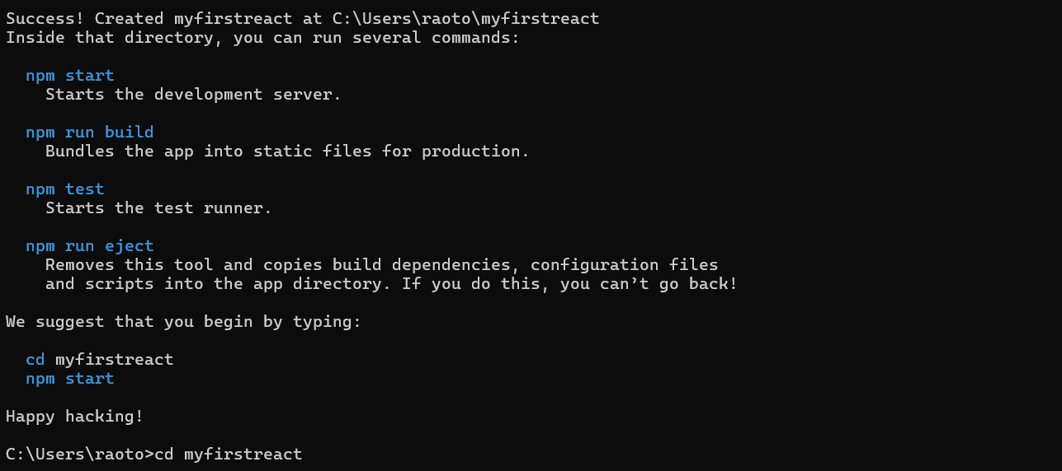

Updated App.js File in Visual Studio Code:
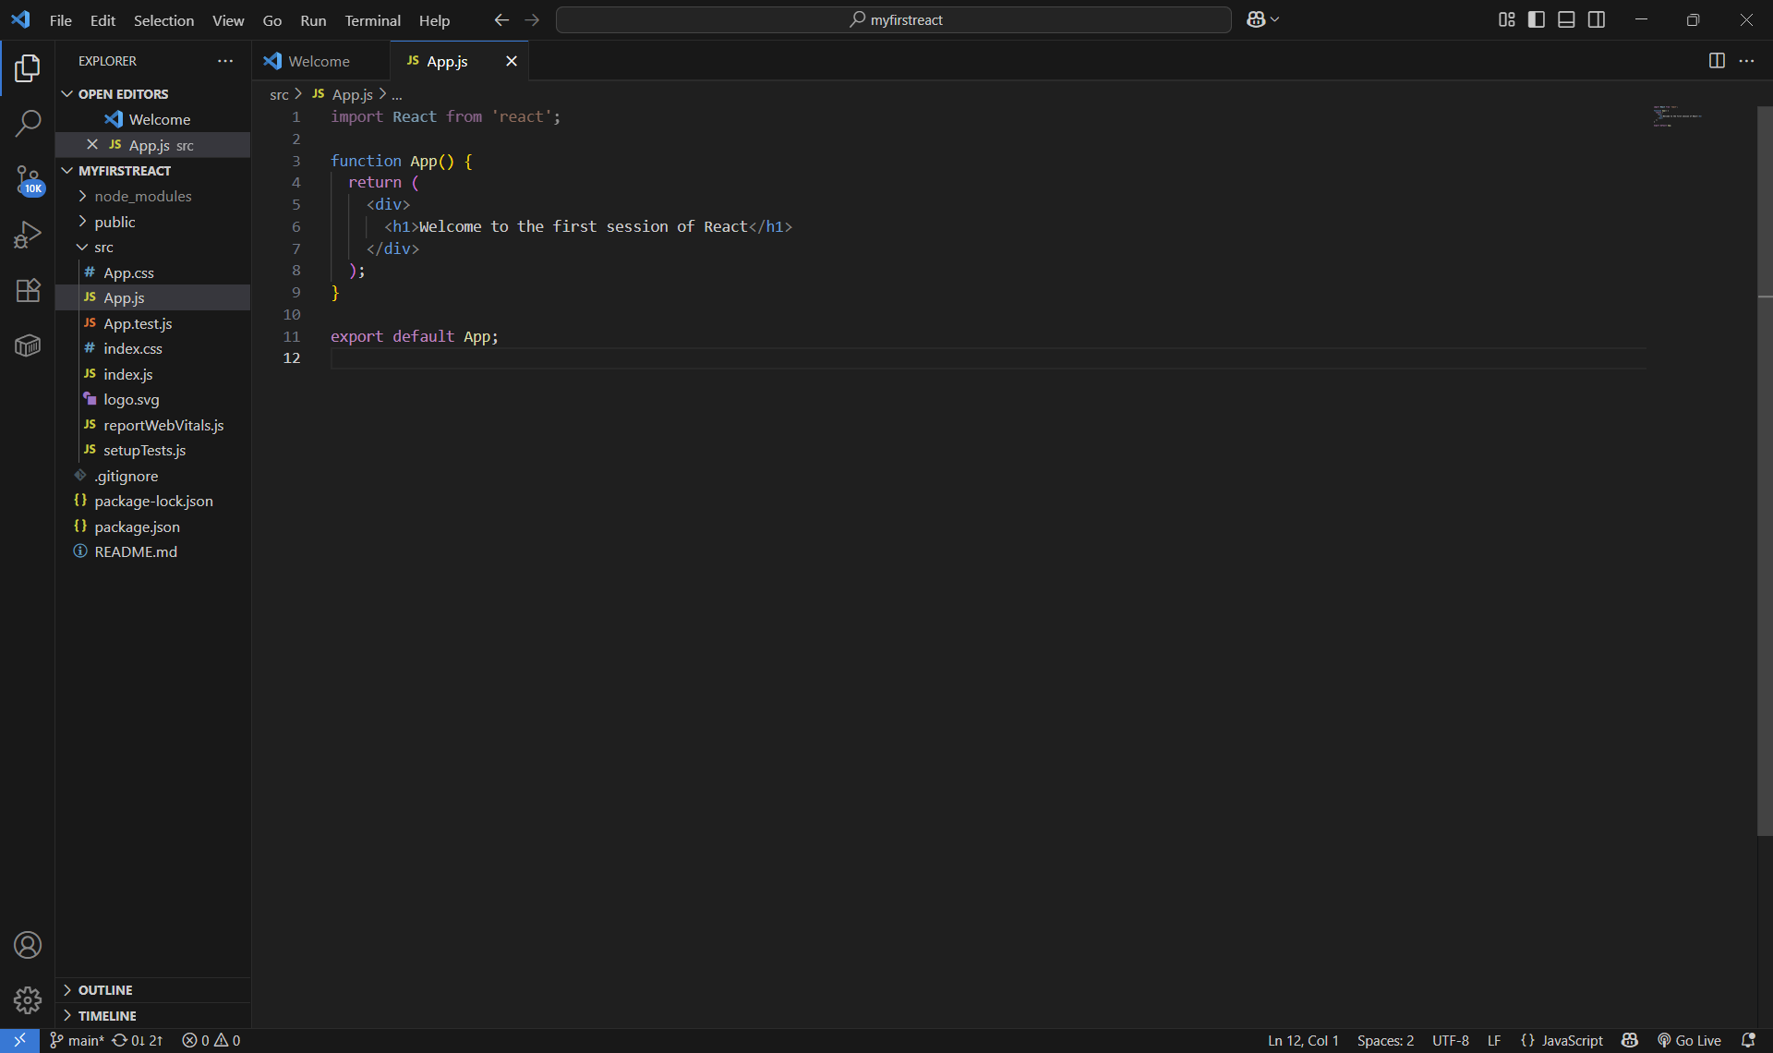
Output of “myfirstreact” Application:
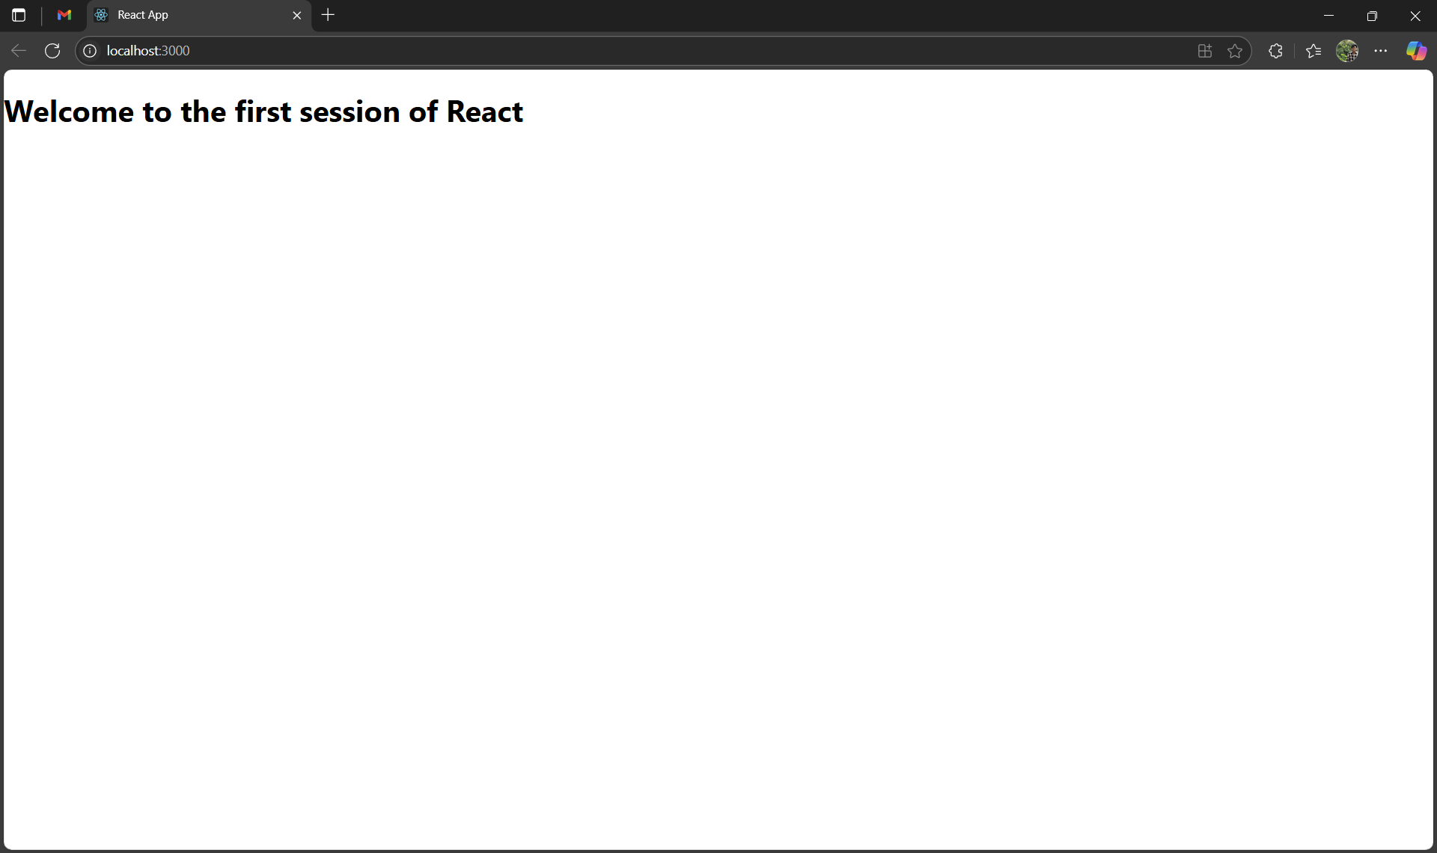
2.StudentApp
Project Folder Structure – React Components Created
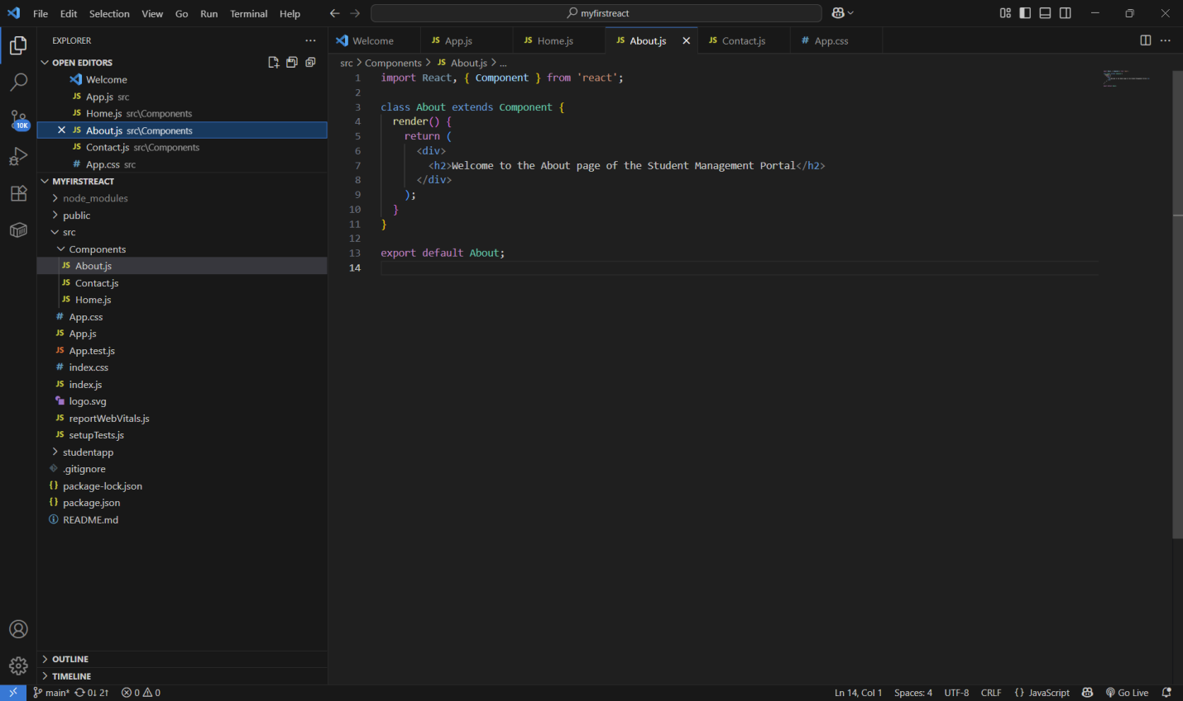

Main Component (App.js) with Function Components Rendered
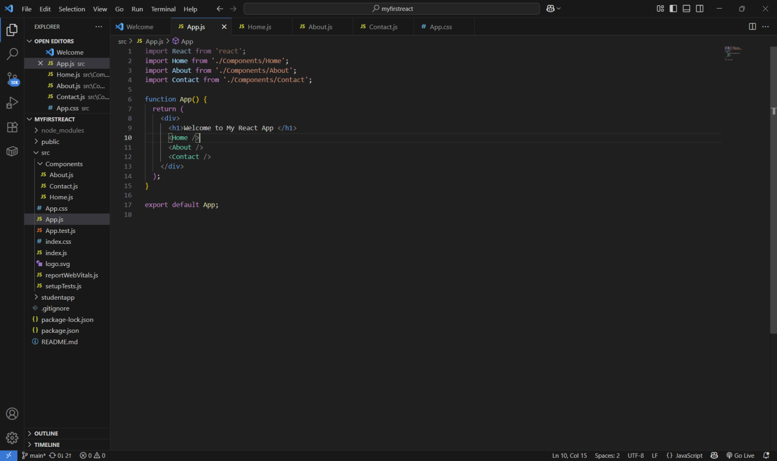
Custom Function Components – Home, About, Contact
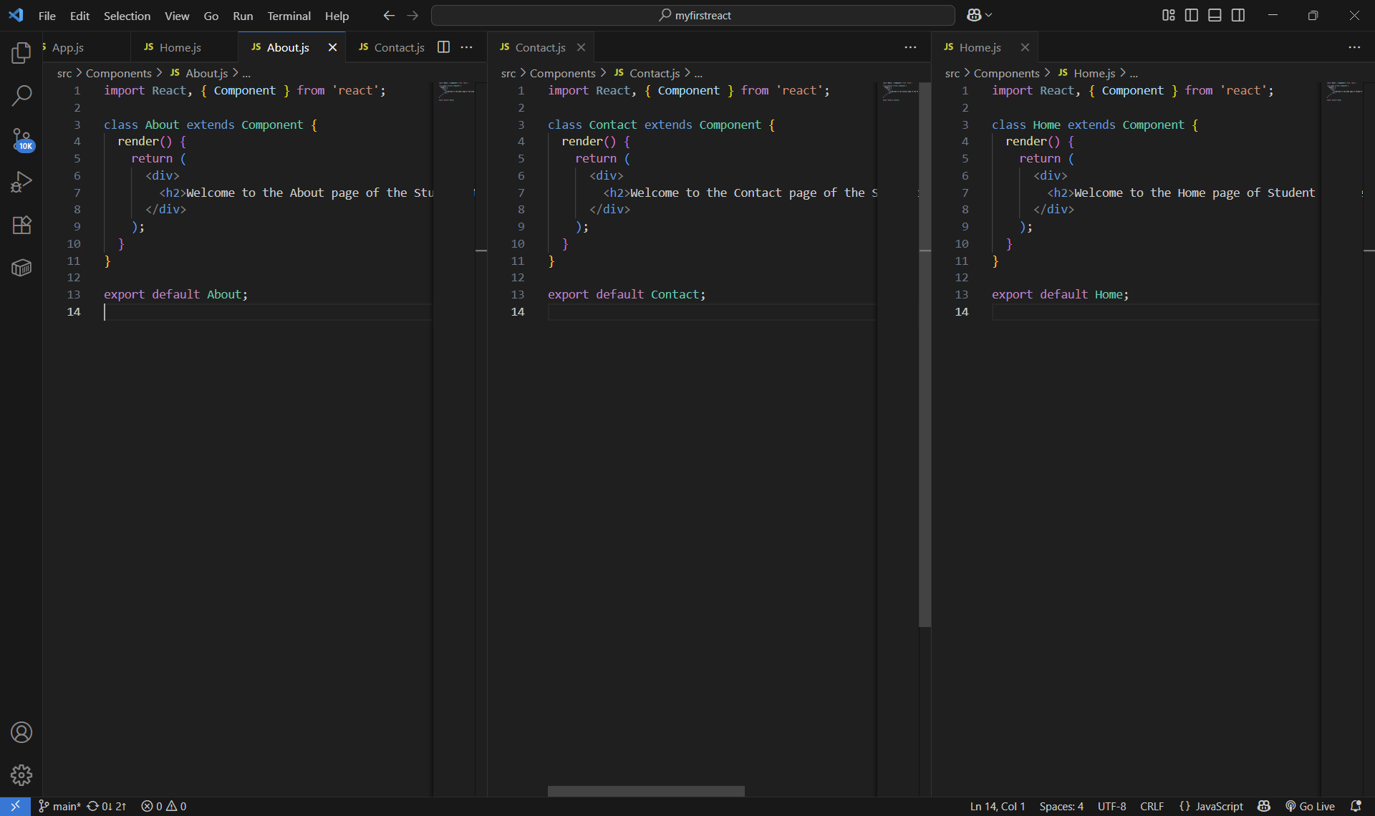
React App Started Successfully – npm start Output
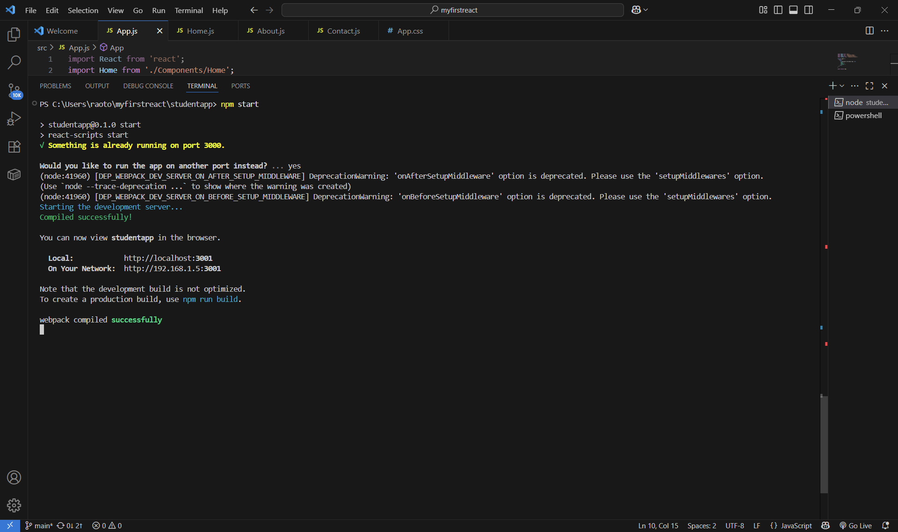
React App Rendered Output in Browser
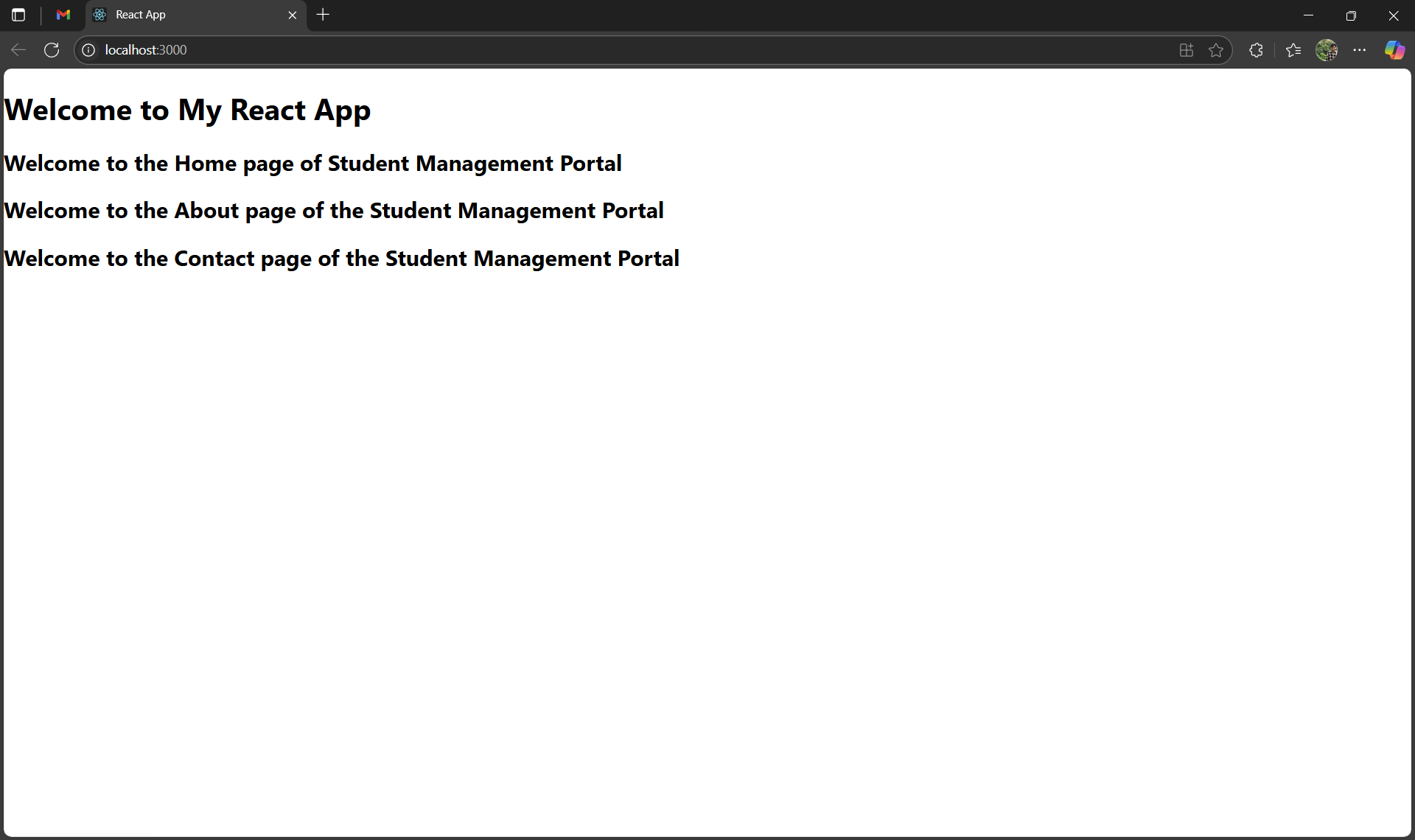
3.React App "scorecalculatorapp"

CalculateScore Component Code
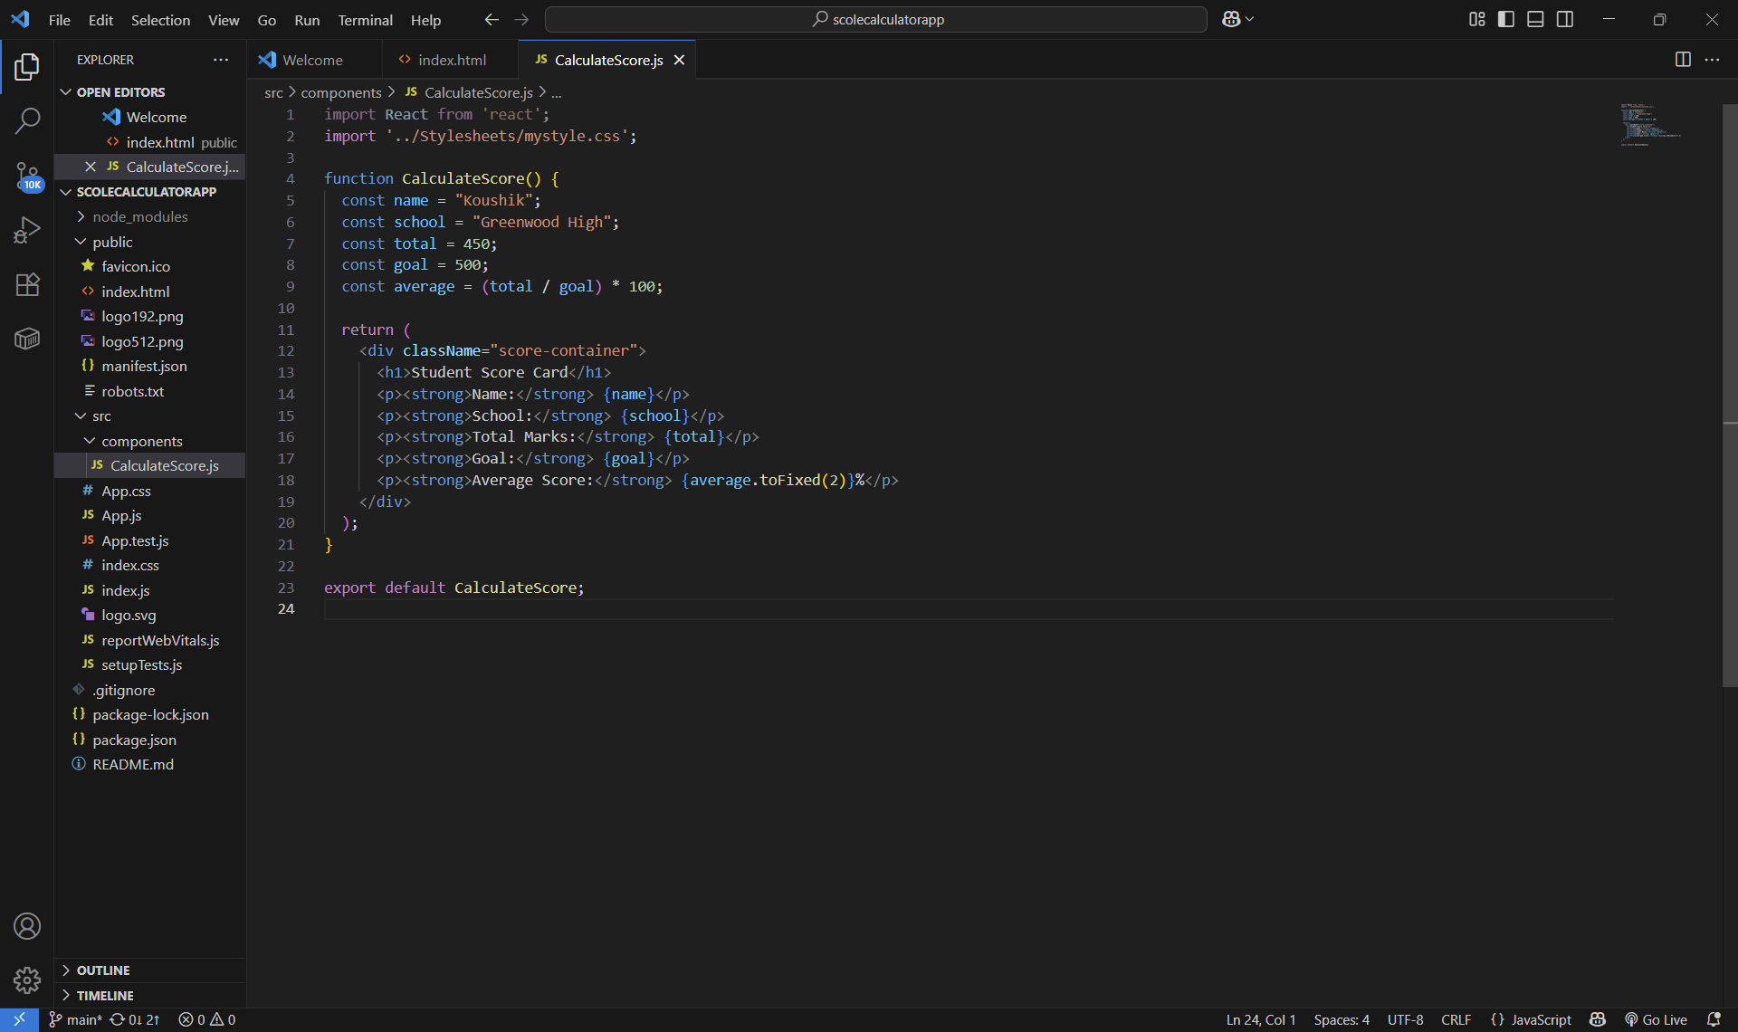

Styles Applied via mystyle.css
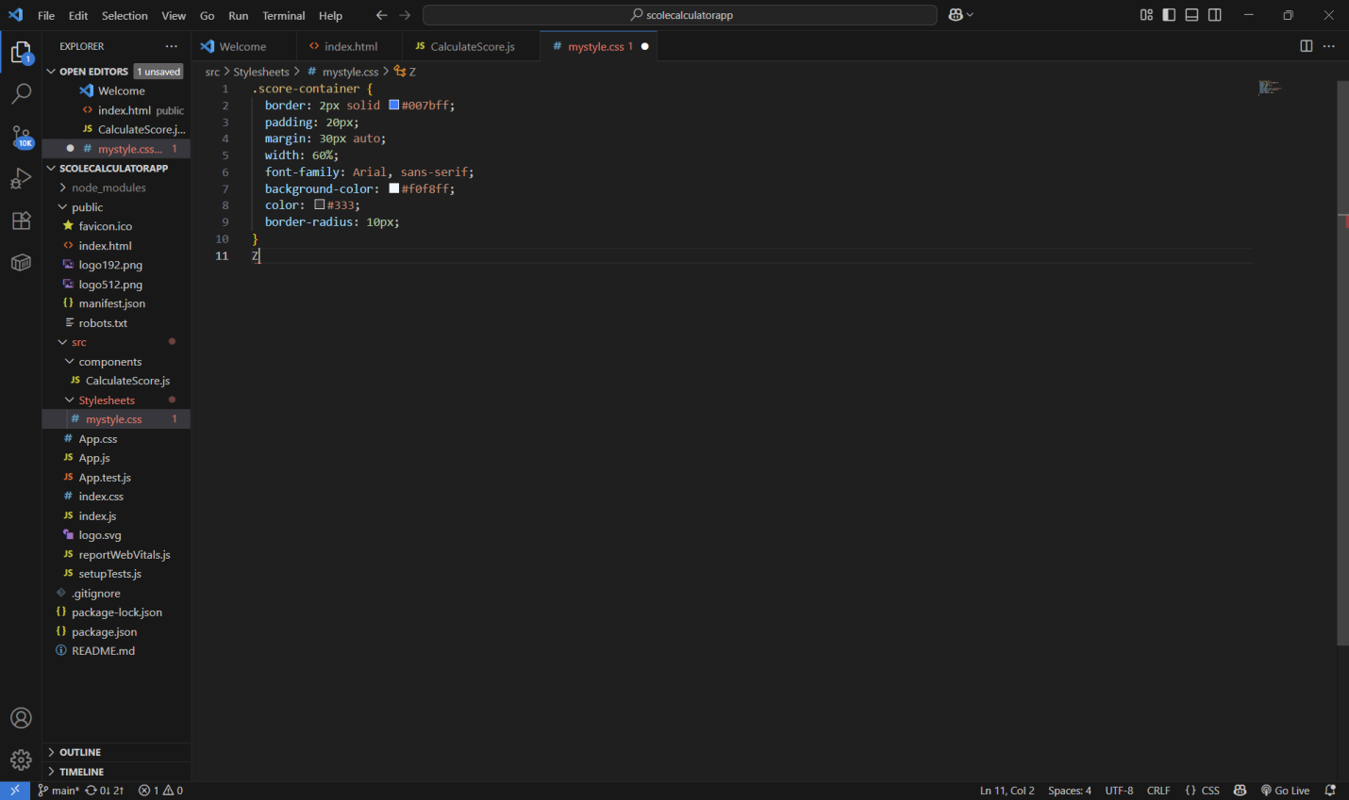
React App Compiled and Running
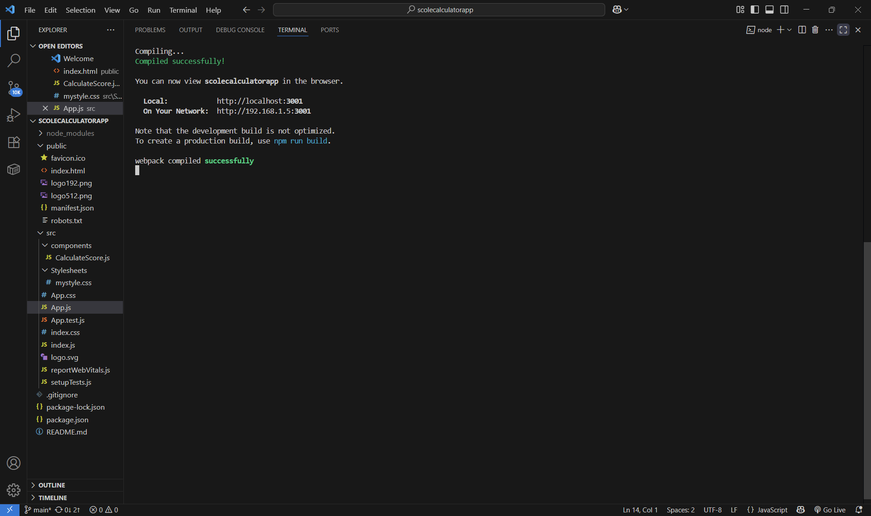

Student Score Display Output in Browser
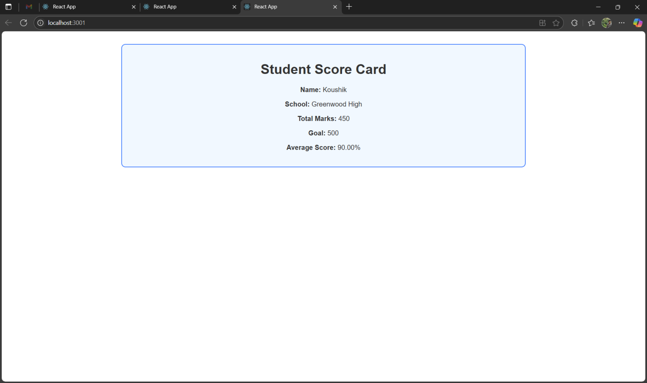

4.Blogapp
Heading: blogapp Project Created
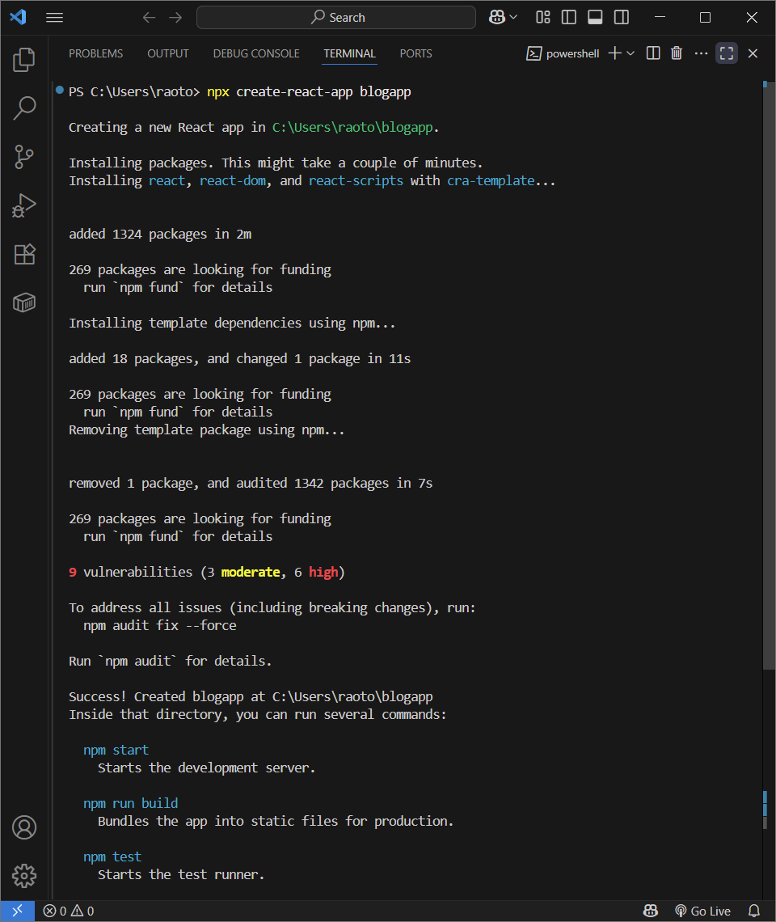
Post Component (Class)
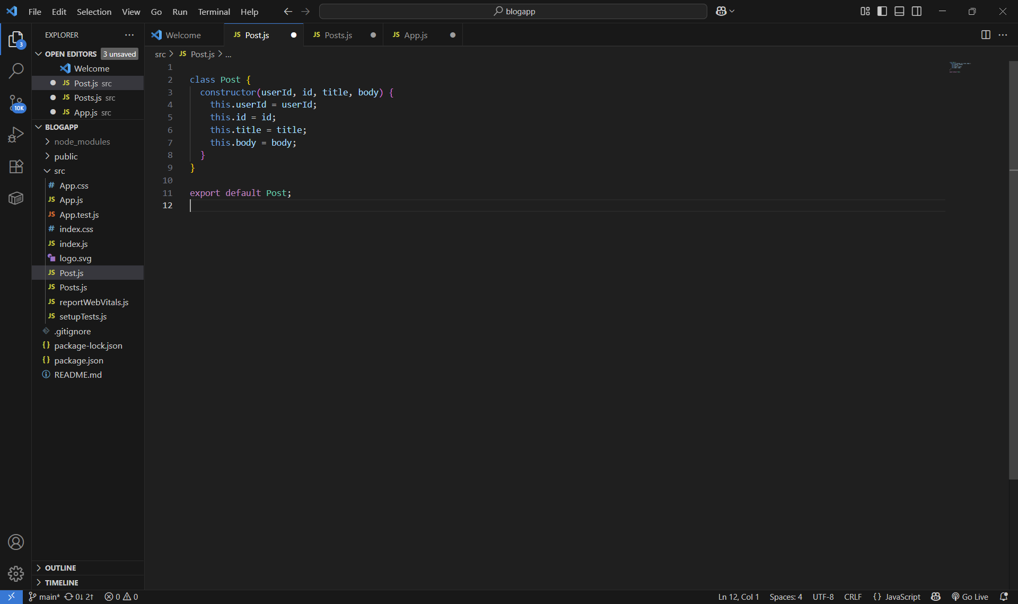
Posts Component with Lifecycle Methods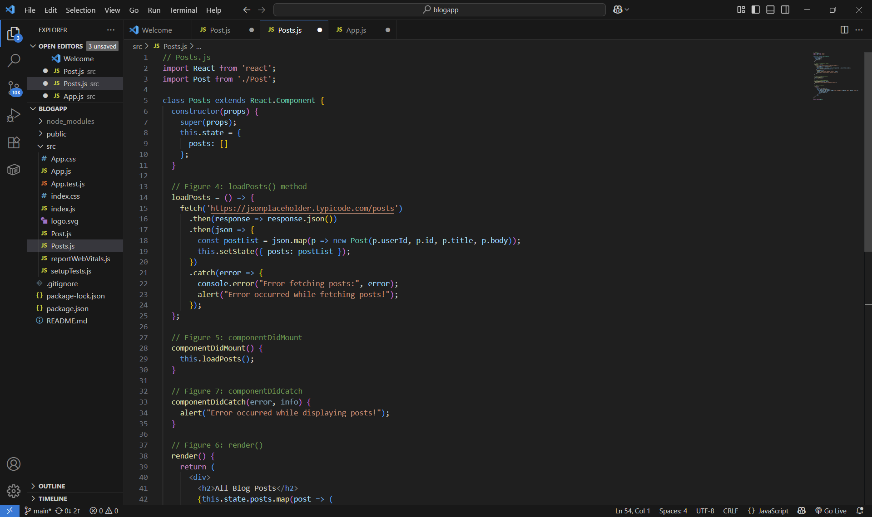

App Component with Posts Rendered
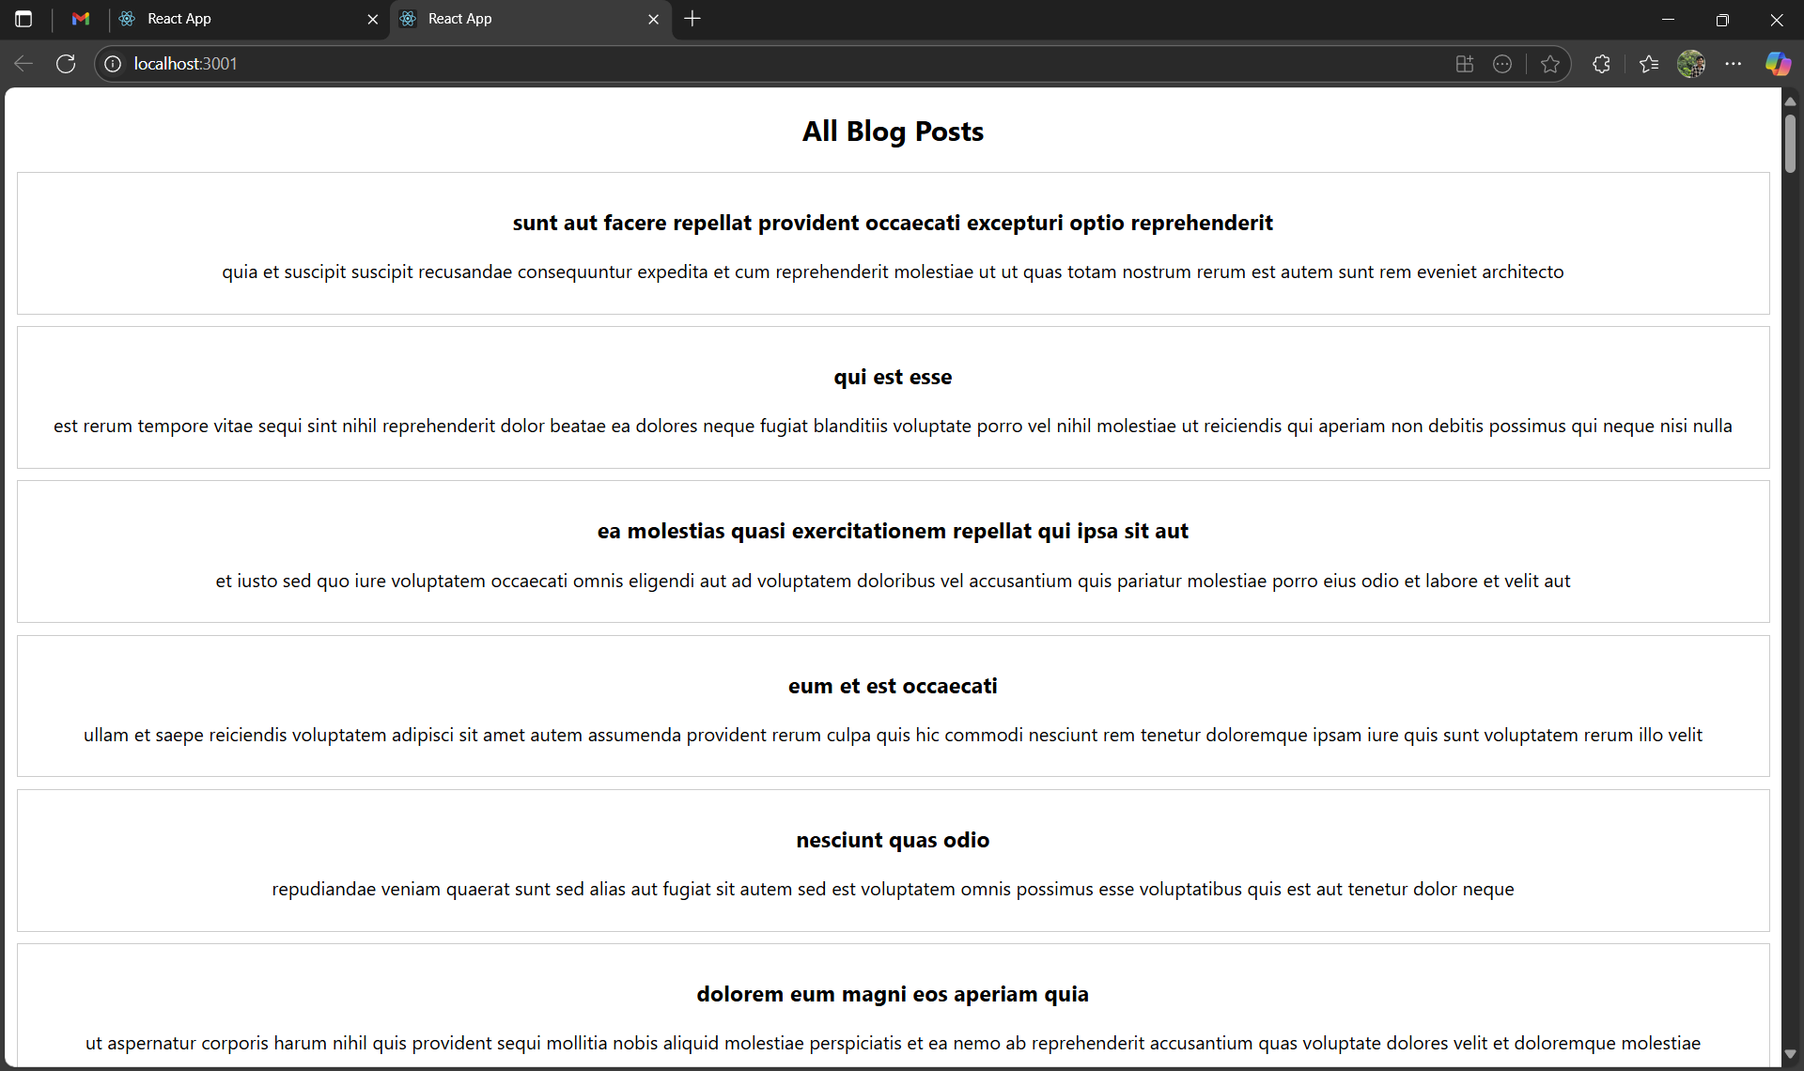

5.Cohorts

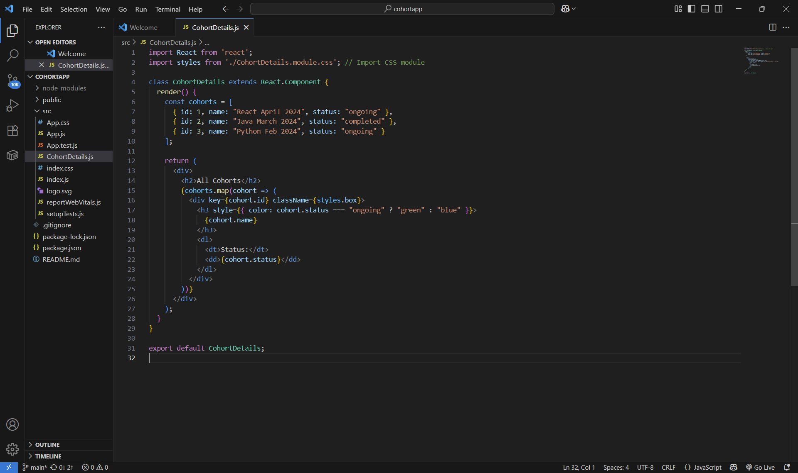

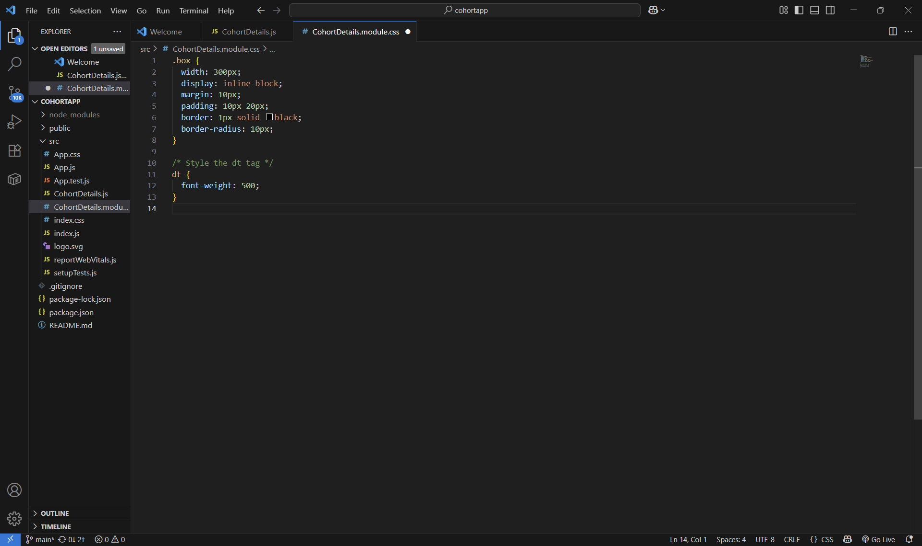
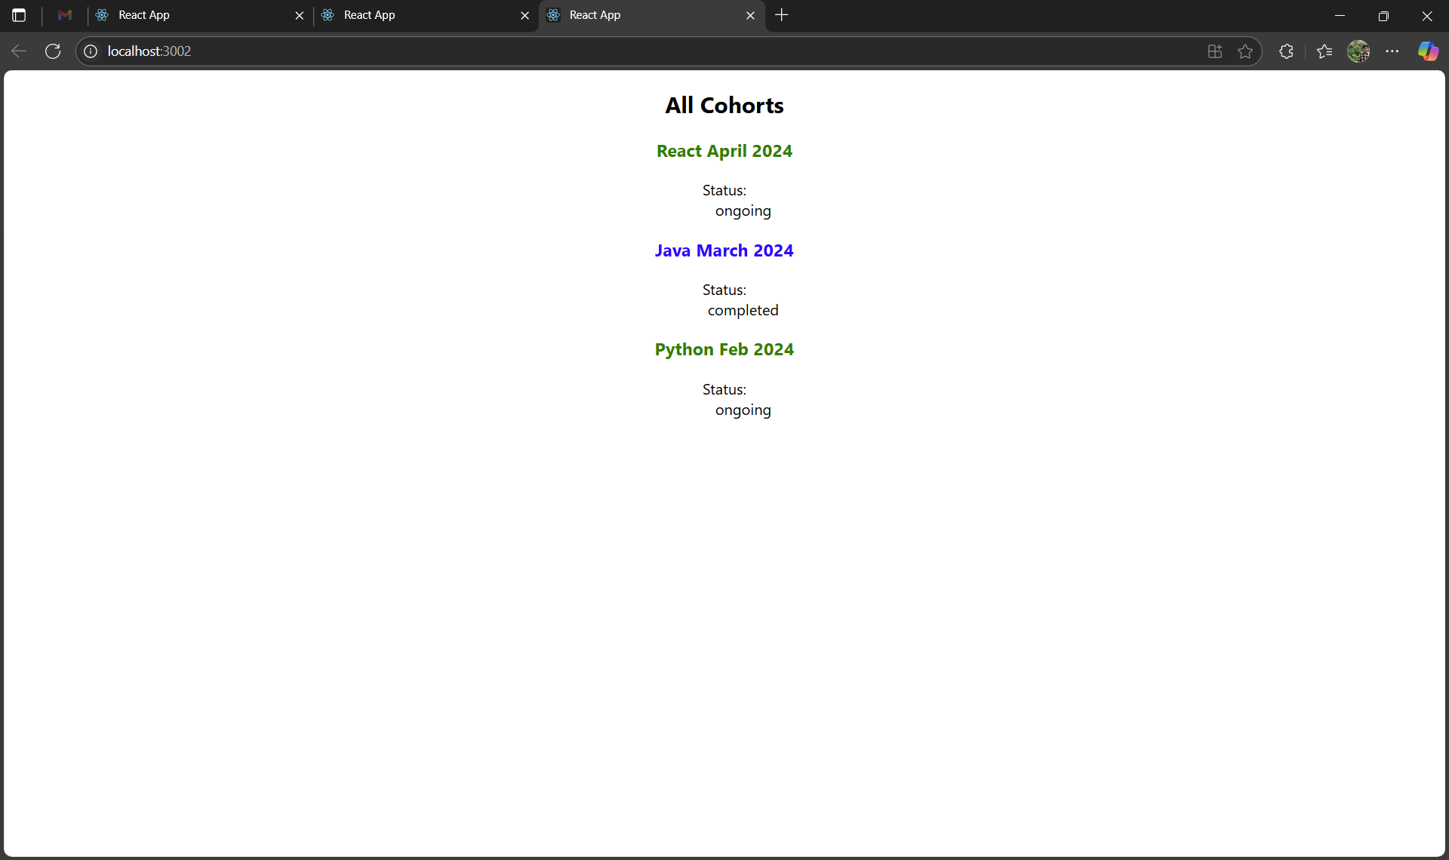
6.TrainerApp
Created all components
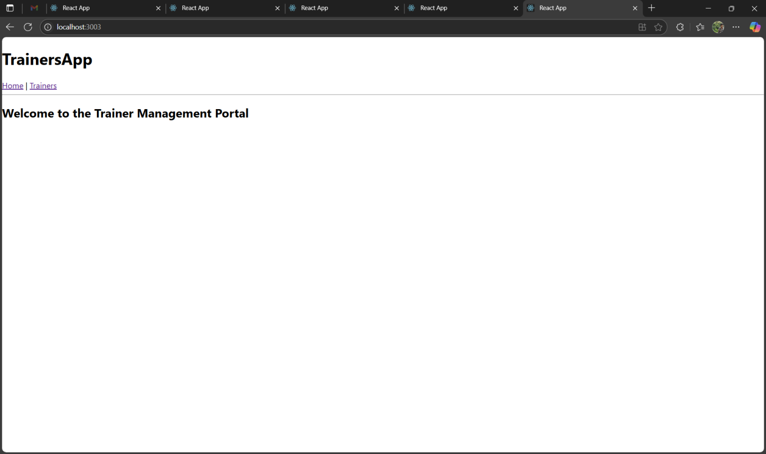

Home Page with Navigation Bar Using React Router
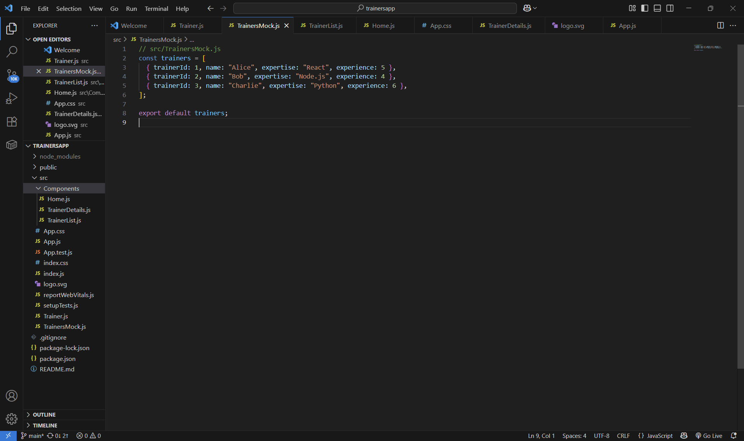
Trainer List Displayed with Route /trainers
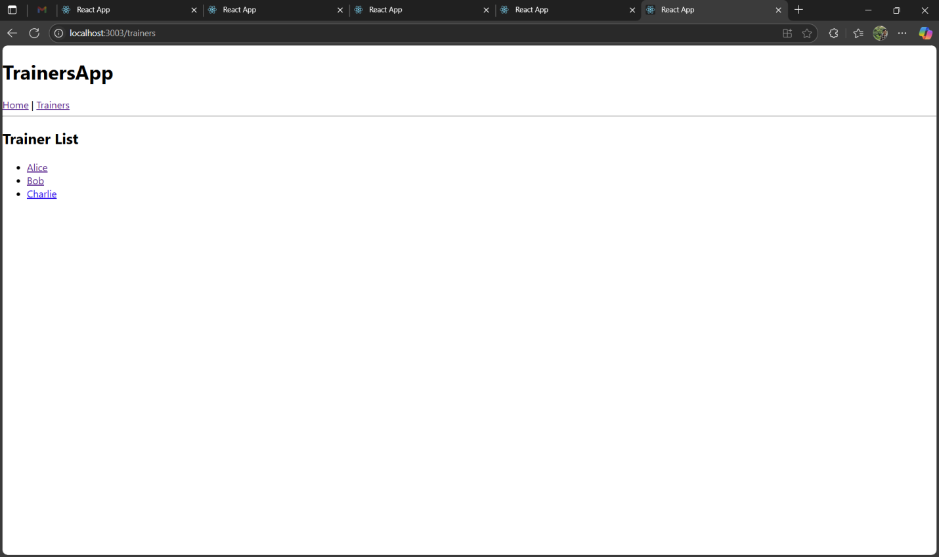

Trainer Details Displayed Using Dynamic Route /trainer/:id
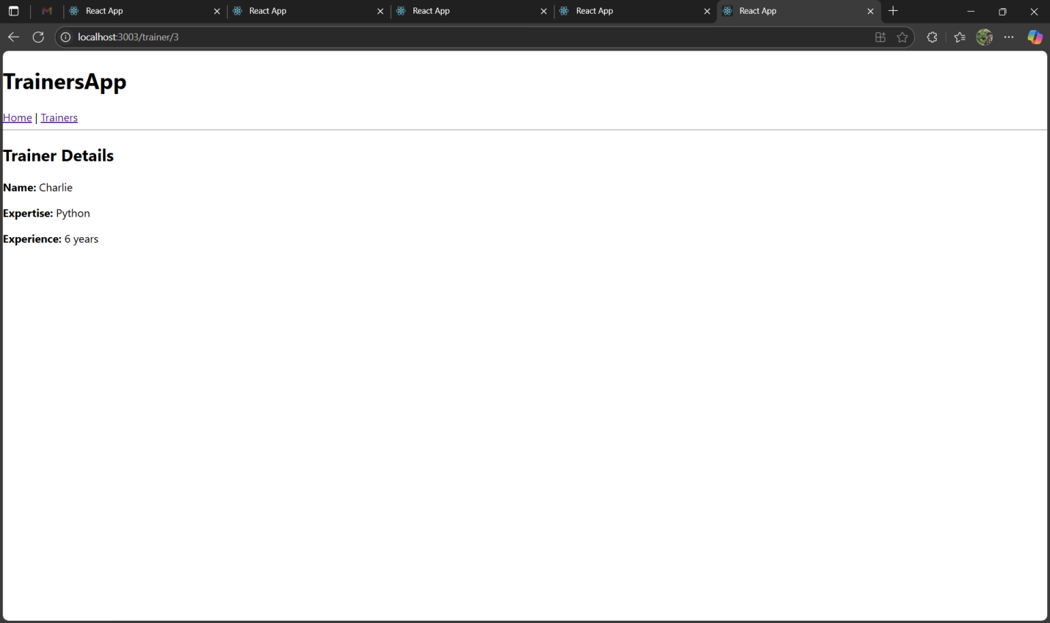

7.React Hands-on Lab – shoppingapp
Terminal showing successful creation of shoppingapp
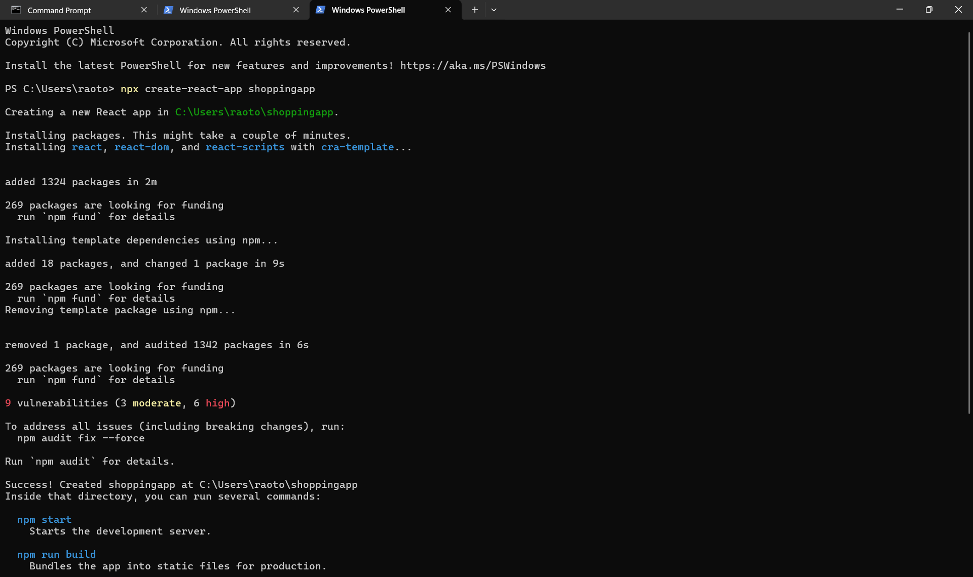

Folder Structure
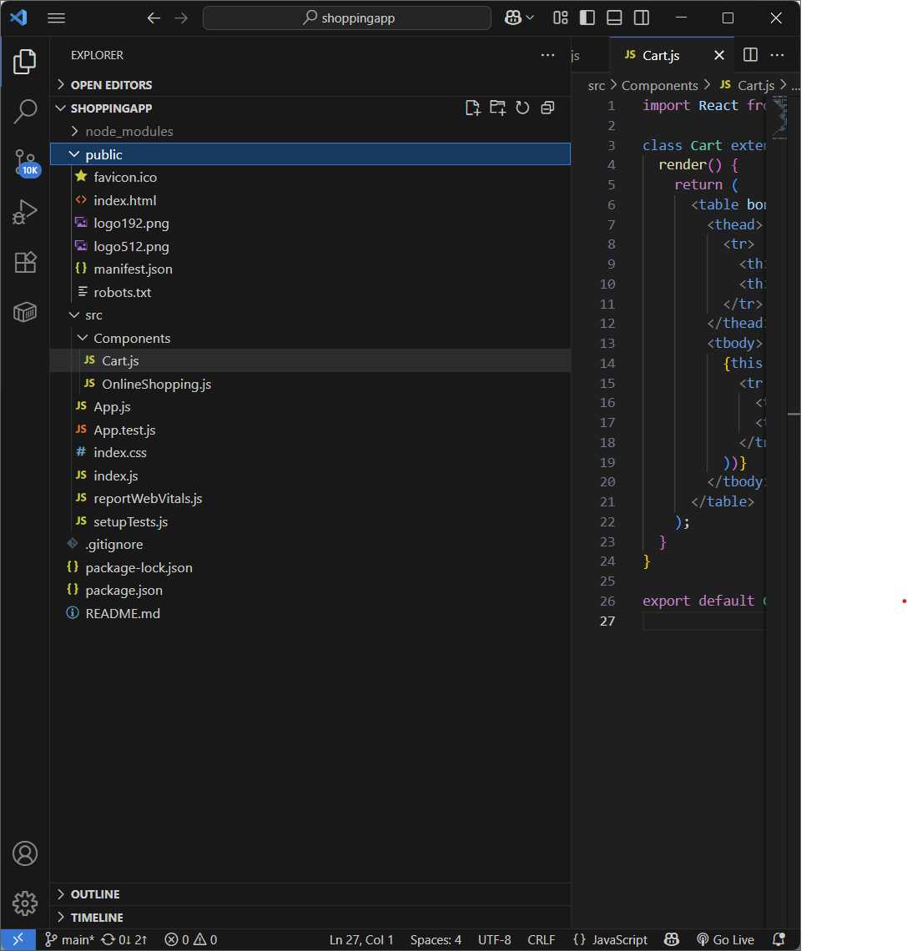

OnlineShopping.js – (Parent)& Cart.js –(Child)
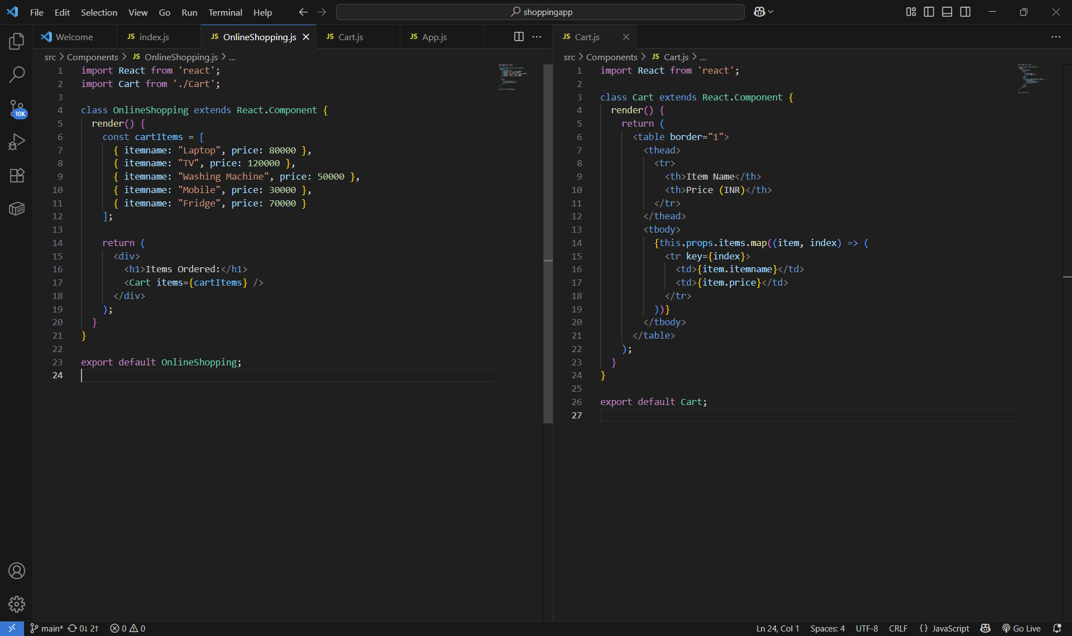
Index.js & App.js Code
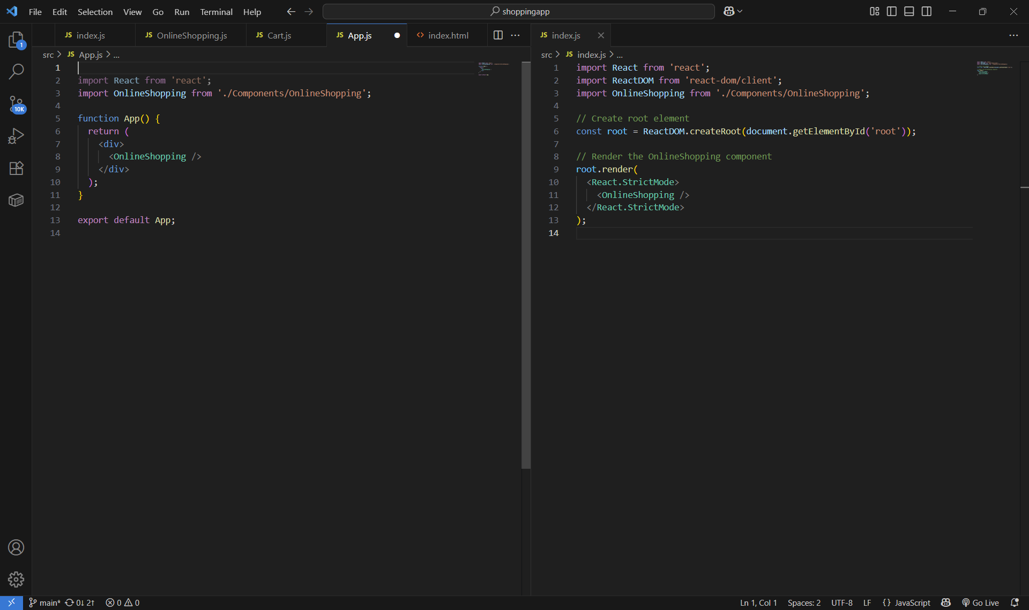

Web browser output
