Accessibility Keyboard

Changelog:

* UPDATE- 18MAY2023
  1. Nav-Pad Code Table updated to 8 button ADA panel (EZ08-23001) w/ custom code for Button 7/8
  2. LED Brightness set to 1 (to address OTG draw issues)

Download:

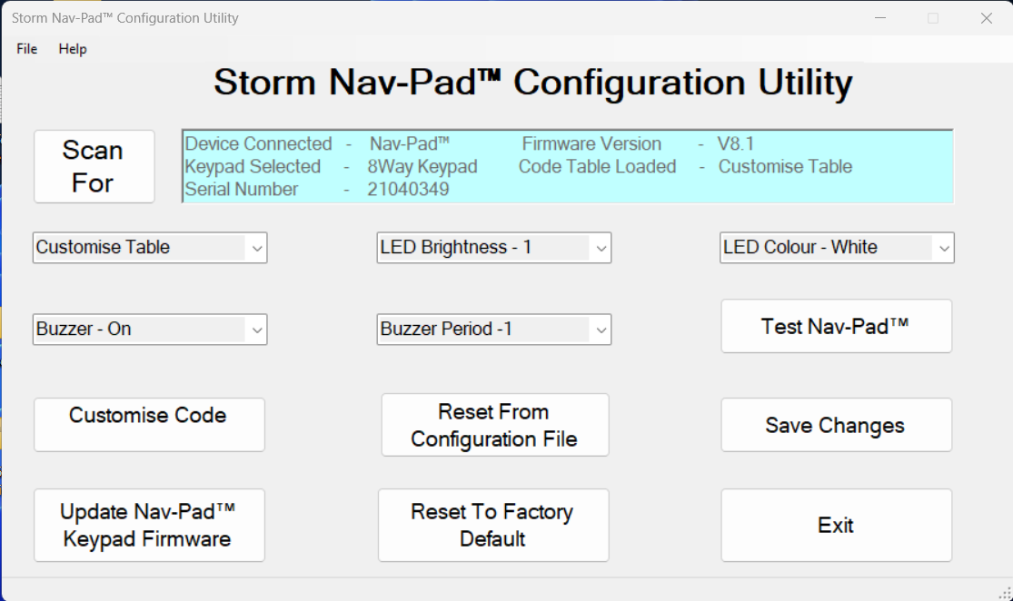

Click on customize code.

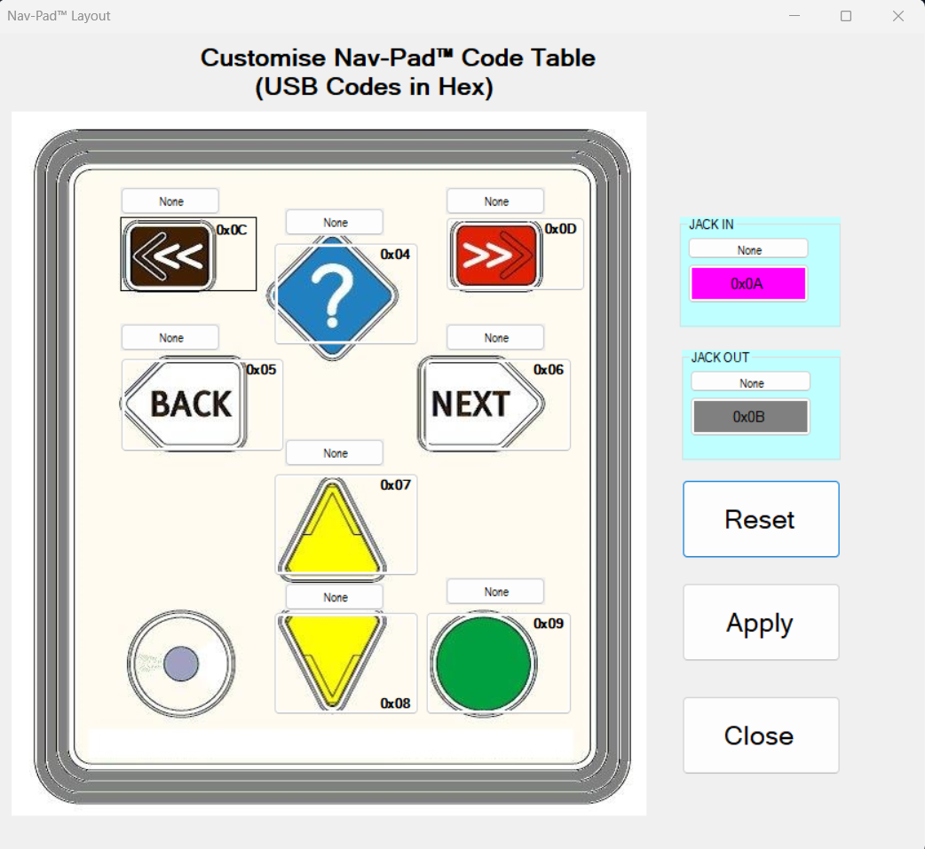

Configure the keys to the following:

? = a

Back = b

Next = c

Yellow Up = d

Yellow Down = e

Green Button = f

Jack In = g

Jack Out = h

⬅️ = i

➡️ = j

Android:

Issue with sound only going to nav pad for now go to developer options and toggle

Media: Disable USB auto routing