WEEK 4
spring-rest-handson, JWT-handson

Spring-rest-handson:
- Create a Spring Web Project using Maven:
Create a SpringLearn Application and build it:
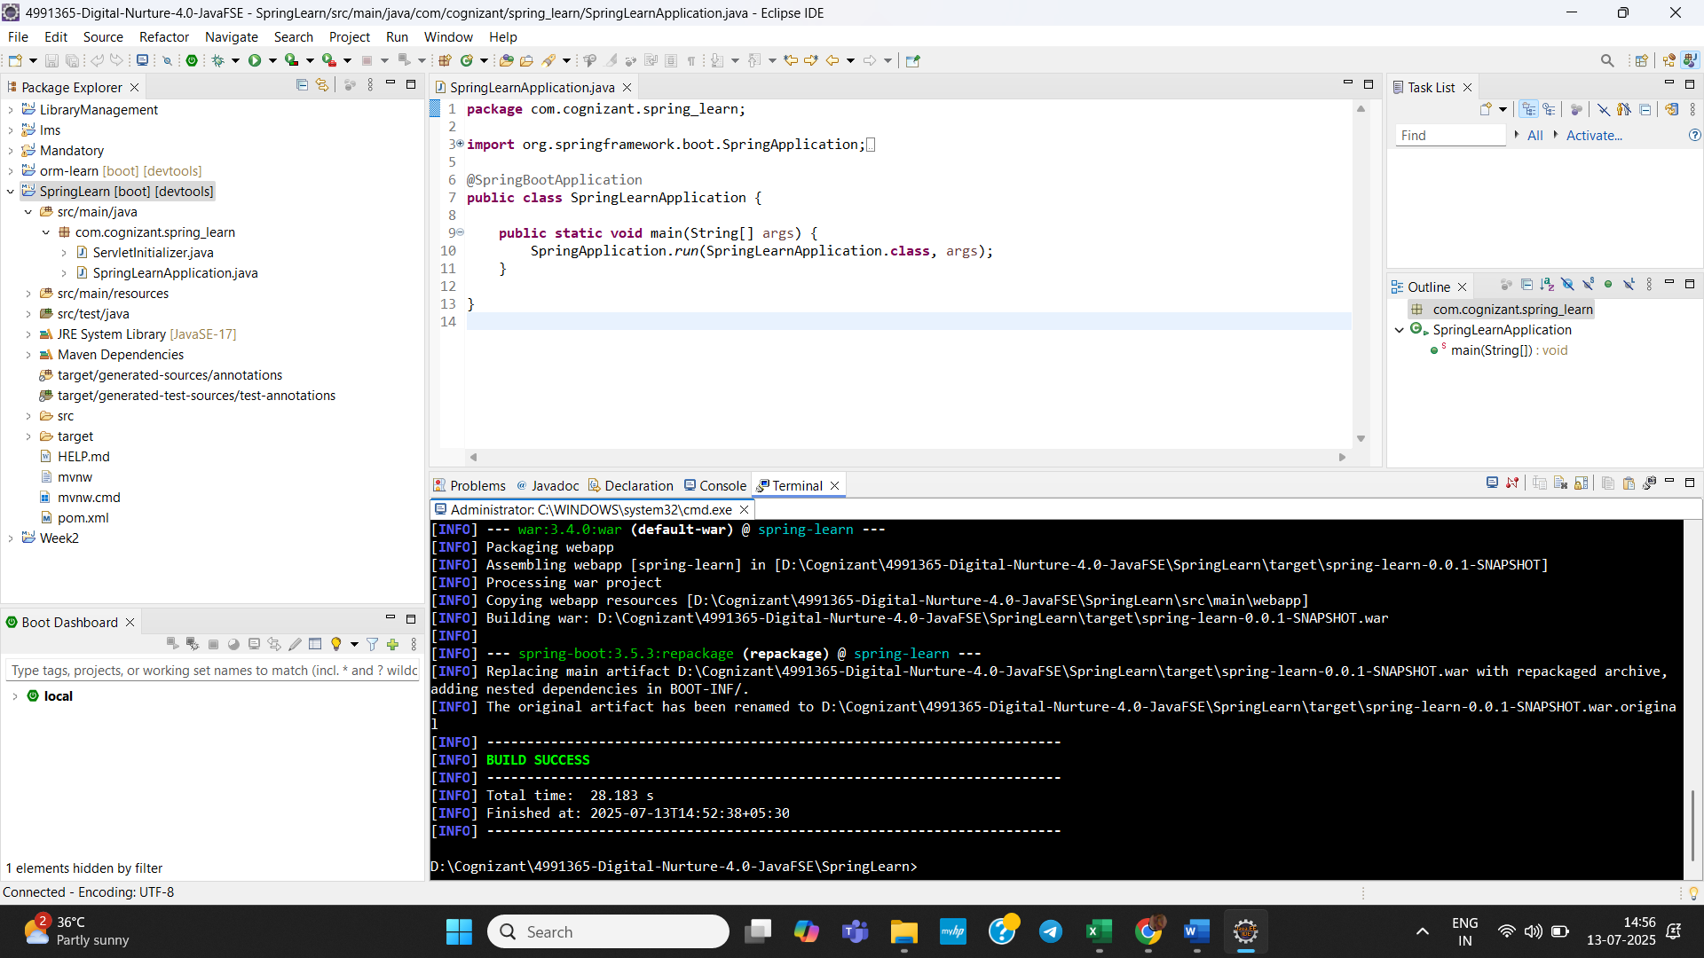
Add Logging to the Application:
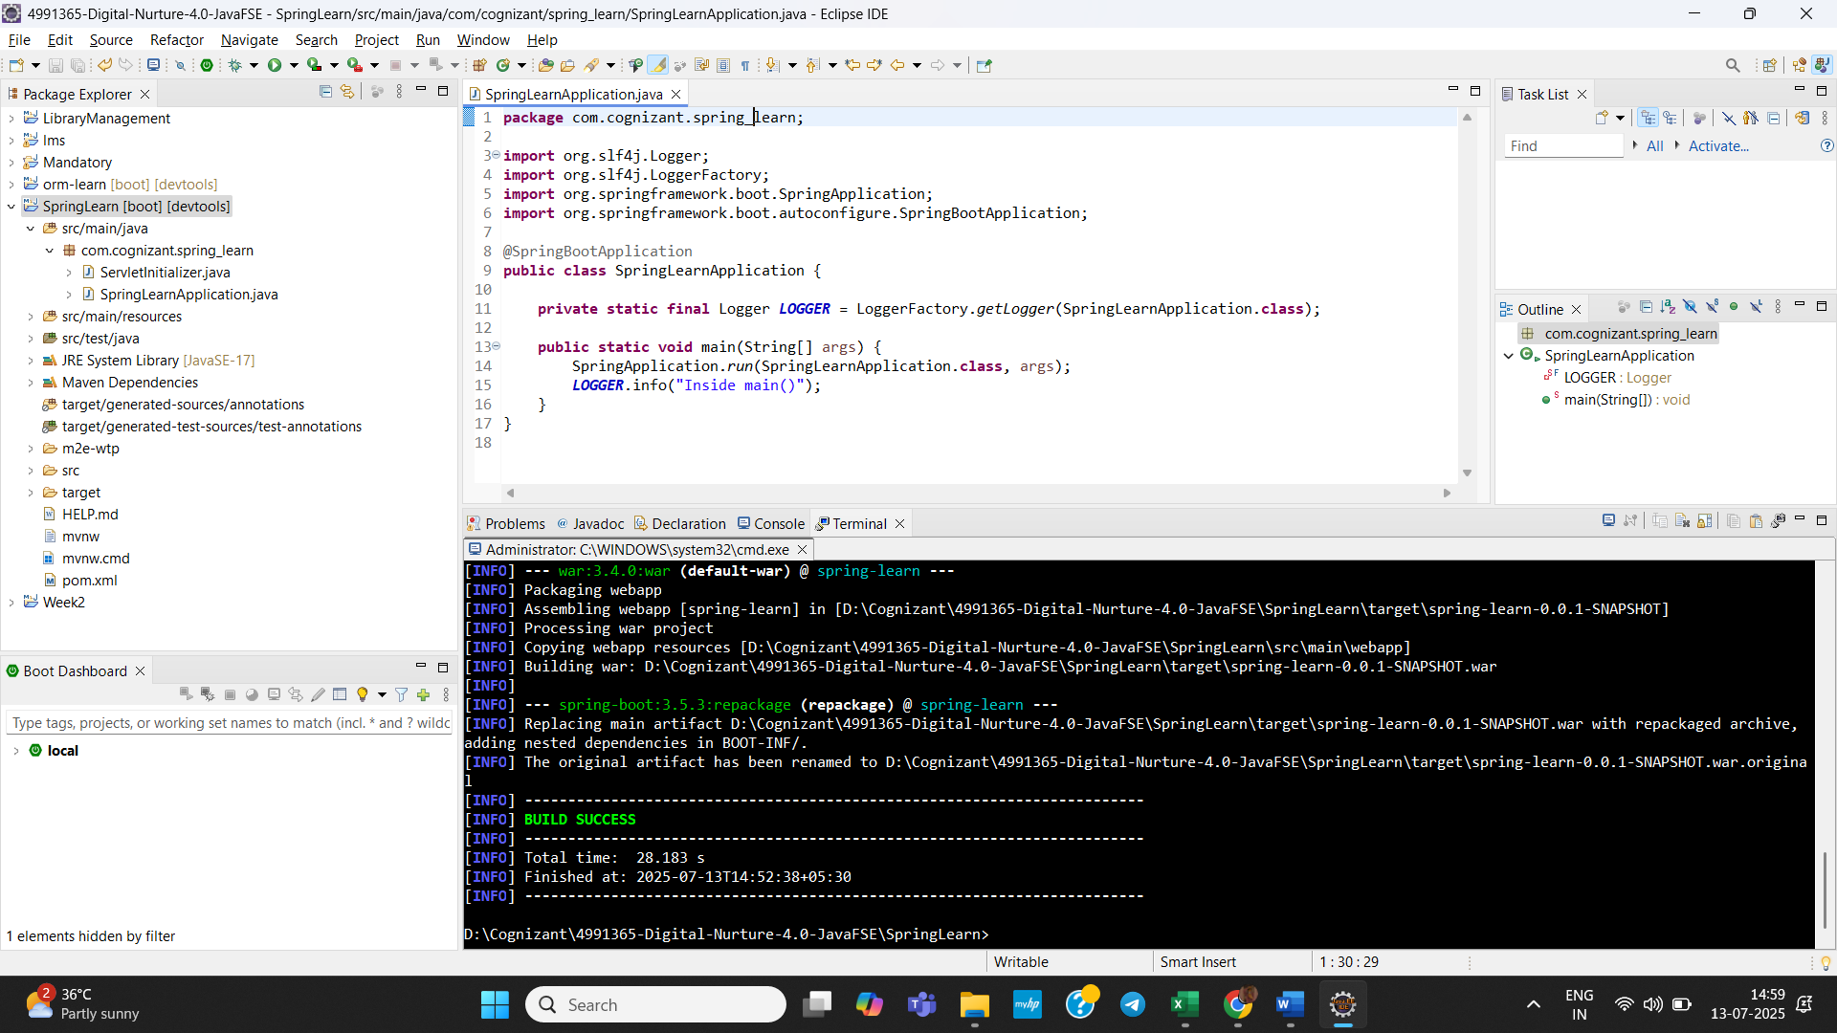

Dependency Hierarchy:
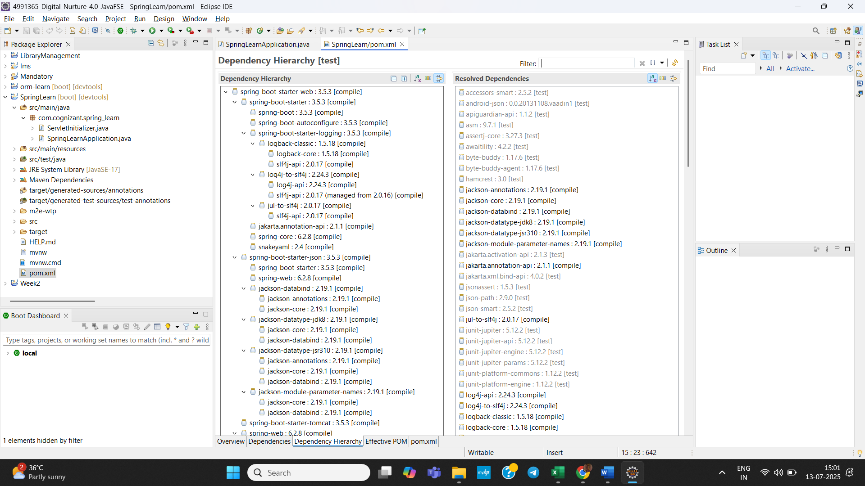
Output:
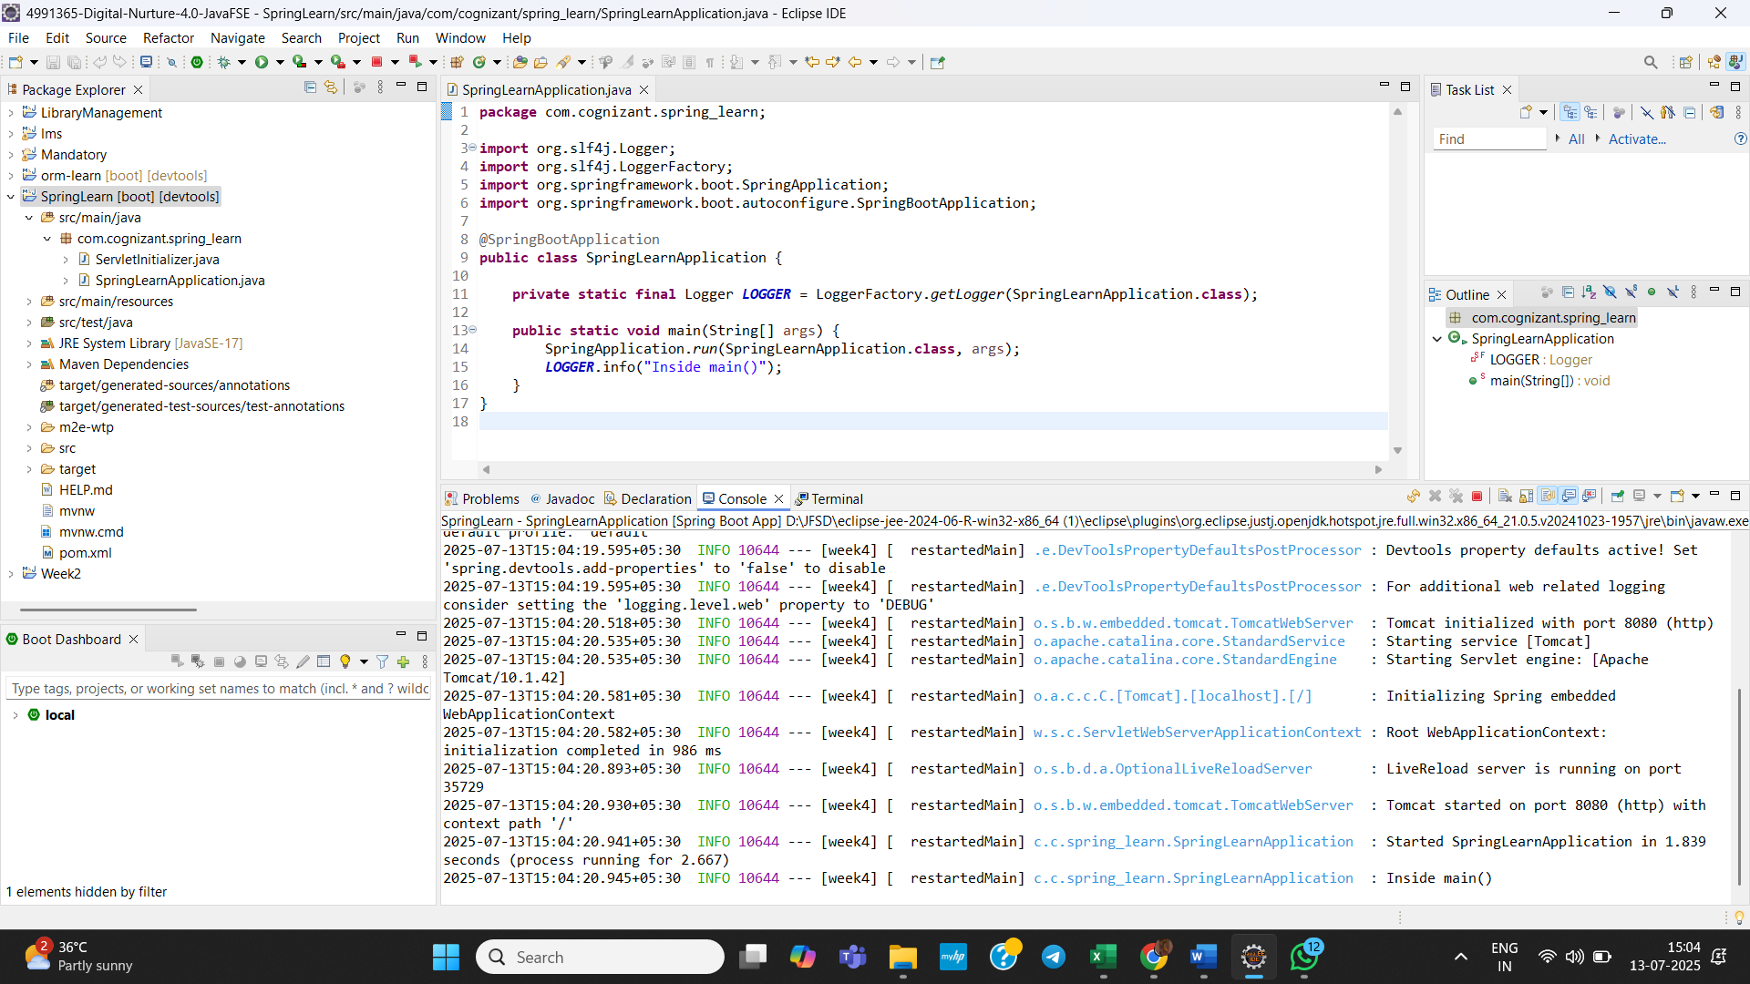

- Spring Core – Load Country from Spring Configuration XML:

Create Country.java in src/main/java :
package com.cognizant.spring_learn;

import org.slf4j.Logger;
import org.slf4j.LoggerFactory;

public class Country {
private static final Logger LOGGER = LoggerFactory.getLogger(Country.class);

private String code;
private String name;

public Country() {
LOGGER.debug("Inside Country Constructor.");
}

public String getCode() {
LOGGER.debug("Inside getCode()");
return code;
}

public void setCode(String code) {
LOGGER.debug("Inside setCode()");
this.code = code;
}

public String getName() {
LOGGER.debug("Inside getName()");
return name;
}

public void setName(String name) {
LOGGER.debug("Inside setName()");
this.name = name;
}

@Override
public String toString() {
return "Country{" +
"code='" + code + '\'' +
", name='" + name + '\'' +
'}';
}
}

Create a Country.xml in src/main/resources:
<?xml version="1.0" encoding="UTF-8"?>
<beans xmlns="http://www.springframework.org/schema/beans"
xmlns:xsi="http://www.w3.org/2001/XMLSchema-instance"
xsi:schemaLocation="
http://www.springframework.org/schema/beans
http://www.springframework.org/schema/beans/spring-beans.xsd">

<bean id="country" class="com.cognizant.springlearn.Country">
<property name="code" value="IN"/>
<property name="name" value="India"/>
</bean>

</beans>

Change SpringLearnApplication code:

package com.cognizant.spring_learn;

import org.slf4j.Logger;
import org.slf4j.LoggerFactory;
import org.springframework.boot.SpringApplication;
import org.springframework.boot.autoconfigure.SpringBootApplication;
import org.springframework.context.ApplicationContext;
import org.springframework.context.annotation.ImportResource;

@SpringBootApplication
@ImportResource("classpath:country.xml") // load the XML bean into Spring Boot context
public class SpringLearnApplication {

private static final Logger LOGGER = LoggerFactory.getLogger(SpringLearnApplication.class);

public static void main(String[] args) {
LOGGER.info("START");

ApplicationContext context = SpringApplication.run(SpringLearnApplication.class, args);
displayCountry(context);

LOGGER.info("END");
}

public static void displayCountry(ApplicationContext context) {
Country country = context.getBean("country", Country.class);
LOGGER.debug("Country : {}", country.toString());
}
}

Output:
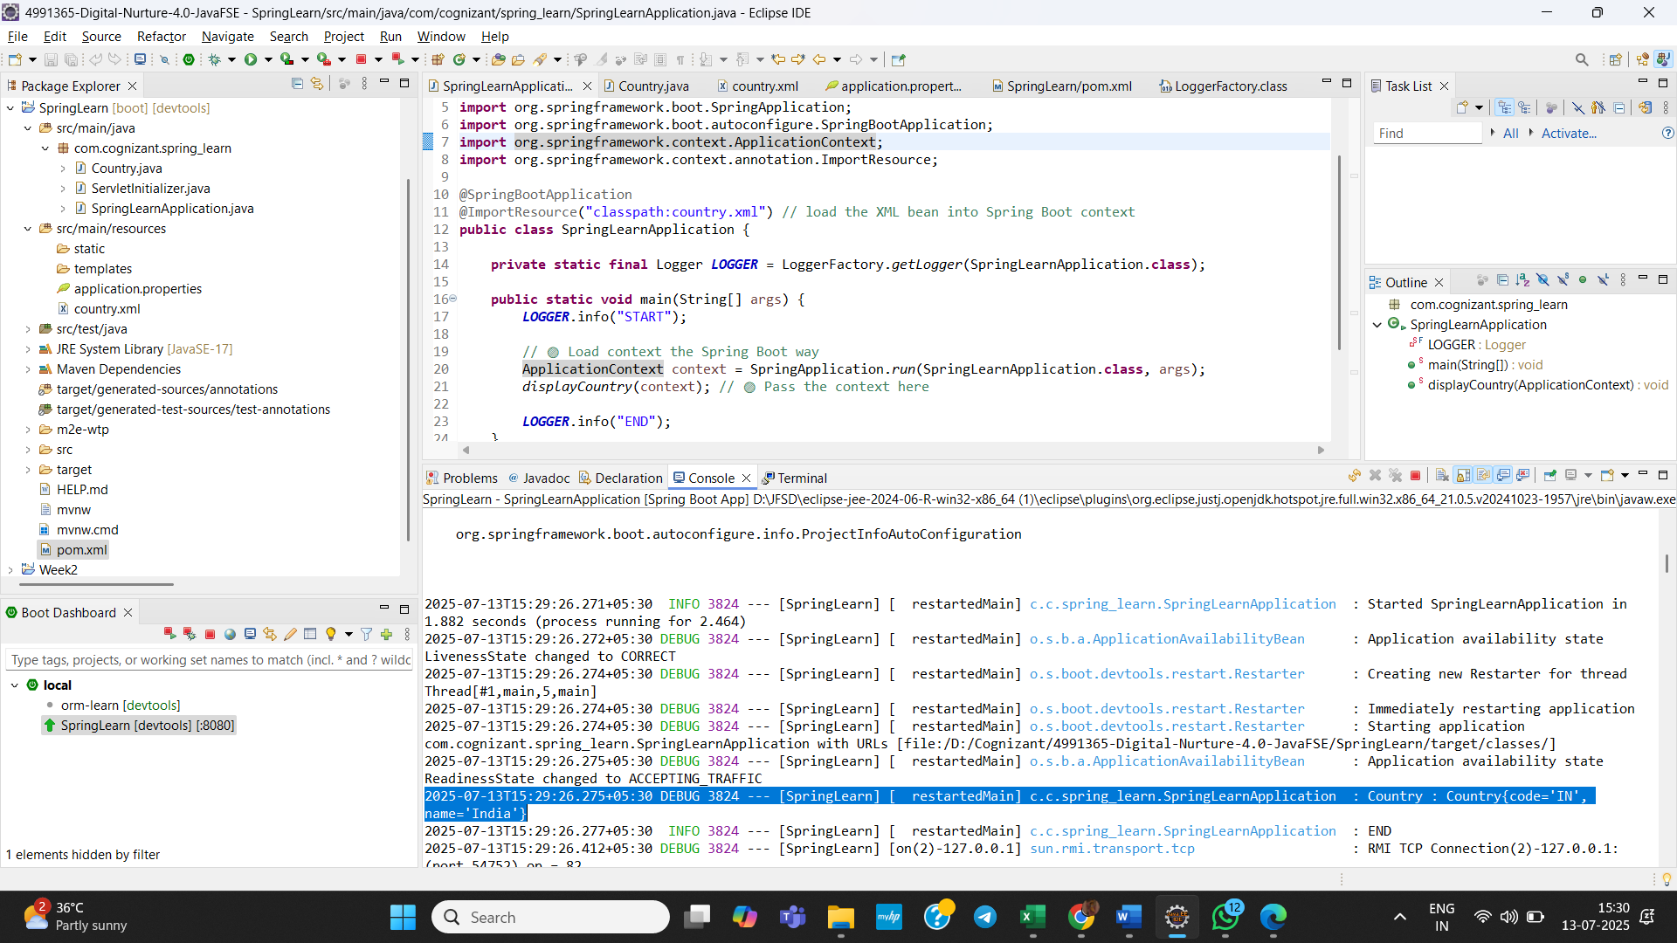

- Hello World RESTful Web Service:

Create a com.cognizant.spring_learn.controller package
Create a HelloController.java :
package com.cognizant.spring_learn.controller;

import org.slf4j.Logger;
import org.slf4j.LoggerFactory;
import org.springframework.web.bind.annotation.*;

@RestController
public class HelloController {

private static final Logger LOGGER = LoggerFactory.getLogger(HelloController.class);

@GetMapping("/hello")
public String sayHello() {
LOGGER.info("START - sayHello()");
LOGGER.info("END - sayHello()");
return "Hello World!!";
}
}
Change port to 8083 in application.properties using :
server.port=8083

Output:
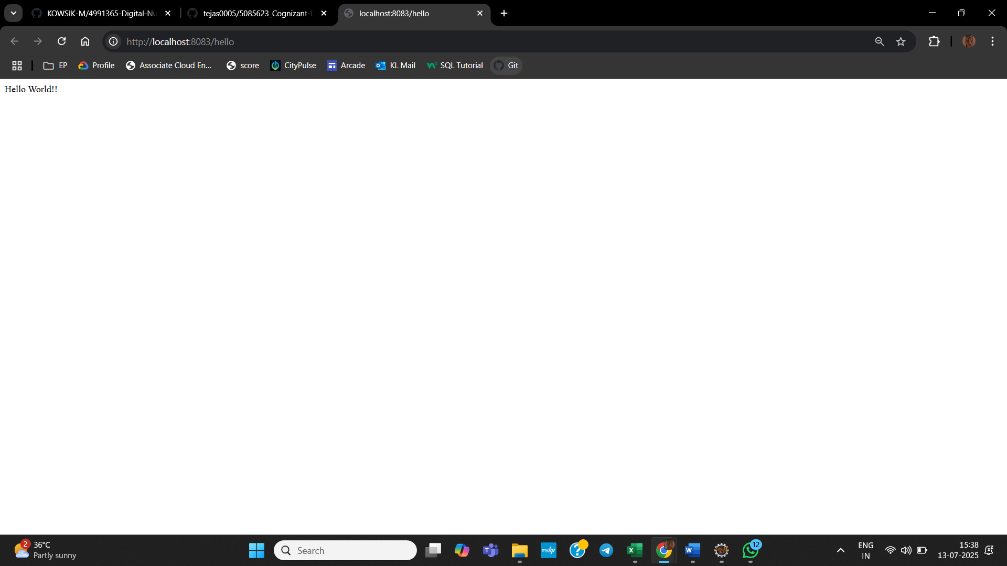

- REST - Country Web Service:
Create CountryController.java:
package com.cognizant.spring_learn.controller;

import com.cognizant.spring_learn.Country;
import org.slf4j.Logger;
import org.slf4j.LoggerFactory;
import org.springframework.beans.factory.annotation.*;
import org.springframework.context.ApplicationContext;
import org.springframework.web.bind.annotation.*;

@RestController
public class CountryController {

private static final Logger LOGGER = LoggerFactory.getLogger(CountryController.class);

@Autowired
private ApplicationContext context;

@RequestMapping("/country")
public Country getCountryIndia() {
LOGGER.info("START - getCountryIndia()");
Country country = context.getBean("country", Country.class);
LOGGER.info("END - getCountryIndia()");
return country;
}
}

Output:
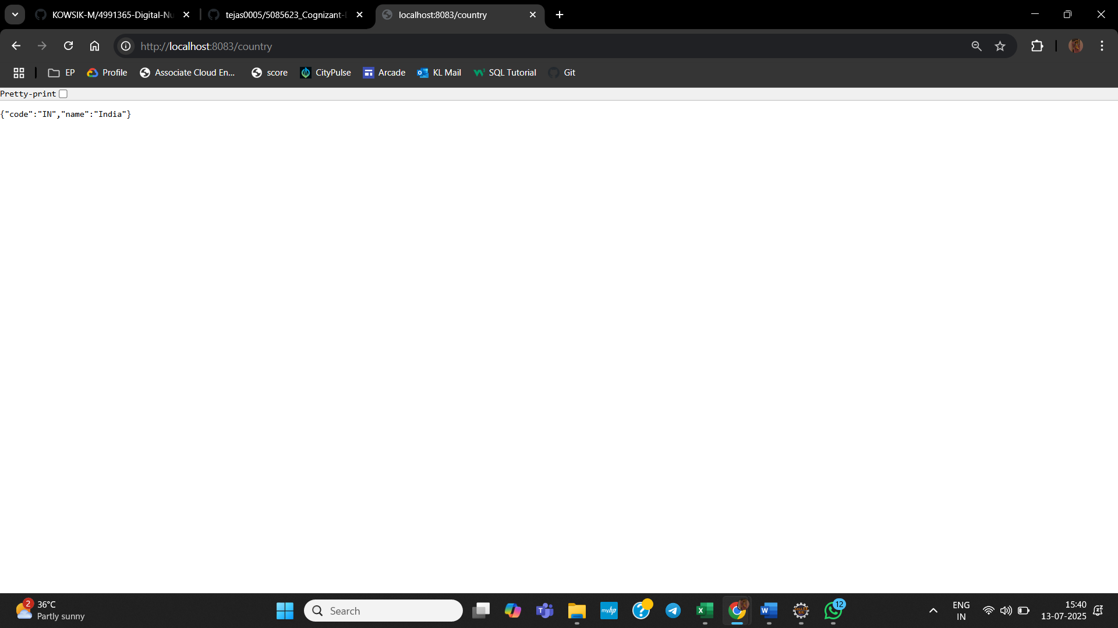

- REST - Get country based on country code:
Update country.xml with a list of countries:
<beans xmlns="http://www.springframework.org/schema/beans"
xmlns:xsi="http://www.w3.org/2001/XMLSchema-instance"
xsi:schemaLocation="
http://www.springframework.org/schema/beans
http://www.springframework.org/schema/beans/spring-beans.xsd">

<bean id="country" class="com.cognizant.spring_learn.Country">
<property name="code" value="IN"/>
<property name="name" value="India"/>
</bean>

<bean id="countryList" class="java.util.ArrayList">
<constructor-arg>
<list>
<bean class="com.cognizant.spring_learn.Country">
<property name="code" value="IN"/>
<property name="name" value="India"/>
</bean>
<bean class="com.cognizant.spring_learn.Country">
<property name="code" value="US"/>
<property name="name" value="United States"/>
</bean>
<bean class="com.cognizant.spring_learn.Country">
<property name="code" value="DE"/>
<property name="name" value="Germany"/>
</bean>
<bean class="com.cognizant.spring_learn.Country">
<property name="code" value="JP"/>
<property name="name" value="Japan"/>
</bean>
</list>
</constructor-arg>
</bean>

</beans>
Create a CountryService in a service package:
package com.cognizant.spring_learn.service;

import com.cognizant.spring_learn.Country;
import org.slf4j.Logger;
import org.slf4j.LoggerFactory;
import org.springframework.beans.factory.annotation.Autowired;
import org.springframework.context.ApplicationContext;
import org.springframework.stereotype.Service;

import java.util.List;

@Service
public class CountryService {

private static final Logger LOGGER = LoggerFactory.getLogger(CountryService.class);

@Autowired
private ApplicationContext context;

public Country getCountry(String code) {
LOGGER.info("START - getCountry()");
List<Country> countryList = (List<Country>) context.getBean("countryList");

// Lambda-based search (case-insensitive)
Country match = countryList.stream()
.filter(c -> c.getCode().equalsIgnoreCase(code))
.findFirst()
.orElse(null);

LOGGER.info("END - getCountry()");
return match;
}
}

Update CountryController to get Country by Country Code:
package com.cognizant.spring_learn.controller;

import com.cognizant.spring_learn.Country;
import com.cognizant.spring_learn.service.CountryService;
import org.slf4j.Logger;
import org.slf4j.LoggerFactory;
import org.springframework.beans.factory.annotation.Autowired;
import org.springframework.web.bind.annotation.*;

@RestController
public class CountryController {

private static final Logger LOGGER = LoggerFactory.getLogger(CountryController.class);

@Autowired
private CountryService countryService;

@GetMapping("/countries/{code}")
public Country getCountry(@PathVariable String code) {
LOGGER.info("START - getCountry()");
Country country = countryService.getCountry(code);
LOGGER.info("END - getCountry()");
return country;
}
}

Output:
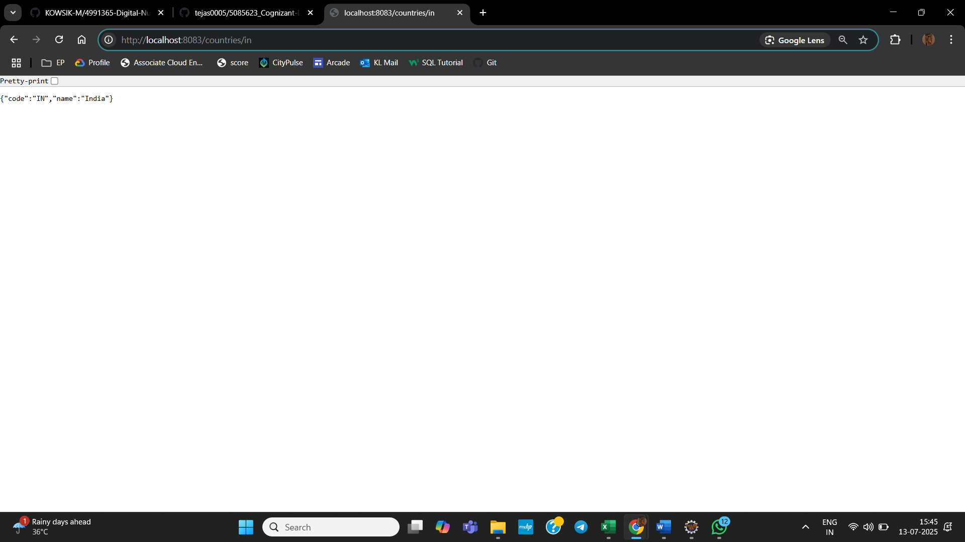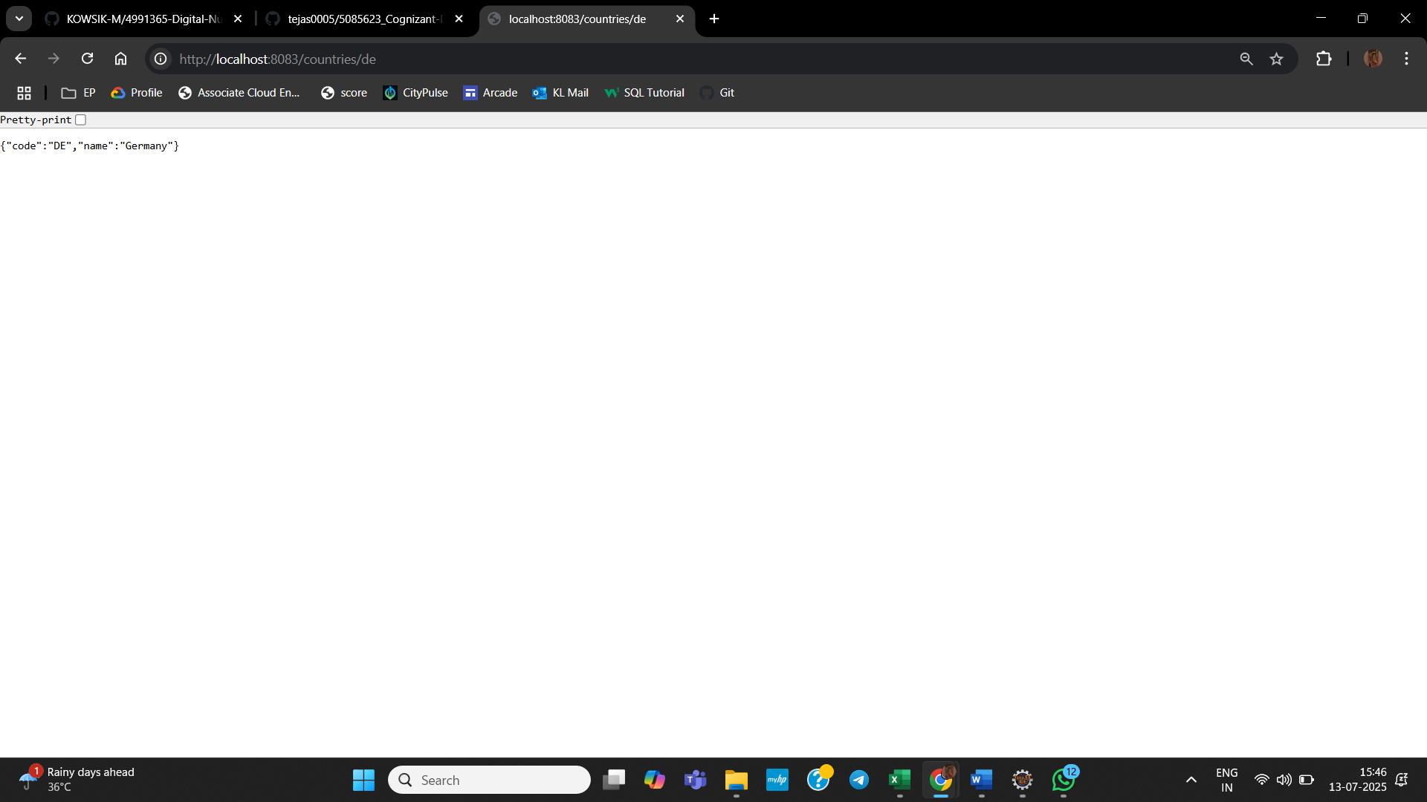

JWT-handson:
- Create authentication service that returns JWT:
Add Spring Security dependency:
<dependency>
<groupId>org.springframework.boot</groupId>
<artifactId>spring-boot-starter-security</artifactId>
</dependency>

Create AuthenticationController.java:
package com.cognizant.spring_learn.controller;

import org.slf4j.Logger;
import org.slf4j.LoggerFactory;
import org.springframework.web.bind.annotation.*;

import java.util.HashMap;
import java.util.Map;

@RestController
public class AuthenticationController {

private static final Logger LOGGER = LoggerFactory.getLogger(AuthenticationController.class);

@GetMapping("/authenticate")
public Map<String, String> authenticate(@RequestHeader("Authorization") String authHeader) {
LOGGER.info("START - authenticate()");
LOGGER.debug("Authorization Header: {}", authHeader);

Map<String, String> map = new HashMap<>();
map.put("token", ""); // JWT will be filled in later

LOGGER.info("END - authenticate()");
return map;
}
}
Create a com.cognizant.spring_learn.config and in that SecurityConfig.java:
package com.cognizant.spring_learn.config;

import org.springframework.context.annotation.Configuration;
import org.springframework.security.config.annotation.web.builders.HttpSecurity;
import org.springframework.security.web.SecurityFilterChain;
import org.springframework.context.annotation.Bean;

@Configuration
public class SecurityConfig {

@Bean
public SecurityFilterChain filterChain(HttpSecurity http) throws Exception {
http.csrf(csrf -> csrf.disable())
.authorizeHttpRequests(authz -> authz
.requestMatchers("/countries").hasRole("USER")
.requestMatchers("/authenticate").hasAnyRole("USER", "ADMIN")
.anyRequest().authenticated()
)
.httpBasic();

return http.build();
}
}
Create a MyUserDetailsConfig:
package com.cognizant.spring_learn.config;

import org.springframework.context.annotation.Bean;
import org.springframework.context.annotation.Configuration;
import org.springframework.security.core.userdetails.*;
import org.springframework.security.provisioning.InMemoryUserDetailsManager;
import org.springframework.security.crypto.bcrypt.BCryptPasswordEncoder;
import org.springframework.security.crypto.password.PasswordEncoder;

@Configuration
public class MyUserDetailsConfig {

@Bean
public InMemoryUserDetailsManager userDetailsService(PasswordEncoder passwordEncoder) {
UserDetails user = User.builder()
.username("user")
.password(passwordEncoder.encode("pwd"))
.roles("USER")
.build();

UserDetails admin = User.builder()
.username("admin")
.password(passwordEncoder.encode("admin"))
.roles("ADMIN")
.build();

return new InMemoryUserDetailsManager(user, admin);
}

@Bean
public PasswordEncoder passwordEncoder() {
return new BCryptPasswordEncoder();
}
}

Output:
