A Project report submitted in partial fulfilment of the requirements for the degree of B.E in Electronics and communication Engineering

By

K.P.Abitha(513221106301)

Under the supervision of

Professor & mentor

Department of Electronics and communication Engineering

Air quality monitoring system

PHASE1:PROBLEM DEFINITION AND DESIGN THINKING

* Problem Statement
* Design Thinking

PROBLEM STATEMENT

* It refers to the contamination of the atmosphere by harmful chemicals or biological materials. It may cause diseases, allergies, and severe health problems in humans and other living organisms and may damage the natural environment.
* The problem statement is your opportunity to explain why you care and what you propose to do in the way of researching the problem. A problem statement is an explanation in research that describes the issue that is in need of study.

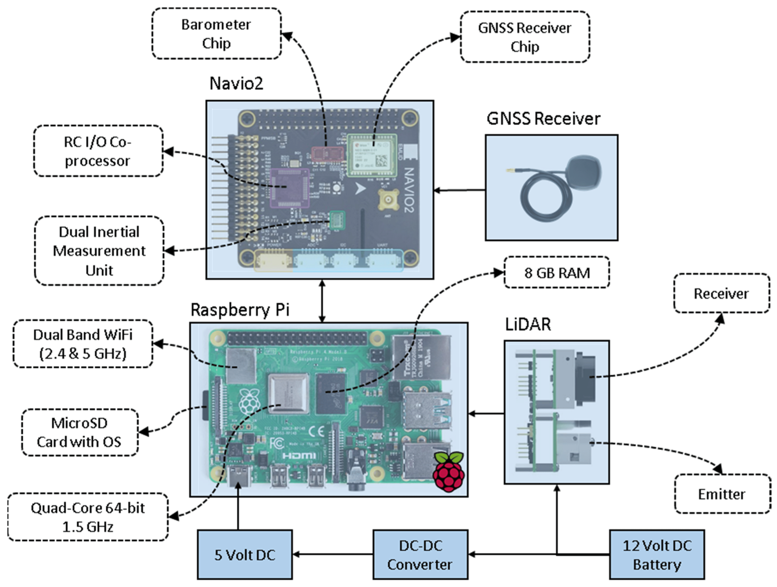

* Air pollution is one of environmental issues that cannot be ignored.
* Inhaling pollutants for a long time causes damages in human health.
* Traditional air quality monitoring methods, such as building air quality monitoring stations, are typically expensive .
* This project is suitable for air quality monitoring in real time.
* Design a tool which will sense quality of air and display it in the form of percentage, Sense how much carbon mono-oxide(CO) is present in air and display in the form of percentage, Sense the temperature and display it in degree Celsius.

DESIGN THINKING APPROACH

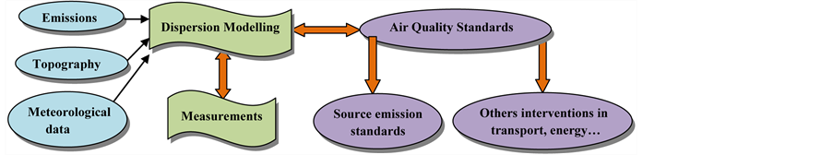

1.Project Objectives:

* Real time air quality refers to information about the current levels of pollutants in air such as particulate matter,ozone,nitrogen dioxide,sulphur dioxide,and carbon monoxide.
* Public can access the constantly updated data.
* This data is often collected by government agencies or private organizations using air quality monitoring stations.
* Collect data for the air quality management,traffic and land use planning purpose.
* Supply data for research investigation.
* It is useful in raising public awareness about air pollution and its health effects and to encourage individuals and communities to take action to reduce pollution.
* It is used to inform decisions about public health.for example,issuing air quality alerts or advisories for vulnerable populations.furthermore,to track health effects of air pollution over time.

2.IOT Devices Designs:

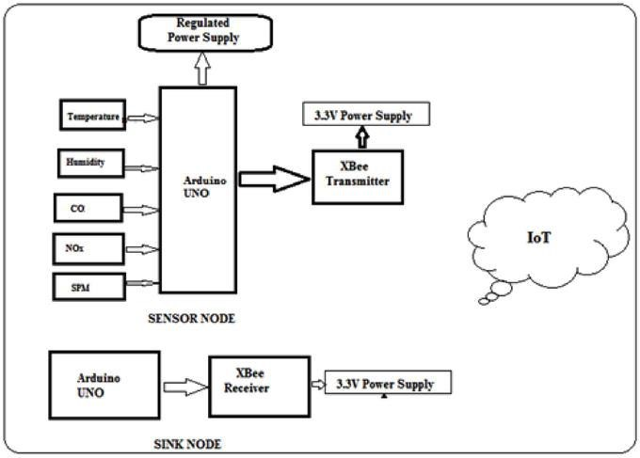

* Detailed concentration distributions and temporal variations of H2S for Gaussian puff model, referring to the guideline models for pollution detection and source identification were given by the environmental risk assessment.
* The source area analysis method was employed to perform the area by means of meteorological data and concentration .
* Avoid burning leaves, trash, and other materials Reduce the number of trips you take in your car.
* Sensors are the primary component of iot based air pollution monitoring systems.They measure various air quality parameters such as particulate matter,carbon monoxide,etc…
* Sensors are classified into two types:physical and chemical sensors physical sensors measure parameters such as temperature,humidity,pressure. While, chemical sensors measure air pollutants.

3.Data sharing platform:

* IOT Devices share the sensor data they collect by connecting to an IoT gateway,which acts as a central hub where IoT devices can send data.
* Before the data is shared,it can also be sent to an edge device where that data is analyzed locally.
* Analyzing data locally reduces the volume of data sent to the cloud,which minimizes bandwidth consumption.
* The connectivity,networking and communication protocols used with these web-enabled devices largely depend on the specific IoT applications deployed.

4.Integration Approach:

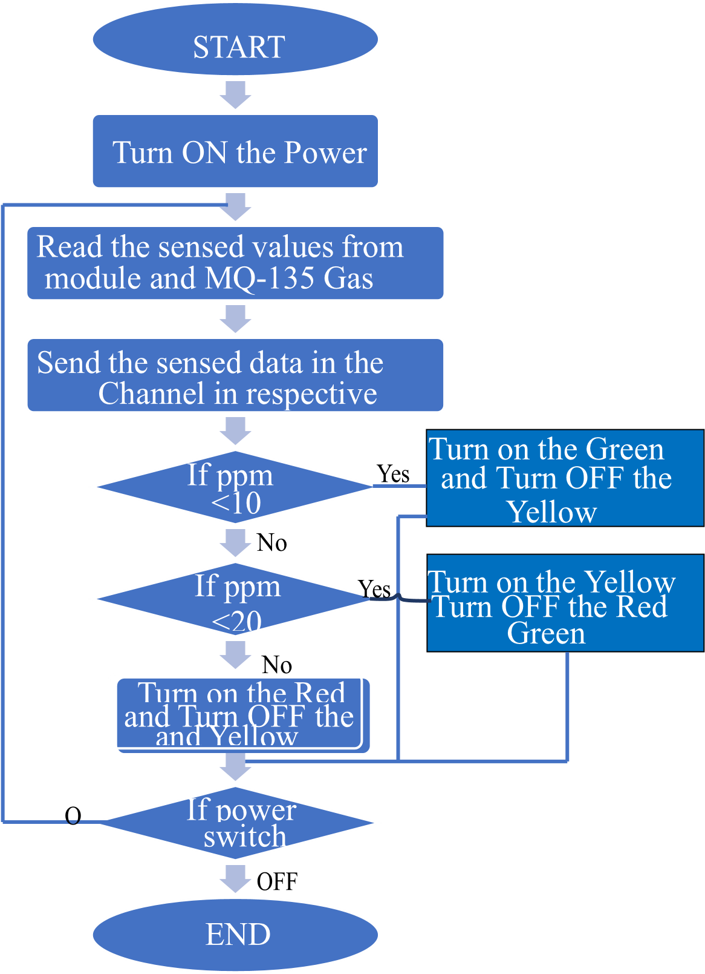

* Air pollution is not often perceived as a priority for village apparatus and community members,because from their standpoint it rarely results in immediate health effects or causes massive disruption of activities.
* In order for air pollution-related health information to lead to behaviour change,continuous and specific support is needed from village apparatus and health cadres within the communities.
* Context-specific information on what to do and when to take action is critical to encourage mitigating actions at the community level.