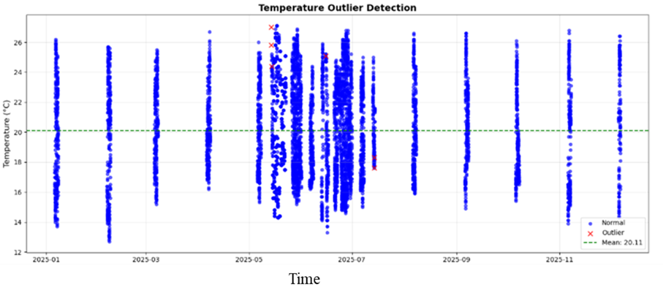
Figure 1: Temperature Data plot
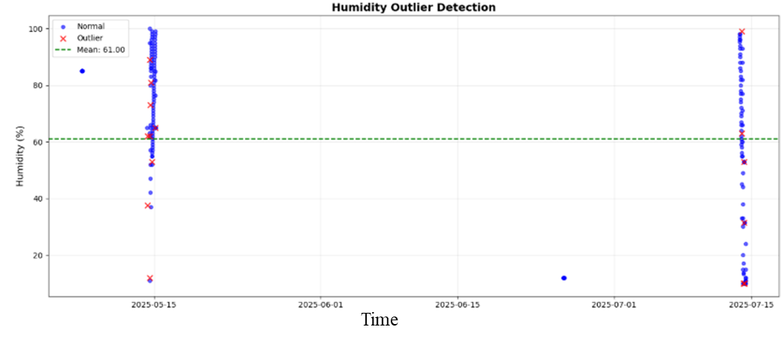
Figure 2: Humidity Data plot
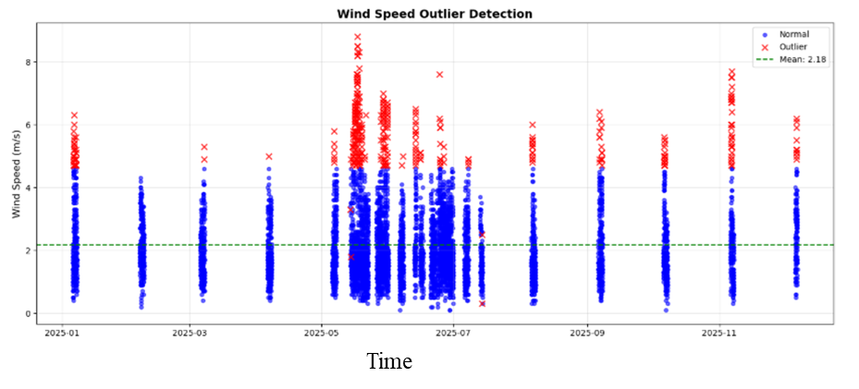
Figure 3: wind speed Data plot
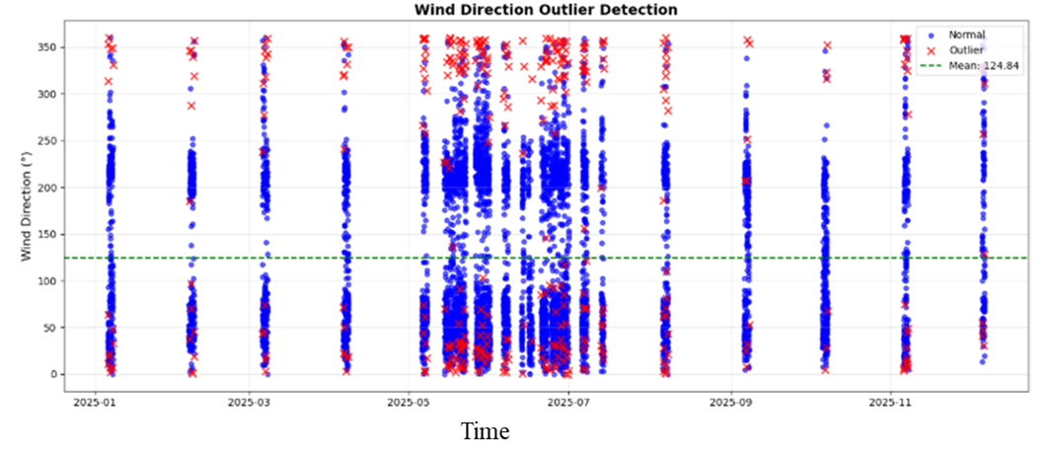
Figure 4: wind directn Data plot
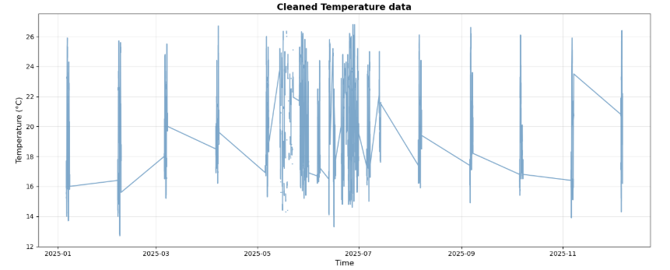
Figure 5: Temp clean data
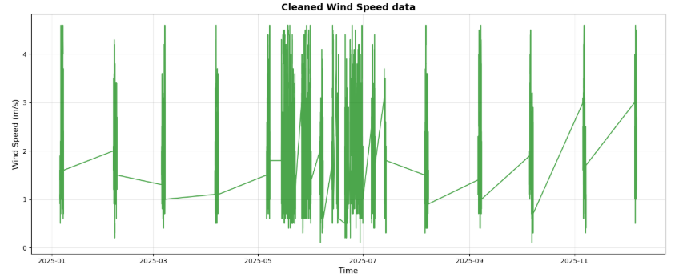
Figure 6: Figure 5: wind speed clean data
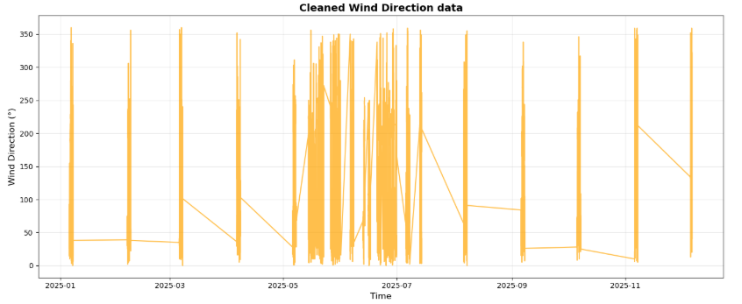
Figure 7: wind dir data

