UML Diagram + Instructions for Spec:
I added some definitions for some of the header files since the UML Diagram (to me at least is very confusing at a glance), so if you feel something can be done better or you have a better way, you are welcome to implement it. Just let me know of any changes you make so I can account for them and make sure to log them on GitHub commits, after all this is group work so 3 minds are better than one. Below are the instructions I came up with for a baseline of what each class should do in theory, you are welcome to add more functionality or anything.

Note: I tried my best to remember everything, I don’t know if I missed any constructors or deconstructors so just let me know if something is missing.
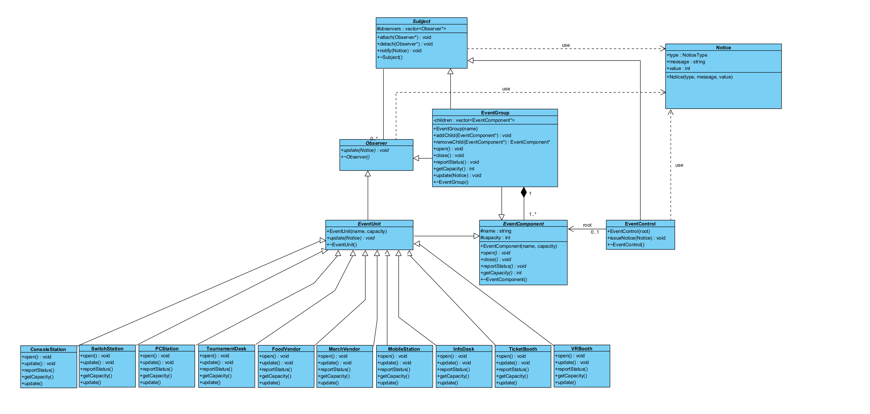
The format is:
- Reference Image
- Accompanying Guidelines
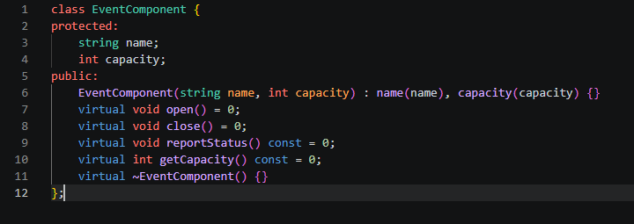
Constructor just sets the two fields. It's public, you can't instantiate EventComponent directly anyway because of the pure virtual methods, so there's nothing extra to protect against.
No other logic here, this is a pure interface plus shared fields.

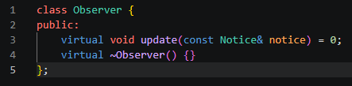
No logic here either. Just the interface.

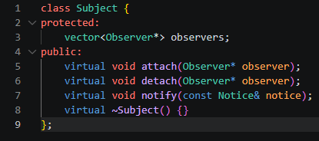
attach(observer): search observers for the same pointer. If already present, do nothing. Otherwise push_back it.
detach(observer): search observers for the pointer. If found, erase it. If not found, do nothing, no error, no crash.
notify(notice): copy observers into a local vector first, then loop over the copy calling, update(notice) on each one. (Copying first stops crashes if an observer attaches/detaches something during its own update() call.)
~Subject(): just observers.clear(). Never call delete on anything in the list, we don't own these pointers.

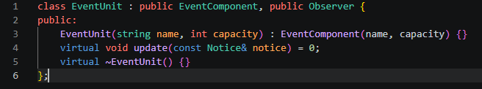
Constructor is public and just forwards name/capacity up to EventComponent, nothing else to set here. (It's never called directly by outside code anyway, since EventUnit still has a pure virtual update() and can't be instantiated, so public vs protected makes no practical difference; public is simpler.)
Leave open(), close(), reportStatus(), getCapacity() undeclared here, they stay inherited as pure virtual from EventComponent, so every concrete leaf below is forced to implement them.
update() also stays pure virtual (= 0), every concrete leaf must write its own.

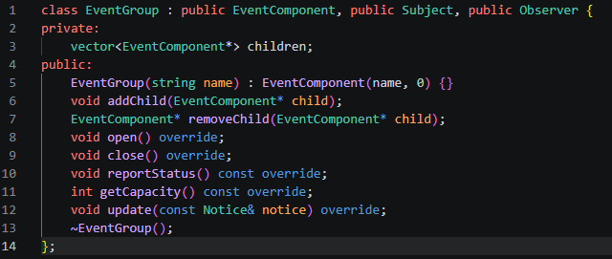
Constructor: only takes name. Pass 0 for capacity to the base, it's meaningless here since getCapacity() is fully derived from children, never stored locally.
addChild(child): children.push_back(child). That's it, do not call attach() here. Composite membership and Observer registration are two separate steps; if you also want this child notified of future notices, call attach() on it separately wherever you build the tree.
removeChild(child): find child by pointer in children, erase it from the vector, and if it was also registered as an observer of this group, call detach(child) on it first. Then return the pointer — do not delete it. Return nullptr if not found.
open(): loop over children and call child->open() on each.
close(): loop over children and call child->close() on each.
reportStatus(): print this group's own name/state, then loop over children calling child->reportStatus() on each (indent the output so it reads as a tree).
getCapacity(): return the sum of child->getCapacity() over all children. No local capacity number of your own, it's 100% derived.
update(notice): this fires when a parent (or EventControl) sends this group a notice. Write whatever local reaction makes sense (e.g. log it, adjust status), then call this->notify(notice) to push the same notice down to whichever children are registered as this group's observers. This is what makes the notifications cascade down multiple tree levels.
~EventGroup(): loop over children, and for each one: if it was attached as an observer of this, call detach() on it first, then delete it. After the loop, the vector destroys itself automatically.

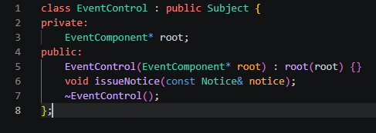
Constructor: just stores the pointer it's given. Doesn't allocate or take ownership of anything.
root is just a pointer for reference, never delete it in this class. Whoever builds the tree in main.cpp owns it and deletes it there.
issueNotice(notice): one line, call this->notify(notice). That's the whole method; it broadcasts to whatever's attached directly to EventControl.
~EventControl(): no body needed beyond the default, ~Subject() handles clearing the observer list.

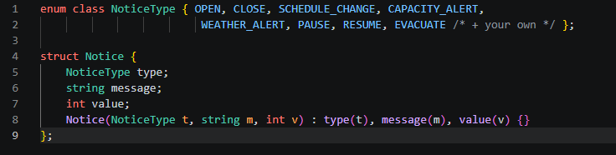
Add more NoticeType values of your choice if you want, you will use these later in the leaves to give them unique functionality.
No other logic, this is a plain data container, nothing computes or mutates inside it.

Okay now for the 10 concrete leaves:
Every leaf below needs a constructor, plus open(), close(), reportStatus(), getCapacity(), and update(const Notice&), and each one's behaviour must be genuinely different, not just a different printed name. Pick your own idea for each.
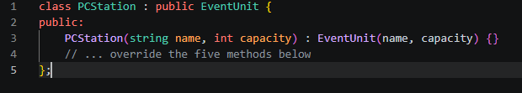
Just forward name/capacity up to EventUnit. If your leaf tracks extra starting state (e.g. MerchVendor's stock level, PCStation's loaded game), add that as an extra constructor parameter with a sensible default, e.g. MerchVendor(string name, int capacity, int stock = 100).

Here are some ideas I came up with, you are welcome to use them or make your own:
PCStation : override open() to boot the station and load a default game; override update() so a WEATHER_ALERT does nothing (indoor unit) but EVACUATE triggers close().
ConsoleStation : override close() to save active sessions before shutting down; update() reacts to CAPACITY_ALERT by capping new sign-ins.
SwitchStation : override getCapacity() to return a lower number if running on battery/portable mode; update() ignores most notices except EVACUATE.
MobileStation : override open()/close() to be near-instant (no setup time); update() on SCHEDULE_CHANGE reshuffles its queue.
VRBooth : override close() to require a cooldown/cleaning step before it can reopen; update() on CAPACITY_ALERT pauses new sessions but lets the current one finish.
TournamentDesk : override reportStatus() to print current bracket/round info; update() on SCHEDULE_CHANGE delays the next match.
InfoDesk : override update() so it reacts to every notice by updating a public announcement board (never closes fully); close() just reduces staffing, doesn't fully shut down.
MerchVendor : override getCapacity() to represent stock level instead of headcount; update() on CAPACITY_ALERT triggers a restock flag.
FoodVendor : override close() to differ by whether it's mid-order (finish current order first); update() on WEATHER_ALERT closes if outdoor-only.
TicketBooth : override open()/close() to control whether new sales are accepted; update() on EVACUATE stops all sales immediately and refuses open() calls until RESUME.
And lastly:
For every leaf: reportStatus() should print something specific to that unit (not just "open" or "closed", say what it's doing), and update() should have an actual if/switch on notice.type producing different internal effects, not just a printed log line.
Here is an idea I came up with, you can use it or reference it, its just meant to serve as a guideline (next page):
