|  |
| --- |
|  |
| Aruba SC360 - Architecture Document |
| |  |  |  | | --- | --- | --- | | Navtej Billing | 6/12/20 | Version 1.1 | |

Revision History

|  |  |  |  |  |  |  |
| --- | --- | --- | --- | --- | --- | --- |
| Sl. No | Version No | Change Description | Authored By | Reviewed By | Approved By | Date |
|  |  |  |  |  |  |  |
|  |  |  |  |  |  |  |
|  |  |  |  |  |  |  |
|  |  |  |  |  |  |  |
|  |  |  |  |  |  |  |
|  |  |  |  |  |  |  |
|  |  |  |  |  |  |  |

Table of Contents

1 Introduction 3

1.1 Project Overview 3

2 Business and Data Gap Analysis 4

2.1 Functional Pain Points: 4

2.2 Technical pain points: 5

3 Business Impact analysis: 7

4 Technical Assessment - As-Is vs. To-Be 8

4.1 Data 8

4.2 Application 15

4.3 Report/Analytics 16

5 Technical Assessment – As-Is Deep dive 18

5.1 Data – Current State 18

5.2 Application – Current State 19

6 Technical Stack Recommendation 22

6.1 Data 22

6.2 Application 22

7 Security & Compliance 28

7.1 Data Flow Diagram 28

7.2 Server Landscape Diagram 28

7.3 Application Flow diagram 28

Introduction

Project Overview

SC360 which is a one-stop decision management solution proposed to provide a personalized platform to enable advanced analytics decision making, visibility, and collaboration. it will provide the relevant notifications, information, and actions to different personas present in different regions to help them generate actionable insights quickly

SC360 aims to achieve the following key business objectives:

* Providing a single source of truth for data that contains accurate and most recent data
* Providing consolidated reports with desired Views as indicated by personas
* Predict outcomes for Key business area and prescribe recommendations for business process optimization
* Provide end to end view of supply chain performance for all personas
* Provide historical activity tracking
* Enable effective inter-team as well as intra team communication across regions

The current environment in Aruba Supply Chain consists of various teams going to multiple tools to collate information for their stand-alone reports. The interface for some of the tools is not very UI/UX friendly. The four pillars of SC360 application – Standardization & Consolidation, Communication & Collaboration, Visibility, and Advanced Analytics will enable Aruba to achieve operational efficiency and improve user sentiment within the team in the following way:

* Standardization and Consolidation
  + Consolidation of existing data sources into a single source
  + KPI Standardization for use across various user personas
  + Report consolidation for better ease of use
* Advanced Analytics
  + Predict Outcomes for Key Business Areas
  + Prescribe recommendations for business process optimization
  + Deep dive capability to identify hidden trends
* Visibility
  + End to end view of Supply Chain Performance
  + Visibility at SKU, Product family, Orders, PO, regional and Financial
  + Alert and monitoring capability
* Communication and Collaboration
  + Enable team collaboration through user group tagging in comments for a better view
  + Historical activity tracking
  + Communication features such as notification, messaging capabilities

Business and Data Gap Analysis

Functional Pain Points:

2.1.1 Communication:

* + Comments auto-refreshes every 5 minutes however there is a delay in viewing them in SPDST
  + Any comments that are unedited for more than a week are not visible in SPDST
  + Simultaneous editing of comments can result in for a loss of data
  + There is a word limit on comments.
  + Lack of ability to send any communication notifications to the recipient.
  + Other SC team members can edit/delete historical comment which cannot be controlled.

2.1.2 Visibility:

* + Visibility on inventory at the warehouse is needed
  + CTO order information is currently unavailable in SPDST (APJ)
  + CTO/BTO order classification missing in SPDST
  + Information of Overdue PO, PO expiring in next two days is missing in SPDST
  + Consolidated view is missing to compare side by side the granular data of backlog plus PO(open/in-transit) for shortage management and fulfilment(supply planners and SCOM).
  + SPDST/BMT lacks ability to bifurcate backlog by internal (intracompany)/stocking (partner) /end customer orders.
  + SPDST lacks the ability to filter shortage by channel/stocking and End Customer order.
  + Complete order visibility is missing in SPDST.
  + Inbound/PO lead time and transit time information in SPDST currently sourcing from IBP
  + KPI Metrics of outbound/order lead time and processing time in SPDST
  + SPDST shows on hand inventory view, however, Inventory planners cannot get the aging of inventory information from SPDST
  + SPDST does not show the default Shipment mode for a PO. Shipment visibility along with cost implication in-case mode is changed from Ocean to Air (this piece needs to be validated whether feasible or not)
  + Partial shipment details not captured in SPDST
  + The demand planner cannot view a new deal. (DP to go > 70% for SKU then revise DP otherwise leave DP untouched)

2.1.3 Data

* + Inaccurate in-transit and limited attributes of PO in SPDST (855/856 EDI files)
  + DP To Go formula is incorrect in SPDST for APJ
  + Backlog info is inaccurate for SPDST in APJ
  + Backlog information is inaccurate for BMT in AMS
  + Delay in SPDST refresh for APJ every Monday due to dependency on the helpdesk for fetching APJ backlog data.
  + Whether within or outside the quarter, open PO view should be based on cut-off date unlike calendar date as being currently followed in SPDST.
  + AUP/ASP data is stale in SPDST currently (currently need to manually extract from PDW Business Cube)
  + No visibility of change in DP to Go field in SPDST due to change in orders RSD as the calculation in the tool is based on quarter to date orders. Demand Planners on the other hand base their calculations on orders RSD.
  + *NPI and EOS information is delayed* (Need to manually collect information from GPLM and project managers)
  + DP Order to go formula to be validated for aligning with Japan
  + There is a delay in the AMS SPDST refresh every Monday due to the failure of dxc jobs.
  + Sellout and channel inventory information is not present in SPDST

2.1.4 Reports and Analytics

* + Confidential information currently visible to anyone who has access to SPDST or other tools
  + Most of the current reports are manual in nature with high dependency on data provided manually by other teams
  + Currently excel reports are very heavy in nature due to multiple data sources used, complex calculations and multiple unused columns.
  + Refresh of reports are done manually which take away a lot of time hence affecting productivity
  + No Flexibility to share the report over the cloud and view them across desktop and mobile devices
  + Collaboration ability in Power BI reports helping in quicker decision making
  + Automated reports to remove manual dependencies.
  + Identify and implement Analytics use cases as agreed with stakeholders

2.1.5 Miscellaneous

* + SPDST User interface is complex and not user friendly.
  + Most of the communications with SC Aruba supply chain team is done over emails which is time-consuming and difficult to trace the history of communications
  + Only one DP in a region can work on collab file at a time, hence affecting productivity.
  + There is a difference between total backlog shown in BMT vs SCOM's tool as BMT considers canceled orders in its calculations in addition to calculating aging for future orders which is not used by SCOM when calculating order aging.
  + Multiple user interfaces/tools making it difficult to retrieve data and arrive at decision faster.
  + No predictive or prescriptive actions are in place, rather the nature of the analysis is more diagnostic

Technical pain points:

* Manual processes are involved in developing and maintaining reports.
* The use of legacy tools and technologies limits the features and capabilities available to the users as well as the system SMEs.
* *Tool performance is slow for SPDST (due to it being an excel based tool).*
* Limited space on the data servers are a big hindrance in the entire architecture
* Excel/CSV files are used as inputs for many systems that are prone to structural changes.
* Data files are received via emails for further processing which creates dependencies.
* Insights or tracking of information are done & shared manually via excels/emails to be used by stakeholders
* Re-processing of the rejected records, after the data quality checks, is not being taken care of at all which leads to missing information.
* A lot of manual effort is spent in sourcing, consolidation, and transformation of data before an insight is generated

Business Impact analysis:

|  |  |
| --- | --- |
| **Area** | **Feature/Activities** |
| **Productivity** | Data consolidation from disparate data sources leading to, reduction in data retrieval time |
| Clean up of raw data (source data)/data wrangling thereby, improving data accuracy |
| Providing collaboration / communication feature in web application for requests |
| Creation of audit trails for comments |
| Self-Serve reporting capability and personalization of front end |
| Automation of reports and auto refresh of SC 360 |
| **Cost Optimization** | Visibility of accurate information to facilitate decision making on shipment mode, PO |
| Reduced working capital through future deal visibility and tracking |
| Optimal usage of manhours through automation of reports and single source of truth. |
| **Inventory Turnover** | Minimizing Inventory exposure from lost deals by better prediction/forecast |
| Visibility of EOL product information for better excess management |
| **Forecast Accuracy** | Improving demand forecast accuracy for fulfilling orders timely / plan more accurately |
| **Order processing lead Time** | Reducing through better visibility of current and future orders |

Technical Assessment - As-Is vs. To-Be

Data

**As-Is**

The following section illustrates the As-is view of the Aruba Supply Chain Operations Analytics & Reporting platform.

The Current environment consists of various applications using the Supply Chain Operations Analytics & Reporting platform which has various tools or end solutions which provide insights to different users. Core systems like SAP Fusion, EDW, SAP IBP, S4 HANA and other input files which are manually placed in the share point are the data sources from which the transactional data are consumed by ETL platforms (pnb-PDW) and the ETL outputs are visualized using various tools/dashboards. The tools are used stand alone or reports are created from extracts of the information available in the tools along with some columns from different sources. The process is manual intensive and prone to error as certain tools may have data that has not been synced with the source systems. In addition, certain regions receive critical information through email reports

Below is the source system that exist in the AS-IS environment.

4.1.1 SPDST

1. Supply Planning Decision Support Tool (SPDST) is a planning tool for Aruba Supply Chain Regional & Global Operation Teams which converges key operational data (Demand, Supply, Order & Fulfilment) into one solution in order to increase the visibility of potential issues, allowing for greater decision making and analysis.
2. Its primary focus is Backlog Order Managements – Shortages and SAB Revenue gaps
3. This tool is specifically built to be used by Supply Planners & SC Order Management Team

4.1.2 BMT

1. Backlog Management Tool (BMT) is a robust system which allows the SCOM (Supply Chain Order Management) to provide a clear view of the open backlog and enable proactive backlog management. This includes the actual status of an order item in production, history information on issues.
2. It provides the insights on the orders where there is a material shortage (RISK) and helps the users to take corrective measures.

4.1.3 Pnb-PDW

1. Pnb-PDW is the primary data warehouse in the entire Supply Chain Operations Analytics & Reporting platform architecture. Pnb-PDW by itself is a Data Warehouse which gets input from the Fusion, S4 and several other source systems and apply lot of complex transformation rules and the data is made available to wide range of user communities. Our scope or the interest would be a small portion in the PDW system which feeds data to SPDST, BMT, Supply Review for generating dashboards & reports

4.1.4 Supplier Review

1. Supply Review is a tool used mostly by Supply Planners to get the shipment related information from suppliers.
2. This tool provides insights related to shortages in previous period, remaining supplies, list of products, shipping quantity, etc… and helps to create net/gross build plan.

4.1.5 Executive Metric Dashboard

1. Executive Metric Dashboards are published on monthly basis in Power-BI tool.
2. This dashboard encompasses around 24 key metrices and the glossary for those can be found [here](https://hpe.sharepoint.com/:w:/r/teams/SC360/_layouts/15/Doc.aspx?sourcedoc=%7B51686DA9-4CF1-4431-BC0A-79761ED3140C%7D&file=Executive%20Metrics%20-%20Procedural%20Doc.docx&action=default&mobileredirect=true).

The current system has the following shortcomings which the SC360 system will address.

* Several manual processes involved in developing and maintaining the reports.
* Use of legacy tools and technologies had limited the features and capabilities available to the users as well as to the application SME.
* Excel/CSV files are used as inputs for many systems which are prone to structural changes.
* Data files are received via emails for daily processing which creates dependencies and risk of data availability in warehouse based on the user availability over the weekend and on annual leave.
* Insights or tracking of information are done & shared manually via excels/emails to be used by stakeholders
* No predictive or perspective actions are in place; rather the nature of the analysis is more diagnostic
* Data Validation/ Data Quality checks are not being done properly, which in turn results in system failure in most of the scenarios.
* Re-processing of the rejected records, after the data quality checks, are not being taken care of at all which leads to missing information.
* Comments are posted by end users in the tools without any approvals.
* Limited space in cloud servers are a big hindrance in the entire architecture

**To-Be**

The following provides the future state view of the SC360.

Conceptual Architecture –

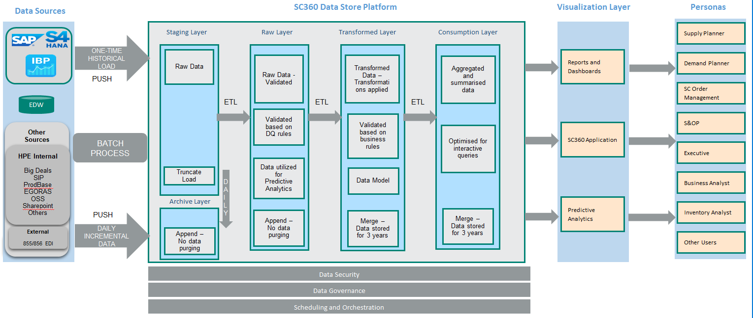

The following architecture provides the future state view of the SC360

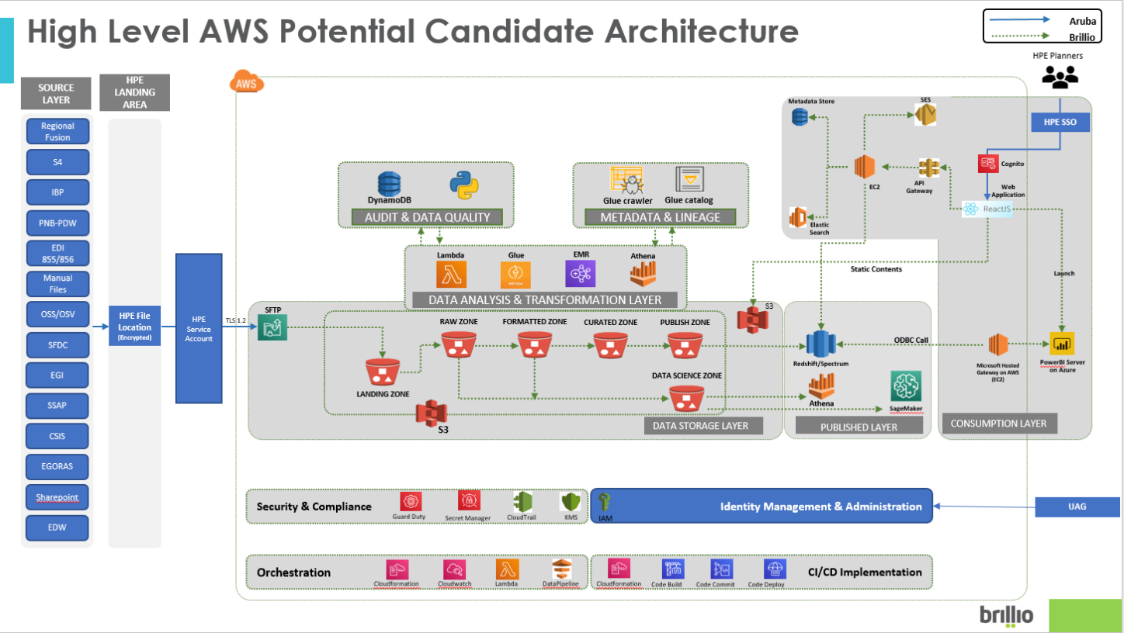

The SC 360 platform components include:

4.1.6 Data Sources

* Source system data sources like SAP Fusion, S4 HANA, EDW, etc…
* It will also include other internal sources like OM, Ariba, WMS, EDW SFFC, Sales Ops/Deals, Finance, ProdBase, EGORAS, OSS/Sandy, OSV-UI/TIDAL, etc…
* External sources include 855/856 EDI files.

4.1.7 Data Ingestion

* Flat files from Source systems into a common location -
* Flat files that would be coming from various source systems e.g. EDW, EGORAS etc will be dumped to a common location on the HPE Server via HPE SSO. AWS SFTP SSH Key will be available in the same HPE Server. So that once the files are dumped in the HPE Server, they will be pulled to AWS S3 (Simple Storage Service) using AWS SFTP.
* Flat files from Source systems into Sharepoint -
* Business users would be uploading some of the data files to the sharepoint location. AWS CloudWatch will run these lambda functions as per the batch timing and AWS Lambda will hit the HPE Sharepoint via HPE SSO and download the file into the /tmp (temp location in AWS Lambda). Then it will store the file onto AWS S3.
* AWS Services Used -
  + AWS SFTP – AWS SFTP is a part of AWS Transfer family. It enables you to easily move your file transfer workloads that use the Secure Shell File Transfer Protocol (SFTP) to AWS without needing to modify your application or manage any SFTP servers.
  + AWS CloudWatch – Amazon CloudWatch provides you with data & actionable insights to monitor your applications, respond to system-wide performance changes, optimize resource utilization, and get a unified view of operational health. Along with this, it helps you schedule jobs as well to perform certain tasks.
  + AWS Lambda – AWS lambda is a microservice which lets you run code without provisioning or managing servers.

4.1.8 Storage Zone

* + Following are the various zones present in Data Storage Layer-

1. Landing Zone

All the incoming data will be stored in this zone as it is without any modification and will be the one closest to the source data. This layer will store the current as well as historical data. The historical data would help in scenarios where reprocessing of data is required or where a data lineage has to be maintained.

1. Raw Zone

Data quality checks and validations will be performed on the data in the landing zone and invalid data will be moved to the rejected folder and the concerned people would be informed regarding the rejections. Valid data would be stored in the Raw layer to be consumed by AI/ML models for predictive analytics.

1. Formatted Zone

Depending on the information gathered regarding the transformations and the final data model, the formatted zone and the curated zone can be merged into one zone so as not to spend more time in replicating data across zones.

1. Curated Zone

Business rules and transformations would be performed on the data in the Raw/formatted zone as well as any data standardizations required would be applied and would be stored in the curated zone.

1. Publish Zone

Data in this zone would be stored in the form of facts and dimensions and would be queried using AWS redshift spectrum.

1. Data Science Zone

This zone would be used by data scientists who want to perform AI/ML activities and would like to create their personal data folders for further analysis.

* AWS Services Used -
  + AWS S3 – Amazon Simple Storage Service (S3) is an object storage service that offers industry-leading scalability., data availability, security and performance.

4.1.9 Transformation Zone

* Based on the size of the data being processed and the transformation requirements, either AWS Glue or AWS EMR (Elastic Map Reduce) will be used for performing ETL operations.
* AWS lambda would be required to spin up-down the EMR clusters as and when required and submit a Transformation job as a step function.
* Similarly, AWS Lambda can submit a job through AWS Glue ETL to transform the data present in various zones in AWS S3.
* AWS Athena will be used for ad-hoc querying for data reconciliation.
* AWS Services Used -
  + AWS EMR – Amazon Elastic Map Reduce (EMR) is the industry-leading cloud big data platform for processing vast amounts of data using open source tools such as Apache Spark, Apache Hive, Presto, etc…
  + AWS Glue – AWS Glue is a fully managed extract, transform, and load (ETL) service that makes it easy for customers to prepare and load their data for analytics. AWS EMR is preferred over AWS Glue For complex ETL transformations & huge volume of data use cases.
  + AWS Lambda - AWS lambda is a microservice which lets you run code without provisioning or managing servers. In the transformation zone, it is be mostly used for tasks like triggering a job, data quality checks, acting as a bridge between services, etc…
  + AWS Athena – AWS Athena is serverless and it is an interactive query service that makes it easy to analyse data in Amazon S3 using standard SQL.

4.1.10 Published Zone

* AWS Redshift will take data from the Publish Zone from AWS S3 and it will serve as the source for Microsoft PowerBI Visualization Tool as well as SC360 application and for analytics.
* Apart from this, this zone would store data in a summarized/aggregated form and views also would be created, so that the front end can pick up this data as it is and display it to the users rather than performing these activities on the fly that might lead to performance issues.
* Amazon DynamoDB will be serving as metadata serving platform for the web application.
* Data Science team will be using AWS SageMaker to build, train & deploy their machine learning models. They will also leverage AWS Athena for instant querying of the data lying in S3.
* AWS Services Used -
  + AWS Redshift – Amazon Redshift is a fully managed, petabyte scale data warehouse service in the cloud.
  + AWS DynamoDB – Amazon DynamoDB is a key-value & document database that delivers single-digit milliseconds performance at any scale.
  + AWS SageMaker – Amazon SageMaker is a fully managed service that provides every developer and data scientists with the ability to build, train, and deploy machine learning (ML) models quickly. It removes the heavy lifting from each step of the process to make it easier to develop high quality models.
  + AWS Athena - AWS Athena is serverless and it is an interactive query service that makes it easy to analyse data in Amazon S3 using standard SQL.

4.1.11 Consumption Zone

* HPE Planners & Partners will access the Web application as well as the Visualization tool (PowerBI) after being authenticated via HPE SSO.
* Microsoft PowerBI Visualization tool will publish multiple dashboards based on personas to Aruba End Users.
* Web Application will serve similar purpose to end users as well.
* Both Web Application & PowerBI tool will be hosted on the AWS EC2 servers.
* AWS Route 53 will be used for DNS in order to route end users to the web application by translating the URL into IP addresses.
* AWS API Gateway will be used for integrating the backend services with the web application using WebSocket API.
* AWS Services Used –
  + AWS EC2 – Amazon Elastic Computing Cloud (EC2) is a web service that provides secure, resizable compute capacity in the cloud.
  + AWS Route53 – Amazon Route 53 is a highly available & scalable cloud Doman Name System (DNS) web service. It is fully compliant with IPv6.
  + AWS API Gateway – Amazon API Gateway is a fully managed service that makes it easy for developers to create, publish, maintain, monitor, and secure APIs at any scale.

4.1.12 Data Security & Compliance

* AWS KMS (Key Management System) provides Server-Side Encryption (SSE) – AES256 to encrypt all the data at rest and metadata present in AWS S3 and AWS Glue Data Catalog. By enabling Transport layer Security (TLS) we can have encryption of the data in transit.
* AWS Guard Duty will be used for threat detection & AWS Secrets manager will be used for credentials management.
* AWS Services Used –
  + AWS KMS – AWS Key Management Service (KMS) makes it easy for you to create and manage cryptographic keys and control their use across a wide range of AWS services and in your application.
  + AWS GuardDuty – Amazon GuardDuty is a threat detection service that continuously monitors for malicious activity and unauthorized behaviour to protect your AWS accounts & workloads.
  + AWS Secrets Manager – AWS Secrets Manager helps you protect secrets needed to access your application, services, and IT resources. It enables you to easily rotate, manage, and retrieve database credentials, API keys, and other secrets throughout their lifecycle.

4.1.13 Data Governance (Metadata Management)

* AWS Glue Crawler will be used to crawl on the folders present in AWS S3 to fetch the metadata information such as schema, compression, location information, etc…
* These metadata as well as lineage information will be stored in AWS Glue Data Catalog.
* AWS Services Used –
  + AWS Glue Crawler & Data Catalog – AWS Glue Crawlers call classifier logic to infer the schema, format & data types of your data and the metadata is stored as tables in the AWS Glue Data Catalog and used in the authoring process of your ETL jobs. AWS Glue Data Catalog can be used in conjunction with AWS EMR for master metadata repository.

4.1.14 Auditing & Data Quality

* Python scripts will be used to perform data quality checks for the incoming files present in Landing Zone in AWS S3 and then they will be moved to Raw Zone.
* Audit logs will be stored in AWS DynamoDB.
* AWS Services Used –
  + AWS DynamoDB – Amazon DynamoDB is a key-value & document database that delivers single-digit milliseconds performance at any scale.

4.1.15 Orchestration

* AWS CloudFormation templates will be used to come up with list of services and their configurations.
* AWS CloudWatch will be used to schedule events to run at a particular point of time.
* AWS lambda & Step Functions will be used to automate the tasks.
* AWS Services Used –
  + AWS CloudFormation – AWS CloudFormation provides a common language to model & provision AWS & third-party application resources in your cloud environment.
  + AWS CloudWatch – Amazon CloudWatch provides you with data & actionable insights to monitor your applications, respond to system-wide performance changes, optimize resource utilization, and get a unified view of operational health.
  + AWS Lambda – AWS lambda is a microservice which lets you run code without provisioning or managing servers. In the transformation zone, it is be mostly used for tasks like triggering a job, data quality checks, acting as a bridge between services, etc…
  + AWS Step Function – AWS Step Function lets you coordinate multiple AWS services into serverless workflows so that you can stitch services together into a feature rich application.

4.1.16 CI/CD Implementation

* AWS Code Build, AWS Code Commit, AWS Code Deploy along with AWS CloudFormation will be used to create the Continuous Integration & Continuous Delivery pipeline.
* AWS Services Used –
  + AWS CloudFormation – AWS CloudFormation provides a common language to model & provision AWS & third-party application resources in your cloud environment.
  + AWS CodeBuild – AWS CodeBuild is a fully managed continuous integration service that compiles source code, runs tests, and produces software packages that are ready to deploy.
  + AWS CodeCommit – AWS CodeCommit is a fully managed source control service that hosts secure Git-based repositories. It makes it easy for teams to collaborate on code in a secure & highly scalable ecosystem.
  + AWS CodeDeploy – AWS CodeDeploy is a fully managed deployment service that automates software deployments to a variety of compute services such as Amazon EC2, AWS Lambda, and your on-premise servers.

4.1.17 Access Management

* Authentication - Our understanding is HPE SSO is a Single Sign On mechanism of authentication and authorization for users internal to Aruba, that enables users to login once and gain access to all internal applications without having to login again.  For SC360 application, Single Sign On will be enabled leveraging HPE SSO REST APIs, allowing pass-through authentication to SC360 application in one step.  Once user is authenticated, security context provided by HP SSO response token and authentication policy is shared to SC360 application.  Application will manage necessary user personas and performs authorization of the user to map with role, access permissions and other internal rules of SC360 application.  HPE SSO token expiration value determines application session validity.
* Authorization – Authorization will be enabled using RBAC (Role based access control).

Each role will be independent of individuals and would be based Personas. All the front-end artifacts like reports, dashboards, applications would be tied to and driven using these personas.

* Each UI component and what data is visible within that UI would be governed by user role-based access control. There will be screen in the UI where, the administrator can assign authorized table/chart/columns visibility per persona/user-group. In other words, admin will capability to restrict data access on dashboard.
* Aruba has shared what security model to follow as part of cyber security requirement especially SSO will be done by HPE and it will be clarified with Darlene once we have final requirements and architecture in place.
* AWS Services Used –
  + AWS SSO – AWS Single Sign-On (SSO) makes it easy to centrally manage access to multiple AWS accounts & business applications and provide users with single sign-on access to all their assigned accounts & applications from one place.
  + AWS Cognito – Amazon Cognito lets you add user sign-up, sign-in, and access control to your web & mobile apps quickly & easily via SAML 2.0

4.1.18 Identity Management & Administration

* One of the Aruba Team members will have Admin access to AWS. (i.e. AWS IAM access will be in control of Aruba) and would be responsible for managing and controlling all admin related activities.
* Brillio Team will come up with AWS Services with configuration details (CloudFormation Template) according to the implementation requirements.
* SC360 implementation team would require the necessary access and rights to perform activities related to the project implementation.
* AWS Services Used –
  + AWS IAM - AWS Identity and Access Management (IAM) enables you to manage access to AWS services and resources securely. Using IAM, you can create and manage AWS users and groups, and use permissions to allow and deny their access to AWS resources.

Application

SC360 is intended to merge key functionalities of existing tools like Supply Planning Decision Support Tool (SPDST). Current system’s technological stack is standalone tool. However, the proposed system(to-be) will be leveraging capabilities of the technological advancements into a web application. The cutting-edge technology stack will enable Aruba SC360 planners to achieve personalization, optimized real-time data visibility, efficient and streamlined communication and collaboration.

**As-Is Vs. To-Be**

|  |  |  |  |  |
| --- | --- | --- | --- | --- |
| **S.no.** | **Criteria** | **As-Is** | **To-Be** | **Comments** |
| 1 | User-Friendly, Simple and Coherent User Interface | Close | Checkmark |  |
| 2 | Auto-Refresh Feature | Close | Checkmark | Manual refresh will not be needed in SC360 as it will display latest data from the source systems |
| 3 | User/Roles Management (Add/Delete/Edit/Manage Profile) | Close | Checkmark |  |
| 4 | Supply Chain Operational Reporting | Close | Checkmark |  |
| 5 | Supply Chain Productivity Reporting | Checkmark | Checkmark | All existing functionalities and view from SPDST will be moved into SC360. |
| 6 | Advanced Supply Chain Insight-Driven Reporting | Close | Checkmark | Advanced analytics use-case will be incorporated in SC360. |
| 7 | Optimized Application Performance | Close | Checkmark |  |
| 8 | Historical Trail of Comments | Close | Checkmark |  |
| 9 | Intuitive to Team Sentiment | Close | Checkmark |  |
| 10 | User Accessibility Feature Enablement | Close | Checkmark |  |
| 11 | Filter Personalization (This will allow user to select specific options from the filter and then save it as variant. Later, user can edit /manage/share these variants with other, users/user-group) | Close | Checkmark | Add, Edit, Manage, Save As, Save and Share a filter variant |
| 12 | Table Personalization (This will allow user to save table settings as variant-columns to display, sort/group parameters, column arrangement) | Close | Checkmark | Add, Edit, Manage, Save As and Save a table variant |
| 13 | Persona Driven | Close | Checkmark |  |
| 14 | Platform Independent (app will run on any operating system-ios, android, windows etc.) | Close | Checkmark |  |
| 15 | Cloud Based SaaS | Close | Checkmark |  |
| 16 | End-to-End Encrypted Data Exchange | Close | Checkmark |  |
| 17 | Internationalization | Close | Checkmark | English(US/UK), Chinese, Japanese and Taiwanese  [Low priority item] |

Report/Analytics

**As Is -**

1. Majority of the reports currently created and managed are manual excel based reports with low degree of automation
2. Small percentage of the reports are created in Viz tools like Power BI and Qlik. Most of them still have heavy dependency on manual files rendering complete automation impossible
3. High localization in the reports based on requirements from individual regions
4. Heavy excel files and high dependency on manual inputs are making decision making a time-consuming process

**To be -**

1. Identified reports (from the report rationalization exercise) consolidated for each business area (like DP, SP, SCOM) and regions using Power BI
2. Uniform use of data sources for reporting to ensure standardization across regions
3. Self-serve reporting capability
4. Unused reports to be retired based on collective decision
5. Flexibility to share the report over cloud and view them across desktop and mobile devices
6. Collaboration ability in Power BI reports to help in quicker decision making
7. High degree of automation in reports to reduce unproductive work hours

Technical Assessment – As-Is Deep dive

Data – Current State

The main objective of this section is to understand each of the application listed as part of Supply chain process in depth in terms of number of input files received in automated or manual method , data volume, transformation rules, redundant files between application, file structure, time it lands in to the system, where it is being used and by which user group, frequency of refresh , database connections, no of tables, stored procedures, views in each of the database.

Based on the workshop with different application teams, the data is being captured in the below template file -

<https://hpe.sharepoint.com/:x:/r/teams/SC360/_layouts/15/guestaccess.aspx?share=ETPbsBRmHkVKk-XuwCNICkQB_-dMnrQRkRCbMFVuU5Dbjg>

This data has been consolidated and categorised based on the current source system and can be referred to in the below location -

1. SPDST -

<https://hpe.sharepoint.com/:x:/r/teams/SC360/Shared%20Documents/Project%20Information/Aruba_Provided_Docs/SPDST/SPDST_DataSources_Consolidation.xlsx?d=w877ef153ea24474795fee2058d99f07e&csf=1&web=1&e=t1p3Df>

1. BMT -

<https://hpe.sharepoint.com/:x:/r/teams/SC360/Shared%20Documents/Project%20Information/Aruba_Provided_Docs/WW%20Aruba%20BMT/BMT_DataSources_Consolidation.xlsx?d=w8a7175ab2f884268a593b68b37f36e7c&csf=1&web=1&e=UTj4mV>

1. Pnb- PDW -

<https://hpe.sharepoint.com/:x:/r/teams/SC360/Shared%20Documents/Project%20Information/Aruba_Provided_Docs/PNB-PDW/PNB-PDW_DataSources_Consolidation.xlsx?d=w4523d51fd9424677bd20343fbfdf98d9&csf=1&web=1&e=G9IsQA>

1. Supplier Review -

<https://hpe.sharepoint.com/:x:/r/teams/SC360/Shared%20Documents/Project%20Information/Aruba_Provided_Docs/Supplier%20Review/SupplierReview_DataSources_Consolidation.xlsx?d=wf90270bc9cde49b99f5c51794fa4b443&csf=1&web=1&e=LJTOXL>

1. OM Dashboard -

<https://hpe.sharepoint.com/:x:/r/teams/SC360/Shared%20Documents/Project%20Information/Aruba_Provided_Docs/WW%20OM%20Dashboard/OM_DataSources_Consolidation.xlsx?d=wdb5ab440236c42d0b522aac698141979&csf=1&web=1&e=Mi0vRf>

1. Executive Metrics -

<https://hpe.sharepoint.com/:x:/r/teams/SC360/Shared%20Documents/Project%20Information/Aruba_Provided_Docs/WW%20OM%20Dashboard/OM_DataSources_Consolidation.xlsx?d=wdb5ab440236c42d0b522aac698141979&csf=1&web=1&e=Mi0vRf>

The connection details for the source systems have been captured in the below document-



The database and table level detailed information for the source systems has been captured in the below document –

This data will be used to identify which columns / tables are widely used and which are stored as a static reference data and the decision will be taken to include in the TO-BE data model and whether it should go into transformation category or into lift and shift or to be ignored on the database based on the usage.

A draft version of Logical data model would be prepared and discussed with other team with in Brillio in line with their understanding and any further request/suggestion would be taken in to consideration and changes be applied on the model and will be presented to the Aruba technical team for further feedback.



Application – Current State

5.2.1 System Design

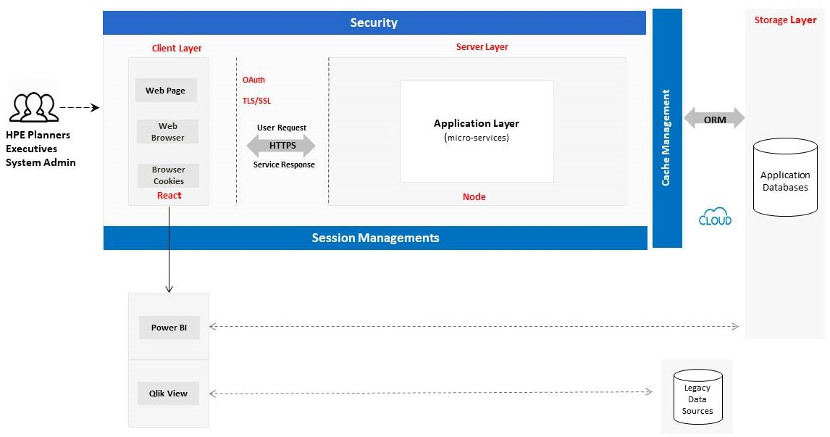

Aruba SC360 System Design

Observations

1. Legacy system data is processed, consolidated, and stored in the application database.
2. Node will now communicate with the database for CRUD operations.
3. React uses HTTP request to communicate with the APIs provided by Nodejs.
4. The entire application will be deployed in cloud as SaaS using GIT/GITHUB.
5. End users can access the application from the cloud.

|  |  |  |  |  |
| --- | --- | --- | --- | --- |
| **S.no** | **Problem Statement** | **Solution** | **Implications** | **Principle** |
| 1 | Connection with Database | Micro-service architecture | Performance | Stable |
| 2 | Underlying Tools/Technologies | Open source | Cost | Robust |
| 3 | Underlying Systems | Cloud Based SaaS | Availability and Scalability | Complete |
| 4 | Expected Design Needs | Persona Driven, Personalization, Visibility, Data security and control, User/Roles Management | Process Improvement, Quality Management | Consistent and Understandable |

5.2.2 Key Architecture Points Matrix

5.2.3 To-Be Web Application Architecture

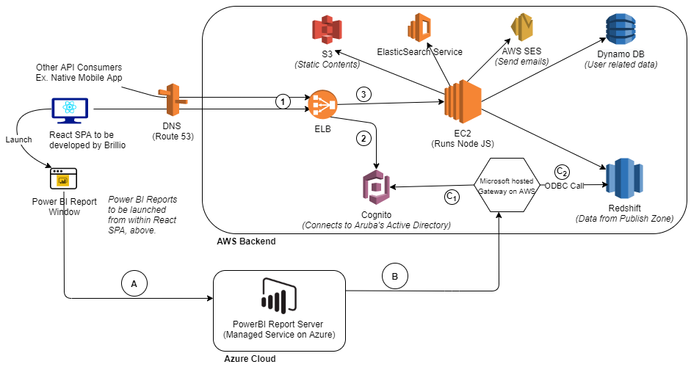

SC360 Proposed Web Application Technical Architecture

Assumptions-

1. Application Database will receive the consolidated and analyzed data from the data engine in the backend.
2. Data flow will be uni-directional to SAP source systems. However, it will be bi-directional between SC360 and dynamo database to store user/role and other details.
3. SSO will be provided by HPE.
4. SSL/TLS certificate will come as complementary license from Aruba Cloud on deployment as confirmed by Aruba.
5. Configurations and privileges necessary for HPE SSO to generate and exchange tokens with SC360 application to work as needed, will be performed by Aruba team.
6. Once user is authenticated using HPE SSO, SC360 will further validate that the authenticated user is authorized to access the application or not. Hence, we will implement user management where admin can add/edit/delete users and such data will be captured using dynamo database.

Explanations-

1. AWS SES will be used to send emails via application. It can also be used to send emails based on a CRON event

2. Devops notes-

1. Three Environments: DEV, UAT, PRE-PROD and PROD
2. Jenkins/ TeamCity

3. ElasticSearch will be used for two purposes:

1. To store and search Comments
2. Centralized logging.

4. Kibana is not shown but may be required for visualization.

5. With ElasticSearch, one can search based on a DateRange. This is over and above Text search.

6. For each Power BI report request, there are two inter cloud Network jumps.

1. Web Browser to Power BI Report Server hosted on Azure Cloud. (https)
2. PowerBI Report Server on Azure to MS Gateway Server hosted on AWS.(https)

Technical Stack Recommendation

Data

Below are the tools recommended for the SC360

|  |  |
| --- | --- |
| Layer | Tools/Component |
| Landing zone | SES, Lambda, SFTP |
| ETL | Lambda, Glue, EMR Spark |
| Data Storage | S3 |
| Published | RedShift Spectrum |
| Access Management | AWS SSO, Cognito |
| Identity Management & Admin | IAM |
| CI/CD Implementation | CloudFormation, cloud build, Cloud Commit, Code Deploy |
| Orchestration | CloudFormation, Cloud watch, Lambda, Step Function |
| Consumption | Power BI, Athena, Web Application, Sage Maker |
| VPC | API Gateway, Route 53 |
| Security & Compliance | AWS Guard Duty, Secret Manager, Shield, WAF, KMS |
| Governance | Glue Crawler, Glue Catalog |

Application

6.2.1. Recommended tool kit for development

|  |  |  |  |
| --- | --- | --- | --- |
|  | **Recommended Tool** | **Must Have** | **Good-To-Have** |
| Front-end | React.js | Y |  |
| Back-end | Node.js | Y |  |
| Database | NoSQL | Y |  |
| Web Interface Testing | Selenium |  | Y |
| Web Application | Jest | Y |  |

6.2.2. Recommended NPM Packages to be installed for UI development (Industry best practices)

|  |  |  |  |  |
| --- | --- | --- | --- | --- |
| **S. no.** | **Package** | **Command** | **Why needed** | **Links** |
| 1. | **create-react-app** | npm i  create-react-app | To create single-page React applications. It offers a modern build setup with no configuration. | 1. <https://create-react-app.dev/docs/getting-started/>  2. [github.com/facebook/create-react-app /](https://jestjs.io/) |
| 2. | **redux** | npm i --save redux | Redux is a predictable state container for JavaScript application to maintain the state of the whole application. | 1.[redux.js.org  2.github.com/reduxjs/redux](https://testing-library.com/docs/react-testing-library/intro) |
| 3. | **React-redux** | npm i --save react-redux | To connect the react application with redux | 1.[redux.js.org  2.github.com/reduxjs/redux](https://testing-library.com/docs/react-testing-library/intro) |
| 4. | **redux-saga** | npm i --save redux-saga | To handle application side effects (i.e. asynchronous things like data fetching and impure things like accessing the browser cache) | 1.redux-saga.js.org/  2.github.com/redux-saga/redux-saga/tree/master/packages/core |
| 5. | **react-router** | npm i --save react-router | To handle routing | 1. <https://reacttraining.com/react-router/>  2.https://github.com/ReactTraining/react-router#readme |
| 6. | **react-router-dom** | npm i --save react-router | To manage routing and work with DOM | 1. <https://reacttraining.com/react-router/>  2.https://github.com/ReactTraining/react-router#readme |
| 7. | **webpack** | npm i --save webpack | Module loader/bundler for JavaScript.  Need to configure **webpack.config.js**. | 1.github.com/webpack/webpack |
| 8. | **babel-loader** | npm i --save babel-loader | Webpack loader for Babel. Babel transpiles ES6/ES7 to ES5 | 1. github.com/babel/babel-loader |
| 9. | **babel-preset-react** | npm install --save-dev @babel/preset-react | React preset for Babel. Just for Babel to understand React terms like JSX.  Need to configure **.babelrc** | 1.babeljs.io/  2.github.com/babel/babel/tree/master/packages/babel-preset-react |
| 10. | **react-feather** | npm i --save react-feather | react-feather is a collection of simply beautiful open source icons for React.js. | 1.[github.com/feathericons/react-feather](https://github.com/feathericons/react-feather) |

6.2.3. Framework/Library to be installed for UI development

|  |  |  |  |  |  |
| --- | --- | --- | --- | --- | --- |
| **Sl. No.** | **Framework/Library** | **Command** | **Why Needed** | **Link** | **Alternative** |
| 1. | **react-bootstrap** | npm i react-bootstrap | For responsive design and styling. | 1.[react-bootstrap.github.io/](https://react-bootstrap.github.io/)  2.[github.com/react-bootstrap/react-bootstrap](https://github.com/react-bootstrap/react-bootstrap) | A. @material-ui/core  1.material-ui.com/  2.github.com/mui-org/material-ui |
| 2. | **react-chartjs-2** | npm i react-chartjs-2 | Implement chart/graph in the react UI.  **N.B** - Choropleth map can be implemented using **highchart** or **d3.** | 1.<https://www.chartjs.org/docs/latest/>  2.github.com/jerairrest/react-chartjs-2 | A. react-highcharts  1.[https://www.highcharts.com/docs/index#](https://www.highcharts.com/docs/index)  2.github.com/kirjs/react-highcharts  B. d3  1. d3js.org  2.Repository  github.com/d3/d3 |
| 3. | **powerbi-report-component** | npm i powerbi-report-component | It's a minimalistic React component for embedding a Microsoft PowerBI report, dashboard or tile into your React application. | 1.<https://github.com/akshay5995/powerbi-report-component> |  |

6.2.4. Chart Libraries for UI development

React has got few libraries for graphs and charts under npm packages.

Suggested: **react-chartjs-2**, **react-highcharts**

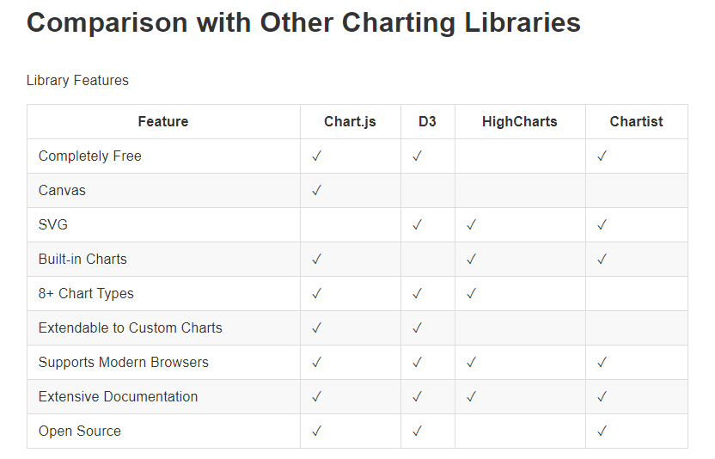

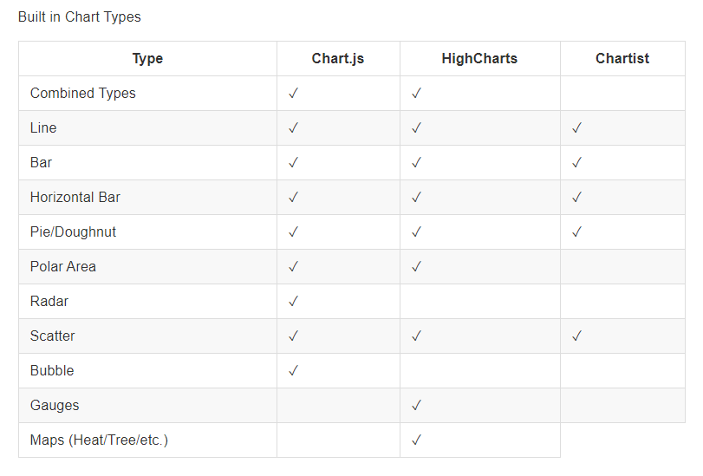

6.2.5. Framework/Library to be installed for Backend development

|  |  |  |  |  |
| --- | --- | --- | --- | --- |
| **S.No** | **Framework/Library** | **Command** | **Why Needed** | **Alternative** |
| 1. | **Express** | npm i express | Application server creation and routing. | 1. Restify |
| 2. | **Node-mailer** | npm i nodemailer --save | Sending Emails |  |
| 3. | **Sequelize** | npm i sequelize | Interaction with database |  |
| 4. | **AWS SDK** | npm i aws-sdk | Interaction with AWS services. Eg. AWS S3 |  |

6.2.6. Suggested Testing tools for UAT

|  |  |  |  |  |  |
| --- | --- | --- | --- | --- | --- |
| **Tool** | **License** | **Why needed** | **Features** | **Alternative Software** | **Links** |
| Jest | Open source | Unit and integration testing | 1. In-built coverage reporting 2. Parallel test running 3. Snapshot testing 4. In-built spies 5. In-built mocking 6. In-built assertions 7. ES6 support 8. Best performance | 1. Mocha 2. Jasmine 3. AVA | [1.https://jestjs.io/ 2. https://mochajs.org/ 3. https://jasmine.github.io/](https://brillioonline.sharepoint.com/sites/ArubaSupplyChain-ProjectDocuments/Shared%20Documents/Project%20Documents/Aruba%20Deliverable/1.https:/jestjs.io/2.%20https:/mochajs.org/3.https:/jasmine.github.io/) |
| React-testing library | Open source | DOM testing | 1. Light weight 2. Easy to develop 3. Provides additional util functionalities on top of react-dom and test-utils | 1. Enzyme 2. React Test Utils | <https://testing-library.com/docs/react-testing-library/intro> |
| Apache JMeter | Open source | Performance testing | 1. Ability to test Java objects, HTTP/HTTPS, SOAP, REST 2. Provides recording, building, and debugging performance tests 3. Most popular performance testing tool | 1. Taurus 2. Locust 3. nGrinder | <https://jmeter.apache.org/> |

# Security & Compliance

Data Flow Diagram

The data flow diagram for Aruba SC360 solution is as seen below:

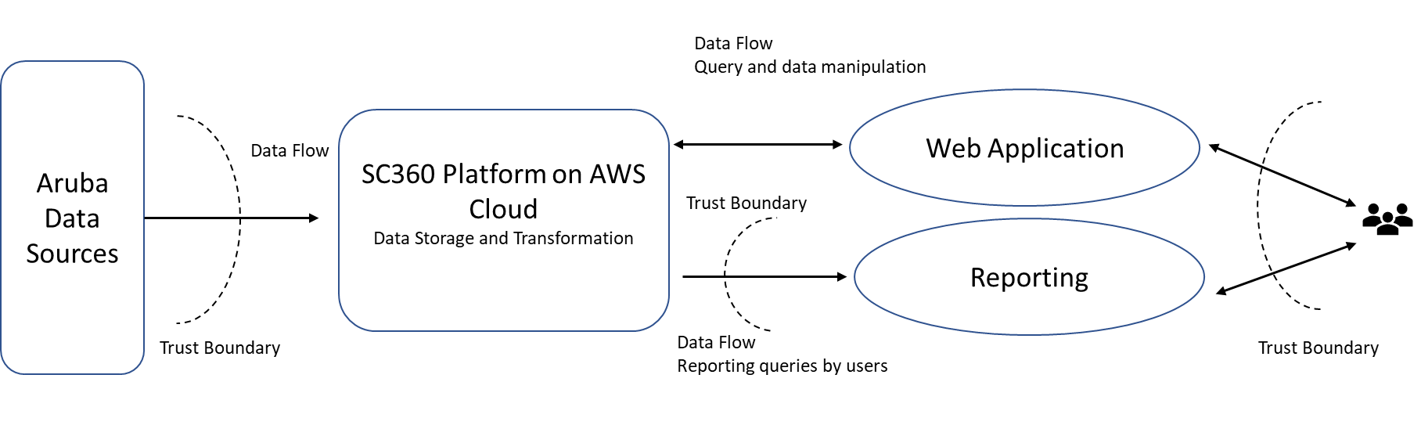

Server Landscape Diagram

The Server landscape for Aruba SC360 solution is as seen below:

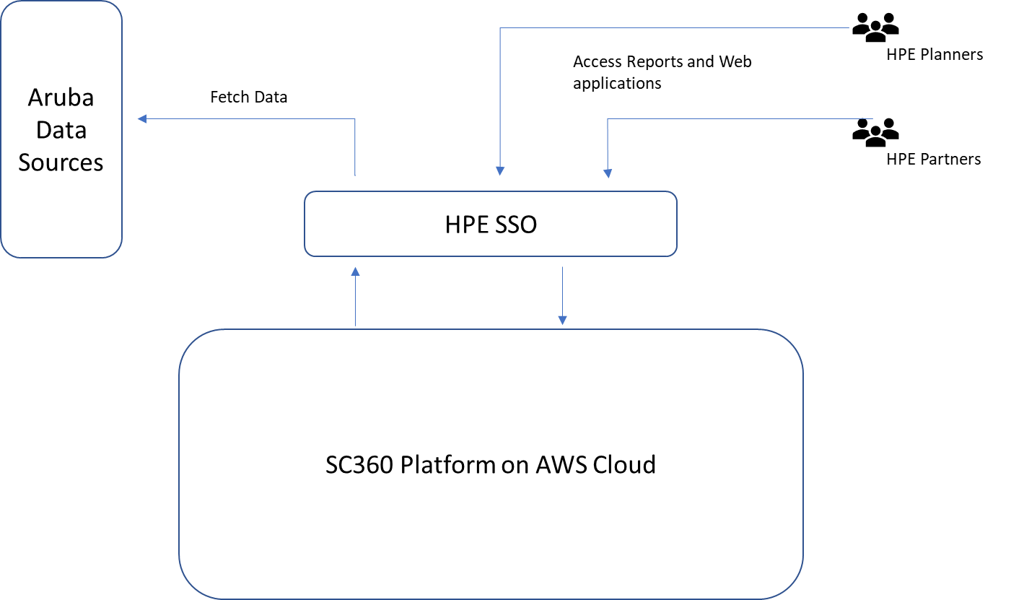

Application Flow diagram

The application landscape for Aruba SC360 solution is as seen below:

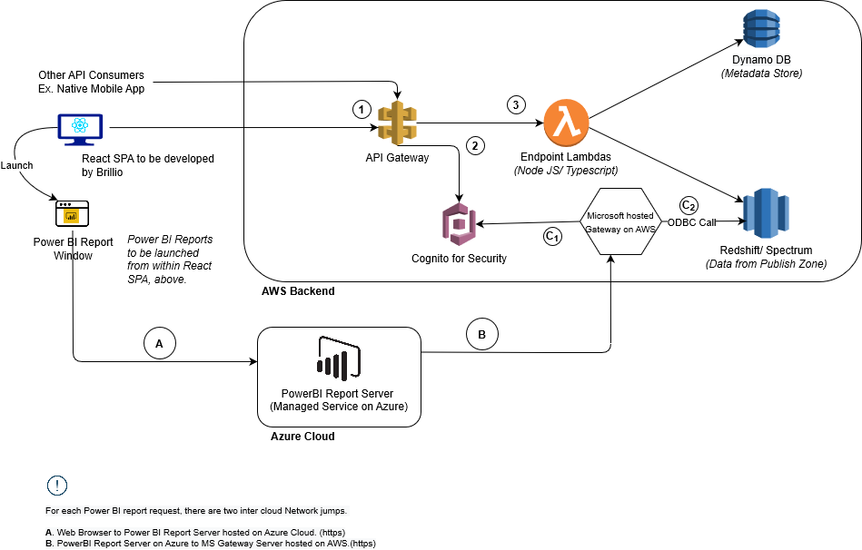

Application User Flow Diagram:

The user flow diagram for Aruba SC360 solution is as seen below:

|  |  |  |  |  |  |  |
| --- | --- | --- | --- | --- | --- | --- |
|  |  |  |  |  |  |  |

