AIR POLLUTION MONITORING SYSTEM USING IOT

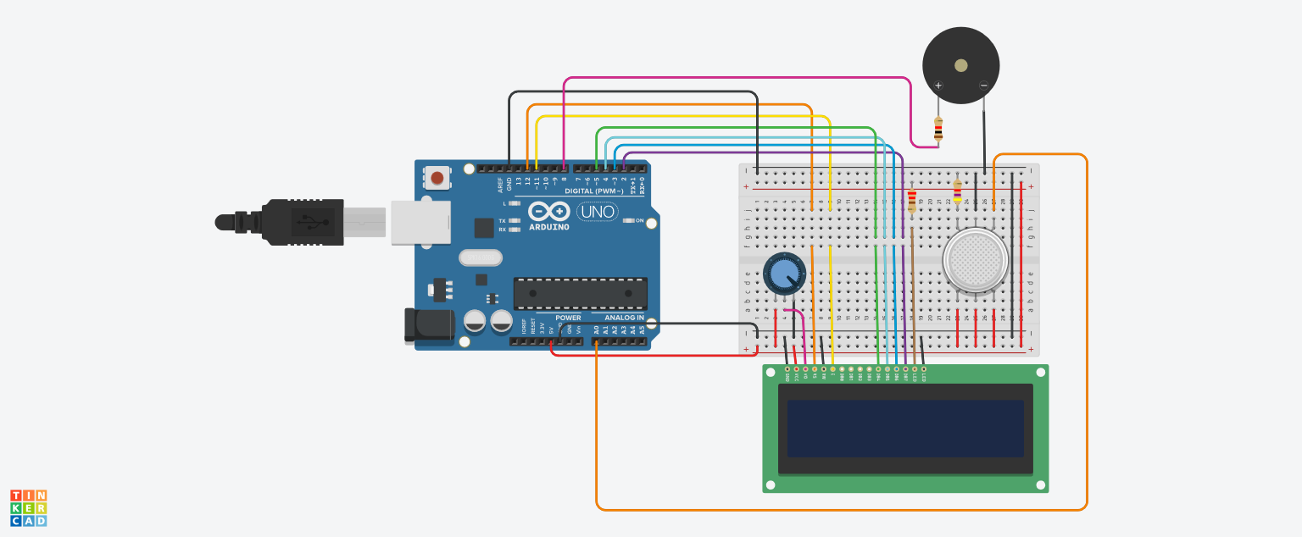

Fig: A Model Of Air Pollution Monitoring System Using Iot

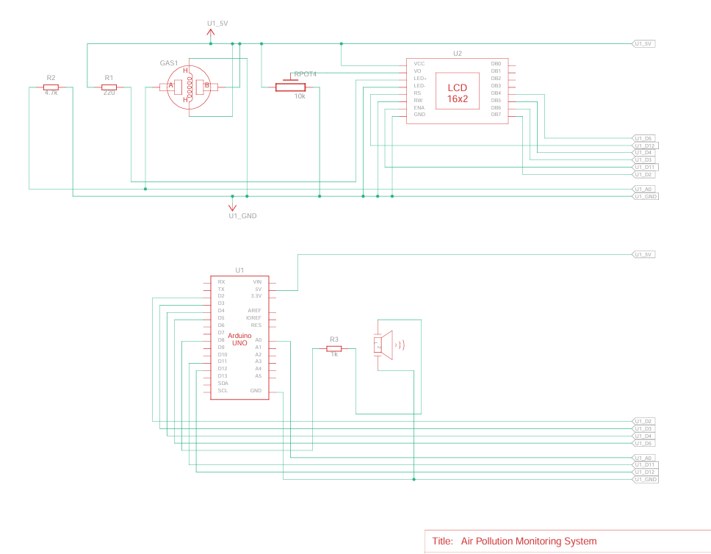

Fig: Circuit Diagram of an Air Pollution Monitoring System

**IoT Monitoring System components**

IoT-based air pollution monitoring systems comprise several components that work together to collect and Analyse the air quality data. The components include:

1. **Sensors**: Sensors are the primary components of IoT-based air pollution monitoring systems. They measure various air quality parameters such as particulate matter, carbon monoxide, sulphur dioxide, and nitrogen oxides. The sensors can be classified into two categories: physical and chemical sensors. Physical sensors measure parameters such as temperature, humidity, and pressure, while chemical sensors measure air pollutants.
2. **Microcontroller**: The microcontroller is the brain of IoT-based air pollution monitoring systems. It receives data from the sensors, processes it, and sends it to the cloud server. The microcontroller is usually a microprocessor such as Arduino, Raspberry Pi, or similar devices.
3. **Communication Module**: The communication module is responsible for transmitting data from the microcontroller to the cloud server. Communication modules can use various wireless technologies such as Wi-Fi, Bluetooth, or cellular networks.
4. **Cloud Server**: The cloud server is a centralized platform for storing, analysing, and sharing air quality data. It collects data from the communicate on module and stores it in a database. The cloud server also provides web and mobile applications for users to access the data.
5. **Power Supply**: IoT-based air pollution monitoring systems require a power supply to operate. In case of permanent installations external power supply is provided and batteries are provided for portable devices.
6. **Enclosure**: The enclosure is the outer covering that protects the components from environmental factors such as dust, water, and temperature.

**Conclusion**:

IoT-based air pollution monitoring systems have become a popular solution for monitoring air quality and managing air pollution levels. These systems comprise several components that work together to collect and analyse air quality data.

Usage of Monitoring System

The IoT-based air pollution monitoring system can be used in various settings, including residential, industrial, and urban areas. It can also be integrated with existing air pollution monitoring systems to enhance their capabilities. The system can provide valuable data to government agencies, researchers, and the public to make informed decisions about air pollution.

[Also Read Ambient Air Quality Monitoring System](https://www.ppsthane.com/blog/ambient-air-quality-monitoring-system)

One of the significant advantages of an IoT-based air pollution monitoring system is its scalability. The system can be easily scaled up or down based on the needs of the users. It can be customized to meet the specific requirements of a particular location, making it a versatile solution for air pollution monitoring.

In conclusion, an IoT-based air pollution monitoring system is a revolutionary solution that can provide accurate and real-time data about the air quality in a particular area. It can help identify the sources of pollution and take necessary measures to reduce it, protecting the environment and human health.

With its scalability and versatility, the IoT-based air pollution monitoring system can be used in various settings and integrated with existing air pollution monitoring systems, making it an ideal solution for air pollution monitoring.

## How does IoT reduce air pollution?

IoT (Internet of Things) plays a crucial role in reducing air pollution through its ability to collect real-time data and enable smart decision-making. IoT devices, such as air quality sensors, can monitor pollutant levels in various environments, including cities, industries, and homes.

This data can be analysed to identify pollution sources, implement targeted mitigation strategies, and track the effectiveness of pollution control measures. IoT-enabled smart city solutions optimize transportation, waste management, and energy consumption, reducing emissions and improving air quality.

Furthermore, IoT-based personal air quality monitors empower individuals to make informed choices and avoid high-pollution areas. By leveraging IoT technology, we can proactively address air pollution, create sustainable solutions, and promote healthier environments for present and future generations.

## How IoT Based Air and Sound Pollution Monitoring System is Implemented?

An IoT-based air and sound pollution monitoring system is implemented using a network of sensors, connectivity technologies, and data analytics platforms. Air quality sensors are deployed in strategic locations to measure pollutant levels such as particulate matter, gases, and volatile organic compounds (VOCs). Sound sensors capture noise levels and patterns in the environment.

These sensors are connected to a central data management system through wireless or wired communication protocols. The collected data is then processed and analysed in real-time, leveraging cloud-based analytics platforms. Users can access the monitoring system through web or mobile applications, which provide visualizations, alerts, and historical data.

This allows authorities, environmental agencies, and individuals to monitor pollution levels, identify hotspots, and take necessary actions for pollution control and mitigation. The system can also integrate with existing infrastructure such as smart city platforms or industrial monitoring systems to provide a comprehensive view of environmental conditions and enable effective decision-making.

SOURCE CODE:

// include the library code:

#include <LiquidCrystal.h>

// initialize the library with the numbers of the interface pins

LiquidCrystal lcd(12, 11, 5, 4, 3, 2);

int pin8 = 8;

int analogPin = A0;

int sensorValue = 0; // store the value read

void setup() {

pinMode(analogPin, INPUT);

pinMode(pin8, OUTPUT);

// set up the LCD's number of columns and rows:

lcd.begin(16, 2);

// Print a message to the LCD.

lcd.print("What is the air ");

lcd.print("quality today?");

Serial.begin(9600);

lcd.display();

}

void loop() {

delay(80);

sensorValue = analogRead(analogPin); // read the input pin

Serial.print("Air Quality in PPM = ");

Serial.println(sensorValue); // debug value

lcd.clear();

lcd.setCursor(0,0);

lcd.print ("Air Quality: ");

lcd.print (sensorValue);

if (sensorValue<=600)

{

Serial.print("Fresh Air ");

Serial.print ("\r\n");

lcd.setCursor(0,1);

lcd.print("Fresh Air");

}

else if( sensorValue>=600 && sensorValue<=850 )

{

Serial.print("Poor Air");

Serial.print ("\r\n");

lcd.setCursor(0,1);

lcd.print("Poor Air");

}

else if (sensorValue>=680 )

{

Serial.print("Very Poor Air");

Serial.print ("\r\n");

lcd.setCursor(0,1);

lcd.print("Very Poor Air");

}

if (sensorValue >680) {

// Activate digital output

digitalWrite(pin8, HIGH);

}

else {

// Deactivate digital output

digitalWrite(pin8, LOW);

}

}

For More Details Click on the below link for reference:

https://www.tinkercad.com/things/5pescypZixY-air-sound-pollution-monitoring#:~:text=Gas%20and%20temperature%20sensors%20are,on%20the%20LCD%20display%20continuously.