Cable Ring Challenge Explained
Problem statement, algorithms, code map, live demo, and judge questions through Phase 7
For the project team preparing for the first elimination round. This guide describes the code currently in the ps4 repository, alongside the rules in the challenge deck. It explains what the system can demonstrate today and where its claims should be qualified.

The 30 second explanation
We take a floor plan, identify the rooms and doors, divide eligible rooms among cable hubs, then draw one closed cable ring per hub. We reject routes that break the six hard rules. Among valid choices, we try to use the fewest hubs and reduce cable length, crossings, overlap, and bends. The command line produces a reviewer JSON file and a visual overlay; Phase 7 adds a live browser canvas for moving elements on the Slide 5 example.
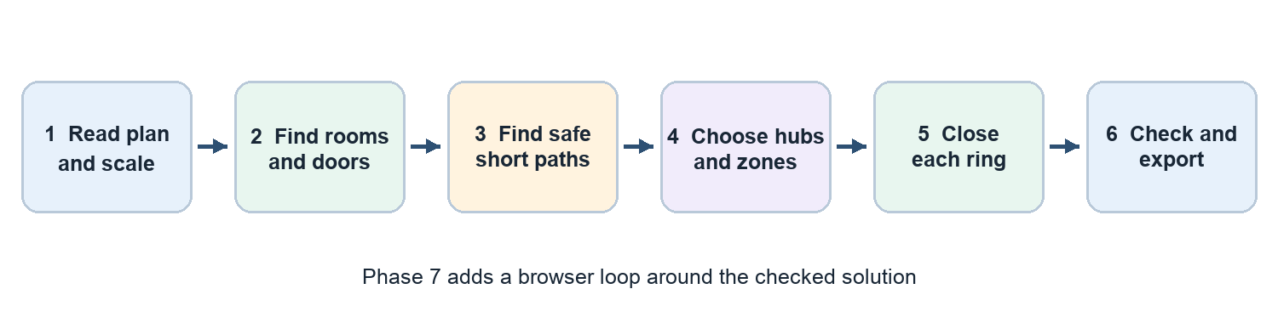
Figure 1 How the seven completed phases fit together

What you should be able to explain after reading
- Why a route can look short but still be invalid.
- How the solver chooses hubs, zones, route paths, and visit order.
- What the score means and what “optimal” can honestly mean here.
- Which file to open when a judge asks how a feature works.

1 What the challenge asks us to build
The challenge is an automated cable layout tool for a residential floor plan. A fixed device node must be served in each eligible room. One or more hubs supply those devices. A hub owns a set of rooms, and its cable must form one complete ring: it starts at that hub, reaches every assigned device exactly once, and returns to the same hub. The output is a machine readable solution with hub placements, room assignments, node order, and cable polylines.
The supplied PowerPoint is the rule source. Its example drawing is illustrative. The repository fixtures are developer created JSON representations used to exercise the implementation; they are not organizer supplied ground truth inputs. The ResPlan dataset archive is source floor plan data, not a ready made Slide 8 solution.

The six hard rules
Rule | Plain language
1 Coverage | Serve every eligible room and its device node exactly as required.
2 Capacity | Each hub covers at most 100 m² and at most five nodes.
3 Door connectivity | All rooms assigned to one hub must form a connected group through doors or open passages.
4 Closed ring | Hub → all its assigned nodes once → the same hub, with no branches.
5 Legal cable path | Use horizontal and vertical segments in free space. Cross room boundaries at doors or passages, not through walls or windows.
6 Hub clearance | Place a hub in an eligible assigned room at least 0.50 m from walls and windows.

Examples of invalid routes: stopping at the last device, skipping or repeating a device, branching into two paths, cutting through a wall, or returning to a different hub. The checker is designed to catch these through its coverage, ring, geometry, and clearance tests.
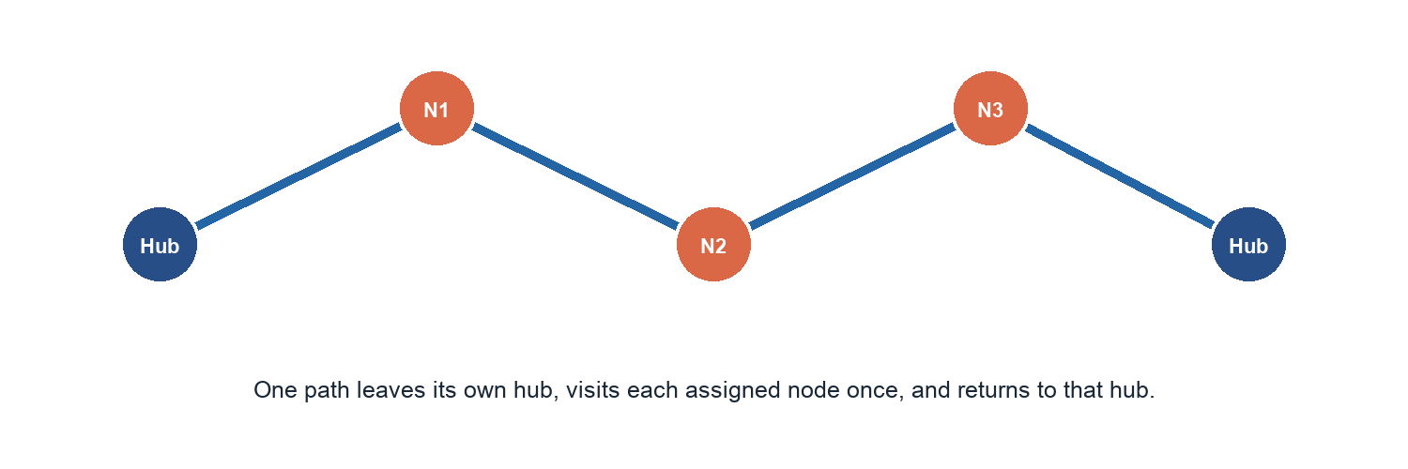
Figure 2 Conceptual visit order only The physical cable uses horizontal and vertical paths

How submissions are ranked
First minimize H, the number of hubs. For solutions with the same H, minimize J = L + 5X + O + 0.5B. L is total cable length in metres, X is cable crossings, O is shared cable overlap in metres, and B is the number of bends. The final tie breaker is the area gap between the largest and smallest hub zones. Geometry is checked with a 1 mm tolerance. A solution with a smaller J cannot beat another solution that uses fewer hubs.
Example: L = 49 m, X = 0, O = 0 m, B = 20 gives J = 49 + 0 + 0 + 10 = 59. Lower J is better only after the hub count is settled.

2 The route from input JSON to output
The input JSON describes the inner boundary, rooms, walls, windows, doors, and plan area. The parser turns drawing coordinates into metres. Intermediate objects then pass through topology, routing, partitioning, synthesis, and checking. The pipeline function calls these stages in order; the CLI wraps it for a user.
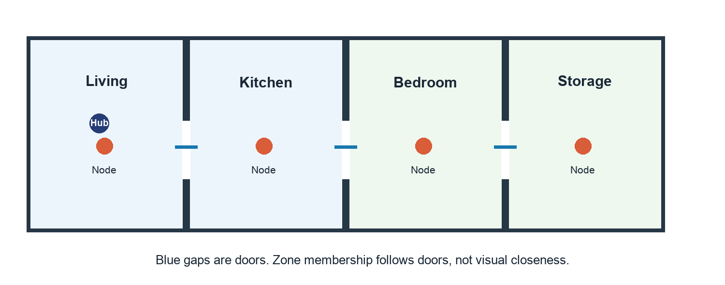
Figure 3 Rooms are graph vertices and the blue doorway gaps are graph edges

Phase 1 Read and measure the plan
The parser first calculates the drawing scale. If inner.area is the drawing area and area is the real area in m², drawing units per metre = square root of inner.area divided by area. It divides coordinates by that factor. The code deliberately does not use net_area for this calculation. It repairs polygons, labels room types, loads fixed nodes, and constructs free space by removing wall and window geometry from the inner boundary.
Why: every later rule is measured in metres. A 0.50 m clearance or 100 m² capacity makes no sense until the plan is scaled. This is the “convert the map to real life size” step.

Phase 2 Understand which rooms connect
portal_extractor.py finds door or open passage crossing points. macro_graph.py builds a room graph: each eligible room is a dot; a legal doorway is a link. A zone can include R1, R2, R3 if there is a door connected path among them. Two rooms that touch along a wall are not connected merely because their outlines touch.
Why: this catches impossible zone assignments before drawing fine cable paths. It also tells the router exactly where a cable may pass between rooms.

Phase 3 Find legal short paths
rectilinear_grid.py builds a sparse grid from useful x and y coordinates, such as device points, hub candidates, obstacles, and door lanes. This is a Hanan style grid: instead of searching every millimetre of floor area, search the lines likely to contain good axis aligned routes. astar_rectilinear.py performs obstacle aware shortest path search on the grid. It remembers the incoming direction, because a turn adds 0.5 to the score. cost_matrix.py precomputes costs between terminals to help later decisions.
Think of a city street map: intersections are choices, walls block streets, and the search finds a low cost drive between two addresses. Distance alone is insufficient because a path with many turns can cost more.

Phase 4 Choose hub groups and hub positions
hub_candidates.py generates legal places for hubs with a small margin beyond the required wall clearance. zone_milp.py lists door connected room groups that fit the 100 m² and five node limits, estimates each group’s best candidate hub and ring order, then asks OR Tools CP SAT to select groups that cover each eligible room exactly once.
A quick lower bound is max(ceiling(total eligible area / 100), ceiling(number of nodes / 5), 1). For 118 m² and six nodes, at least two hubs are needed. The solver starts at this number and tries larger counts only when required. Inside a fixed hub count it prioritizes estimated cable cost, then zone area balance.
The code calls this zone search “MILP”, but its actual optimizer is CP SAT set partitioning. Each candidate group has a yes/no variable; every room must appear in exactly one chosen group.

Phase 5 Pick visit order and draw closed rings
exact_ring_tsp.py uses a direction aware dynamic program related to the travelling salesperson problem. It compares possible node orders for each hub, accounting for the direction at which a path reaches or leaves a node. loop_synthesizer.py converts that order into actual axis aligned polylines, uses paired doorway lanes for entering and leaving narrow leaf rooms, and counts length, crossings, overlap, and bends. It closes the route back at its own hub.
Why two steps: “which device comes next?” and “which exact path do we draw between devices?” are different questions. A short visit order can still produce a bad cable route when walls and doors are considered.
Important implementation detail: the Slide 5 fixture has two specialized route functions in loop_synthesizer.py for specific hub positions and node sets. This makes the benchmark illustration reproducible. For a new plan, the general synthesis path runs instead. Demonstrate both the Slide 5 fixture and an independent plan.

Phase 6 Verify and package the answer
checker.py is the independent referee. It reads the output geometry and recalculates the six validity rules and all score numbers rather than trusting the solver’s reported totals. json_exporter.py writes the expected Slide 8 style JSON. visualizer.py renders a PNG showing the rooms and cable routes. pipeline.py connects Phases 1 to 6. cli.py accepts file paths, runs the pipeline, and prints the scorecard.
Why: a valid scorecard is evidence that the generated route obeys implemented checks; a pretty picture alone is not.

3 Phase 7 What the interactive studio does
The Phase 7 browser shows the floor plan, nodes, hubs, cable lines, current score, and six rule indicators. It is served by FastAPI. The frontend is plain HTML, CSS, and JavaScript using an HTML5 canvas; it is not the React Konva implementation mentioned in the v2 plan. The browser sends drag events through a WebSocket and receives updated state from the Python server.
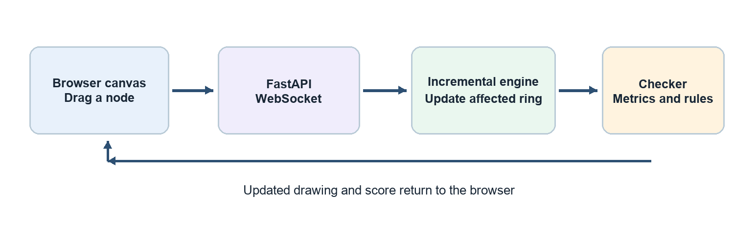
Figure 4 The Phase 7 feedback loop
incremental_router.py holds an in memory baseline solution for the Slide 5 fixture. A node or hub drag changes its position and locally updates the affected ring, then calls the checker again. halo_tracker.py marks positions within 0.50 m of obstacles or outside eligible space as unsafe. The browser displays these results and can download the current Slide 8 JSON. The server also exposes REST endpoints for state, mutations, export, reset, and health.
Two boundaries to say clearly: the studio currently starts from the Slide 5 fixture rather than importing any plan through its UI. A door slide changes portal lane coordinates and checks the current solution, but does not fully resynthesize cable geometry. A room boundary shift changes an area value and rechecks capacity; it does not redraw the room polygon or rerun the complete hub partition search. Treat these as interactive prototype controls, not full architectural replanning.
The Phase 7 verification report records 78 passing tests and roughly 5 to 7 ms engine updates for node and hub drags on the Slide 5 fixture. That is a measured sample, not a guarantee for every plan or a measurement of browser rendering time. The report recommended a human visual check of the studio. Its fixed baseline reports J = 59 in the verification notes, while the separate CLI solve in the example reported J = 54.28; these are different route states, so do not present them as the same run.

4 How the pieces are wired
Input or action | Code path | Result
Solve a JSON plan | cli.py → pipeline.py → phases 1 to 6 | JSON solution, checker scorecard, optional PNG
Drag a node in browser | app.js → /ws/co-design → server.py → incremental_router.py → checker.py | New ring state, metrics, pass or fail flags
Export from browser | app.js → /api/export → json_exporter.py | Downloaded Slide 8 style JSON
Reset browser | app.js → /api/reset → baseline loader | Original Slide 5 state

File guide for a judge walkthrough
File or folder | What to say
config.py and contracts.py | Shared limits, types, and data objects passed between phases.
phase1_ingestion | Read geometry, room categories, fixed nodes, and metric scale.
phase2_topology | Extract legal door passages and build the room connection graph.
phase3_micro_routing | Build a legal grid, find axis aligned paths, and cache pair costs.
phase4_partitioning | Generate hub sites and choose connected capacity compliant zones with CP SAT.
phase5_ring_sequencing | Choose node visit order and construct closed cable polylines.
phase6_output | Independently check six rules, compute score, export JSON, draw overlay, run pipeline.
phase7_interactive | Run live engine, clearance halos, FastAPI server, and browser canvas.
cli.py | User entry point for a plan or the interactive server.
tests and tests/fixtures | Regression tests and example JSON plans. Slide 5 is a fixture, not official input.

5 What does optimal mean here
Our search tries to optimize in the challenge’s priority order. It starts at a mathematical lower bound for the hub count, enumerates connected zones within capacity, compares candidate hub sites and device permutations, and uses CP SAT to choose a covering set. The direction aware route search then looks for low cost legal paths. Finally the independent checker measures the actual output.
Do not claim a universal global optimum for every floor plan. The zone price uses precomputed or fallback path estimates; the final geometry can differ from that estimate. Hub locations come from generated candidates, rather than every possible point. CP SAT has a five second time limit and accepts a feasible solution as well as one proved optimal. The Slide 5 route also has a specialized synthesis branch. The safe claim is: “We search for a low cost valid solution under the official ranking, and independently verify the solution we output.”
The example CLI run reported Slide 5 as valid with H = 2, L = 45.28 m, B = 18, X = 0, O = 0, and J = 54.28. This is a concrete checked result, not proof that no better valid layout exists. Its roughly 3.64 second runtime in that run also exceeds a 2.5 second aspirational target, so quote measured time for the machine used.

6 A first round demonstration
- From the ps4 project root, run the CLI on tests/fixtures/slide5_schematic.json with output JSON and PNG paths. Point out VALID, all six PASS marks, H, and J in the scorecard.
- Open the generated PNG to show the closed routes visually. Open the JSON to show actual hub coordinates, ordered node sequence, and cable polylines. Explain that the CLI generated these files during the run.
- Run a second plan such as tests/fixtures/new_four_room_plan.json. This is more representative of the generic solver because Slide 5 has a special case route branch.
- Start the studio with the CLI --serve flag, open http://127.0.0.1:8000, drag a node, and show the live score and rule status. Export JSON. Mention that this UI currently uses the Slide 5 baseline.
Example commands from the ps4 root:
PYTHONPATH=src python3 -m resplan_router.cli -i tests/fixtures/slide5_schematic.json -o /tmp/slide5_solution.json -v /tmp/slide5_overlay.png
PYTHONPATH=src python3 -m resplan_router.cli -i tests/fixtures/new_four_room_plan.json -o /tmp/four_room_solution.json -v /tmp/four_room_overlay.png
PYTHONPATH=src python3 -m resplan_router.cli --serve
Use the project’s working Python environment. The repository declares its solver dependencies in pyproject.toml; FastAPI and Uvicorn are needed for the studio server, though they are not currently listed there.

7 Questions judges may ask
Question | Short accurate answer
Why use a graph? | A room graph captures legal door connections; it prevents grouping rooms through solid walls.
Why use a grid and shortest path search? | Cable must be horizontal or vertical and avoid obstacles. A sparse grid keeps that geometric search manageable.
Why CP SAT? | Hub assignment is a constrained yes or no selection problem: cover every eligible room once while meeting capacities and minimizing the ranked objective.
Why a travelling salesperson method? | Each ring must visit every assigned node once and return to its hub. That is a tour ordering problem.
How do you know a route is valid? | A separate checker recalculates all six hard rules and the score from the output geometry.
Is the result mathematically optimal? | We minimize over searched candidates; the checker proves validity, not global optimality. Solver limits and geometry choices can leave improvements.
Is the canvas the same as the full solver? | It builds on the same models and checker but currently uses the Slide 5 baseline and local incremental updates.
What is left after Phase 7? | The v2 plan continues with later phases. General plan import, fuller live replanning, and broader performance evidence are still future work.

Appendix Individual source files
Use this list to open the exact implementation when a judge asks to see evidence. All paths below are inside src/resplan_router unless otherwise shown.
File | Responsibility
config.py | Numerical defaults including capacity, clearance, and checking tolerance.
contracts.py | Typed data models shared by all stages, such as plans, portals, assignments, and rings.
phase1_ingestion/scale_converter.py | Derives drawing units per metre and converts geometry to real coordinates.
phase1_ingestion/parser.py | Repairs plan geometry, labels rooms, and constructs free space and obstacles.
phase1_ingestion/node_loader.py | Creates fixed device nodes from eligible rooms.
phase2_topology/portal_extractor.py | Finds doors and open passages and their crossing points.
phase2_topology/macro_graph.py | Builds room adjacency and identifies connected/leaf rooms.
phase3_micro_routing/rectilinear_grid.py | Creates the sparse horizontal and vertical legal routing network.
phase3_micro_routing/astar_rectilinear.py | Searches the network while accounting for bends.
phase3_micro_routing/cost_matrix.py | Caches pairwise terminal route costs for hub and order decisions.
phase4_partitioning/hub_candidates.py | Lists usable hub points with required clearance.
phase4_partitioning/zone_milp.py | Enumerates connected capacity limited zones and solves their set partition.
phase5_ring_sequencing/exact_ring_tsp.py | Searches closed node visit sequences using directional route costs.
phase5_ring_sequencing/loop_synthesizer.py | Turns sequences into concrete polylines and measures route penalties.
phase6_output/checker.py | Rechecks hard rules and recomputes objective from route geometry.
phase6_output/json_exporter.py | Serializes the solution in Slide 8 style JSON.
phase6_output/visualizer.py | Draws the floor plan and cable overlay PNG.
phase6_output/pipeline.py | Calls the first six phases in order.
phase7_interactive/halo_tracker.py | Computes live wall and obstacle clearance feedback.
phase7_interactive/incremental_router.py | Stores baseline state and updates rings and scores after edits.
phase7_interactive/server.py | FastAPI REST and WebSocket service.
phase7_interactive/static/index.html | Browser layout, canvas, controls, and reviewer HUD.
phase7_interactive/static/app.js | Canvas drawing, dragging, live messages, and JSON download.
phase7_interactive/static/style.css | Studio visual styling.
cli.py | Entry point for batch solve and --serve studio mode.

Input and output fields to recognize
The current example input is tests/fixtures/new_four_room_plan.json. It has plan_id, area, inner boundary coordinates, a rooms list with room_id, category, and polygon, plus wall and door geometry. The schema can also include windows. The parser derives one fixed node per eligible room. The JSON is the plan to solve, not the answer to submit.
Stage | Fields worth showing a judge
Input plan | area and inner set physical scale; rooms identify eligible spaces; walls, windows, and doors control legal movement.
Output top level | plan_id, units, hubs, and reported_metrics.
Each output hub | hub_id, room_id, location, assigned_rooms, assigned_nodes, closed_sequence, route_segments, ring_length_m.
Each route segment | from, to, length_m, and polyline as ordered [x, y] points in metres.

Read a polyline as the actual cable geometry, point by point. The closed_sequence says the visit order. Both are necessary: a correct list of devices can still have a cable segment that hits a wall. The checker recalculates metrics from the geometry and reports violations when its checks fail.

Sources checked for this guide
Challenge deck: Cable Ring Challenge - Problem Statement4.pptx, especially Slides 3 to 8. Project plan: v2.md and .gsd/STATE.md. Implementation: src/resplan_router/ and tests/. Phase 7 evidence: .gsd/phases/7/VERIFICATION.md. Checked against the local repository on 16 October 2026. The code and deck are the authority for stated behavior; performance numbers are from the cited verification report or the provided CLI run.

