Analysis Report: The Impact of Neurobehavior on Feeding Outcomes in Neonates with Congenital Heart Disease

Authors: Brody Gibson, Kline Dubose, Sima Najafzadehkhoei, and Sophie Huebler

Date: 04 December 2023

# Abstract

Infants under the age of 4 weeks who receive surgery for congenital heart disease are monitored using the Neonatal Intensive Care Unit Network Neurobehavioral Scale (NNNS) to assess neurological behavior. The present study was conducted to observe the associations of NNNS attention scores and hospitalization duration with oral feeding patterns. Beta regression models used to analyze pre- and post- op attention scores with the percentage of feeds taken orally by the time of patient discharge did not show a statistically or clinically significant association. Cox proportional hazard models to analyze patient time to oral feed showed no significant associations with attention scores before or after operation.

# Data

The NNNS score dataset consists of a single-center retrospective cohort of infants aged 0 to 4 weeks with congenital heart disease (CHD). Each of the infants underwent surgery and received at least one pre-operative or post-operative NNNS score between August 2015 to October 2017. There were 132 infants admitted to the cardiac intensive care unit during the study period. Of those 132 infants admitted during the study period, four were excluded due to congenital upper airway or neurological abnormality.

# Research Objectives

1. Investigate the relationship between lower pre- and post-op attention scores and the percentage of oral feeds at the time of discharge.
2. Investigate whether lower pre- and post-op attention scores are associated with extended time to achieve full oral feeds following surgery.

# Statistical Methods

The primary objective of examining the relationship between lower pre- and post- operation attention scores and the percentage of oral feeds at the time of discharge was addressed using beta regression with logit link, adjusted for clinically relevant covariates. Because of the high number of patients not taking oral feeds at discharge, resulting in a value of 0 in the response variable, zero-inflated beta-regression models were be applied. The value of 1 (indicating 100% oral feed) was also present but rare. Sample size excluded the possibility of removal, so the following transformation was applied: (y(n-1)+0.5)/n, where y is the proportion of oral feeds at discharge and n is the number of non-zero responses. Clinically relevant covariates were included in observation, including sex, genetic syndrome, age at surgery, prematurity, cardiac anatomy, length of intubation, extubation failure (Y/N), and gastrointestinal complications. Covariates were chosen based on their availability and clinical relevance (as assumed by their inclusion in the data set) rather than their univariate relationships with the response variable, although the univariate relationships were examined using single variable beta regression as a preliminary check for possible trends. Beta regressions were performed with the gamlss package in R.

Three beta regressions were constructed to answer the primary research objective. The first model included all covariates and both pre and post attention score.

**% oral feeds** at discharge  
 Age.at.Surgery..days Post-attention scores

The second model includes all covariates and pre attention scores.

**% oral feeds** at discharge  
 Age.at.Surgery..days Pre-attention scores

The third model includes all covariates and post attention scores.

**% oral feeds** at discharge  
 Age.at.Surgery..days Post-attention scores

To answer the study's second objective, we used Cox proportional hazards models to analyze the association between time (in days) to receive full feed and pre and post-surgery attention scores. For the analysis, time was measured in days from the surgery to the date of discharge (censored) or the date that the patient reached full oral feeding (event). There were no patient deaths or competing endpoints to contend with.

We constructed various models and compared; these included both univariate models looking at the simple relationship between our “survival” and our pre- and post-surgery attention scores to multivariate models with clinically relevant covariates.

Statistical analyses were performed using a complete case analysis of a single data set, pre-processed outside the scope of this report, with 115 observations. Hypothesis testing was performed at an alpha level 0.05. All analyses were conducted in R.

# Results

Beta regression for the primary objective returned insignificant results for the tested associations. The two secondary models with pre-op attention scores and post-op attention scores only were used as sensitivity analyses and confirmed the insignificant results. Two covariates, duration of intubation and extubation failure, were significant in the multivariable regression model but not univariate models testing their relationship between percent of oral feeds at discharge. One variable, type of cardiac collapse, showed univariate association with percent of oral feed at discharge in the second half of the zero inflated beta model, and the significant relationship was preserved in the univariate model. In all cases, cardiac collapse without arch obstruction was used as the reference group.

The results of the Cox proportional hazard regression model for postoperative NNNS attention scores were not significantly associated with time (in days) to achieve full oral feeds in both the univariable model (HR = 1.16, 95% CI 0.86, 0.95, P value = 0.143)(Table 6) and the multivariable model (HR = 1.26, 95% CI 0.97, 1.64, P value = 0.086)(Table 5). In the multivariable analysis, postoperative NNNS was a marginally good predictor of time to full oral feed, but the association was not significant (P value = 0.086). The overall model demonstrated good predictive accuracy (concordance = 0.708, Likelihood ratio test: P < 0.001, Wald test P = 0.0002, and Log rank score test: P = 0.0001) with other variables showing good prediction for time to achieve full oral feeds (Table 5).

Similarly, both the univariable and multivariable cox proportional hazard regression results showed no significant association between postoperative NNNS attention scores and time (in days) to achieve full oral feeds (HR: 1.15, 95% CI 0.87, 0.90; P value = 0.257; HR = 0.93, 95% CI 0.71, 1.21, P value = 0.57, respectively)(Tables 8,7). The overall model exhibited good predictive accuracy (concordance = 0.707, likelihood ratio test: P = 3e-05; Wald test P = 5e-04; and Log rank score test: P = 2e-04) with several variables showing a significant association.

## Tables and Figures

## 

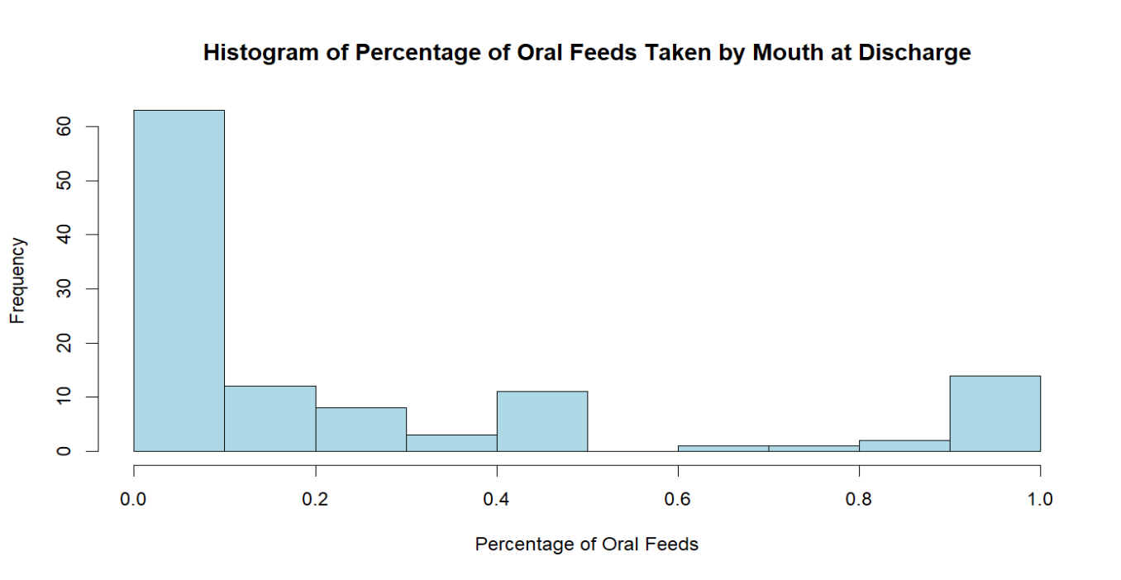

Figure 1: Histogram of Percent of Oral Feeds taken at Discharge for All Patients.

|  |
| --- |
| Table 2a: Beta Regression With Pre- and Post- Op Scores When Oral Feed at Discharge is Greater Than 0% |
|  |

|  |
| --- |
| Table 2b: Beta Regression With Pre- and Post- Op Scores When Oral Feed at Discharge is 0% |
|  |

|  |
| --- |
| Table 3a: Beta Regression With Pre-Op Scores When Oral Feed at Discharge is Greater Than 0% |
|  |

|  |
| --- |
| Table 3b: Beta Regression With Pre-Op Scores When Oral Feed at Discharge is 0% |
|  |

|  |
| --- |
| Table 4a: Beta Regression With Post-Op Scores When Oral Feed at Discharge is Greater Than 0% |
|  |

|  |
| --- |
| Table 4b: Beta Regression With Pre-Op Scores When Oral Feed at Discharge is 0% |
|  |

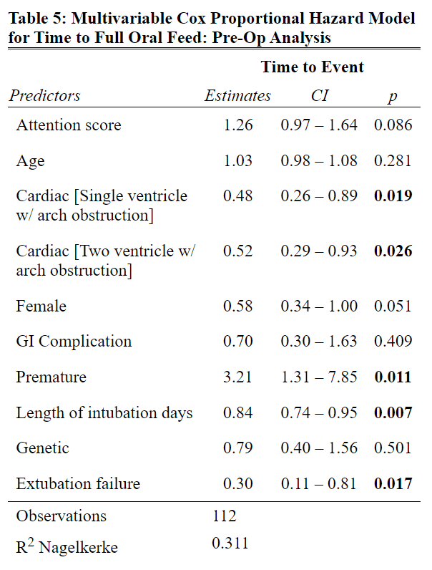

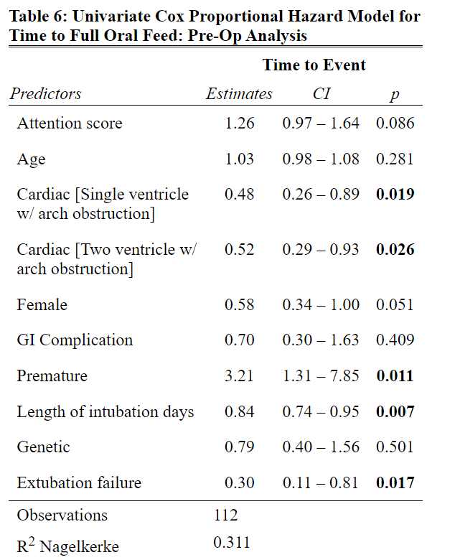

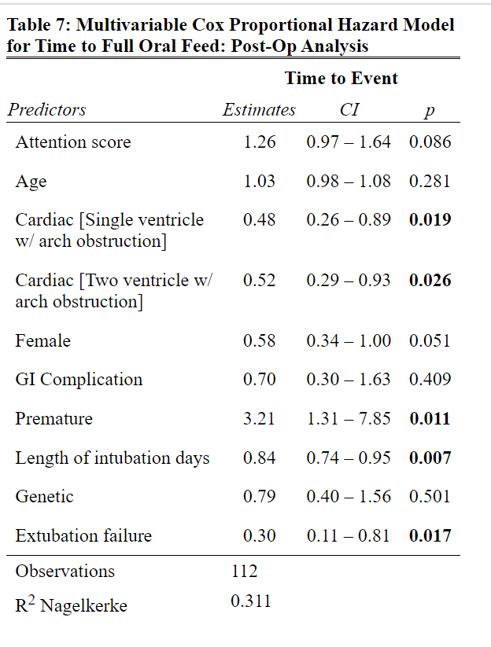

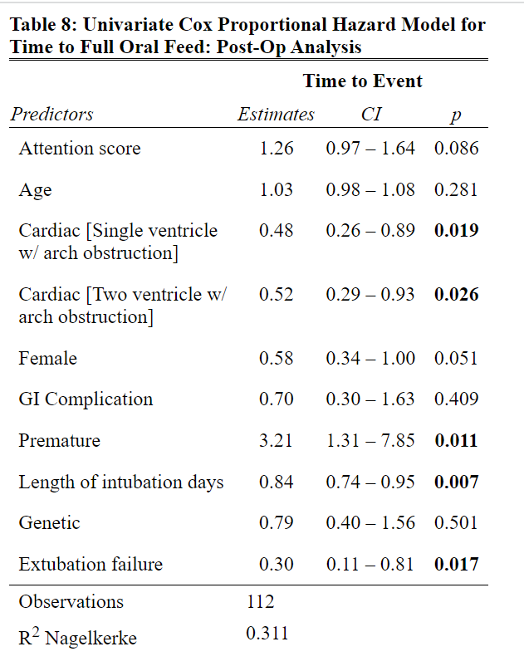

# Discussion

We concluded that there is no association between attention scores on the NNNS assessment and the percent of oral feeds of infants at discharge. We also saw that both preoperative and postoperative NNNS attention scores did not independently show statistically significant associations with time to achieve full oral feeds. Furthermore, both the pre-and postoperative multivariable models, including various clinical variables, demonstrated a stronger predictive power but were still not significantly associated with time to achieve full oral feed.

Limitations of the study include the small sample size, the missing data, and the possible measurement error trending towards 0 or 100% oral feeding at discharge. Further studies might take into account the rest of the NNNS assessment subdomains, possibly within a latent variable framework to assess the association of neurological state as a whole with oral feeding patterns.

# Additional Information

## Guidelines for Authorship

In general, authorship is merited and expected for PHR/SDBC statisticians and collaborators. Exceptions may be made if the number of authors is limited by the journal, but please discuss with the PHR/SDBD collaborators. The criteria for authorship by the International Committee of Medical Journal Editors can be found online at: <https://medicine.utah.edu/ccts/sdbc/publish.php>.

PHR/SDBC Policy requires manuscripts, posters and abstracts be made available to PHR/SDBC statisticians and collaborators with reasonable time (1 week+ for papers) prior to submission.

## Acknowledging CCTS funding

Please remember to acknowledge the SDBC: “This investigation was supported by the University of Utah Study Design and Biostatistics Center, with funding in part from the National Center for Research Resources and the National Center for Advancing Translational Sciences, National Institutes of Health, through Grant UL1TR002538.”.