Software Requirements Specification
for
eXceed Vote Project
Prepared by
KPST
Tanachot Techajarupan 5410547624

Parwart Narujjiroj 5410546253

Sajarporn Chindalikit 5410547136

Kunat Pipatanakul 5410545982

Date 21/10/2012

Table of Contents

Introduction 2

Purpose 2

Project Scope 2

References 2

Overall Description 2

Product Perspective 2

Product Features 2

User Classes and Characteristics 2

Operating Environment 2

Design and Implementation Constraints 2

User Documentation 2

Assumptions and Dependencies 2

System Features 2

External Interface Requirements 2

User Interfaces 2

Hardware Interfaces 2

Software Interfaces 2

Communications Interfaces 2

Other Nonfunctional Requirements 2

Performance Requirements 2

Safety Requirements 2

Security Requirements 2

Software Quality Attributes 2

Acceptance Criteria 2

Revision History
Name | Date | Reason For Change | Version
KPST | 21/10/2012 | create template

- Introduction
  - Purpose
The purpose of this document is to describe the functionality and non-functionality of the eXceed Vote Project for the 2012 KU Software Engineering class.

  - Project Scope
The eXceed Camp has been voted by paper for long time and then Mr.Panpiti the one who run the eXceed Camp had an idea why we do not create a software which is used for vote inside the camp so it is the origin of eXceed Vote Project, a software program which base on web-online service that user can vote via the Internet browser faster and more suitable than voting via paper.

  - References
- KPST, Exceed Vote Vision and Scope Document

- Overall Description
  - Product Perspective
The eXceed Project come to replace the old-fashion vote which is consumed many papers that wasted and destructed an environment. The eXceed Vote Project is on the web-online service so the system must require the Internet access to connect that mean you can vote from anywhere even thought outside the camp.
  - Product Features

Phase1 : We will launch the web-online service which bases on the Internet server and database inside. First,The UI is a login homepage, The User who is authorized can log in and go to vote pages that he/she could choose with his/her favorite one with each question/statement.

Phase2 : We will implement non-functionality feature such as Supportable Thai-English languages, User Manual, Changing Theme, Comment Box If all implements are convenient.

  - User Classes and Characteristics
User : The average user is a computer engineering student who takes part in the eXceed Camp, is authorized and uses the eXceed Vote to vote this user.
Commissioner : The people who run the eXceed camp and manage the system.

  - Operating Environment
OE-1: The eXceed Vote shall operate with the following Web browsers: Microsoft Internet Explorer versions 5.0 or more, Google Chrome version 16.0 or more, Mozilla FireFox version 3.0 or more, Netscape Communicator version 4.7, and Netscape versions 6 and 7.
OE-2: The eXceed Vote shall operate with phpMyAdmin 3.0 or more.
OE-3: The eXceed Vote shall operate on a server running the current corporate approved Apache WebServer.
OE-4: The eXceed Vote shall permit user access from the corporate Intranet and, if a user is authorized for outside access through the corporate firewall, from an Internet connection at the user’s home or mobile.

  - Design and Implementation Constraints
CO-1: The system’s design, code, and maintenance documentation shall conform to the Process Impact Intranet Development Standard, Version 1.3 [2].
CO-2: The core system code shall implement by Java.
CO-3: The system shall use the current corporate standard MySql database.
CO-4: All HTML code shall conform to the HTML 5.0 standard.
CO-5: All scripts shall be written in JavaScript.
  - User Documentation

UD-1: The system shall provide an online hierarchical and cross-linked help system in HTML that describes and illustrates all system functions by PDF files, JPEG-picture and Short-Demo Video.
  - Assumptions and Dependencies
AS1- : The eXceed Vote is open for vote in the eXceed Camp between the running camp day.
DE1- : The operation depends on the Internet access for connecting between Web-online server and database.

- System Features

3.1 UC1: Vote for Project

Voter votes via the online internet client computer browser, mobile phone.
Scope
Client computer browser, mobile phone
Level
user goal
Primary Actor
Voter
Stakeholders and their interests
Voter wants to vote fast and accurately.
Administrator wants a reliable and efficient system.
Preconditions
Commissioner administrates who can be a voter.
Voter identifies himself/herself.
Main Success Scenario
- Voter logs in.
- Voter chooses his/her vote.
- Voter summits his/her vote.
Alternative Flows or Extensions
a1. No identification found after log in.
b1. Voter is not permitted to vote.
c1. Voter has out of ticket(s) to vote.

Open Issues
1. What happen if voter refreshed the page between submitting the vote?

3.2 UC2: Edit the vote

Voter edits his/her vote(s) via the online client computer.
Scope
Client computer, mobile phone.
Level
user goal
Primary Actor
Voter
Stakeholders and their interests
Voter wants to change his/her vote(s).
Preconditions
Voter has already voted.
Main Success Scenario
- Voter chooses the changing vote menu.
- The system asks voter for sure to return ticket(s).
- If the voter confirmed to do, the system returned ticket(s) which voter has used to vote.
- Voter can use ticket(s) again.
Alternative Flows or Extensions
a1. No identification found after log in.
b1. Voter is not permitted to vote.
c1. Voter has out of ticket(s) to vote.

Open Issues
1. What happen if voter refreshed the page between editing the vote?

3.3 UC3: Invite a guess voter

Commissioner invites a guest to be a special voter.
Scope
Client computer, mobile phone.
Level
user goal
Primary Actor
Commissioner
Stakeholders and their interests
Administrator wants reliable and efficient system.
Preconditions
Commissioner knows his/her guess(es).
Main Success Scenario
- Commissioner creates an account for guest.
- Commissioner initializes number of ticket(s).
- Commissioner confirms to create an account.
Alternative Flows or Extensions
a1. No identification found after log in.
b1. Account has already exist.
c1. Number of ticket(s) less than one.
Open Issues
1. Could we invite the same voter that has been invited?

3.4 UC4: Identify the Voter

Voters identify themselves
Scope
Client Computer
Level
sub function
Primary Actor
Voter
Stakeholders and their interests
Commissioner has to add a list of voter in database.
Voters want the easiest way to identify themselves.
Administrator wants no mistakes in the system.
Preconditions
Commissioner invites the voter to the system.
Main Success Scenario
- Voters identify themselves via external interface.
- Voters give us the permission to access their information
Alternative Flows or Extensions
3a1. No authorization found for this voter.
3b1. Voter does not give his/her permission to access his/her information.
Open Issues
1. Can we get the access to his/her social network?
- Can the commissioner know voter external interface information?

- External Interface Requirements
  - User Interfaces
UI-1: The eXceed Vote uses HTML the Internet graphic user interface to connect with the user which supports PC, Laptop, Mobile phone and tablet.
UI-2: The Web-Online service permit the selection from PC and mobile key-broad, mouses, touchpad.
  - Hardware Interfaces

The Hardware Interfaces of the system are handled by the Windows Server 2003 Operating System. No hardware dependent code will be written by the team in Phase 1 of the eXceed Vote.
  - Software Interfaces
- Operating System
  - The software is being designed to run on Windows Server XP. Windows Server 2003 includes the latest version of Internet Information Services, version 6.0
- Web Server
  - The software is being designed to run on Internet Information Server version 6.0.
- Database
  - The software will access the SQL Server 2005 Enterprise Edition database for the following features.
    - Mailing Update Requests
    - Adding an Organization
    - Creating a Contact List
    - Manually Updating an Organization
    - Viewing the Summary
    - Sending a Mail Update Request
- Libraries
  - The software will be created using the Microsoft .NET version 1.5 framework.
- Page Layout Tools
  - Based on the Phase 2 requirements, the team has selected Adobe InDesign 2.0, and a companion database product, EmSoftware’s InData 2.0. InDesign provides the necessary page layout functionality, while InData gives InDesign the ability to fill InDesign document with database records iteratively, based on a template.

  - Communications Interfaces
- Web Interface
  - The application will be accessed over the Internet. All features will accessible through the web site.

- Other Nonfunctional Requirements
  - Performance Requirements

US1: Modem Connection: The users of this web page who have a 56Kbps modem connection to the Internet should expect to be able to load any page in the eXceed Vote Directory within 10 seconds.

US2: Broadband Connection: The users of this web page who have a broadband connection should be able to load every page within 2 seconds.

US3: Number of Users: The number of supported users will be 400. This means that at any given time, the application will be able to maintain the performance levels specified in Modem and Broadband connection.
  - Safety Requirements
No safety requirements have been identified.
  - Security Requirements
SE-1: Users shall be required to log in to the eXceed Vote System for identification.
SE-2: Commissioners shall log in according to the restricted computer system access policy.
SE-3: The system shall permit only members who are on the list of authorized for vote or manage.
SE-4: Users who have been authorized can use the system from anywhere with the Internet access.
SE-5: The system shall permit Commissioners to manage the vote and change the vote.

  - Software Quality Attributes
Availability-1: The eXceed Vote System shall be available to users on the corporate Internet and to dial-in users 99.9% of the time between running the eXceed Camp.
Availability-2: The eXceed Vote System shall be maintained in 5 minutes after out of the vote date.
Robustness-1: If the connection between the user and the system is broken prior to an User being either confirmed or canceled, the eXceed Vote System shall enable the user to recover an incomplete the choose.

- Acceptance Criteria
Appendix A: Glossary
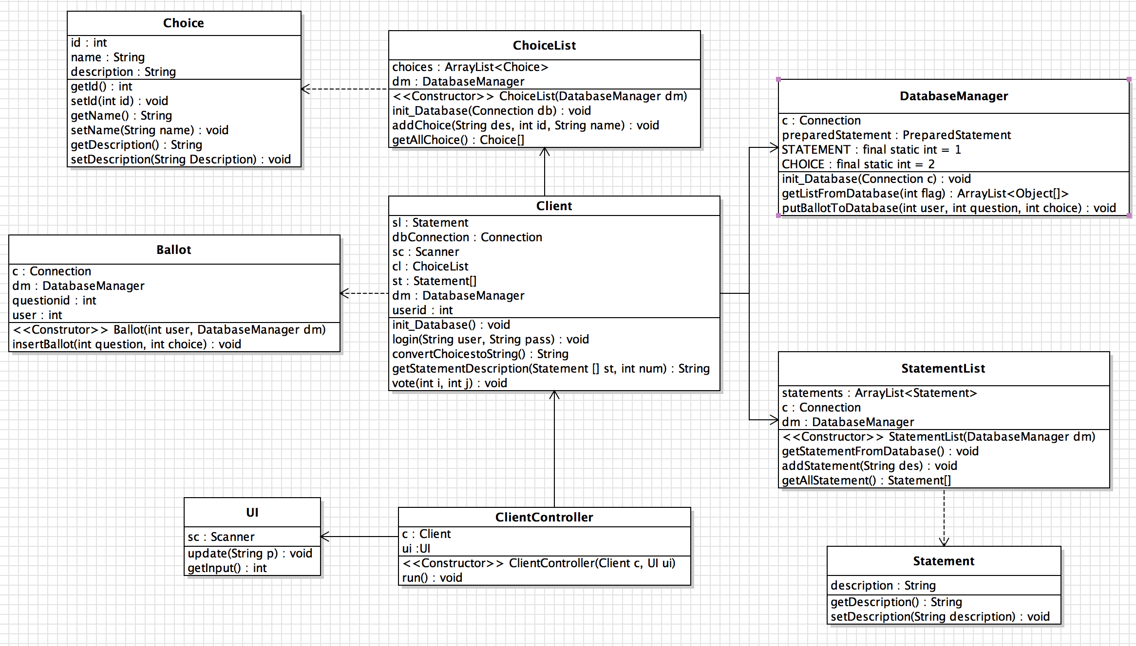
At this time, there is no particular language that requires explanation for the development team. As the database is completed, new terms may need to be defined.

Appendix B: Analysis Models

