Tanachot Techajarupan 5410547624

Parwart Narujjiroj 5410546253

Sajarporn Chindalikit 5410547136

Kunat Pipatanakul 5410545982

UI Mock-ups

This is the log-in mock-up that the user can log in via his/her username and password or his/her facebook account.

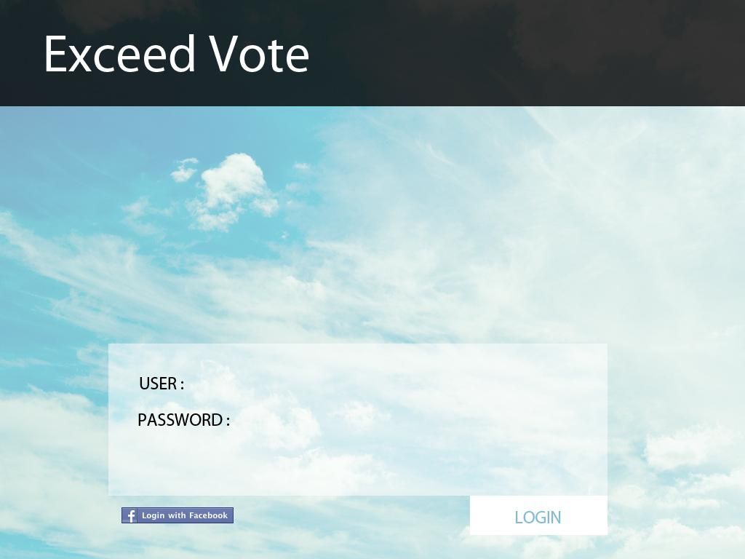

This is the main mock-up that show the user information.
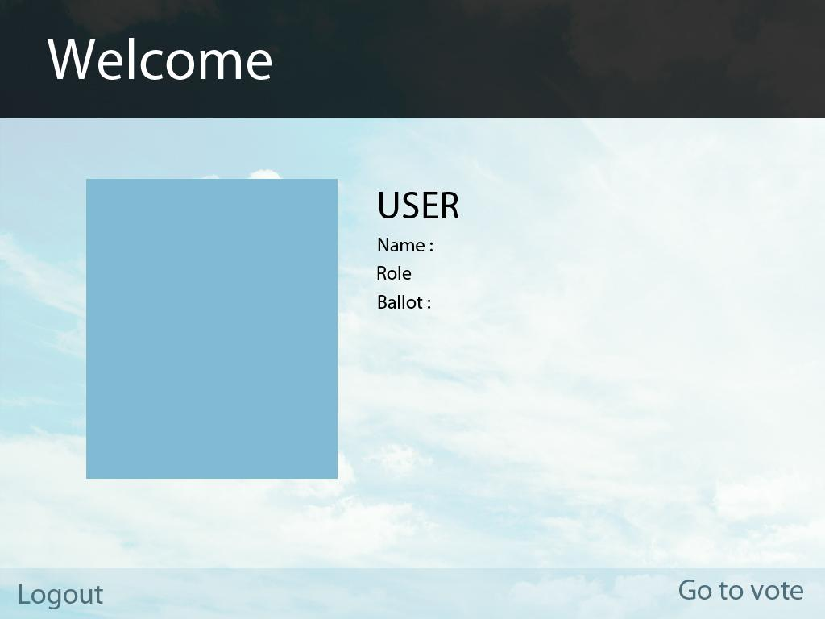

This is the vote system mock-up that user can choose which one is his/her favourite and vote.

