**Documentation for Linux Assessment**

**Problem Statement 1:**

Your name is Jane.

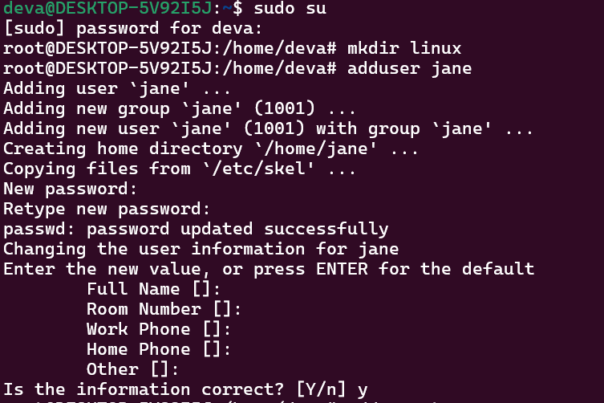

Create a repository for your project named “Linux”.

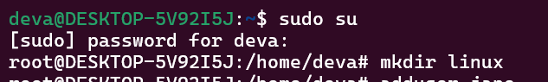

The folder is created outside the home directory of Jane.

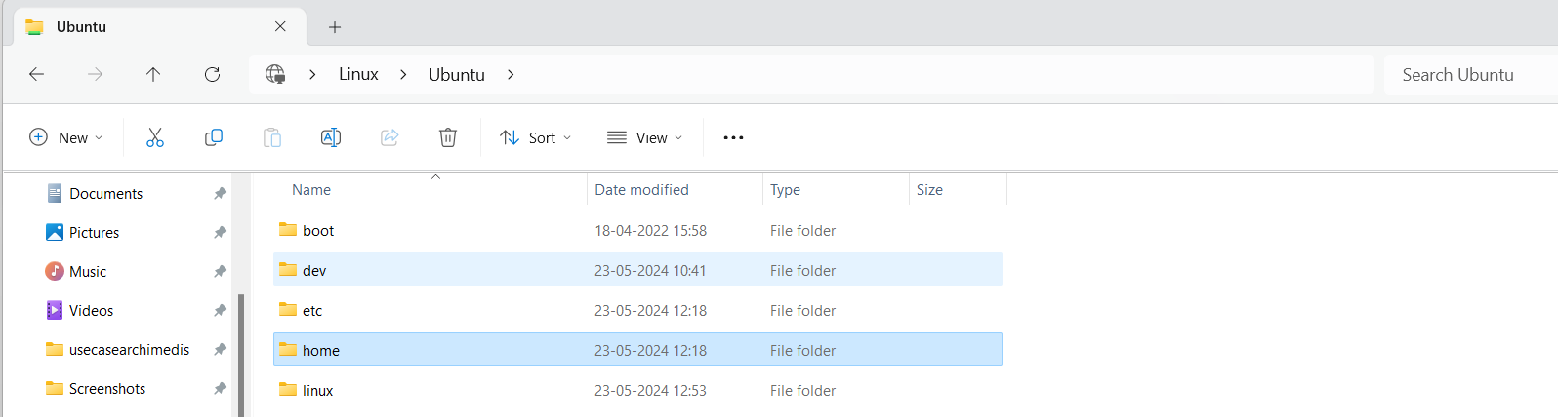

It is a group project and your friend Tom also has to have access to this repository.



**Things to be noted:**

• You create a user Tom with short description and password and a home directory.

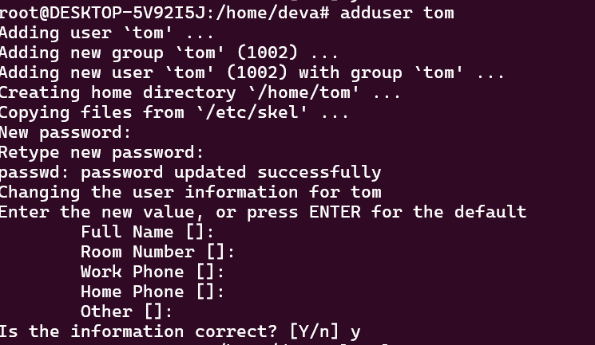

•Let Tom modify his shell and password.

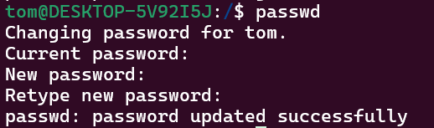

•Tom shouldn’t be able to access your home folder.

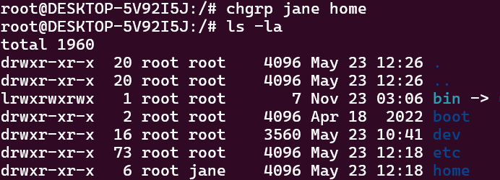

•Create another folder named ‘notes’ where you keep your study notes and Tom and may be other friends can also have same access to it. Guest shouldn’t be able to modify anything.

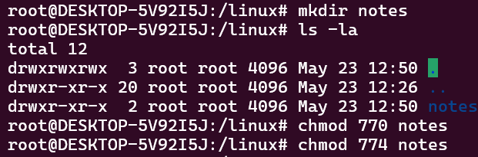

•Create another folder named ‘research’ where you keep the list of your researches. Others can have a look at list of researches in it but no one should be able to read, write it.

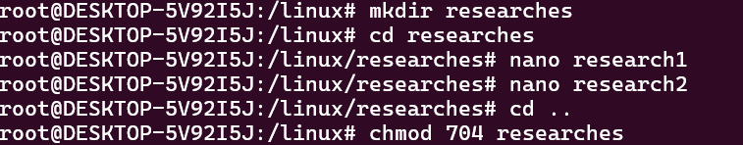

**Problem Statement 2:**

You are trying to access port 5432, but the system throwing an error by stating process 5432 is already. How do you restart the program in 5432.

**Things to do:**

1. Check all the running process
2. Kill the selected process

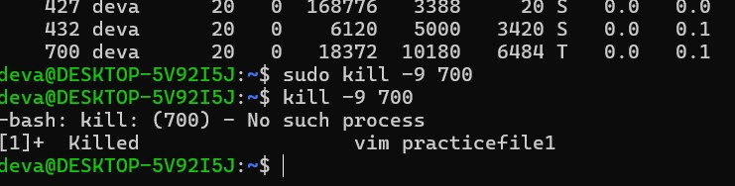

**Problem Statement 3:**

Demonstrate hard link .

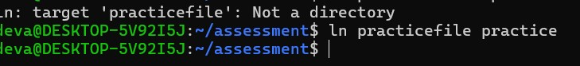

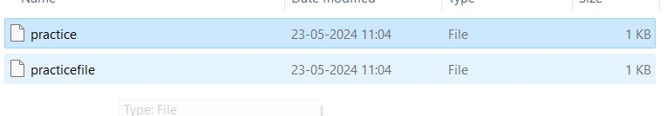

Demonstrate soft link .



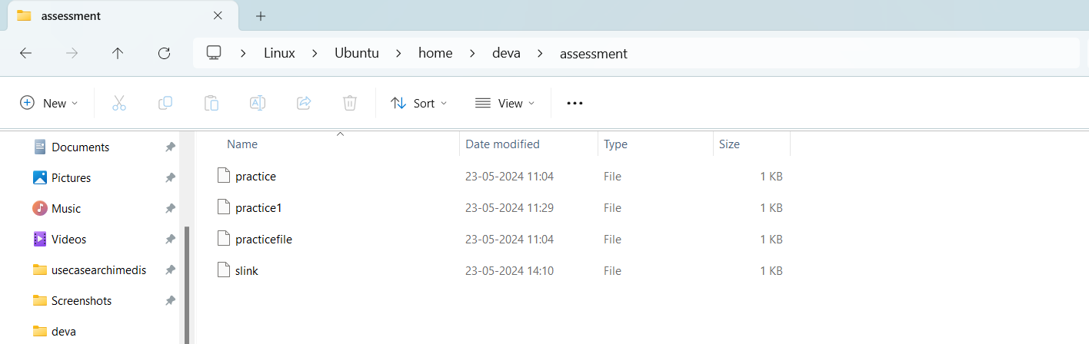

**Problem Statement 4:**

Demonstrate file permissions and group permissions

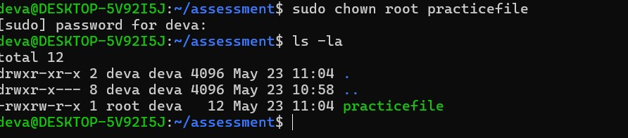

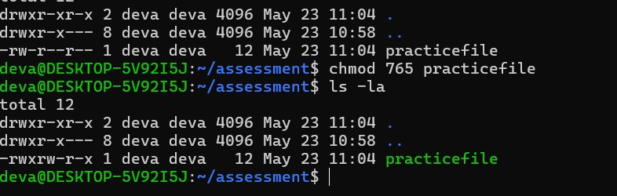

**Problem Statement 5:**

User needs to create a new file and copying to new location and rename the file before deleting the file.

