**Documentation for SQL Assessment**

**Design a database for E-commerce site**

* Create a E-Commerce database table.

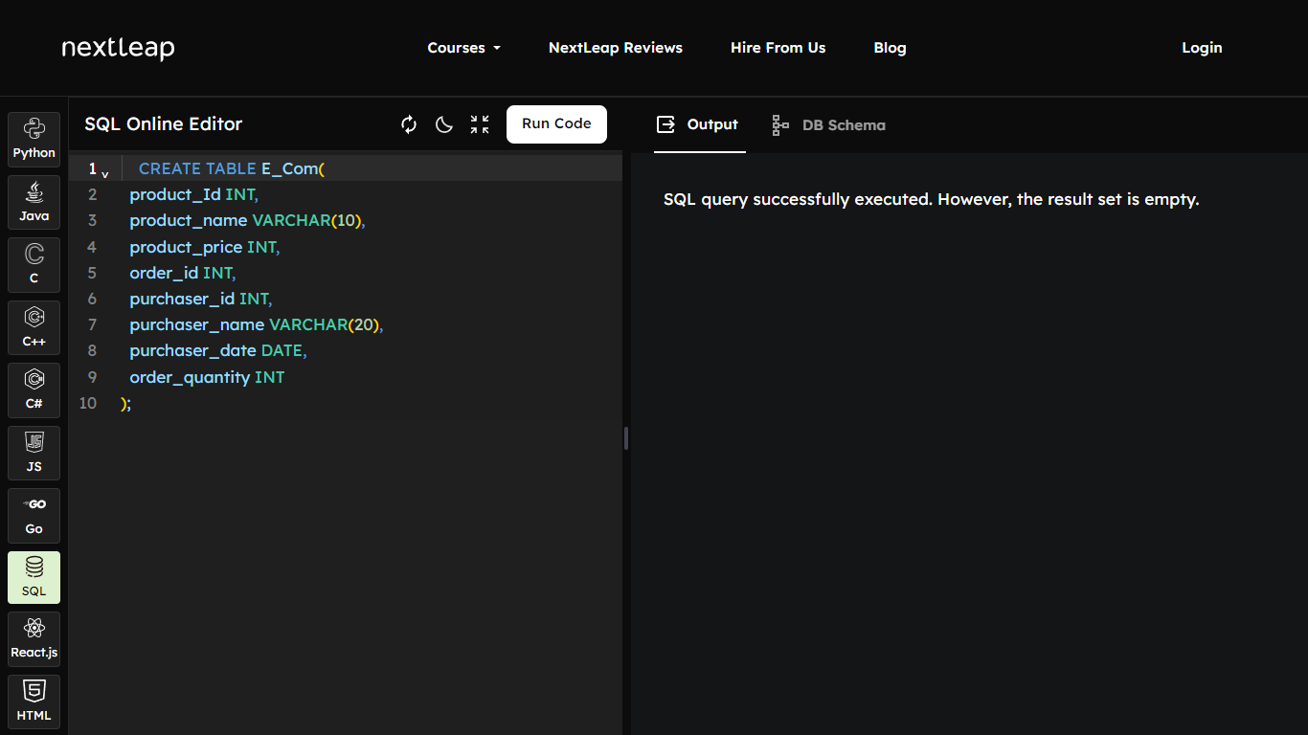

* Insert Value into E-Commerce database table.

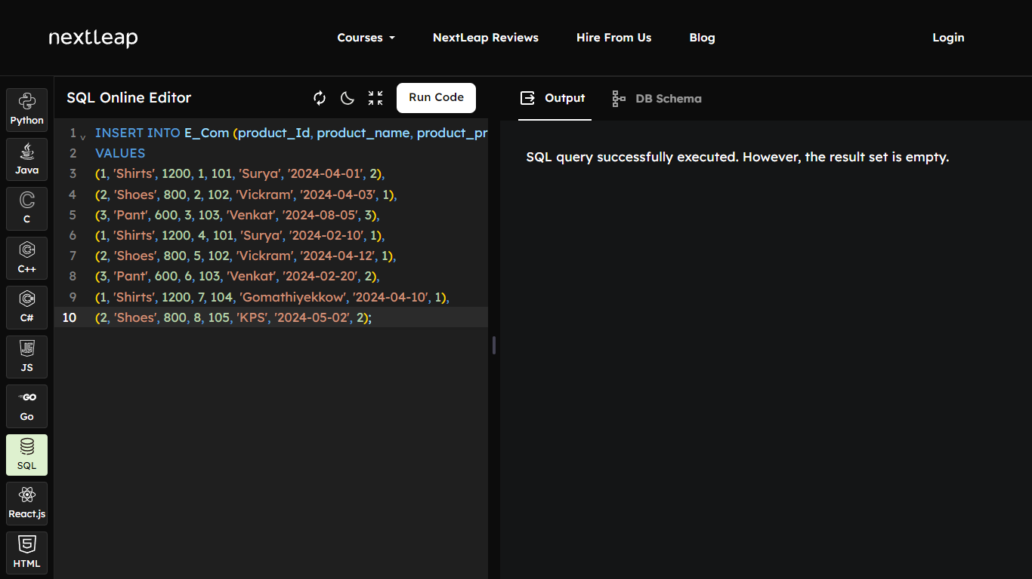

* Showing Tables.

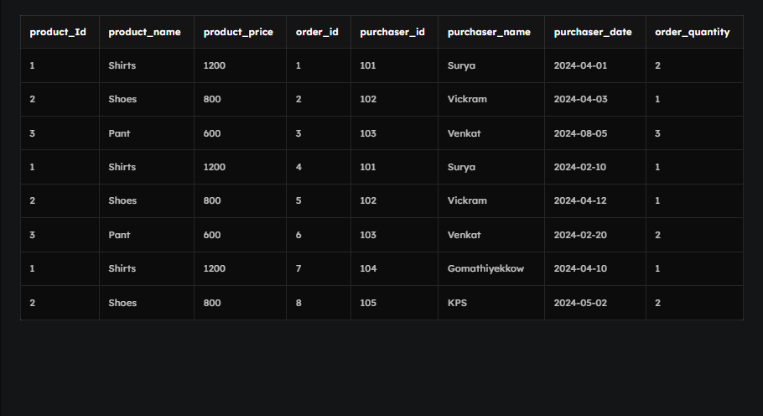

1. List top purchaser of the site.

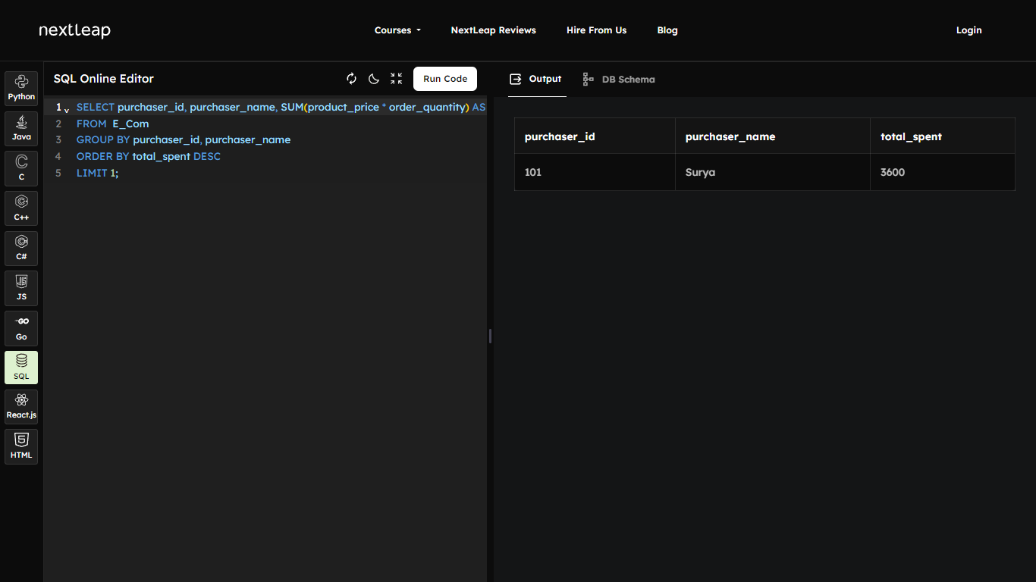

1. List Maximum order for the month. In this Database MONTH function not working.

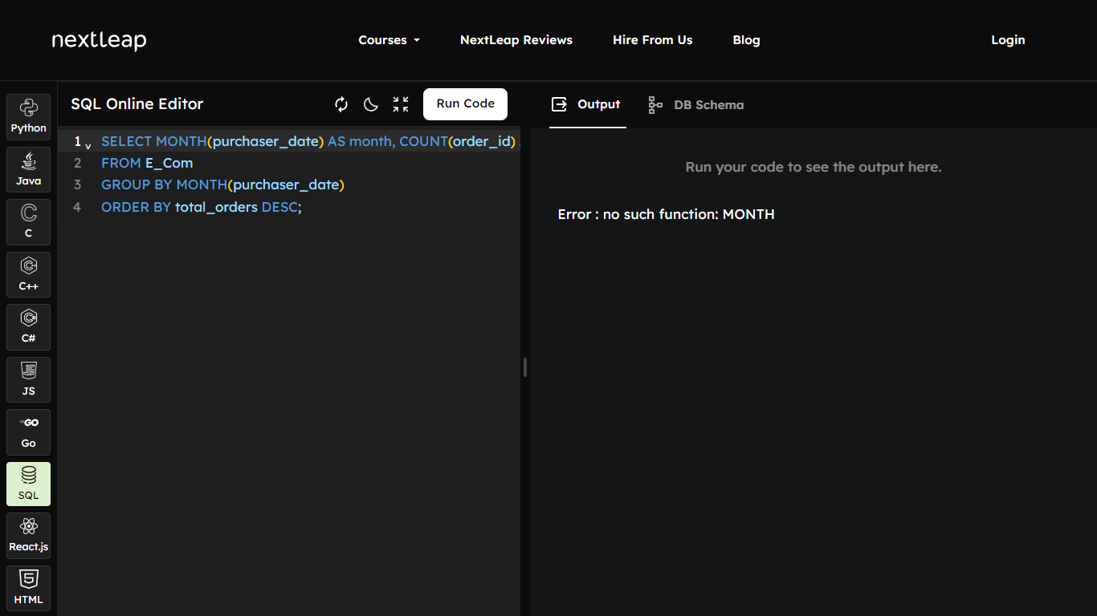

1. List day wise orders of a particular product.

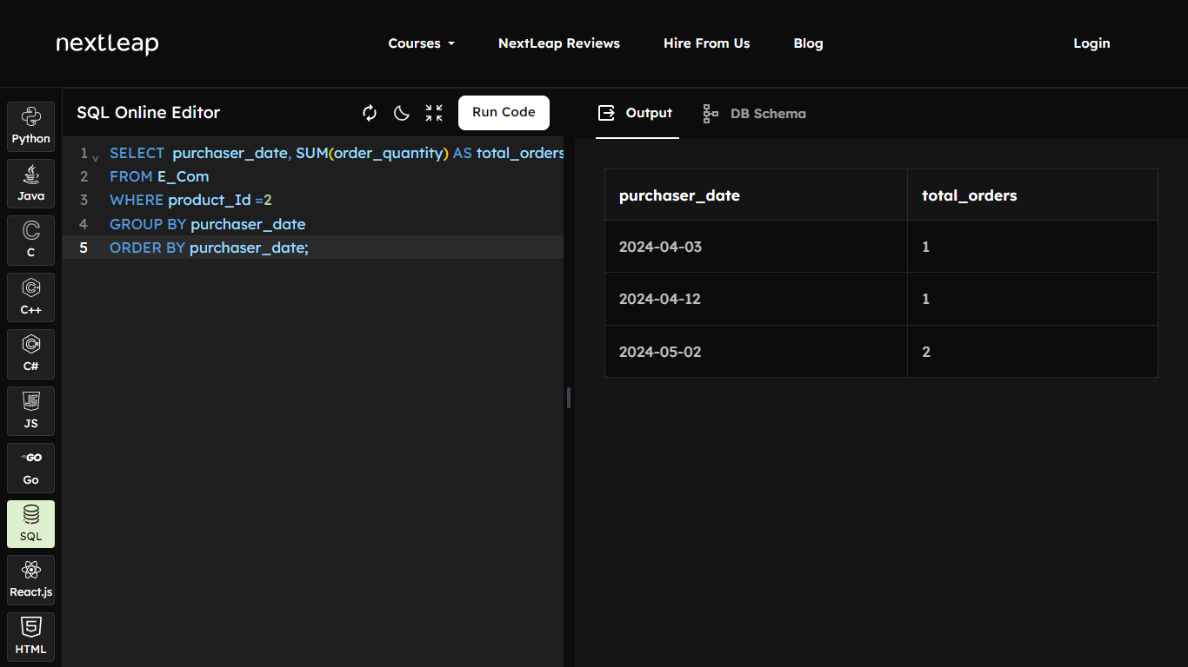

1. List 2nd most selling product.

